Table of Contents

CHAPTER 1: INTRODUCTION TO HYPERLEDGER FABRIC 7

Blockchain 7

Hyperledger 7

Hyperledger-Fabric 7

Hyperledger-Composer 7

Components in a Blockchain Solution 8

Ledger 8

Chaincode / Smart Contract 8

Peer Network 8

Membership 8

Events 8

Systems Management 9

Wallet 9

Systems Integration 9

Public vs. Private Blockchains 9

Public Blockchain 9

Private Blockchain 9

How to decide which blockchain to use? 10

Few Blockchain Usecases: 11

AIM 12

Lab Exercise 1: Building a UseCase 13

TASK#1: Private Blockchain Usecase & Stories 14

TASK#2: Identify Blockchain Components 15

TASK#3: Identify Transactions 16

TASK#4: Identify Business Permissions 19

TASK#5: Define Models 20

TASK#6: Deploy & Testing in Playground 24

SUMMARY 27

REFERENCES 28

CHAPTER 2: HYPERLEDGER FABRIC FUNDAMENTALS 29

Distributed Ledger 29

Nodes: 30

Channel: 31

Node Types: Ordered, Anchor & Endorser 32

Client Node: 32

Peer Node: 32

HyperLedger Transaction Flow: 34

Endorsement Policies 35

Transaction evaluation against endorsement policy 36

Membership Service Provider (MSP) 37

Certificate Authority 38

AIM 39

Lab Exercise 2: CHAINCODE BASICS 40

TASK#1: Create a Business Network Scaffolding 41

TASK#2: Write basic model, chaincode and test 43

TASK #3: Start fabric and create peer admin card 47

TASK #4: Create Archive & Deploy Runtime 51

TASK#5: Running chaincode Test 55

TASK#6: Launch & use explorer 57

SUMMARY 61

REFERENCES 62

CHAPTER 3: PARTICIPANT, IDENTITIES & ACCESS CONTROL 63

Lab Exercise 3: Adding Participants, Identities & Access Controls 66

TASK#1: Define Participants & Transactions 67

TASK#2: Defining Access Control 72

TASK#3: Deploy in Playground 77

TASK#4: Create Participants 80

TASK#5: Create Identity 83

TASK#6: Test Access 86

Test Your Knowledge 92

SUMMARY 93

CHAPTER 4: HYPERLEDGER – CLIENT APP 94

Theory 94

High Level Architecture 94

Queries: 94

Events 95

Lab Exercise 4: Coding client App, Queries & Events 96

TASK#1: Coding Client App 97

TASK#1.1: Coding requestAffiliation() 97

TASK#1.2: Coding getCollegeList() 100

TASK#1.3: Coding approveAffiliation() 102

TASK#1.4: Coding enrollProgram() 105

TASK#1.5: Coding takeAdmission() 107

TASK#1.6: Coding getStudentList() 109

TASK#1.7: coding issueCertificate() 111

TASK#2: Using Queries 113

TASK#3: Blockchain Events & Subscription 116

Test Your Knowledge 120

CHAPTER 5: CREATING FRONT END INTERACTIVE INTERFACES 121

Theory 121

Front End Application Patterns 121

1. Composer Rest Server middleware Architecture: 121

2. Custom middleware pattern: 122

3. Desktop Application Architecture 122

Lab Exercise 5: Building Interactive Frontend 123

TASK#1: Coding the Web – HTML 124

TASK#1.1: Directory Structure CSS and Script includes 126

TASK#1.2: Coding HTML for different sections 128

TASK#2: Connecting the Frontend to call Client App 132

TASK#3: Adding dependency packages 134

TASK#4: Setting up the node server 136

TASK#5: Running the use-case End to End 138

SUMMARY 146

CHAPTER 6: Exploring Blockchain 147

Theory 147

Hyperledger Fabric Blockchain Creation Workflow 147

Lab Exercise 6: Exploring Hyperledger 148

TASK#1: Download & Setup Fabric Sample - BYFN 149

TASK#2: Generate Crypto Material & launch network 151

TASK#3: Setup Hyperledger Explorer 158

TASK#4: Build & Run the Explorer 163

TASK#5: Exploring the explorer… 165

SUMMARY 169

CHAPTER 7: Adding a new Peer 170

Theory 170

Peers 170

University Usecase – A new Peer 171

Lab Exercise 7: Adding a peer to Hyperledger Fabric 172

TASK#1: Download Binaries & setup path 173

TASK#2: Generate Crypto Material 175

TASK#3: Configure Docker Services 178

TASK#4: Configure Scripts – Join Peer1 to the channel 181

TASK#5: Peer Admin Card creation 183

TASK#6: Test the network 185

TASK#6.1: Visualize Docker Setup 185

TASK#6.2: Launch University-Usecase example 186

TASK#6.3: Stop 1 Peer and Validate Blocks 188

SUMMARY 193

CHAPTER 8: Adding a new organization to the existing Network. 194

Theory 194

Problem Statement: 194

Solution: 194

Business Network 194

Current Setup 194

New Setup 195

Lab Exercise 8: Adding a new Org to existing Hyperledger Fabric Composer Network 196

TASK#1: Setup Environment 197

TASK#1.a: Copy org2 artifacts & setup fabric binaries 197

TASK#1.b: Map peer0.org1 volume to host 199

TASK#1.c: Launch University-Usecase example 201

TASK#2: Generate Crypto Material for Org2 202

TASK#3: Fetch current config block and append the new Org2 material 205

TASK#4: Sign & Update the new configuration 212

TASK#5: Spin Up Org2 215

TASK#6: Org2 Joins the channel 218

TASK#7 Test Network 221

SUMMARY 223

CHAPTER 9: Scaling Hyperledger on Multiple Hosts 224

Theory 224

University Usecase – New Setup 224

Lab Exercise 9: Scaling Hyperledger on Multiple Hosts 226

TASK#1: Download Binaries & setup path On Host#1 227

TASK#2: Generate Crypto Material 229

TASK#3: Configure Docker Services 233

TASK#4: Configure Scripts – Join Peers to the channel 238

TASK#5: Peer Admin Card creation 241

TASK#6: Create Docker Swarm network 246

TASK#7: Deploy and Launch the Network 249

TASK#8: Testing the network 256

TASK#8.1: Visual Testing docker containers 256

TASK#8.2: couchDB Validation 257

TASK#8.3: Run UI – Make Transaction & Validate Blocks 259

SUMMARY 262

# CHAPTER 1: INTRODUCTION TO HYPERLEDGER FABRIC

## Blockchain

Block chain is a continuously growing list of digital records called blocks, which are linked and secured using cryptography. Each block typically contains a cryptographic hash of the previous block, a timestamp and transaction data.

A blockchain is inherently resistant to modification of the data. It is an open, distributed ledger that can record transactions between two parties efficiently and in a verifiable and permanent way.

*Definition from wiki…*

## Hyperledger

Hyperledger is an open source and openly governed collaborative effort to advance cross-industry blockchain technologies for business, hosted by The Linux Foundation.

## Hyperledger-Fabric

Hyperledger Fabric is a blockchain framework implementation and one of the Hyperledger projects, intended as a foundation for developing applications/solutions with a modular architecture

## Hyperledger-Composer

Hyperledger Composer is a set of collaboration tools for building blockchain business networks that make it simple and fast for business owners and developers to create smart contracts and blockchain applications to solve business problems.

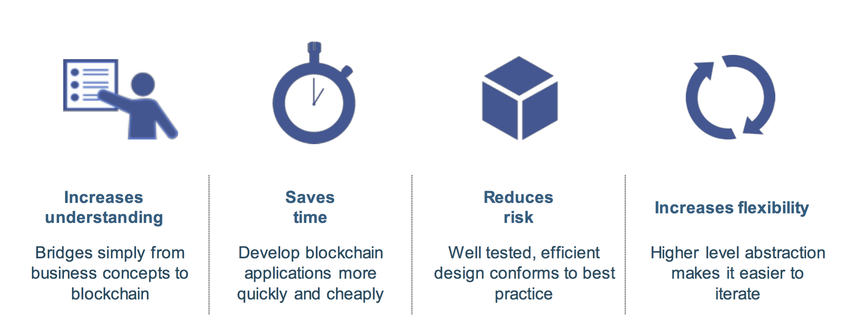

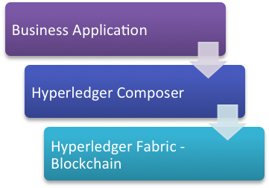

Node.js

(javascript)

Distributed

Processing

## 

## Components in a Blockchain Solution

### Ledger

A ledger is a channel’s chain and current state data which is maintained by each peer on the channel.

### Chaincode / Smart Contract

Software running on a ledger, to encode assets and the transaction instructions (business logic) for modifying the assets

### Peer Network

A broader term overarching the entire transactional flow, which serves to generate an agreement on the order and to confirm the correctness of the set of transactions constituting a block

### Membership

Membership Services authenticates, authorizes, and manages identities on a permissioned blockchain network

### Events

Creates notifications of significant operations on the blockchain (e.g. a new block), as well as notifications related to smart contracts.

### Systems Management

Provides the ability to create, change and monitor blockchain components

### Wallet

Securely manages a user’s security credentials

### Systems Integration

Responsible for integrating Blockchain bi-directionally with external systems. Not part of blockchain, but used with it

## Public vs. Private Blockchains

### Public Blockchain



* Transactions are viewable by anyone
* Participant identity is more difficult to control
* For example: Bitcoin, Ethereum

### Private Blockchain



- Network members are known but transactions are secret

- Needs control who make the change to blockchain registry

- For example; Hyperledger Fabric

### How to decide which blockchain to use?

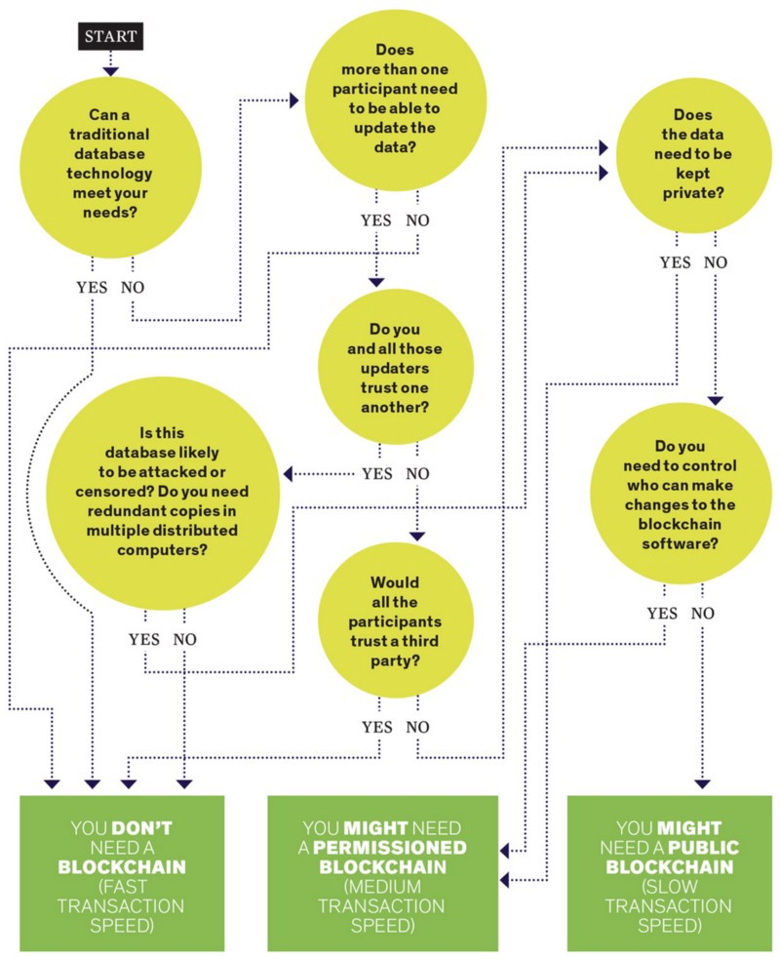

### Few Blockchain Usecases:

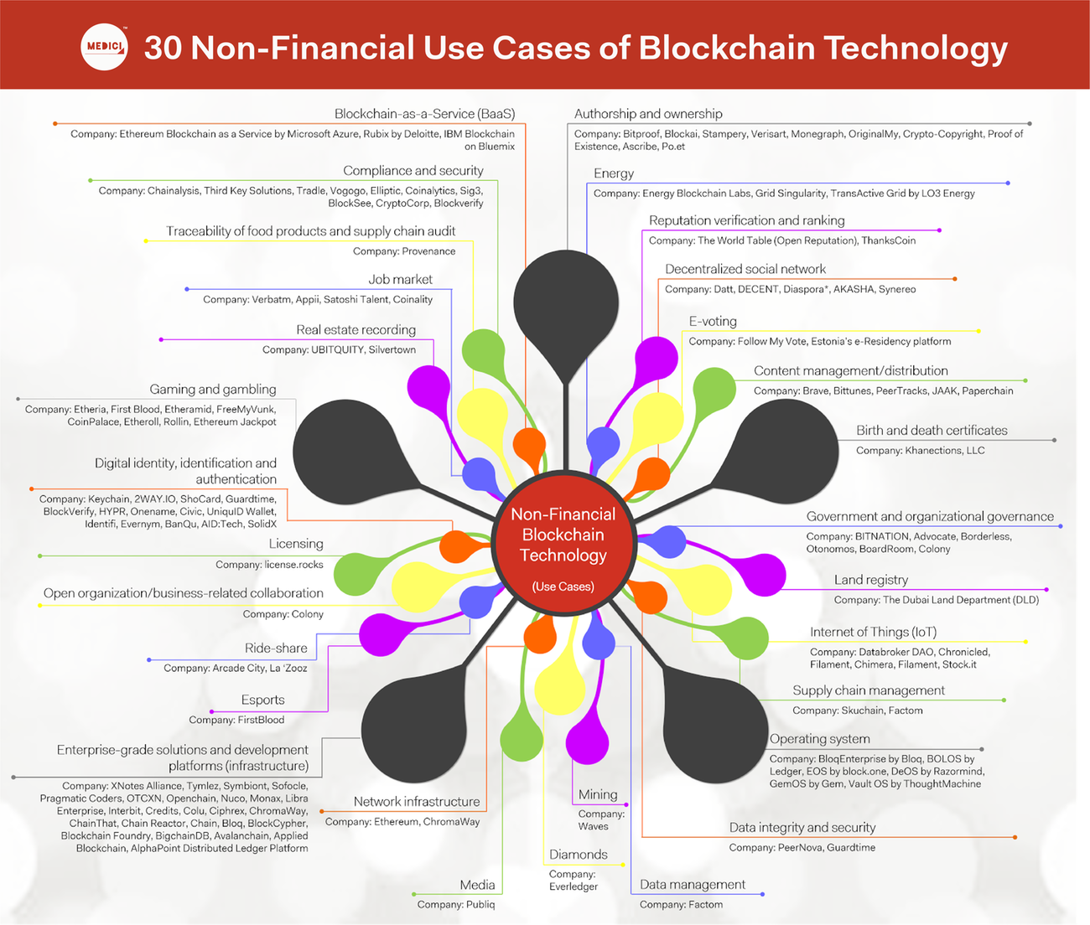

# AIM

After you completed all the following chapters with lab exercises, you will be able to:

* Have Development Environment Setup for Hyperledger Fabric
* Understand on types of nodes & their functions
* Create permissioned blockchain network
* Use Authorizations and authentication
* Write chaincode and call transactions via composer tools and rest server
* Understand different Hyperledger architecture templates

# Lab Exercise 1: Building a UseCase

|  |
| --- |
|  |

1. **Identify Usecase Story**
2. **Identify Blockchain Components**
3. **Identify Transactions**
4. **Identify Business Permissions**
5. **Define Models**
6. **Deploy & Test in Playground**

## TASK#1: Private Blockchain Usecase & Stories

* **University**: As a University, I am an intitution for higher studies. I want to affiliate Colleges and cources. Enroll Students and Award certificates
* **Students**: As a student I want to take admissiom, enroll for a specific education program and get awarded with certification of successful completion
* **Colleges**: As a college, I provide students specialized courses as per the guidelines/affiliation with university.
* **Verifier**: As a verifier, I want to verify if the certificate ID (public address) is valid and its corressponding details (Issued to, Status, etc). I can also search all certificates assocaited with a Nation-ID (or tokenized ID)
* **Business Network Admin (BNA)**: As a network admin I want to deploy code and runtimes.

## TASK#2: Identify Blockchain Components

## TASK#3: Identify Transactions

Step 1:

**requestAffiliation()**

**Input:**

*- College Detail*

**Output:** *Status*

**By Praticipant:** *college*

**On Praticipant:** *University*

**enrollStudent()**

**Input:**

*- Student Detail*

**Output:** *Student EnrollmentID*

**By Praticipant:** *College*

**On Praticipant:** *University*

**issueCertificate()**

**Input:**

*- Certificate Detail*

**Output:** *Public Address*

**By Praticipant:** *College*

**On Praticipant:** *University*

**enrollCourse()**

**Input:**

*- Course Detail*

**Output:** *CourseID*

**By Praticipant:** *College*

**On Praticipant:** *University*

**renewCertificate()**

**Input:**

*- Certificate Detail*

**Output:** *Status-Success/fail*

**By Praticipant:** *College*

**On Praticipant:** *University*

**searchCertificateByID()**

**Input:**

*- National-ID / Enrollment-ID*

**Output:** Certificate *List*

**By Praticipant:** *Verifier*

**On Praticipant:** *Blockchain*

**verifyCertificate()**

**Input:** *Public Address*

**Output:** *Certifcate Details*

**By Praticipant:** *Verifier (anyone)*

Step #3:

1. requestAffiliation()
2. enrollCourse()
3. enrollStudent()
4. issueCertificate()
5. verifyCertificate()
6. searchCertificatesByID()

2, 3b, 4

3a

5, 6

1

Step #4:

## 

## TASK#4: Identify Business Permissions

## 

## TASK#5: Define Models

Step 1: Asset

* The main asset that we are dealing with is the Certificate that we will store in the blockchain and will be encrypted & digitally signed

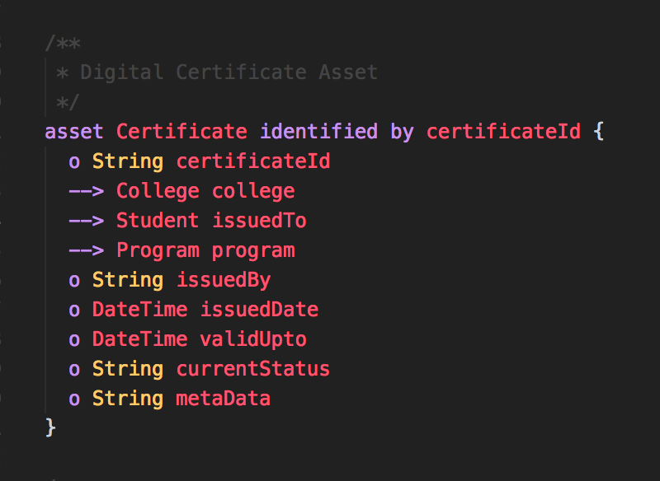

* Note: ( 🡪 ) Defines the reference to other previously defined Network classes

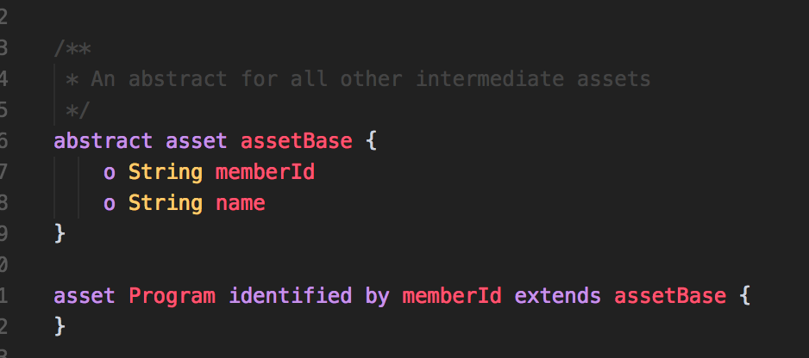

Step 2: Participants

* In the simple usecase of university we have Members with following properties
  + Identified by memberID
  + Has a Name
* As these properties and common within all participants let’s encapsulate it in an abstract with name MemberParticipant

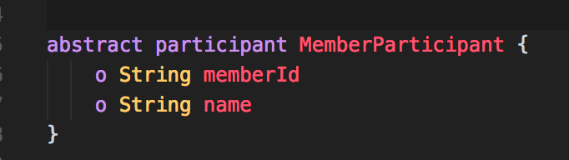

* We then extend all particiapnts with this base MemberParticipant abstract

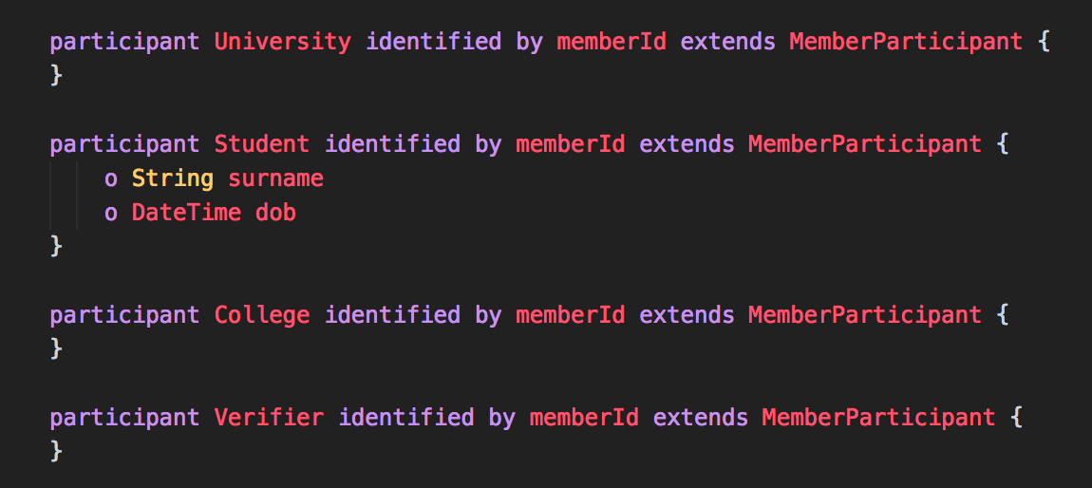

Step 3: Transactions

* Transactions can be defined in a similar modeling language
* We need to define all the parameters that are needed to complete the requested transaction

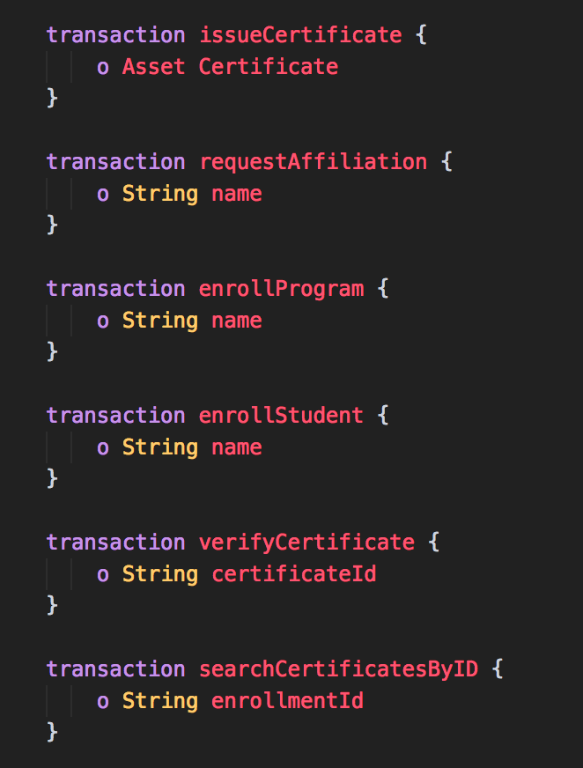

Step 4: Events

* Events are also declared similar to transactions and defines parameters that is broadcasted with the event.

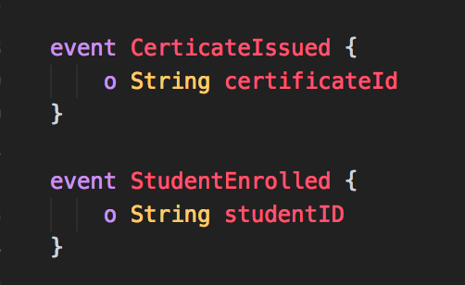

## TASK#6: Deploy & Testing in Playground

Step 1: Create Archive File

* Copy and unzip chapter01.zip to a folder
* CD into the ‘chapter1’ folder
* Create a folder ‘dist’ and cd into it
* Now type the following command to create an archive file

> composer archive create –t dir –n ../

* This will create a .bna file in the dist folder which contain all the created model files in its binary (.cto : Business model files)

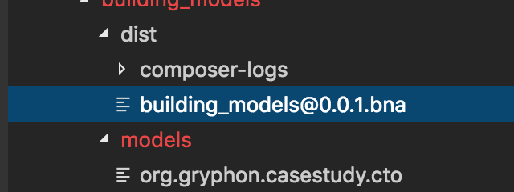

Step 2: Open your Internet browser and navigate to the following website:

https://composer-playground.mybluemix.net/

It will take a while to prepare your browser

Use the deploy button as shown in figure below to deploy the archive

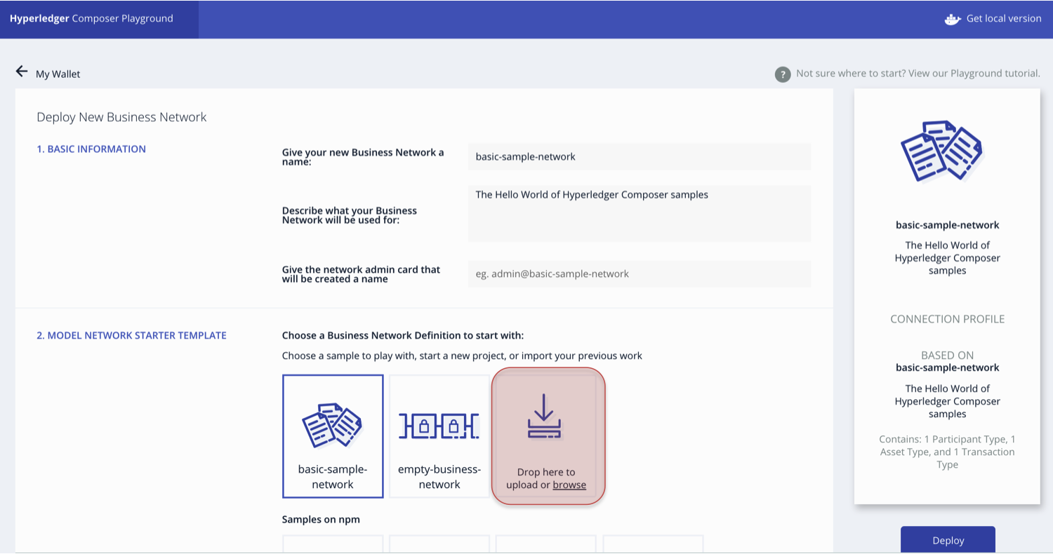

After deploying, start the application click the highlighted button as in figure below;

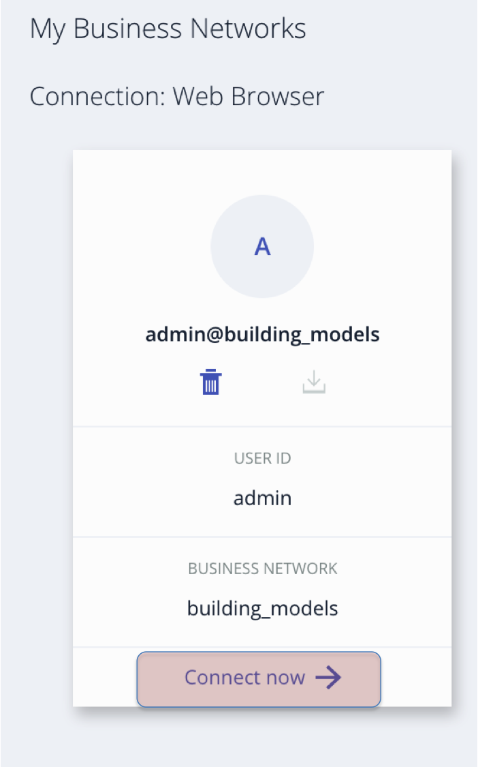

Step 3: Test using playground

Browse to the test panel as in figure below;

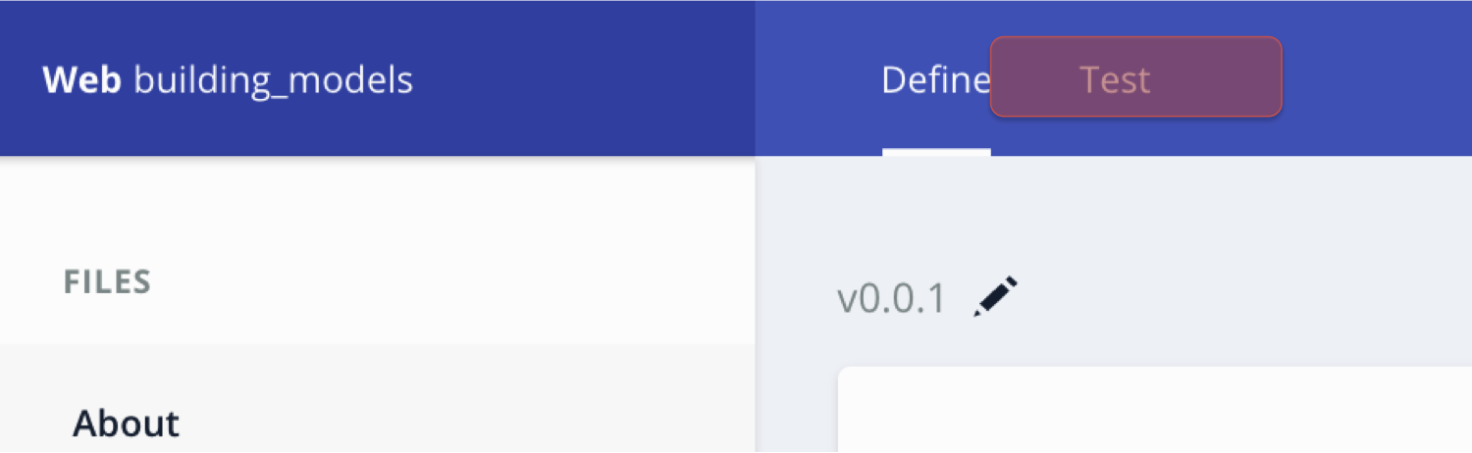

Left column will shows the entire asset, participants, which you can create and Test

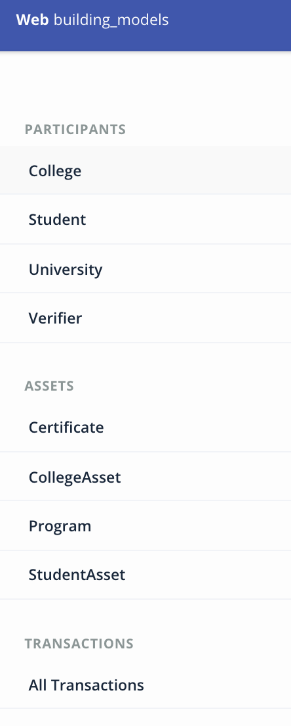

# SUMMARY

* Hyperledger is a Distributed Ledger Technology for the business
* Chaincode automates the Business processes
* Four Essential characteristics that make HyperLedger Suitable for Business are
  + Permissioned Network
  + Transaction confidentiality
  + No Mining needed compared to peers
  + Programmable using chaincode

# REFERENCES

* http://hyperledger.org
* http://hyperledger.org/projects/fabric
* https://hyperledger-fabric.readthedocs.io/en/latest/build_network.html

# CHAPTER 2: HYPERLEDGER FABRIC FUNDAMENTALS

**Theory**

In this chapter, we will cover the fundamental blocks of Hyperledger fabric, discuss about what constitutes of the distributed ledger in fabric, types of node in fabric, endorsement policies, membership cards and the certificate authority.

In the lab section we will create our first business network, model our first university use-case, write chaincode and its test.

Finally we shall deploy the created business network and test it using chai and mocha framework. Also use explorer to add entries to the asset and validate the transaction history using the Historian registry and explorer.

## Distributed Ledger

The ledger is the sequenced, tamper-resistant record of all state transitions. State transitions are a result of chaincode invocations (“transactions”) submitted by participating parties. Each transaction results in a set of asset key-value pairs that are committed to the ledger as creates, updates, or deletes.

In Fabric Ledger has two parts:

* **State data**: Representation of current state of the assets
* **Transaction Logs**: Record of all the transactions which modified the state data

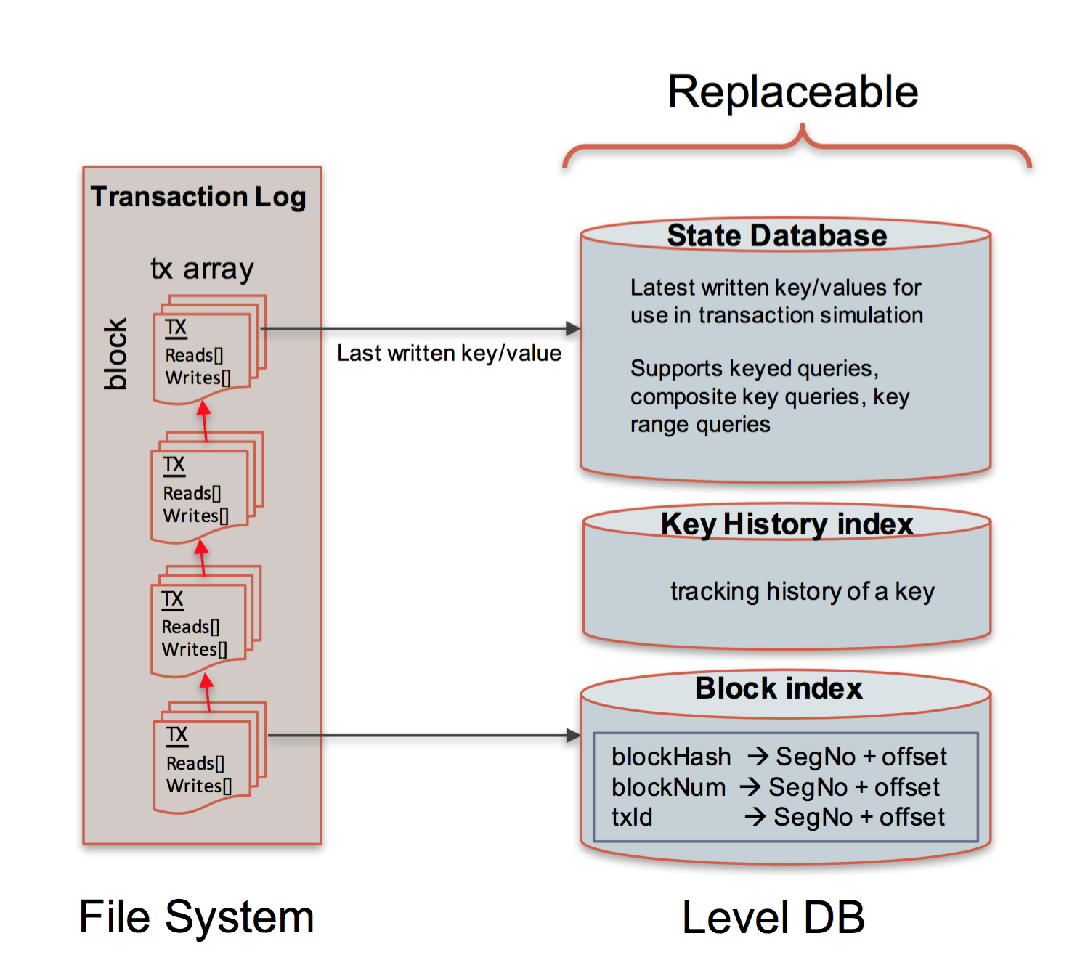

|  |  |  |
| --- | --- | --- |
|  | **Transaction Logs**: | **State data** |
| Type | Is Immutable | Mutable |
| Operations | Create, Retrive | ALL – CRUD |
| DB | levelDB | levelDB / CouchDB |
| Behaviour | Embedded within Peers | Key-value paired (Json or Binary) |
| Query | Supports Simple Query | CouchDB Supports complex queries |

Each transaction has a unique ID, its time-stamped and contains signatures of every endorsing peer and are submitted to ordering service

The ledger is comprised of a blockchain (‘chain’) to store the immutable, sequenced record in blocks, as well as a state database to maintain current fabric state. There is one ledger per channel. Each peer maintains a copy of the ledger for each channel of which they are member.

## Nodes:

The concept of node is common in all blockchain technologies. Node becomes the communication end point in blockchain technology. Nodes connect to other nodes and that is how a blockchain is formed.

Nodes use some kind of peer-to-peer protocol for keeping the distributed ledger in sync across the network.

In public blockchain like Ethereum; anyone can participate as a node by downloading node client called wallet. But incase of permissioned Hyperledger network, things are quite different.

In Hyperledger, nodes need valid certificate to be able to communicate to the network and the participants use applications that connect to network by way of the nodes. Participant’s identity is not the same as the nodes identity. The participant that executes or invokes a transaction their certificate is used for signing that transaction. The network to check if they should trust the node uses node’s certificate or not. Incase the nodes certificate is revoked or has expired in that case the transaction thought signed by a valid certificate held by the participant is broadcasted to the network but the transaction will be rejected because the certificate that node is using has been expired or has been revoked.

In Hyperledger, all Nodes are NOT equal. There are three distinct types of nodes:

1. **Client Node:** That initiates the transaction
2. **Peer Nodes:** Commits Transaction & keeps the data in sync across the ledger
3. **Ordered:** They are the communication backbones and responsible for the distribution of the transactions

## Channel:

Members can participate on multiple hyperledger blockchain networks. Transaction in each network is isolated and this is made possible by way of what is referred to the channels

Channel is a data partitioning mechanism to control transaction visibility only to stakeholders, other members on the network are not allowed to access the channel and will not  see transactions on the channel

## 

A chaincode may be deployed on multiple channels, each instance is isolated within its channel. Similarly each channel maintains their own ledger. [This is as of Hyperledger version 1.0 and may change].

Separation of the ledger, by defining the specific channel for each ledger and peer node memberships are defined in Chaincode configuration. It is stored in the Genesis block of the ledger, which also stores the members, policies, and anchor peers.  The Genesis block defines the read/write access on a channel.

Peers are connected to the channel and can receive all the transactions that are broadcasted on that channel. Consensus takes place within a channel by members of the channel.

## Node Types: Ordered, Anchor & Endorser

### Client Node:

The client represents the entity that acts on behalf of an end-user. It must connect to a peer for communicating with the blockchain. The client may connect to any peer of its choice. Clients create and thereby invoke transactions.

### Peer Node:

They are nodes that maintain the state and copy of a shared ledger.  Peers are authenticated by certificates issued by MSP. In HyperLedger Fabric, there are three types of peer nodes depending upon the assigned roles:

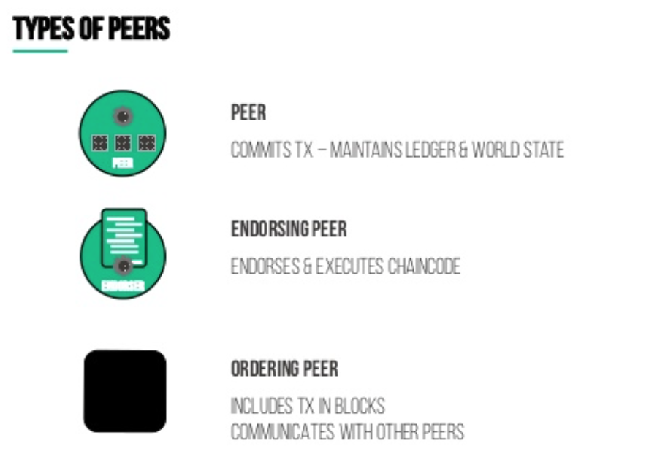

**Endorsing Peers** (Endorsers) – An endorser executes and endorses transactions

The endorsing peers take up the role of endorsing transactions before it is ordered and committed as per the policy defined in Chaincode. The client application creating the transaction and sends it to endorsing peers as per the policy in chaincode.  The endorsement policy is instantiated at the chaincode of the client application and forwarded to the endorsing peers. The endorsing peer evaluates and validates the transaction and produces an endorsement signature and then returns it to the application. There may be one or more pre-specified set of endorsing peers involved as per the endorsement policy. The transaction is evaluated and declared valid only if it has been endorsed by the endorsing peers as per policy.

**Ordering Service Nodes (Orderers) –**

* Responsible for consistent ledger state across the network
  + Consensus Mechanism
  + Ensures order of Transactions
* Creates Blocks & Provides atomic delivery/broadcast
* Message Oriented Middleware options for orderer service in Hyperledger:
  + SOLO: Single Node (Good for Development)
  + Kafka: High throughput, scalable & Fault Tolerant

All transactions from the network are received by the orderer and it orders and groups them and then packages the transactions and creates blocks. The orderer service delivers blocks to the committing peers allowed to be part of a Channel. The orderer services do not review transaction information. The orderer makes guaranteed atomic delivery of blocks to committing peers on the channel. The orderer supports multiple channels using a publish/subscribe messaging system (based on Apache Kafka and Zookeeper). The ordered provides a practical Byzantine Fault tolerance for failures without a single-point of failure.

Ordering service nodes also provide the following services:

* Authentication of clients
* Maintenance of a system chain that defines ordering service configurations, root certs and MSP IDs for authenticated organizations and a grouping of profiles containing the various consortia within the network.
* Filtering and validation for configuration transactions that reconfigure or create a channel.

**Committing Peers** (Committers) – Verifies endorsements and validates transaction results

They receive blocks from Orderer service, which already endorsed by the endorsing peers. The Committing peers ultimately commit the transactional state by adding the blocks to the ledger. Before commital, the peers validate or invalidate the transaction by verifying if the endorsement policies are met, authenticate the signatures and also verify the version info (if there is any double spending).

### HyperLedger Transaction Flow:

Assuming the HyperLedger Fabric 1.0 up and running, in a typical transaction flow of asset exchange:

* All application users and peer node members are registered in the MSP and issued with Keys/certificates from the CA for authenticating the network.  The Chaincode representing the initial state is installed on the peers and the channels are active.
* The application client initiates a transaction (Client A makes a request to Client B to transfer an asset). The endorsement policy states that the request must be endorsed by Peer A and Peer B.
* The application submits a transaction proposal to the endorsing peers A and B.
* The endorsing peers receive and verify the transaction proposal and its signature, then executes the transaction and return a signed proposal response back to the application client.
* The application client verifies the responses from the endorsing peers. It assembles the response into a transaction and sends it to the Orderer service.
* The Orderer services order the transactions chronologically and package those transactions as blocks specific to a channel.
* The Orderer service delivers the blocks of the transactions to all the peers on the channel.
* The peers perform the validation of the blocks for endorsement policy, signatures verification and version info, and finally appends the block to the chain and commit the state database – Notifies the application client.

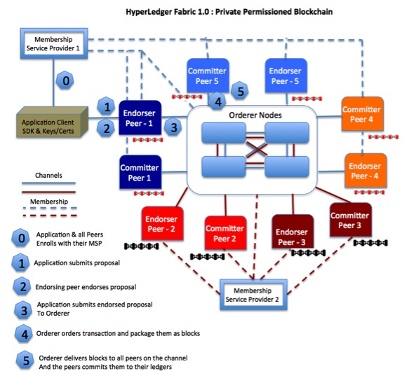

## Endorsement Policies

An endorsement policy is a condition on what *endorses* a transaction. Blockchain peers have a pre-specified set of endorsement policies, which are referenced by a deploy transaction that installs specific chaincode. Endorsement policies can be parameterized, and these parameters can be specified by a deploy transaction.

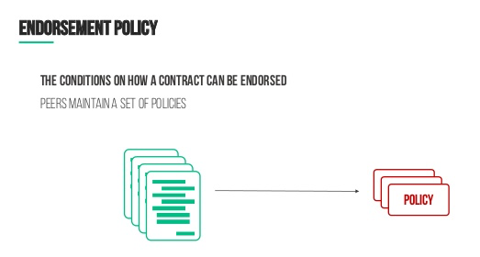

To guarantee blockchain and security properties, the set of endorsement policies should be a set of proven policies with limited set of functions in order to ensure bounded execution time (termination), determinism, performance and security guarantees.

Dynamic addition of endorsement policies (e.g., by deploy transaction on chaincode deploy time) is very sensitive in terms of bounded policy evaluation time (termination), determinism, performance and security guarantees. Therefore, dynamic addition of endorsement policies is not allowed, but can be supported in future.

### Transaction evaluation against endorsement policy

A transaction is declared valid only if it has been endorsed according to the policy. An invoke transaction for a chaincode will first have to obtain an *endorsement* that satisfies the chaincode’s policy or it will not be committed. This takes place through the interaction between the submitting client and endorsing peers as explained in Section 2.

Formally the endorsement policy is a predicate on the endorsement, and potentially further state that evaluates to TRUE or FALSE. For deploy transactions the endorsement is obtained according to a system-wide policy (for example, from the system chaincode).

An endorsement policy predicate refers to certain variables. Potentially it may refer to:

1. Keys or identities relating to the chaincode (found in the metadata of the chaincode), for example, a set of endorsers;
2. Further metadata of the chaincode;
3. Elements of the endorsement and endorsement.tran-proposal;
4. And potentially more.

The above list is ordered by increasing expressiveness and complexity, that is, it will be relatively simple to support policies that only refer to keys and identities of nodes.

The evaluation of an endorsement policy predicate must be deterministic. An endorsement shall be evaluated locally by every peer such that a peer does *not* need to interact with other peers, yet all correct peers evaluate the endorsement policy in the same way.

## Membership Service Provider (MSP)

“Abstract component of the system that provides credentials to the clients, and the peers for then to participate in the Hyperledger Fabric network”

MSP implementation is based on the PKI (Public Key Infrastructure)

Service it Provides:

* Authorization Service
  + Role based
  + Examples:
    - Can this user further issue identity?
    - Can user deploy chaincode?
* Authentication Service
  + Where users Identity gets validated
  + Examples:
    - Is the user’s/peer’s certificate valid?
    - Is peer allowed to participate?

## 

## Certificate Authority

As a platform for **permissioned** blockchain networks, Hyperledger Fabric includes a modular **Certificate Authority (CA)** component for managing the network identities of all member organizations and their users. The requirement for a permissioned identity for every user enables ACL-based control over network activity, and guarantees that every transaction is ultimately traceable to a registered user.

* The CA (Fabric CA by default) issues a root certificate (rootCert) to each member (organization or individual) that is authorized to join the network.
* The CA also issues an enrollment certificate (eCert) to each member component, server side applications and occasionally end users.
* Each enrolled user is also granted an allocation of transaction certificates (tCerts). Each tCert authorizes one network transaction.

This certificate-based control over network membership and actions enables members to restrict access to private and confidential channels, applications, and data, by specific user identities.

# AIM

After you completed this chapter with lab exercises, you will be able to:

* Have an understanding of Registries, distributed ledgers, types of nodes & their functions
* Create your first Hyperledger Business Network
* Start Hyperledger fabric, create archive, deploy runtimes and execute the tests
* Use explorer to add / update asset, run transactions and validate general system business methods like historian and identities

# Lab Exercise 2: CHAINCODE BASICS

|  |
| --- |
|  |

1. **Create a Business Network using Yo Scaffolding**
2. **Write Basic Model + Chaincode + Test**
   1. **npm install**
3. **Start Fabric and Create PeerAdmin Card**
4. **Deploy Runtime**
   1. **Create Archive**
   2. **Import Admin Card**
   3. **Deploy To Runtime**
5. **Testing Chaincode**
6. **Running Explorer**
   1. **Launch explorer**
   2. **Use Explorer to add a asset**
   3. **Run Transactions**
   4. **View Historian**



## TASK#1: Create a Business Network Scaffolding

**Step 1:** Create a new folder and cd into it. Launch terminal window and use following commands

mkdir chapter2

cd chapter2

**Step 2:**  Use Yo-Generator to create a business Scaffolding. Using the terminal window enter following commands

yo hyperledger-composer

**Step 3:**  Choose **‘Business Network’** from the choice using your keyboard

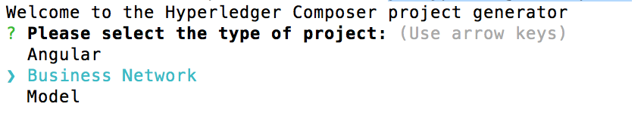

**Step 4:** After you have selected Business Network option you will be asked few details which you need to provide, shown below;



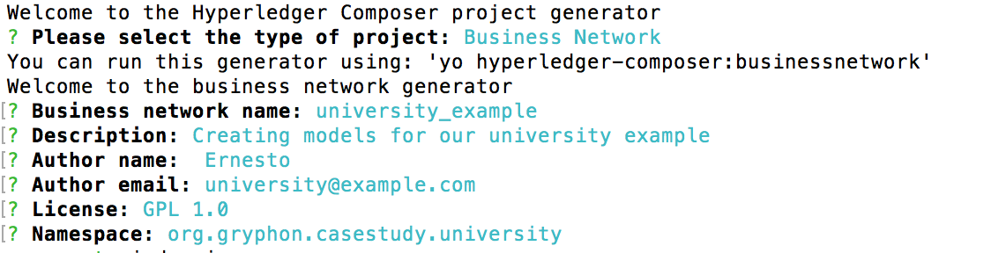

**Step 5:** Open the ‘chapter02’ folder in Visual Studio code to find the following directory structure

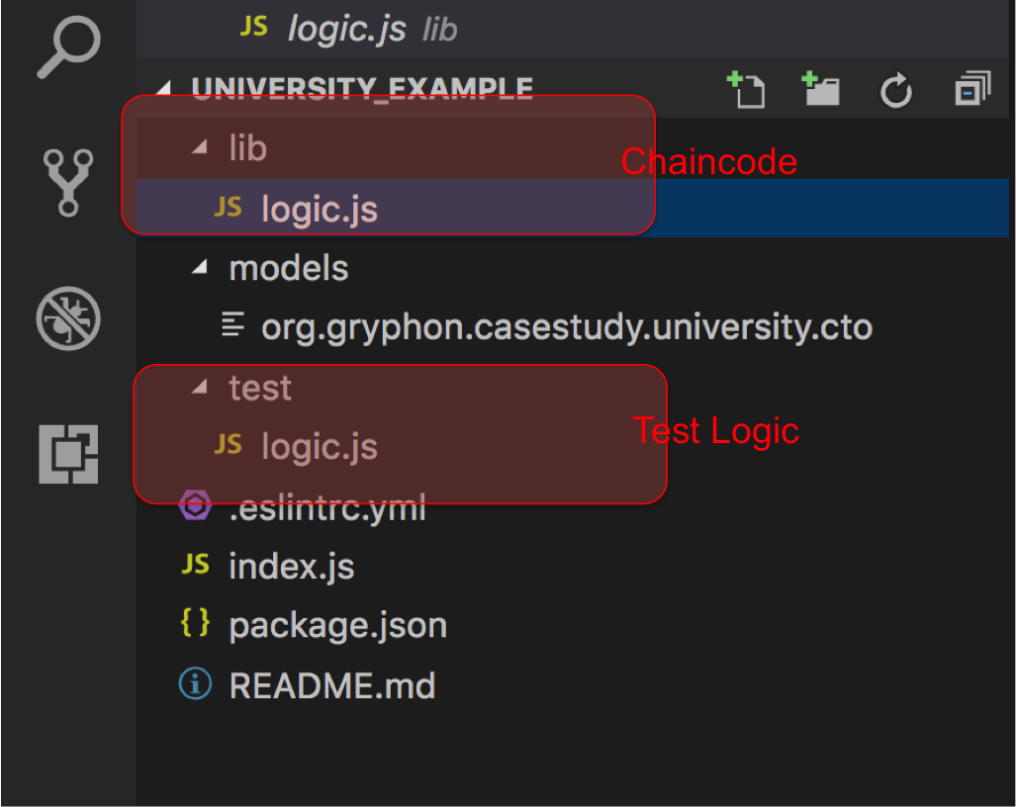

**Task 1 is complete!**



## TASK#2: Write basic model, chaincode and test

**\*\* We will use the code ‘chapter02’ provided with this lab as a sample chaincode**

**Step 1:** Open **‘chapter02’** code folder supplied with this book using Visual Studio Code;

This folder is similar to the Business Network Scaffolding created earlier but with few changes as below;

* ‘logic.js’ under lib folder is replaced with our university example chaincode and renamed to ‘chaincode.js’
* ‘logic.js’ under test folder is replaced with ‘chaincode-test.js’ file which will test our university sample chaincode
* ‘org.gryphon.casestudy.university.cto’ under the models folder is modified to use a single asset in our university example
* Additional ‘script’ folder added to speed up the development process

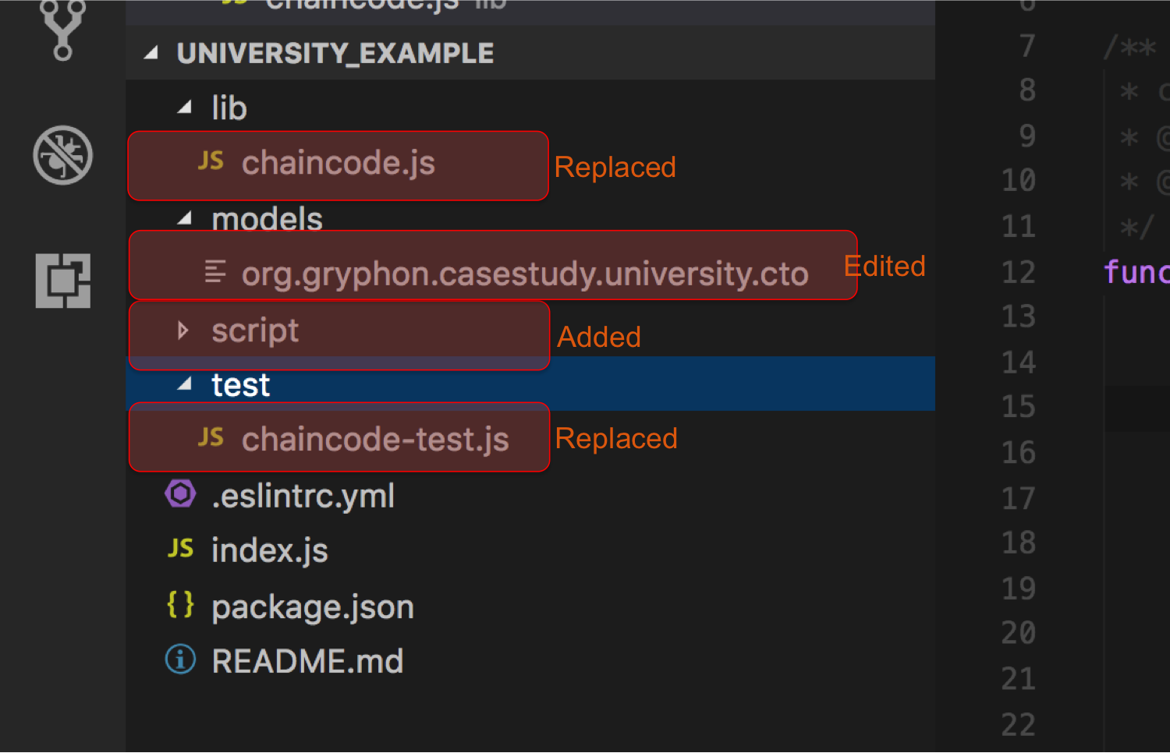



**Step 2:** Let us review what we have in our university **‘basic’** example

* Model file: org.gryphon.casestudy.university.cto

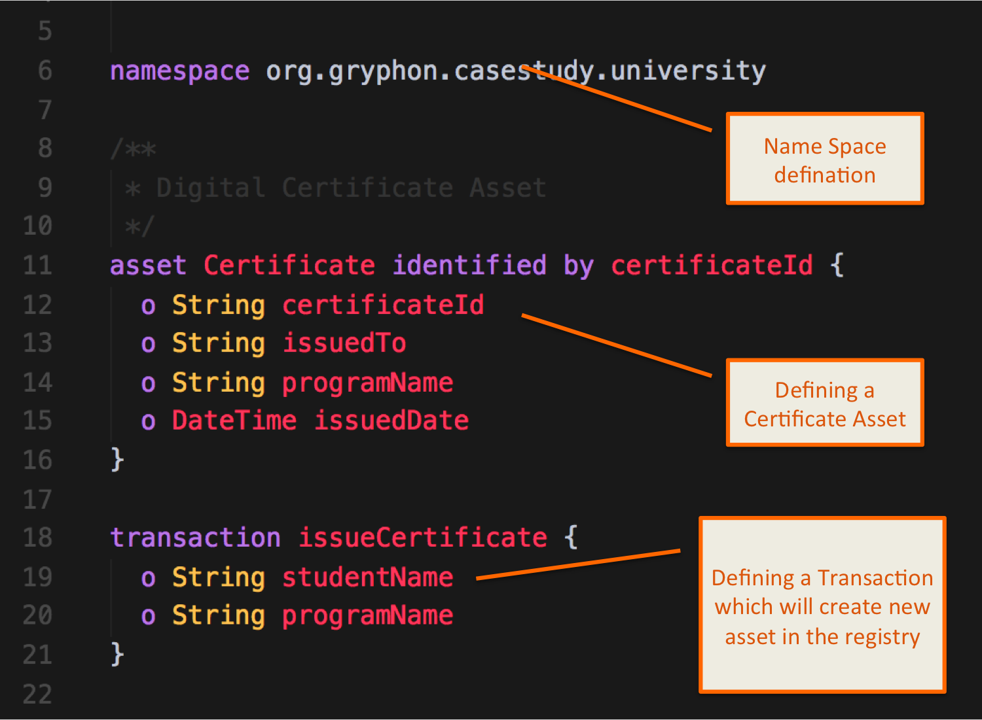



* Review Chaincode: ‘chaincode.js’

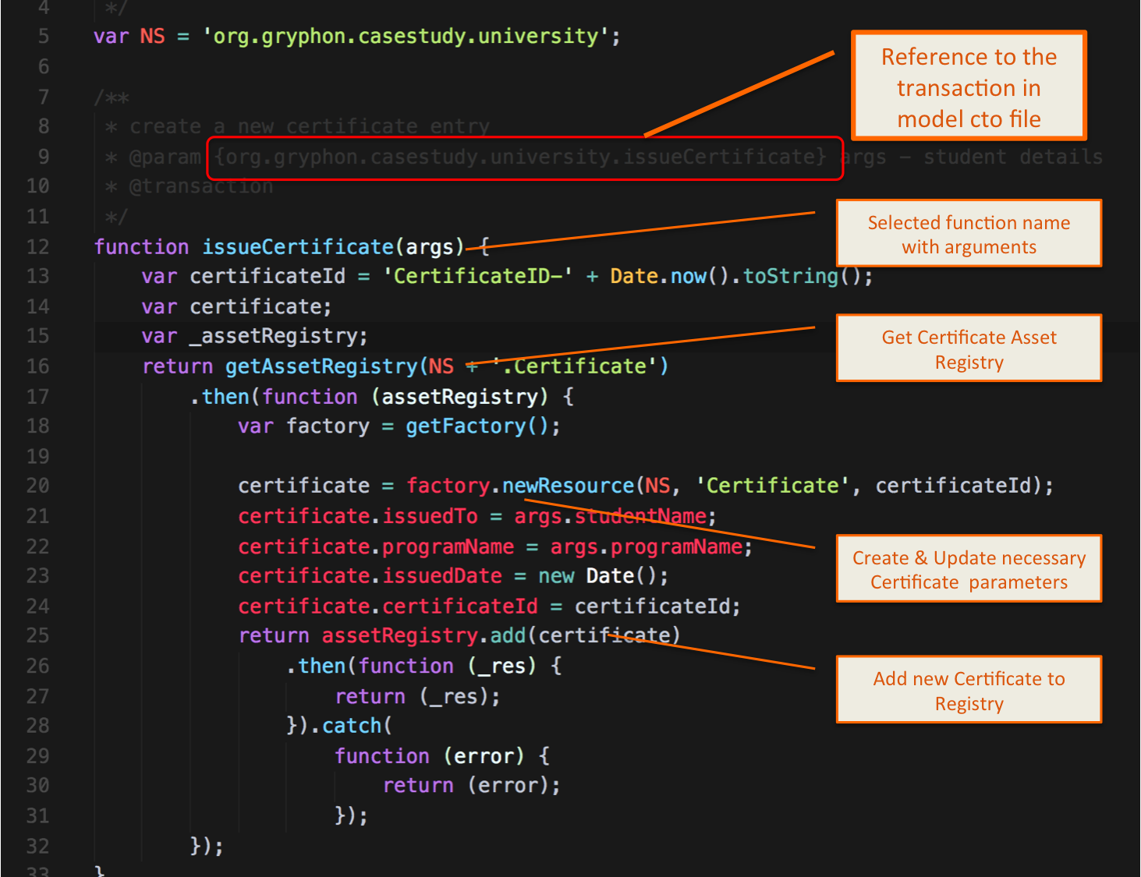

* Review Test code: ‘chaincode-test.js’



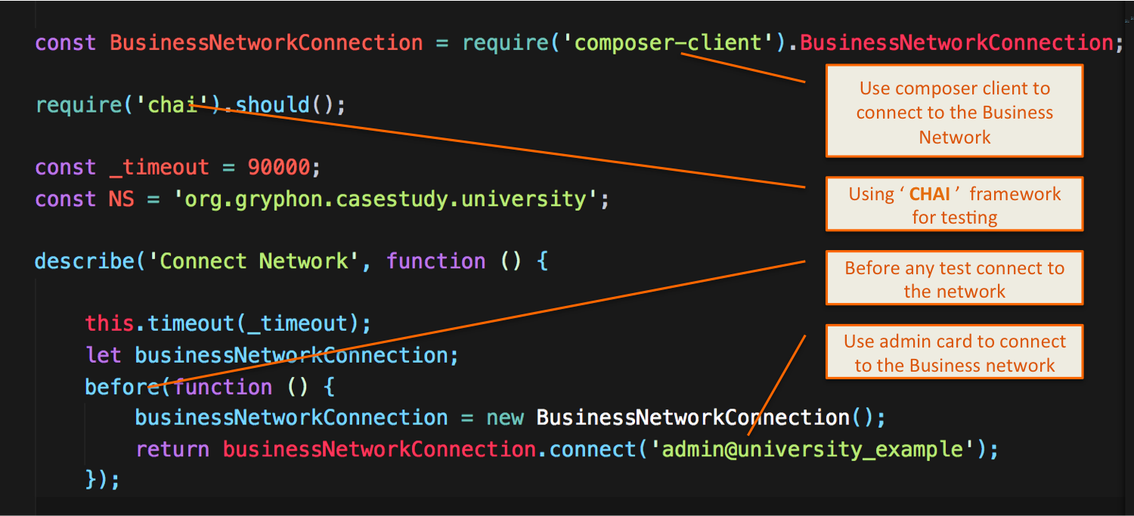

‘chaincode-test.js’ => continued…

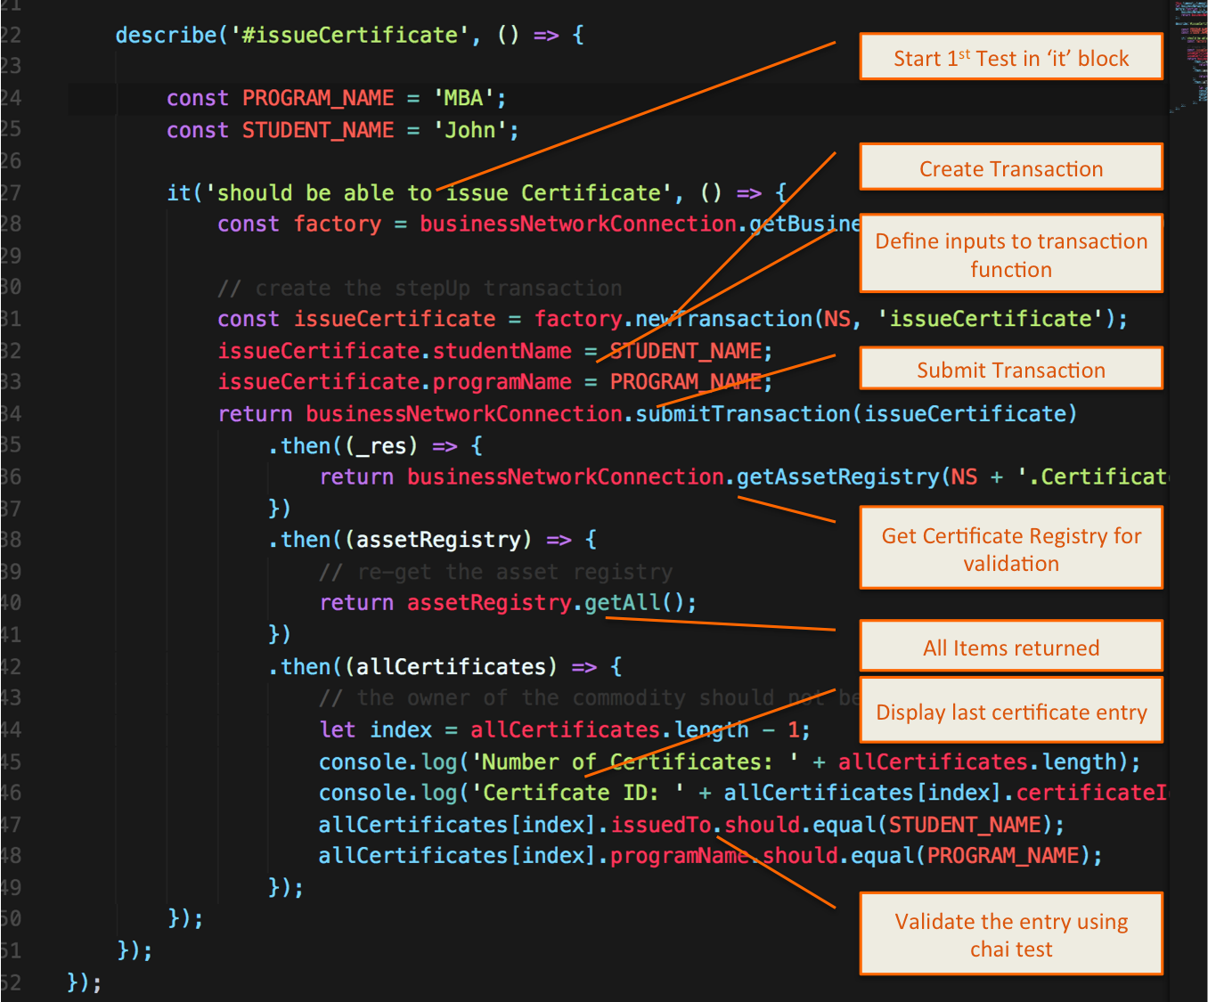

**Task 2 is complete!**

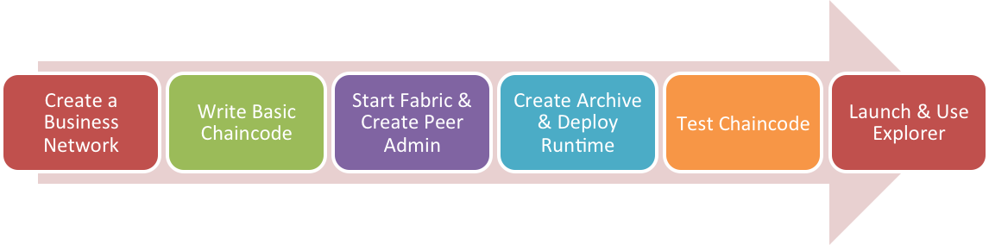

## TASK #3: Start fabric and create peer admin card

**Step 1:** Launch terminal window and use following commands to change the directory to the installed fabric-tools folder

cd ~/fabric-tools/

**Step 2:** Use the startFabric.sh script to start the fabric environment.

./startFabric.sh

This command will create and launch the necessary docker containers

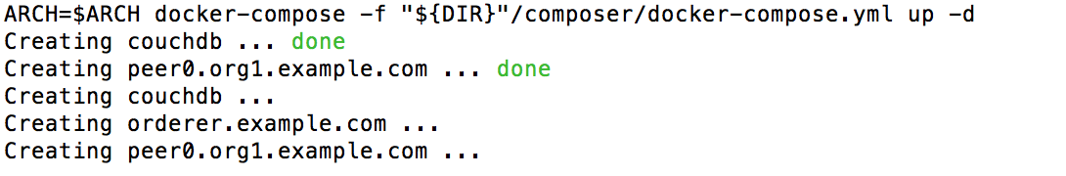

You can see containers in your Visual Studio Code (Docker Plugin installed)

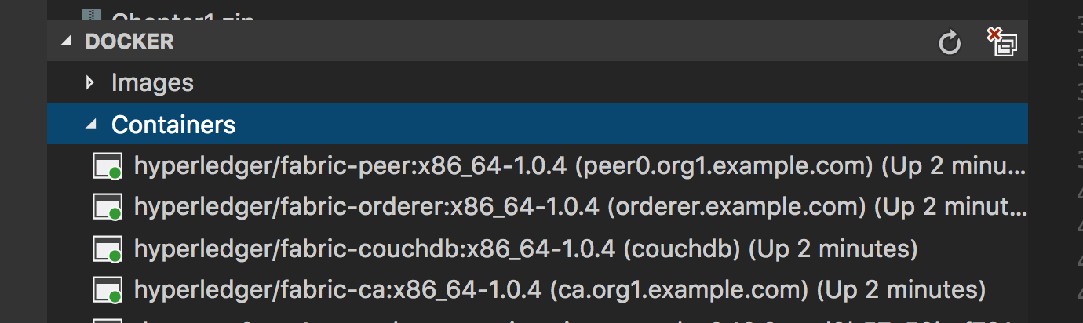

**Step 3:** Create Peer Admin Card to be able to deploy business runtimes.



From the fabric-tools directory use the createPeerAdmin.sh script

cd ~/fabric-tools/

./createPeerAdminCard.sh

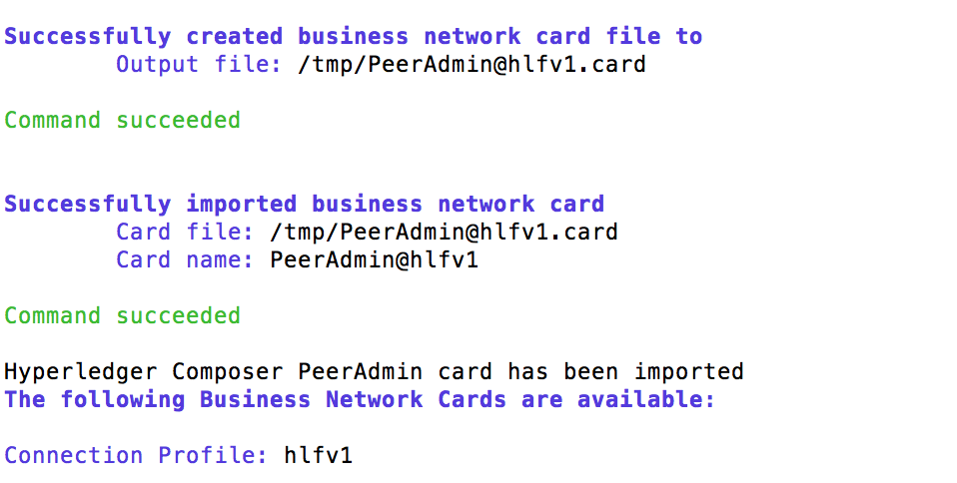

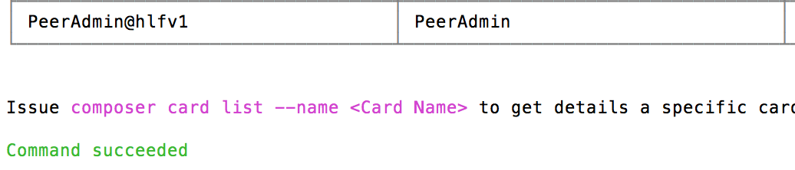



**Step 4:** To speed up the development process few scripts are available. You can use script in the ‘chapter02’ code folder to start fabric and create peer admin card

**\*\*\* From next time we will be using this script only to start fabric and create peer card before deploying hence follow these steps \*\*\***

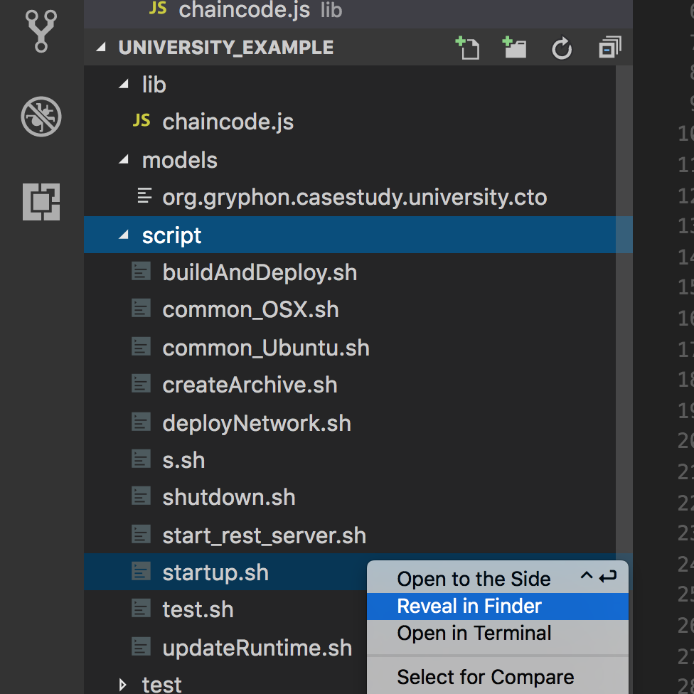

**Change the path below in startup.sh script corresponding to your OS**

* **For MAC USERS**

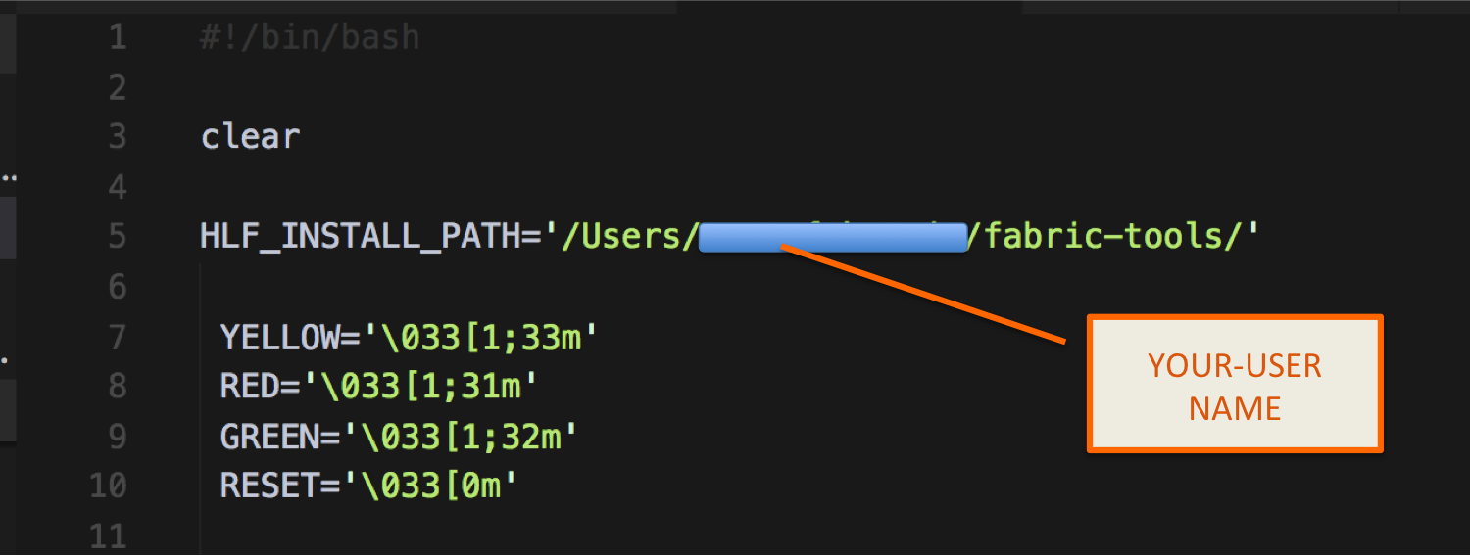

**For Ubuntu Users:**



HLF_INSTALL_PATH='~/(username)/fabric-tools/'

After this change has been done you can run this script from the visual studio terminal window directly

username-MBP:script username $ ./startup.sh

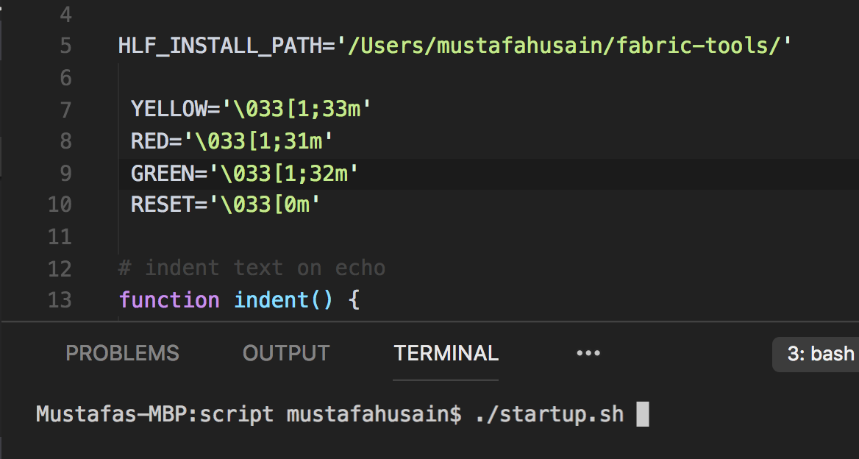

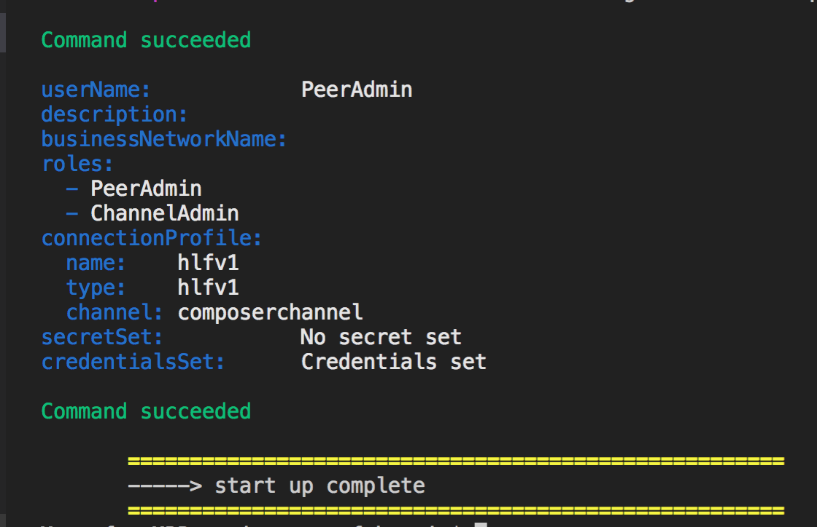

**Task 3 is complete!**

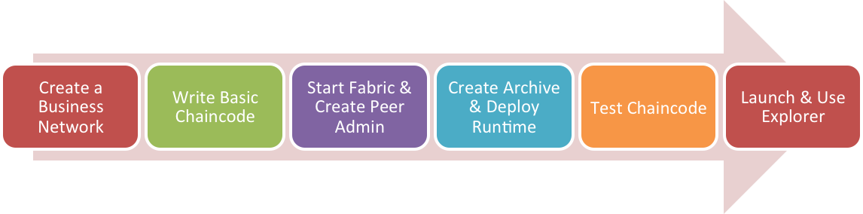

## TASK #4: Create Archive & Deploy Runtime

**Step 1:** Open ‘chapter02’ code provided in Visual Studio Code. Open terminal window and cd into the 'chapter02’ directory

**Step 2:** Create a ‘dist’ directoty

mkdir dist

**Step 3:** Type the following command to create the archive

composer archive create -t dir -n . -a ./dist/university_example.bna

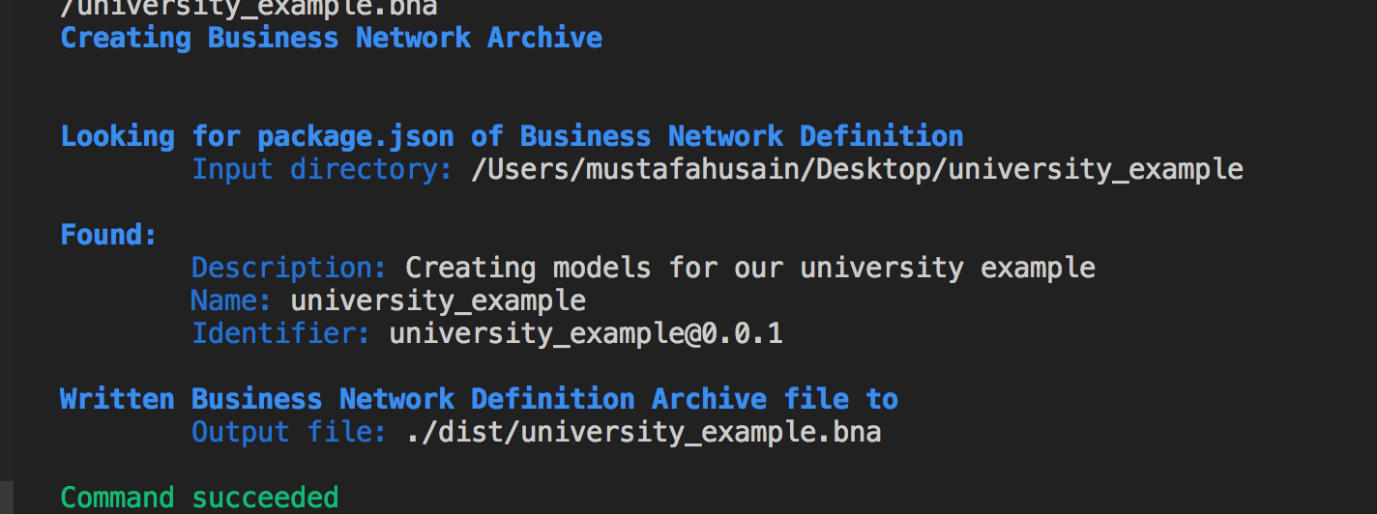

This creates the archive **‘university_example.bna’** in the ./dist folder created earlier.

**Step 4:** Now install the created peer admin card

First cd into the created ‘dist’ directory

cd dist



Type the following command in the terminal window

composer runtime install --card PeerAdmin@hlfv1 --businessNetworkName university_example

This will take sometime and deploy the runtime

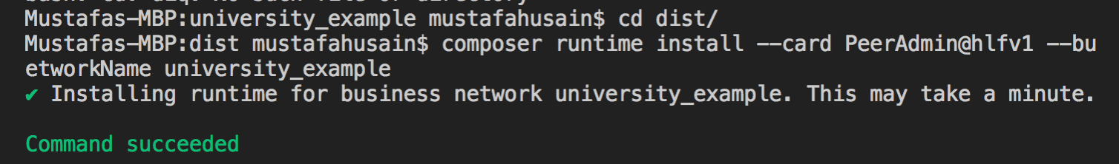

**Step 5: Start Business network** andcreate a network admin card to handle all network related operations

Type the following command in the terminal window and press enter:

composer network start -c PeerAdmin@hlfv1 -A admin -S adminpw -a university_example.bna --file networkadmin.card

This uses the Peer Admin card to create the Network Admin cards

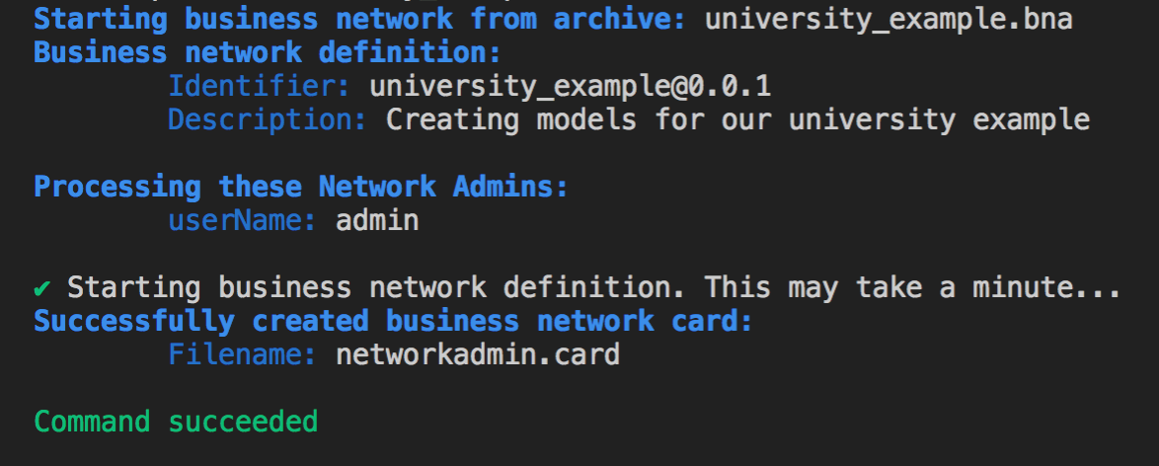



This command will create a network admin card **‘networkadmin.card’** in dist folder

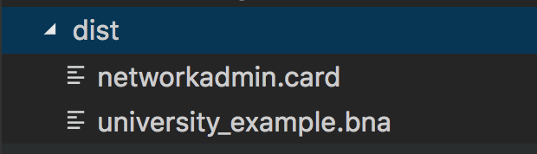

**Step 6: Import Business network admin card** just created. Type the following command in terminal window

composer card import --file networkadmin.card

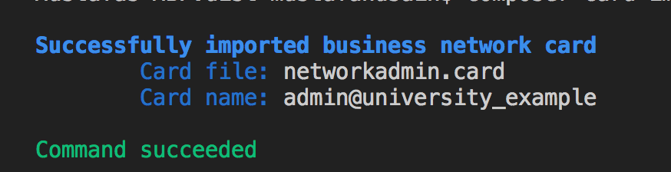

**Step 7:** To verify everything has been completed successfully we need to ping the network and check for success.Type the following command in terminal window

composer network ping --card admin@university_example

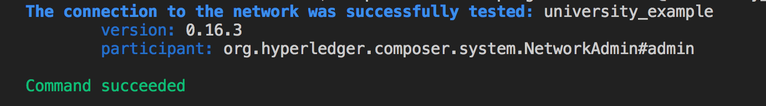



**[Alternative]: Doing all the steps one by one is cumbersome, hence to speedup the development process,** a script has been written.

1. Move into the scripts folder of ‘chapter02’

cd script

1. Run buildAndDeploy.sh script

./buildAndDeploy.sh

**What does the script do?**

* Everything done in Task #3 and #4 is done via this script
* Please ensure to have the correct path of hyperledger folder setup according to your operating system

**Task 4 is complete!**



## TASK#5: Running chaincode Test

**Step 1:** Open ‘chapter02’ code provided in Visual Studio Code. Open terminal window and cd into the 'chapter02’ directory

**Step 2:** Install the node modules by typing the following command into the terminal window

npm install

This will take a bit of time and install all the required node modules in the ./node_module folder



It may show some warnings but that should be OK.

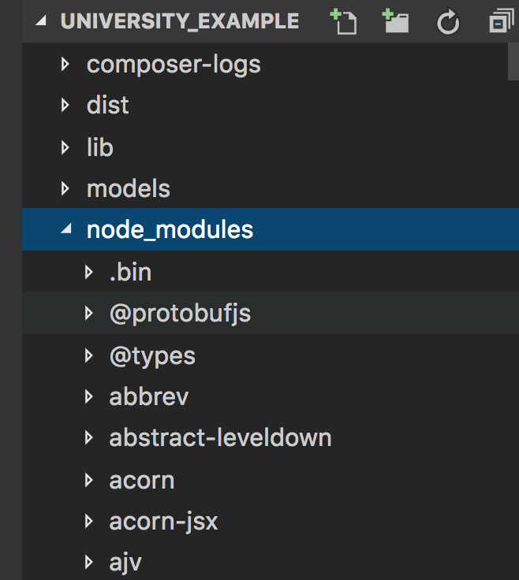



**Step 3:** After the node modules are installed type the following command to run the test

npm test

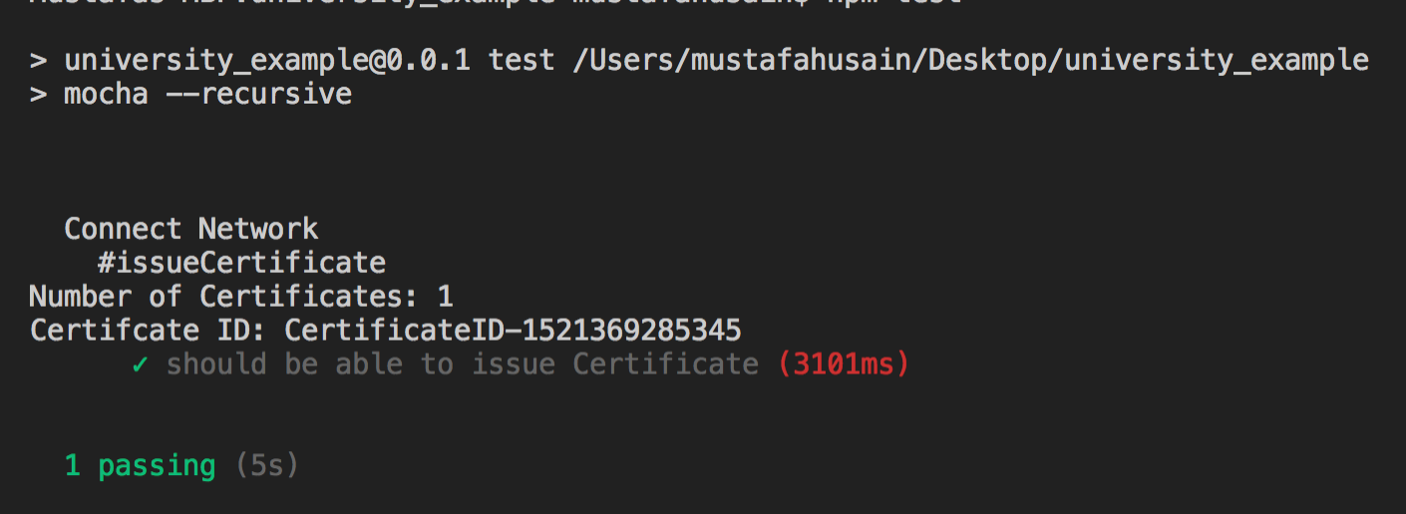

**Task 5 is complete!**



## TASK#6: Launch & use explorer

**Step 1:** Open ‘chapter02’ code provided in Visual Studio Code. Open terminal window and cd into the 'chapter02’ directory

**Step 2:** Launch explorer using the following command

composer-rest-server -c "admin@university_example"

On successful completion of the command explorer rest server will be launched address as below;

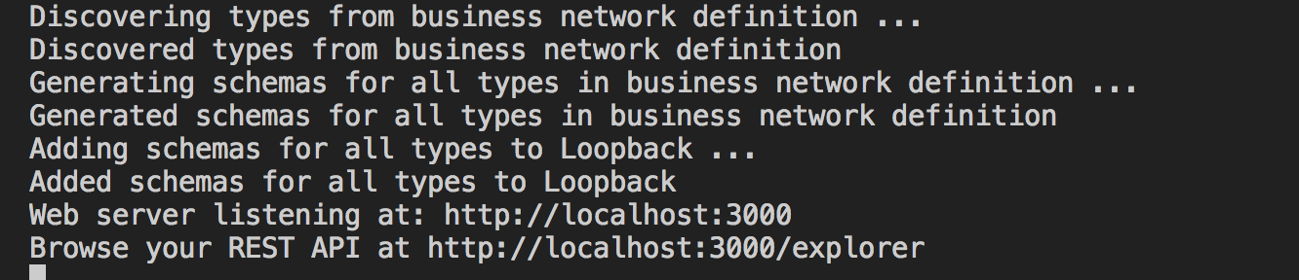

**Step 3:** Launch internet explorer and enter the following url:

<http://localhost:3000/explorer/>

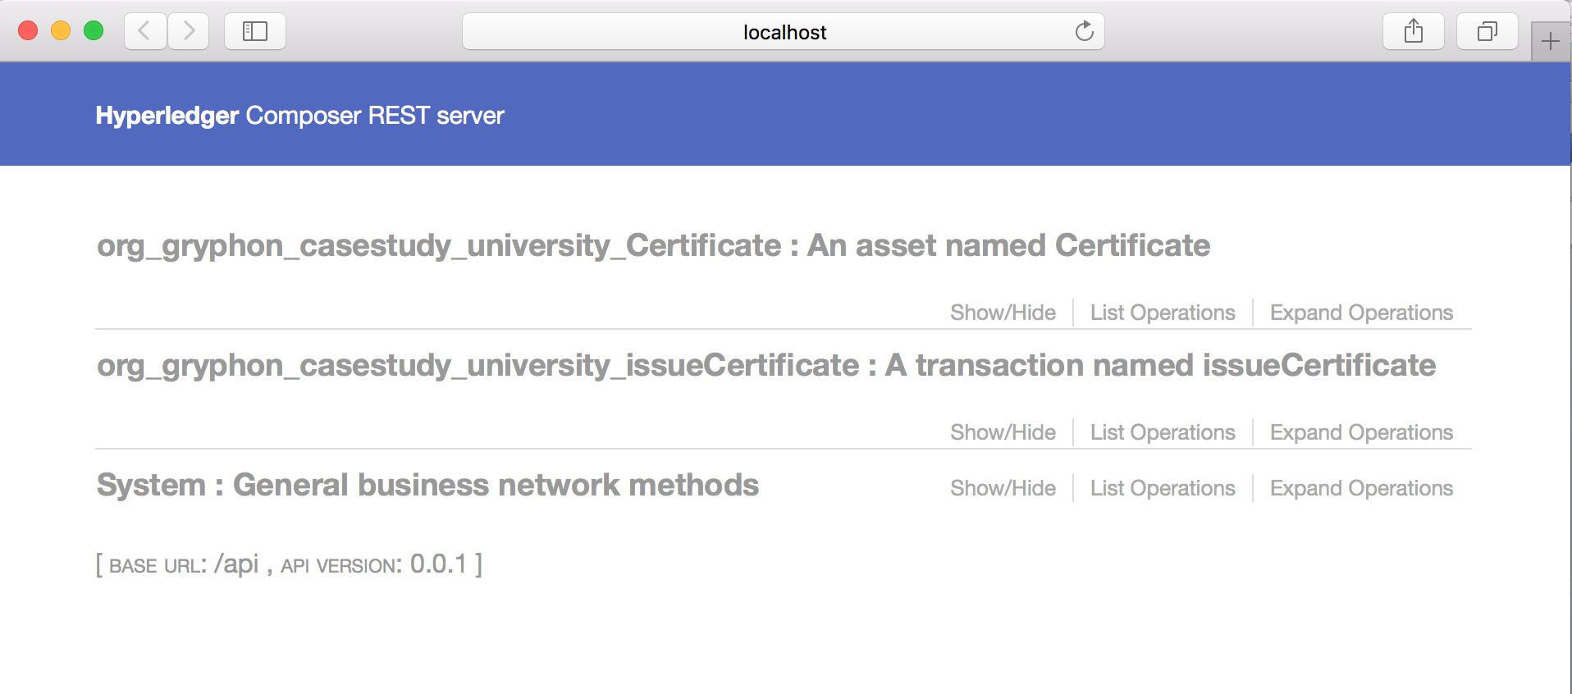



**Step 4:** Click on “org_gryphon_casestudy_university_issueCertificate : A transaction named issueCertificate”

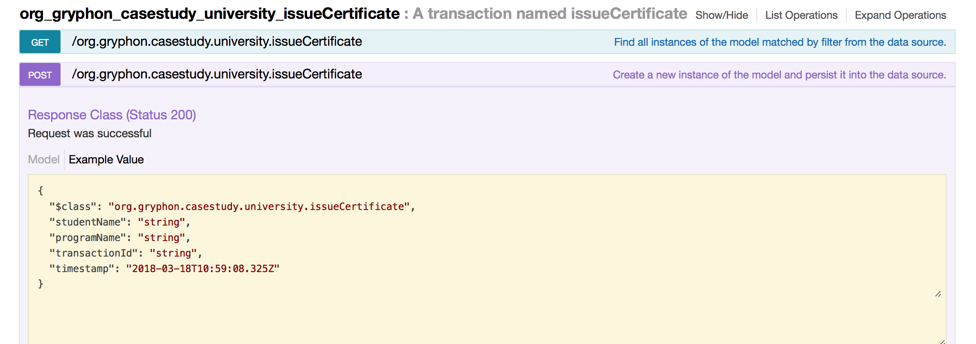

Using the example modify the transaction parameters and click “Try it out” as below

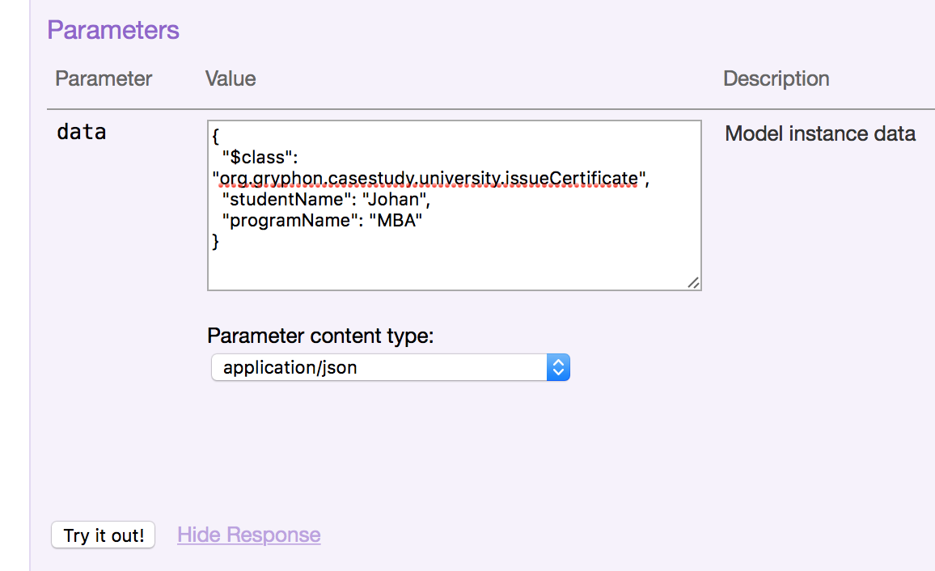

On clicking “Try it out” button you will response similar to below;

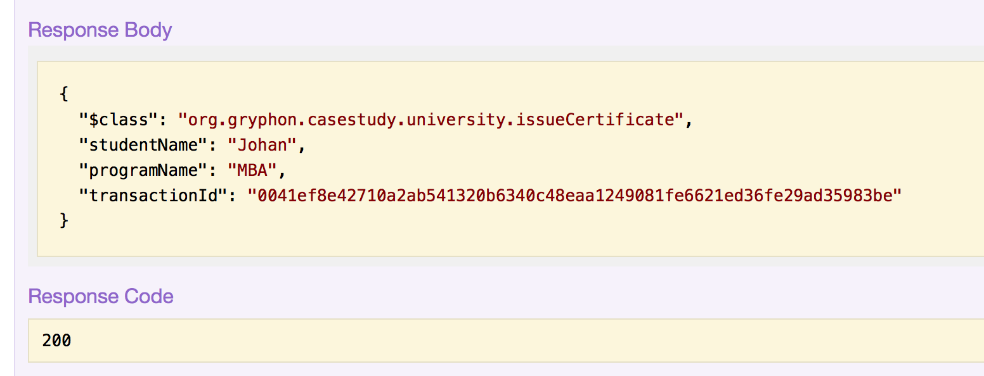



**Step 5:** Click on “org_gryphon_casestudy_university_Certificate : An asset named Certificate”

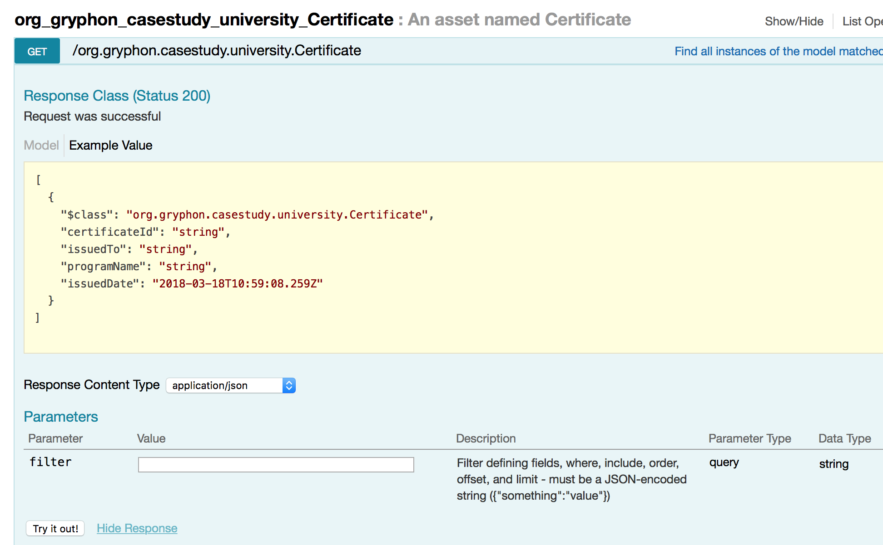

On clicking “Try it out” button you will receive the list of all the ‘Certificate’ Assets as below;

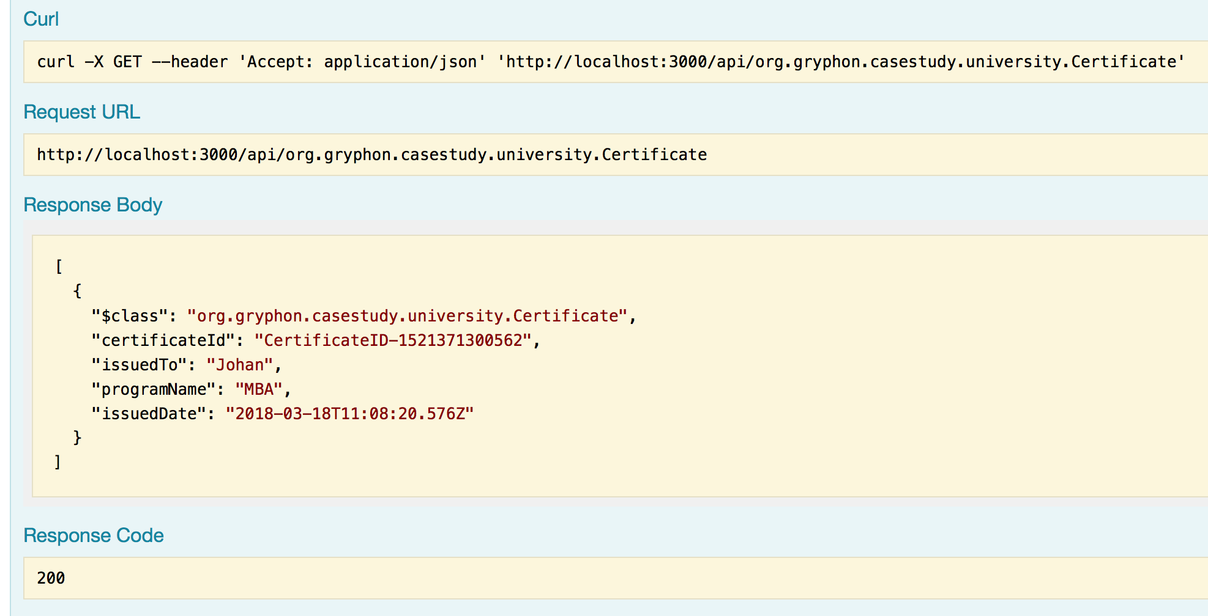



**Step 6:** Click on “System : General business network methods”. Click “Get” method and then click “Try it out!” button at the bottom;

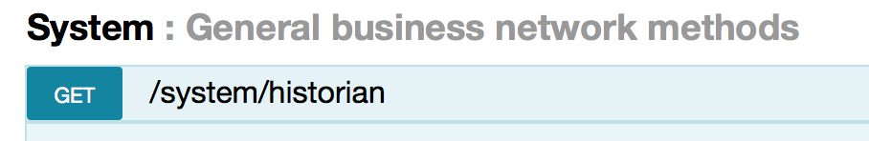

Historian will list all the transactions done to date

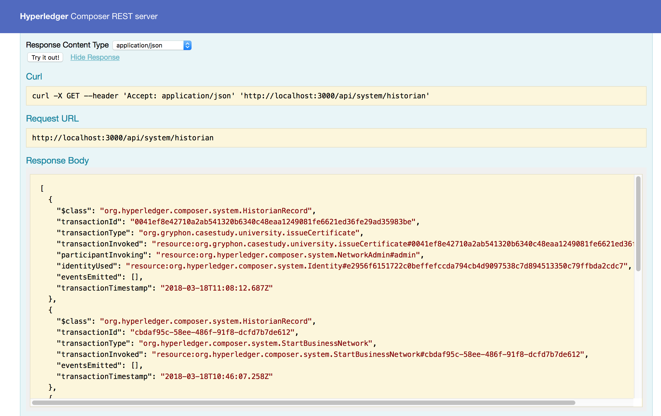

**Task 5 is complete!**

# SUMMARY

Hyperledger is a permissioned network. To be able to deploy chaincode and runtime network business cards are needed.

In this chapter we have learnt the following:

* How to start fabric composer
* Create Peer Admin Card and the Network Admin Card
* How chaincode is written and tested using chai framework
* Create archive and deploy the runtime
* How to use scripts for deploying and running during development process
* How use explorer to validate transactions, assets and the system methods

# REFERENCES

* http://hyperledger.org
* http://hyperledger.org/projects/fabric
* https://hyperledger-fabric.readthedocs.io/

# CHAPTER 3: PARTICIPANT, IDENTITIES & ACCESS CONTROL

**Theory**

In this chapter, we will cover access control and authorization, which are a very important part of Hyperledger and the security architecture of a business network. Hyperledger enables an administrator control what resources or data a participant, or indeed participant role - is authorized to see or do, in a business network.

In the lab section we will explore and define an ACL file for our University example use-case and provide access permissions to different participants.

Access control rules (the language that defines ACLs) fall into two main areas:

* Authority to access system, network or administrative resources and operations in the System namespace (governing Network and System operations)
* Authority to access resources or perform operations within a given business network itself (like Create, Read, Update assets)

Finally, we will use the online Playground to try out some simple and conditional access rules. In doing so, we will interact with our University use-case network as various identities - ultimately, it is the users of the blockchain that we want to apply access control to.

**Participants and identities**

A **Participant** is an *actor* in a business network. A participant might represent an individual or an organization. A participant can create assets, and also share assets with other participants. A participant can interact with assets by submitting transactions.

A participant has a set of Identity that can be validated to prove the identity of that participant.

Hyperledger Fabric is a Private Permissioned Network for Businesses. Businesses interact with only known identities.

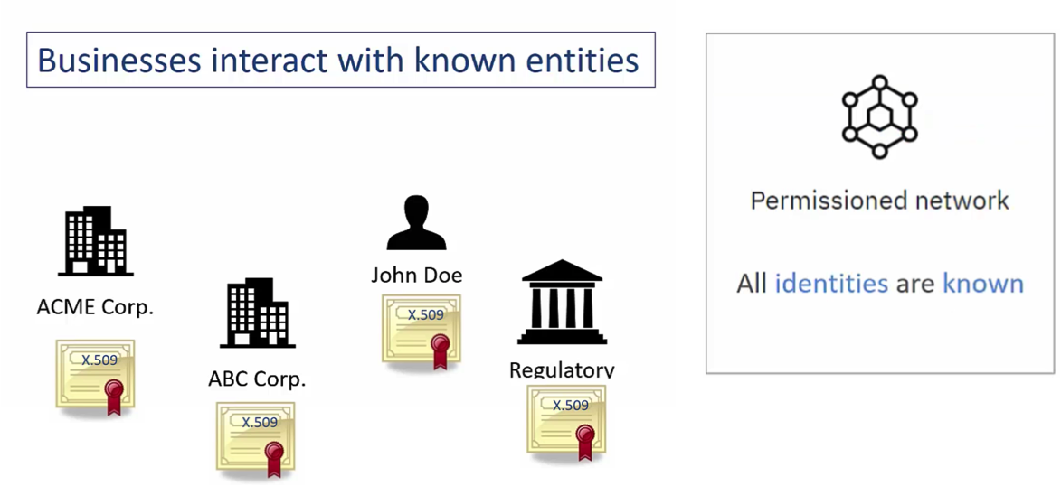

In Hyperledger, participants are separated from the set of identities that they can use to interact with a business network.

In order for a new participant to join a business network, a new instance of that participant must be created in the business network. The participant instance stores all of the required information about that participant, but it does not give that participant access to interact with the business network.

In order to grant the participant access to interact with the business network, an identity must then be issued to that participant. The new participant can then use that identity document to interact with the business network.

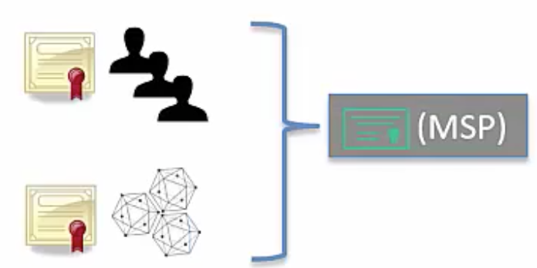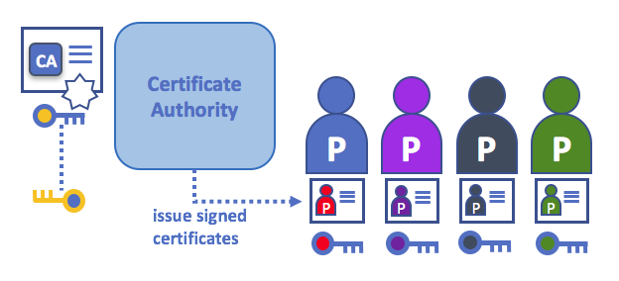

Identity usually expire after a set period of time. Identity may also be lost or stolen. If the identity expires, or if it needs to be replaced, then it must be Revoked so it can no longer be used to interact with the business network.

However, revoking an identity document does not remove the information about that participant and any assets that they own. Revoking the identity document simply removes the participant’s ability to interact with the business network using that identity. Access to the business network can be restored by issuing the participant with a new identity.

These participant and identity management actions are performed by an existing participant in the business network, for example a regulatory body, or a participant in the same organization who has been trusted to manage participants/identities in that organization.

# Lab Exercise 3: Adding Participants, Identities & Access Controls

|  |
| --- |
|  |

1. **Define Participants and associated Transactions**
2. **Define Access (ACL File)**
3. **Deploy in Playground**
4. **Create Participant**
5. **Create Identity**
6. **Login To Business Network & Test Access**

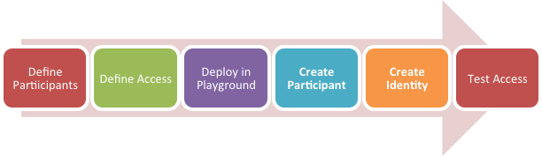

## TASK#1: Define Participants & Transactions

**Step 1:** Open ‘chapter03’ code provided in Visual Studio Code.

*#****Info****: ‘chapter03’ is a Business Network Scaffolding created as in Chapter#2-Task 1 with following changes:*

1. *Chaincode ‘logic.js’ is replaced with ‘chaincode.js’*
2. *Test ‘logic.js’ is replaced with ‘chaincode-test.js’*
3. *‘script’ folder is added*

**Step 2:** Adding Participants:

We will segregate all the participants in different namespaces that helps in defining access.

**Step 2.1:** Open *‘models/org.gryphon.casestudy.base.cto’* file in Visual Studio Code

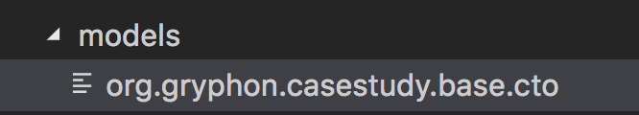

**Step 2.1:** Defining abstract for class for all participants with mandatory common attributes

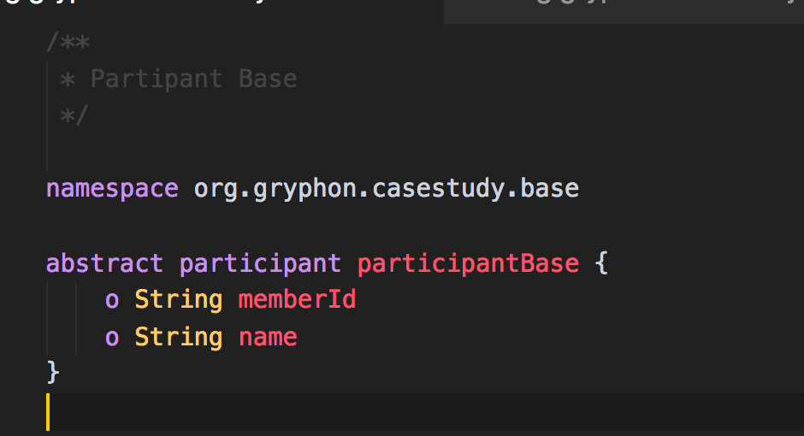



**Step 2.2:** Open *‘models/org.gryphon.casestudy.college.cto’* file in Visual Studio Code.

Define Namespace for college related participant and transactions.

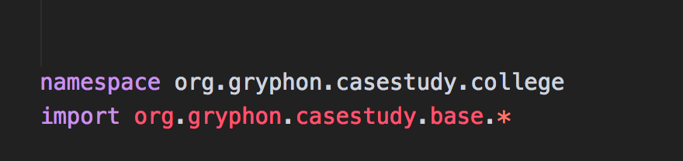

**Step 2.3:** Define ‘College’ Participant

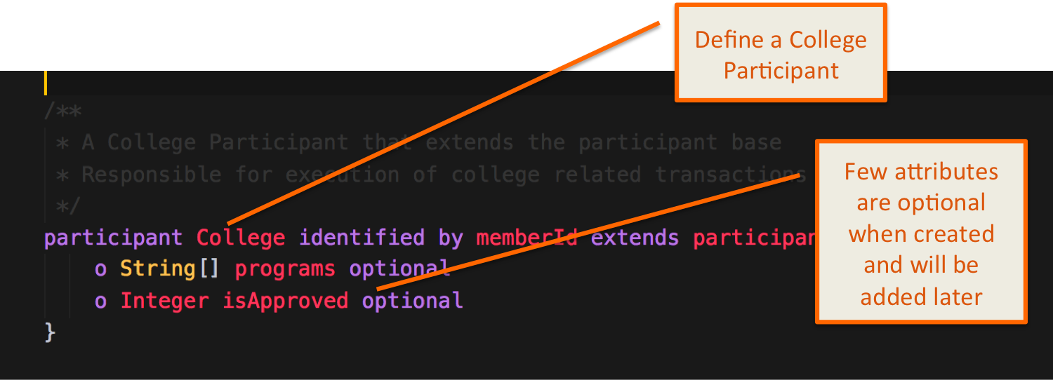

**Step 2.4:** Define Transactions that ‘College’ Participant can carry out

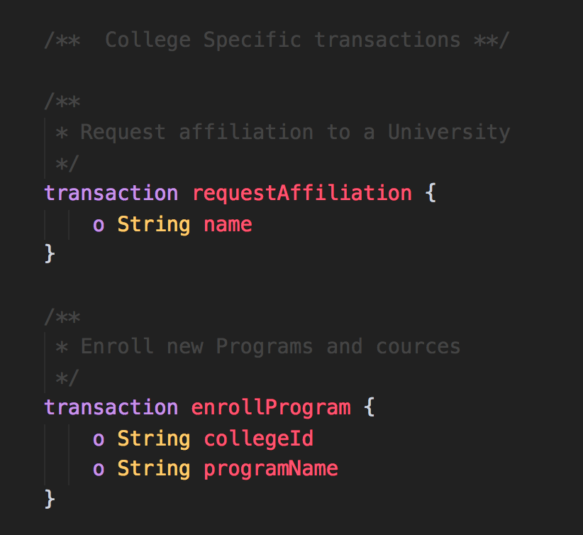



**Step 2.5:** SimilarlyOpen *‘models/org.gryphon.casestudy.university.cto’* file in Visual Studio Code and define university Participant and Transactions

**\*\* Note**: We have already seen Certificate Asset in previous chapter.

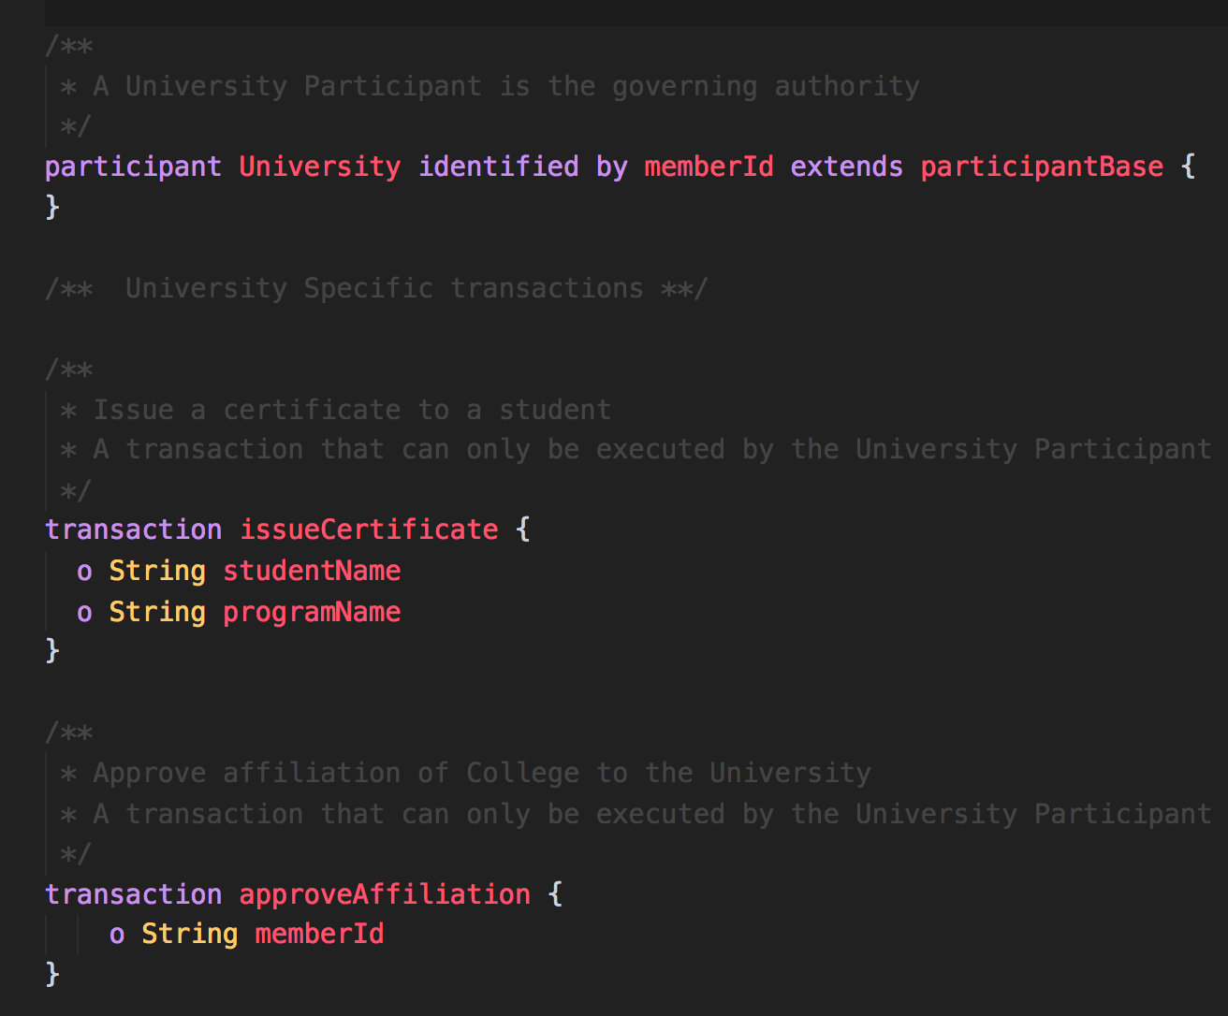

**Step 2.6:** Also define student & verifier Participant and Transactions in corresponding .cto model files:

*‘org.gryphon.casestudy.student.cto’*



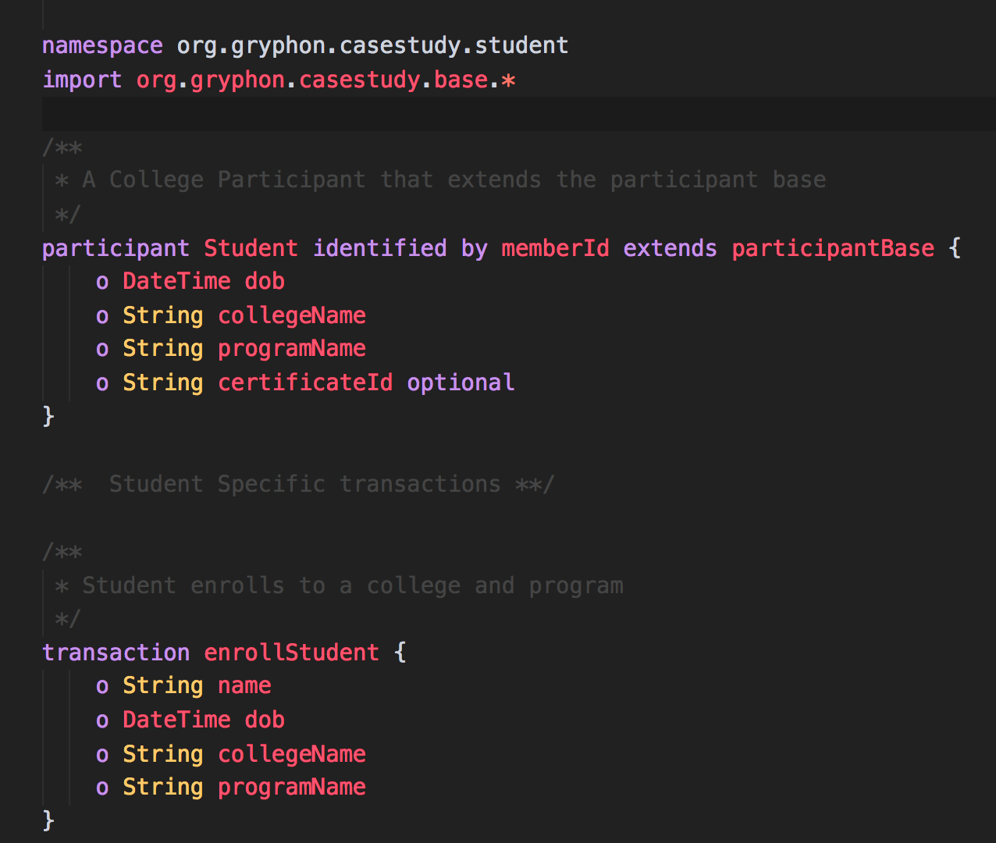

*‘org.gryphon.casestudy.verifier.cto’*

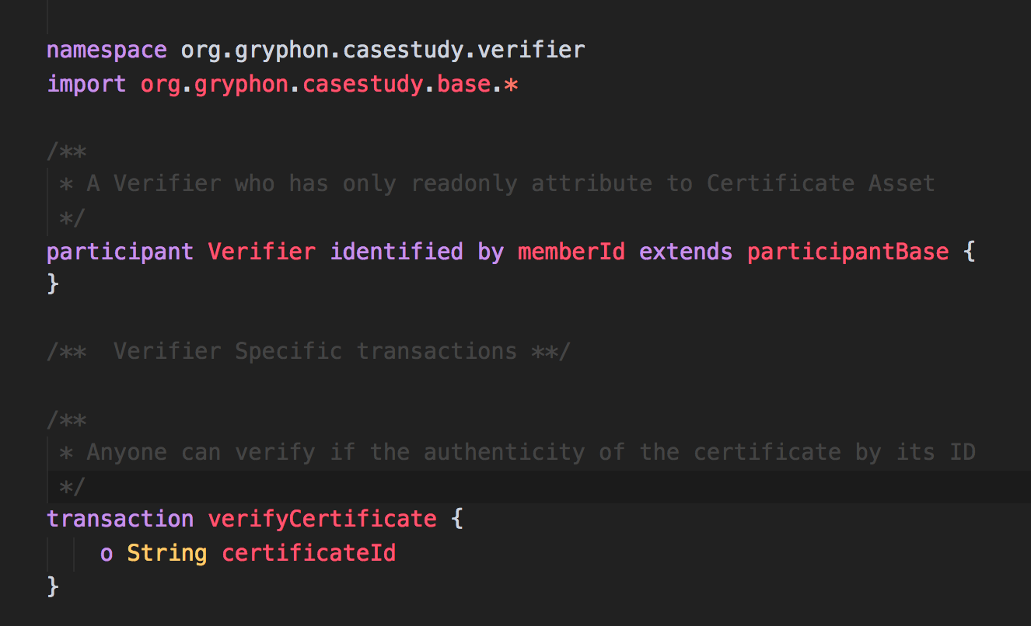



**Step 3:** Define chaincode corresponding to the respective transactions defined.

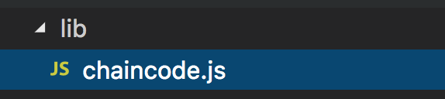

**\*\* Note:** Writing chaincode was shown in previous chapter. Here we define chaincode for remaining transactions

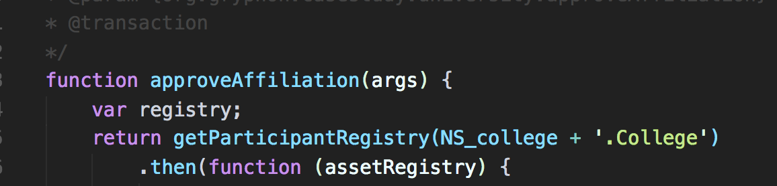

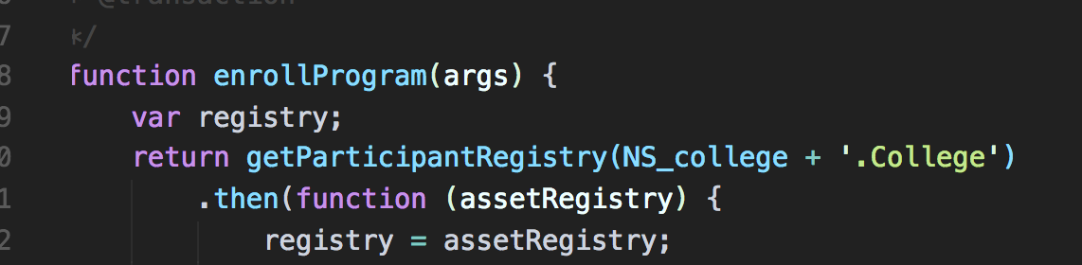

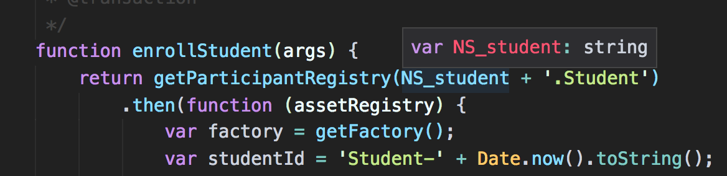

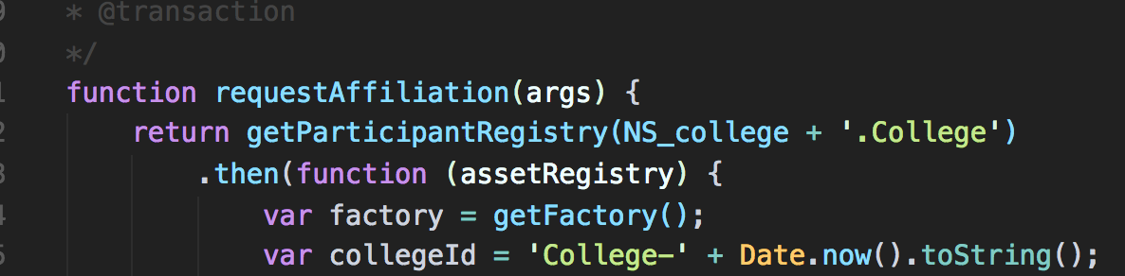

**Task 1 is complete!**

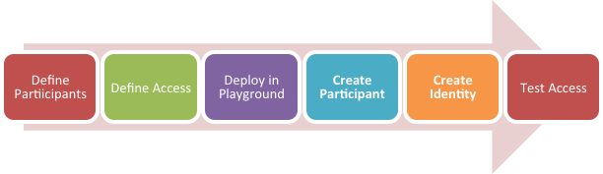

## TASK#2: Defining Access Control

**Step 1:** Open ‘chapter03’ code provided in Visual Studio Code and Open *‘permissions.acl’* file

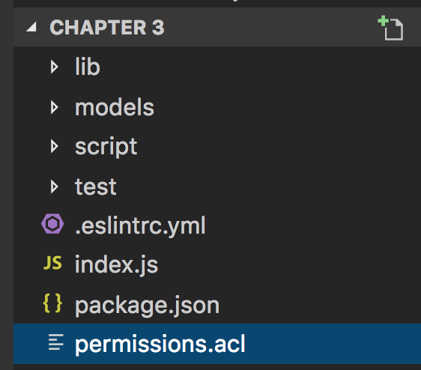

**Step 1:** Define permissions for NetworkAdmin User.

***#Info:*** *If ‘.acl’ is NOT defined all users have full permissions, however once ‘.acl’ is defined all permissions are revoked and you need to define permissions even for the NetworkAdmin in order for the Admin to perform deployment and administrative functions.*

**Step 1.1**: Grant business network administrators full access to user resources

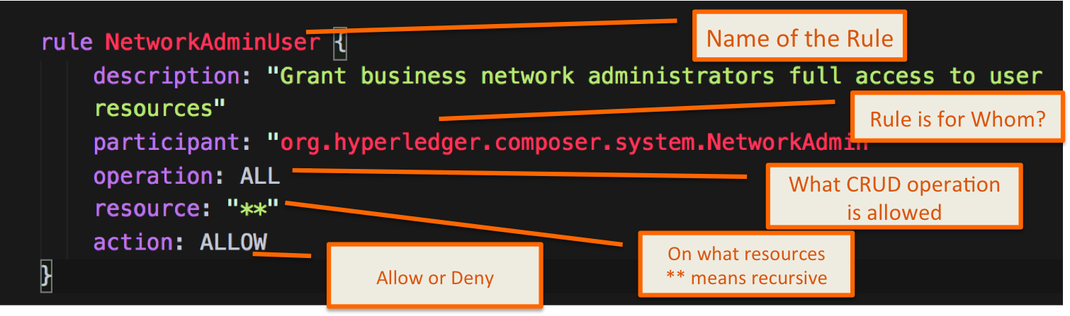



**Step 1.2**: Grant business network administrators full access to system resources

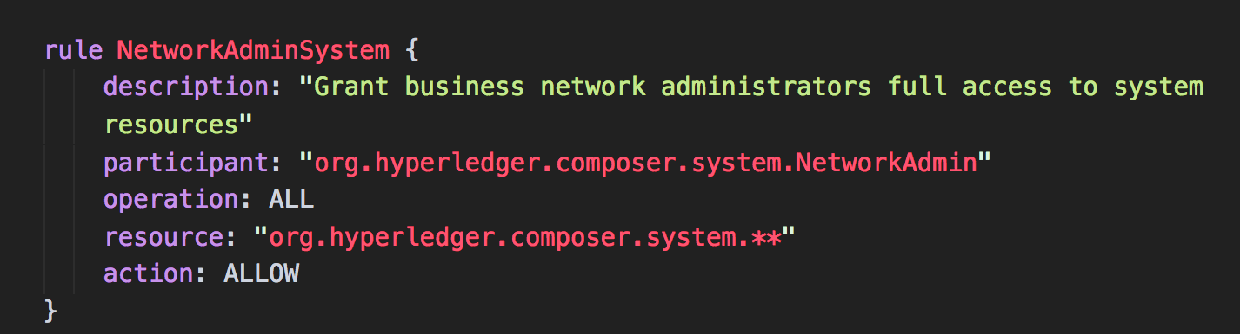

**Step 2**: Now that the NetworkAdmin access to all system and user resources are provided, we provide access to the Participants in our example. The intension here is to provide isolation, so that the Participant can carry out operations / transactions related to their authority only. All other operations/transactions should be restricted.

**Step 2.1**: Grant College Participant full access to resources in college namespace and restrict access to resources in other namespace

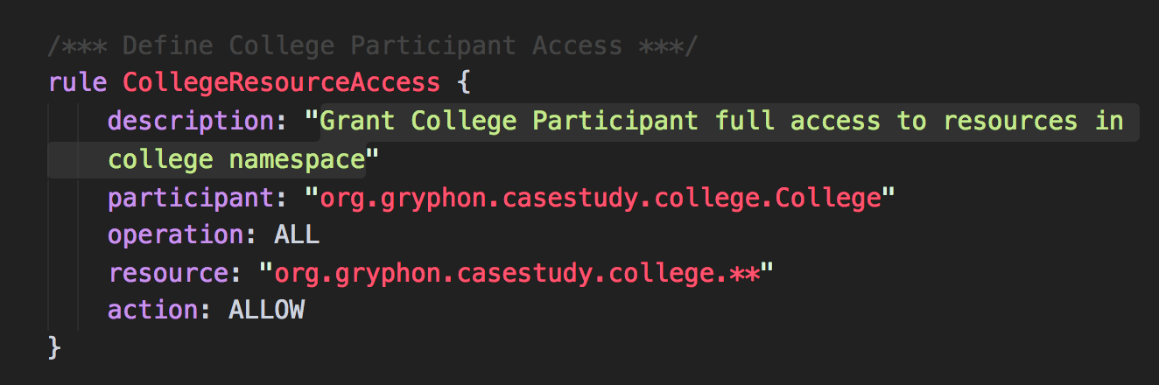



**Step 2.2**: Grant College Participant readonly access to system resources. This will ensure we are able to use Playground to read status of all resources and we can test our ACL file

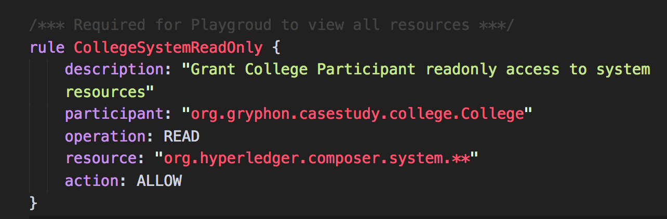

**Step 2.3**: Grant access to perform transactions. Any transaction will create an entry in the historian, as transaction record is immutable. We need to provide this access to our College Participant so that it can perform appropriate transactions ‘*requestAffiliation’* and ‘*enrollProgram’*.

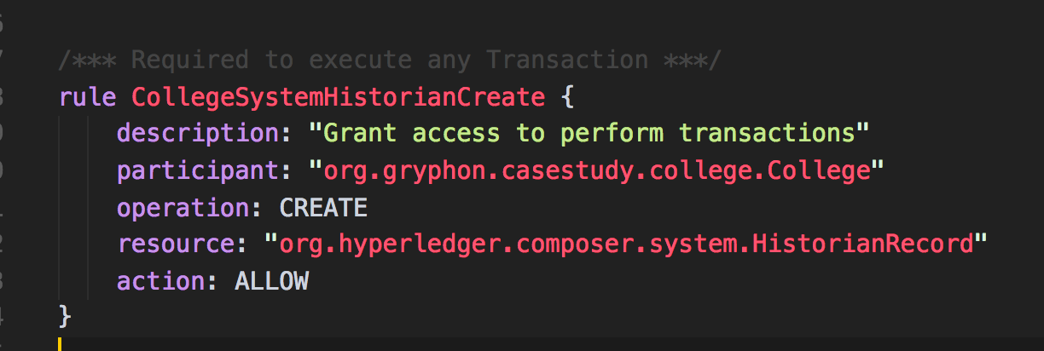



**Step 3**: Similarly we define access to other Participants:

**Step 3.1**: For Student Participant

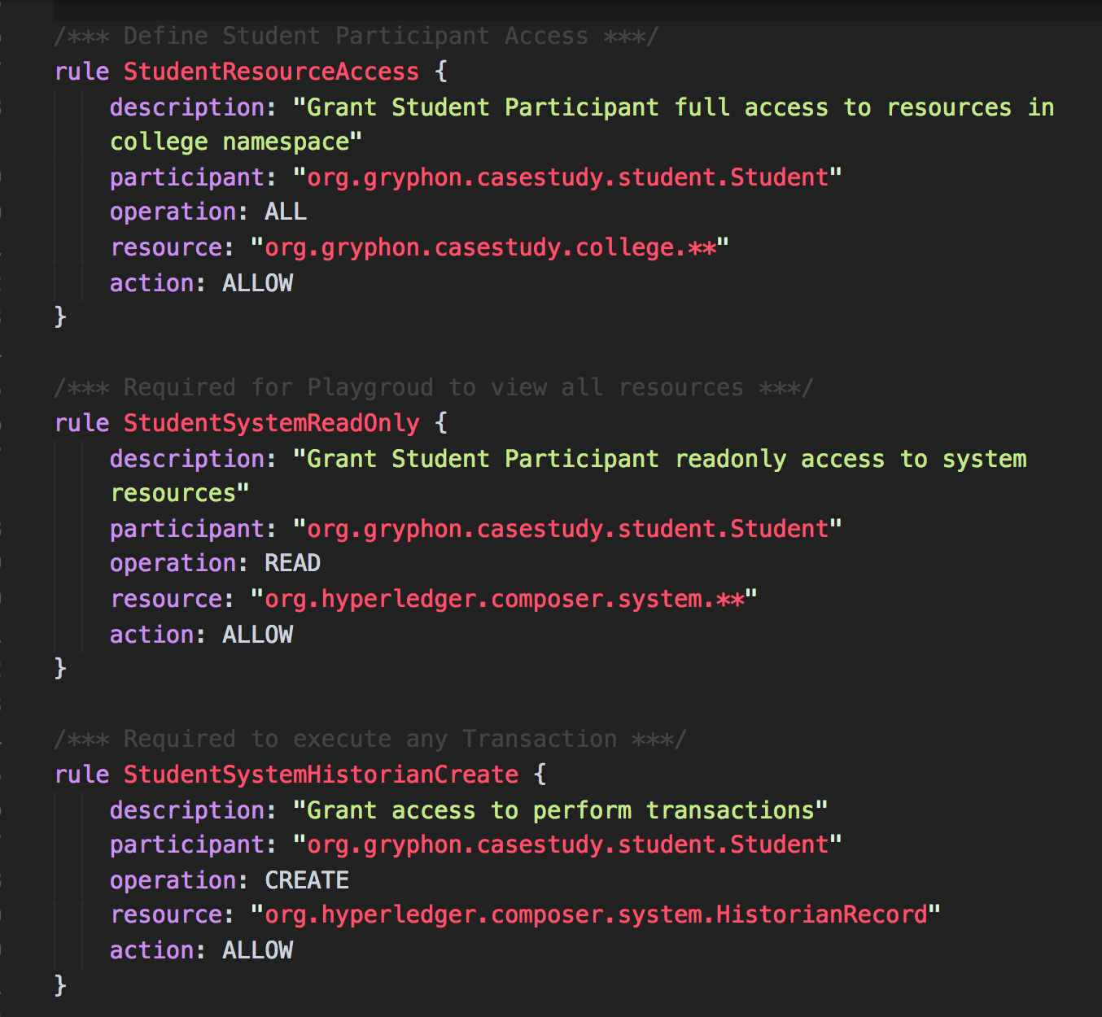



**Step 3.1**: For University Participant, we need to update College Registry and also Student Registry. Hence for simplicity we will provide them access to all user resources. In actual we should explicitly define what operations, on what resources needs to be granted.

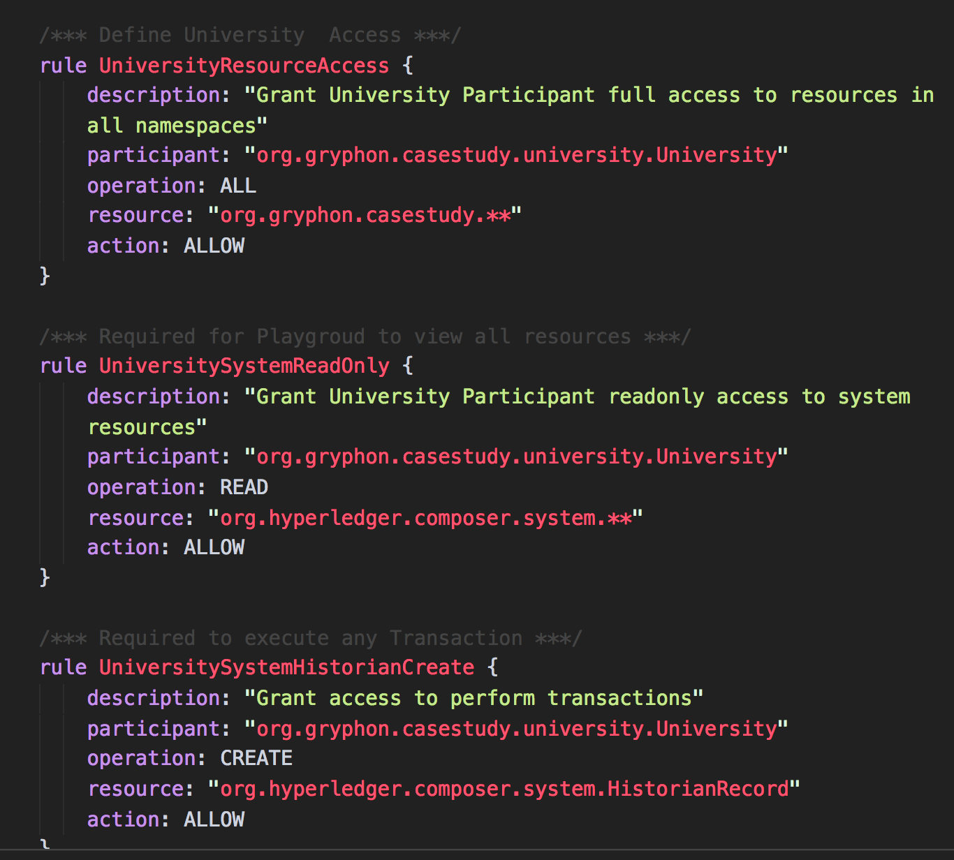

**Task 2 is complete!**



## TASK#3: Deploy in Playground

**Step 1:** Open ‘chapter03’ code provided in Visual Studio Code. Open terminal window and cd into the script’ directory

cd script

**Step 2:** Create Business Network Archive using the provided scripts; Type the following command in terminal window to run the archive script

./createArchive.sh

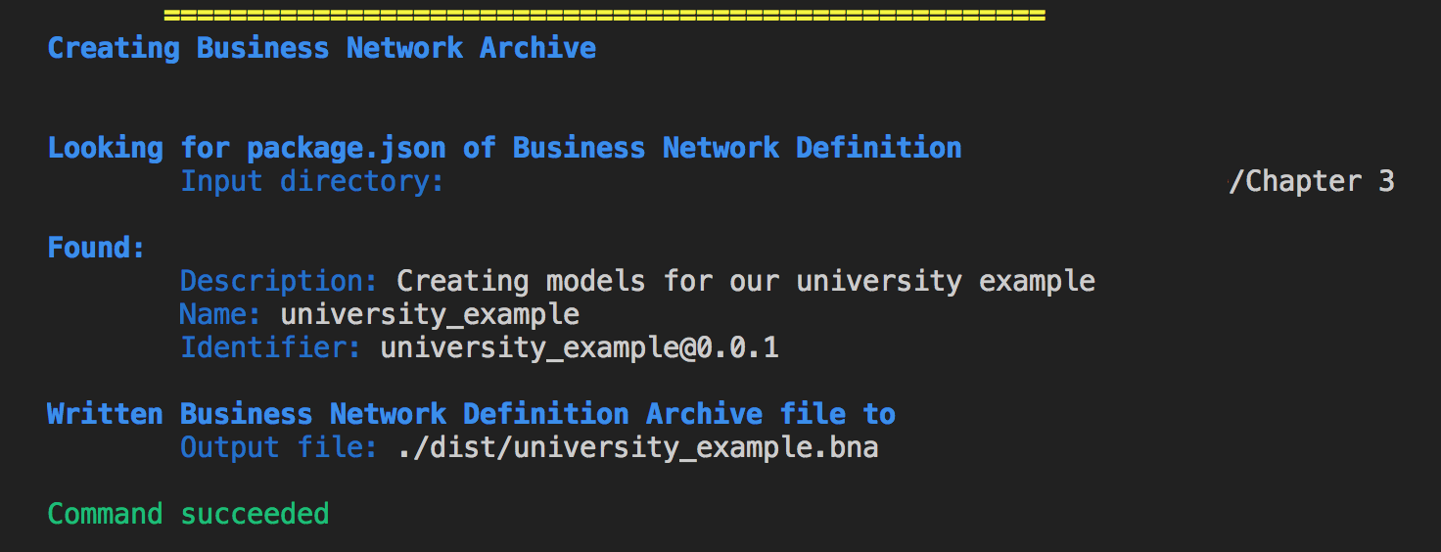

On successful completion of the command a *‘university_example.bna’* is created in the ‘dist’ folder

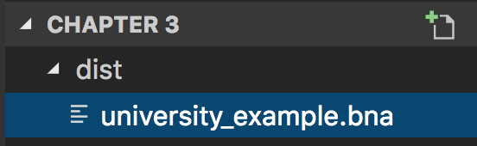



**Step 3:** Launch internet browser and goto the following URL:

<https://composer-playground.mybluemix.net>

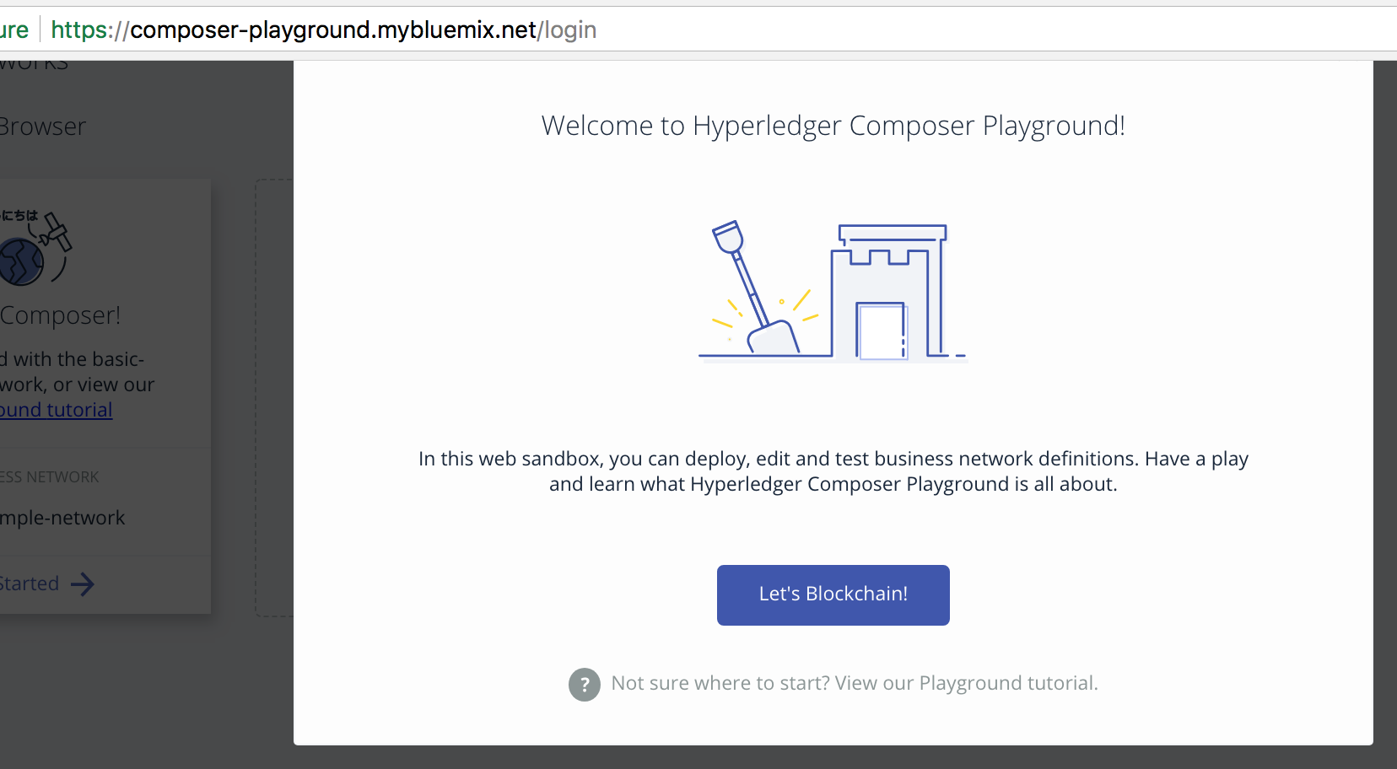

**Step 4:** Click ‘Deploy Network’ as below

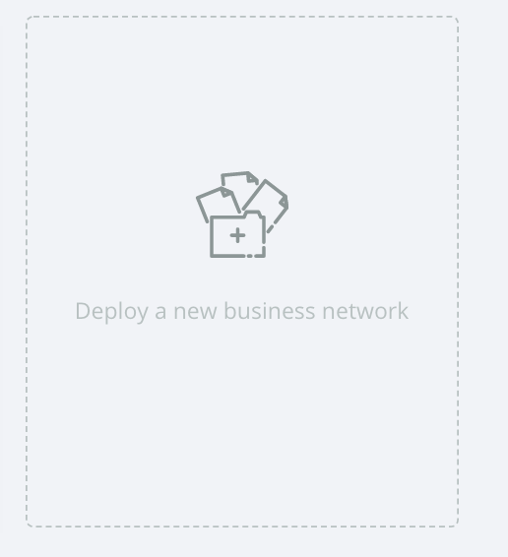

**Step 5:** Choose ‘Drop File to Upload’ option and upload the recently created ***‘university_example.bna’*** file from the ***‘dist’*** folder.



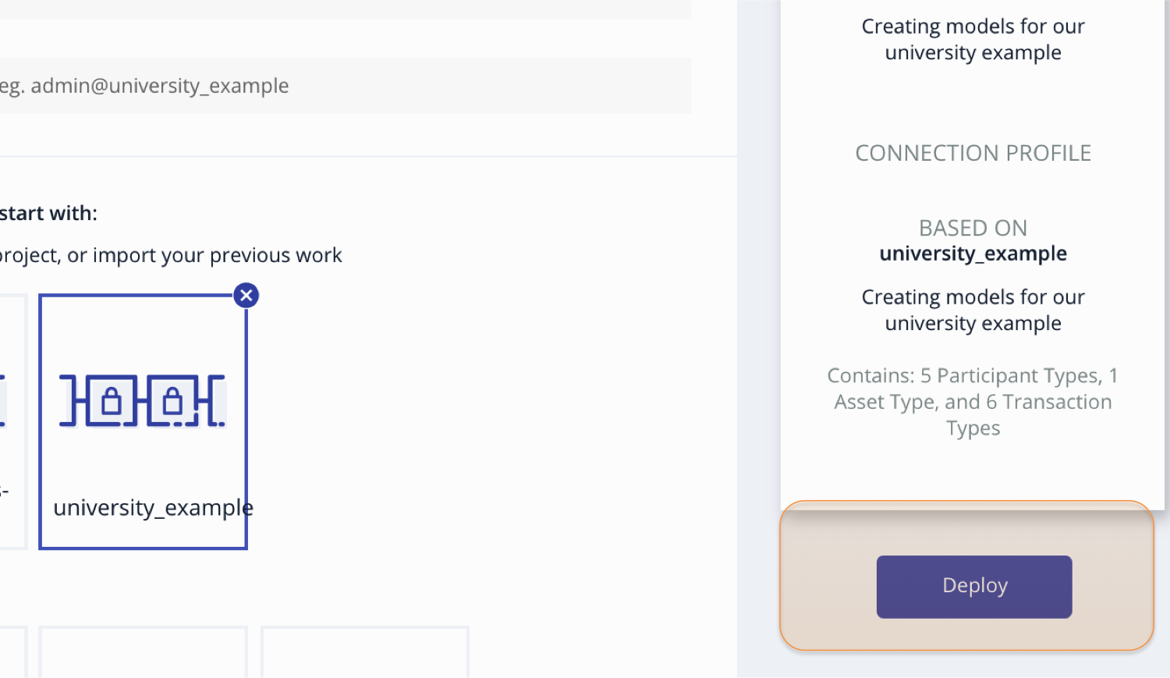

**Step 6:** Choose ‘Deploy’ button to deploy the ***‘.bna’*** file

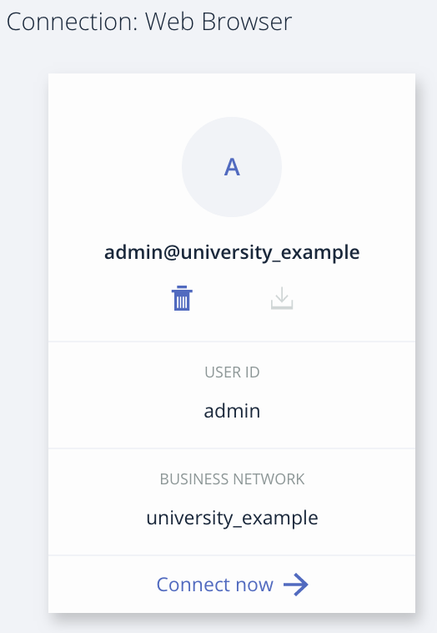

NetworkAdmin User is created on deployment of business network.

**Task 3 is complete!**



## TASK#4: Create Participants

**Step 1:** Business Network Archive was deployed in previous task to Playground. Use the NetworkAdmin User created on deployment to connect to the network.

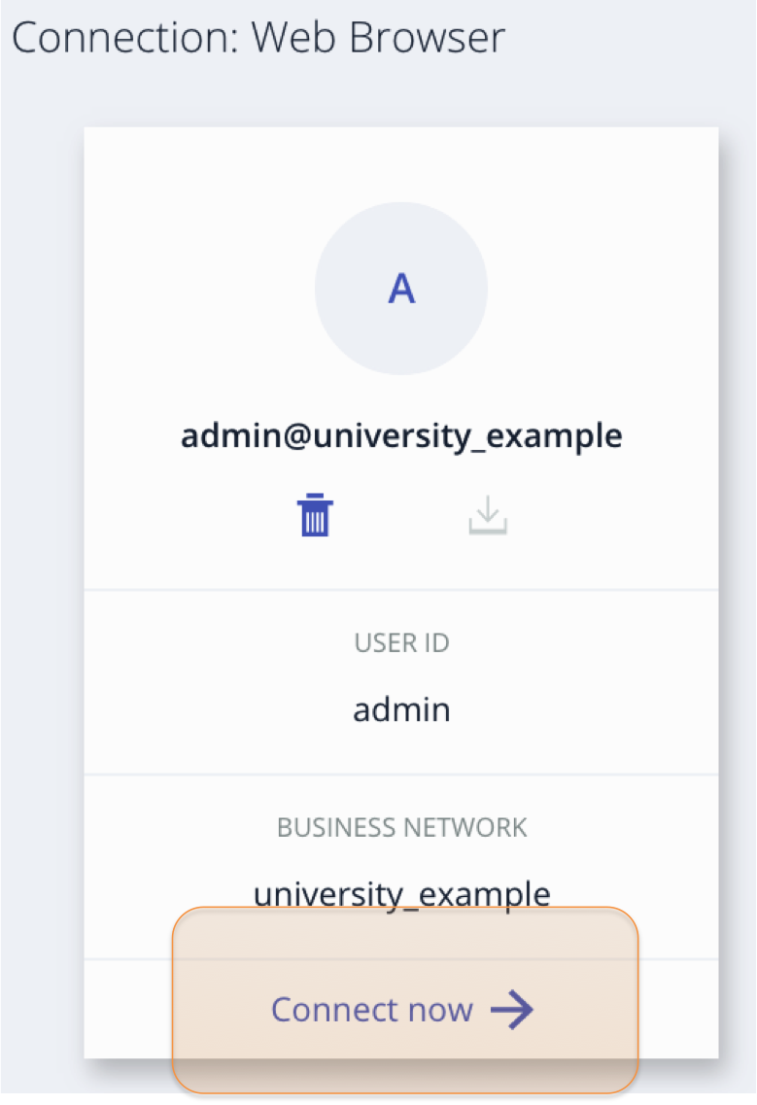

**Step 2:** Click on ‘Test’ tab to start interacting with the business network

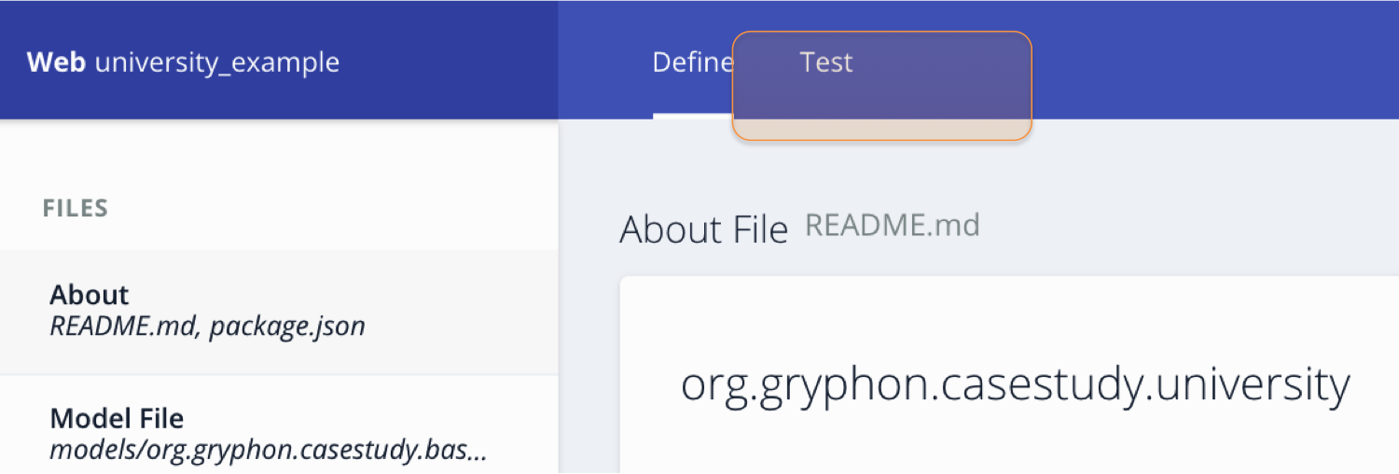



**Step 3**: Creating College participants:

**Step 3.1**: To create College Participant, click on ‘College’ Tab under participant list

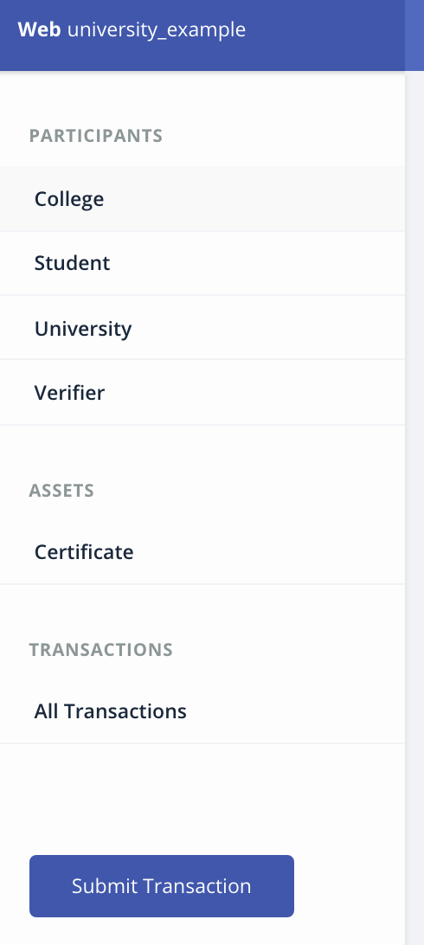

**Step 3.2**: Then use ‘Create new Participant’ button on the top right to add participant details

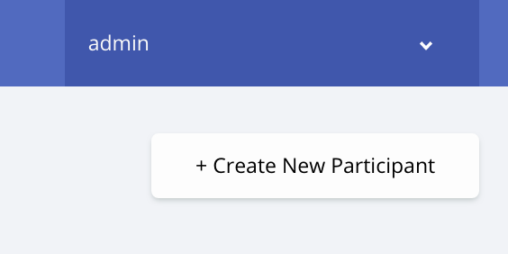



**Step 3.3:** Use following details to create a new participant

{

"$class": "org.gryphon.casestudy.college.College",

"programs": [ "MBA" ],

"isApproved": 1,

"memberId": "College-1522380799679",

"name": "YCCE"

}

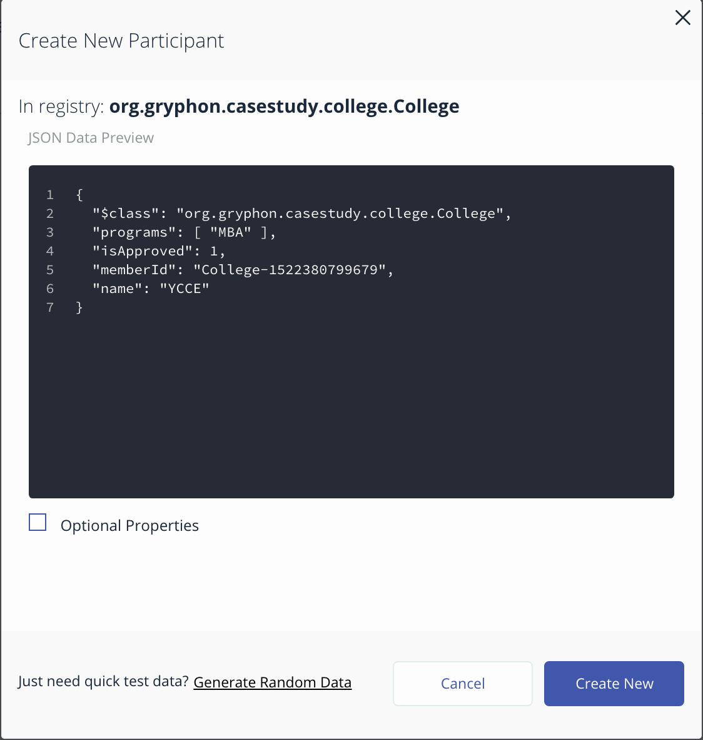

On completion a new College Participant is created.

**Task 4 is complete!**



## TASK#5: Create Identity

**Step 1:** Business Network Archive was deployed and ‘College’ Participant was created in previous task. Use the dropdown button on top right with the admin label and click on ‘ID Registry’

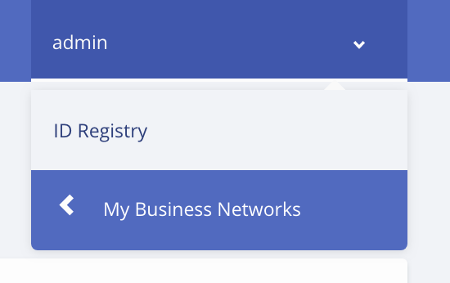

‘ID Registry’ contains the entries of all the Participants and associated Identities. New Identities for the participant can be created or earlier identities can be revoked from here.

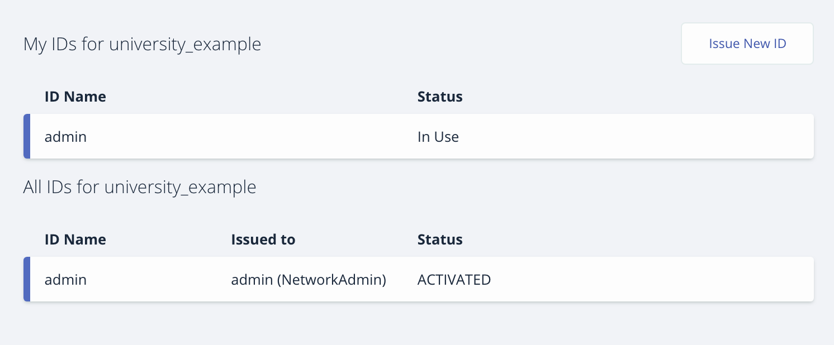

**Step 2:** Click on ‘Issue New ID’



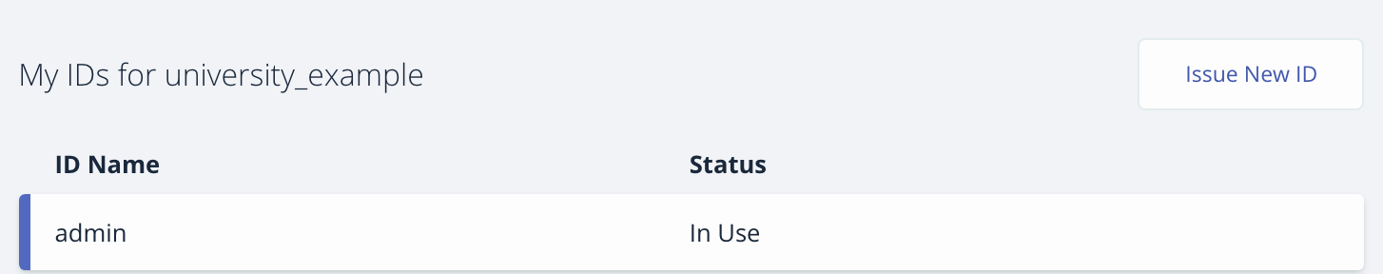

**Step 3:** Enter a name to the identity and also specify to which Participant identity has to be issued. In our case a college participant with ID: ***College-1522380799679***

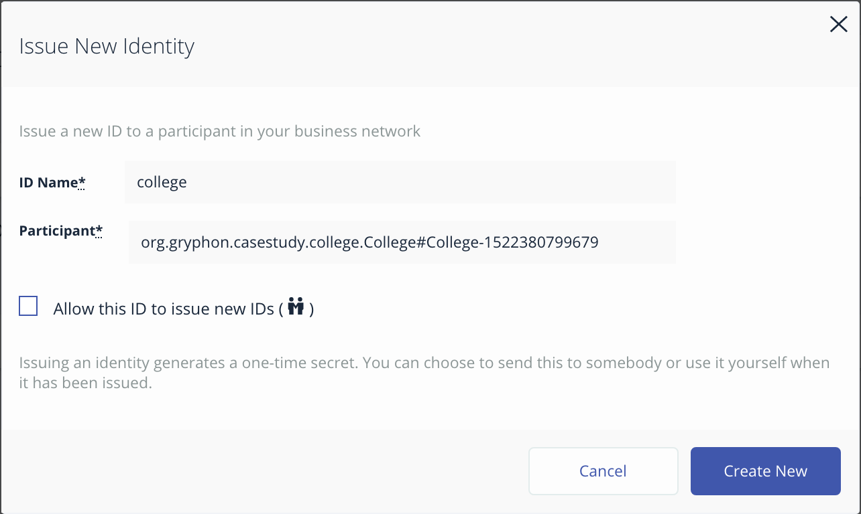

A new Identity has been created for the College Participant. Listing as shown below;



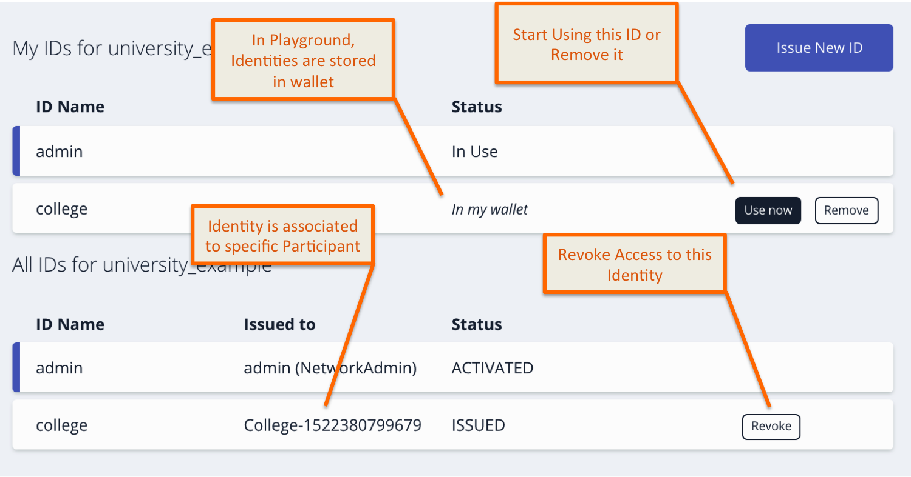

**Step 4:** To use the newly created identity for College participant, click “Use now” button against the identity.



**Task 5 is complete!**



## TASK#6: Test Access

**Step 1:** Business Network Archive was deployed, ‘College’ Participant and its associated identity was created in previous task. We need to use this newly created Identity to test the access. Click ‘Use now’.



‘admin’ ID’s status will start showing as ‘In my wallet’ and college ID will be ‘In Use’, indicating that our new Identity is at work.

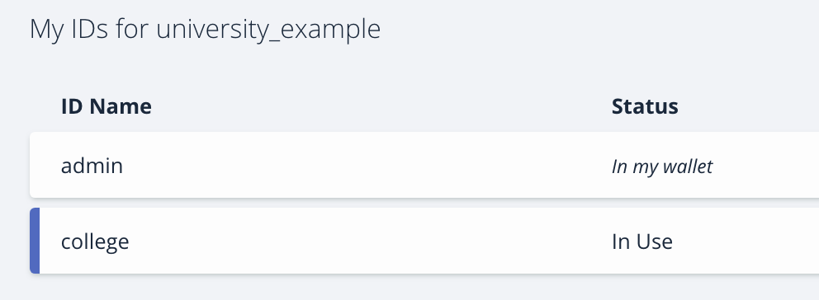

**Step 2:** Click on the ‘Test’ tab to navigate to the Playground

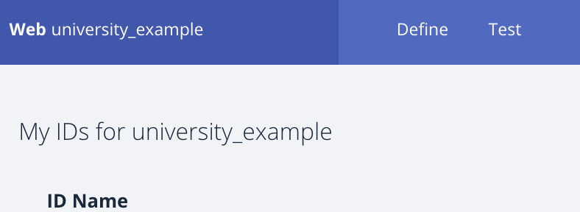



**Step 3:** We can invoke transaction using the ‘Submit Transaction’ button on left bottom of the ‘Test’ page

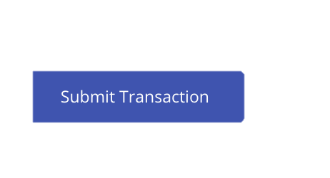

On clicking the button, transaction dialog shall appear;

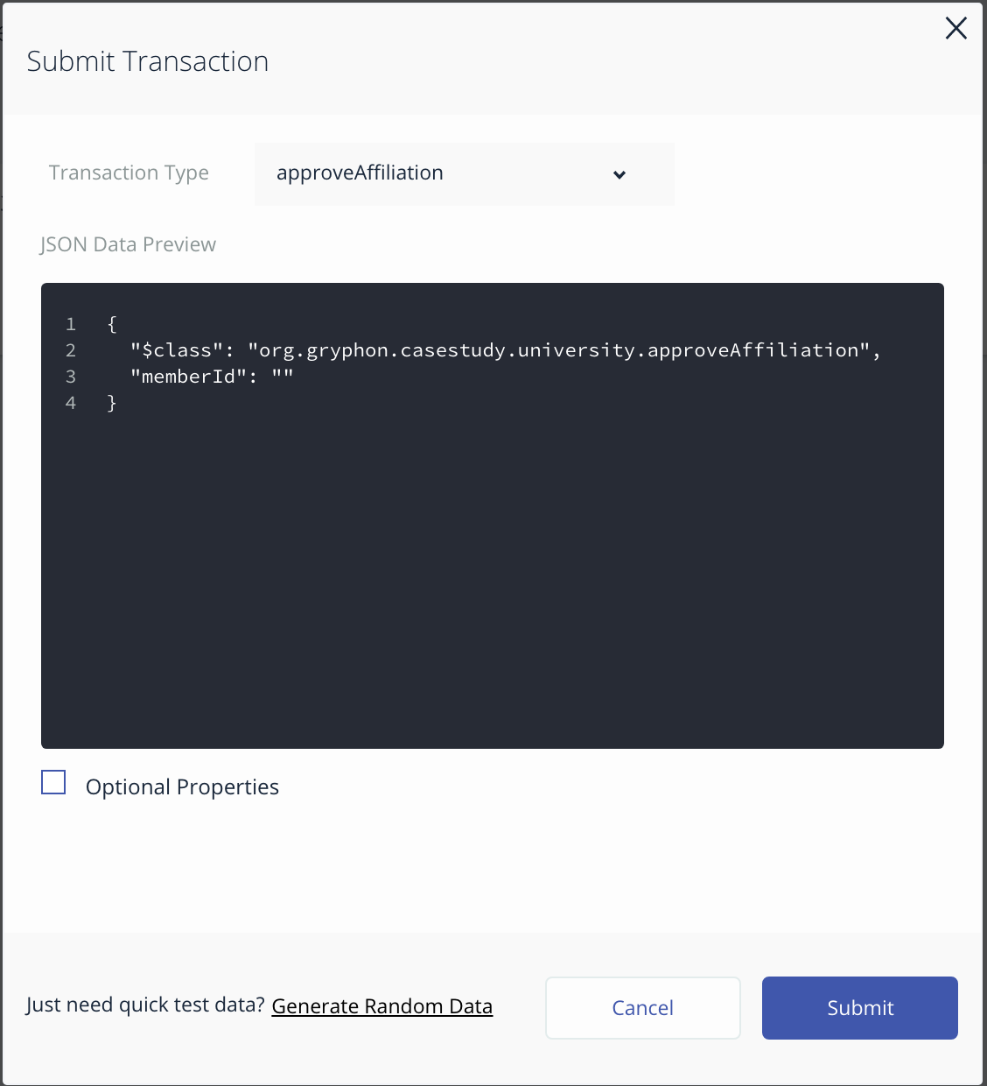

**Step 4:** Testing a **permissioned** transactions [ ***‘requestAffliation’*** & ***‘enrollProgram’*** ]

**Step 4.1:** In submit transaction dialog select transaction type as ***‘enrollProgram’*** and use the following json to add “B.E Electronics” program to the existing college ‘YCCE’ with ID: College-1522380799679



{

"$class": "org.gryphon.casestudy.college.enrollProgram",

"collegeId": "College-1522380799679",

"programName": "B.E Electronics"

}

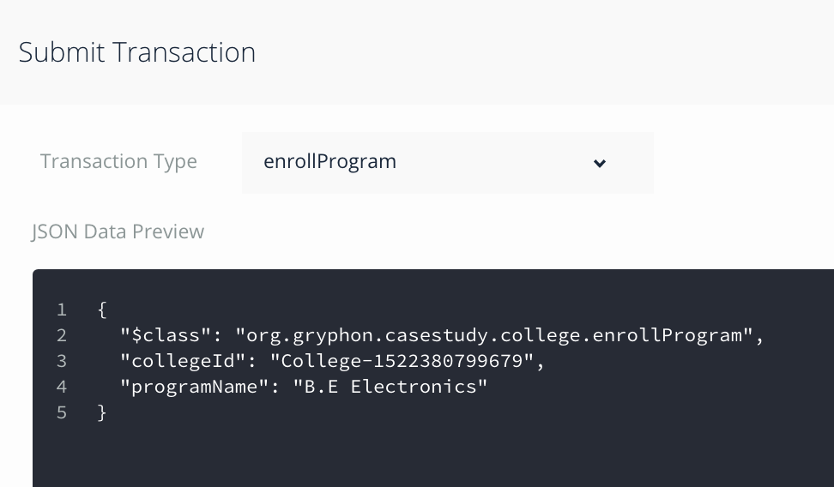

**Step 4.2:** Click Submit. On successful completion, we should be able to see a second program ‘B.E Electronics’ in the list of programs for the specific college

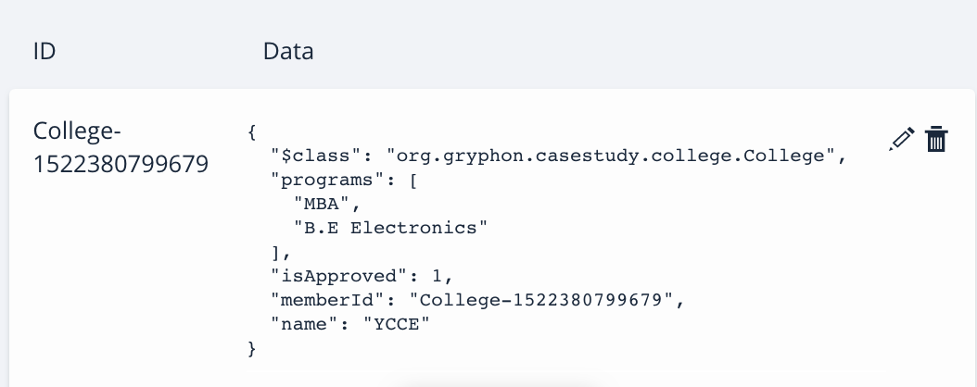

**Step 4.3:** Similarly Submit a new ***‘requestAffliation’*** transaction using argument data as below;



{

"$class": "org.gryphon.casestudy.college.requestAffiliation",

"name": "New College"

}

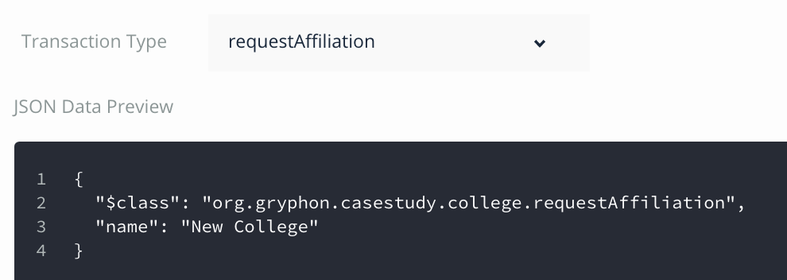

On successful execution a new college participant will be created.

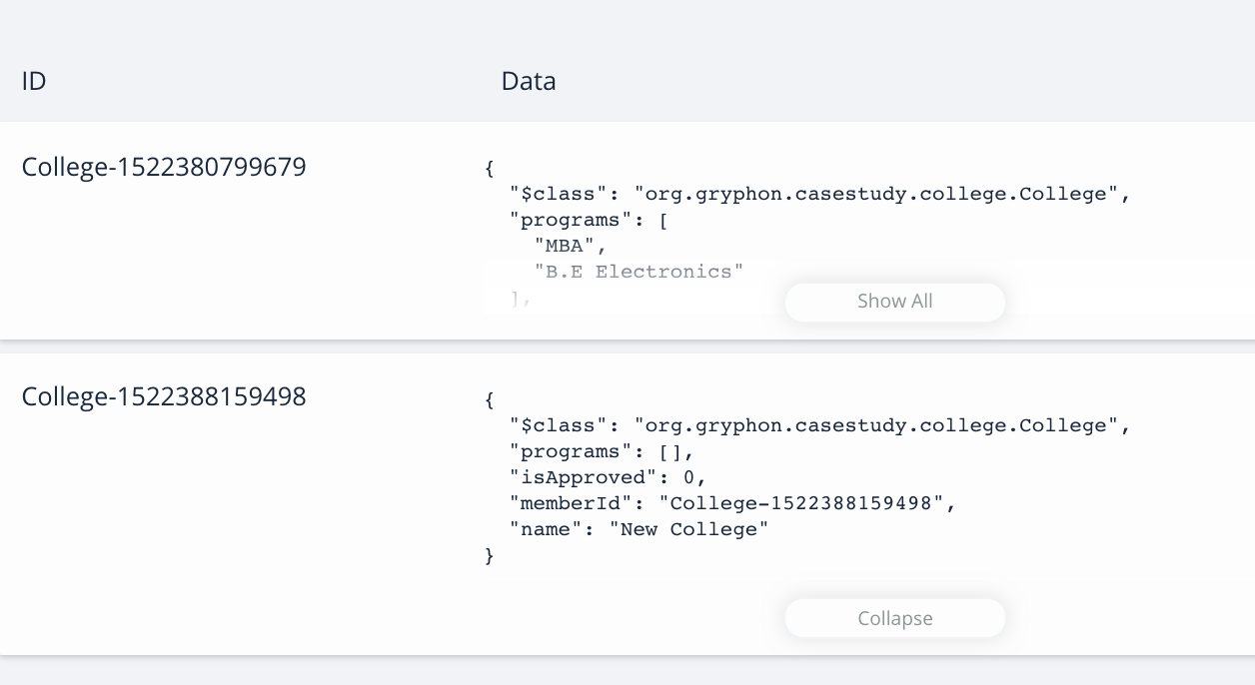

***#Result:*** *We are able to successfully execute chaincode transactions within namespace org.gryphon.casestudy.college and access as specified in ‘permissions.acl’ file*



**Step 5:** Testing a **restricted permissioned** transactions [ ***‘approveAffliation’*** & ***‘issueCertificate’*** ]

**Step 5.1:** Let us try to execute ***‘approveAffliation’*** transaction which only University is authorized as per our ‘permissions.acl’ file and see if permission are granted as expected;

Lets approve ‘New College’ participant;

***\*\* Note:*** *Please use college ID that is generated by your system for ‘New College’ participant*

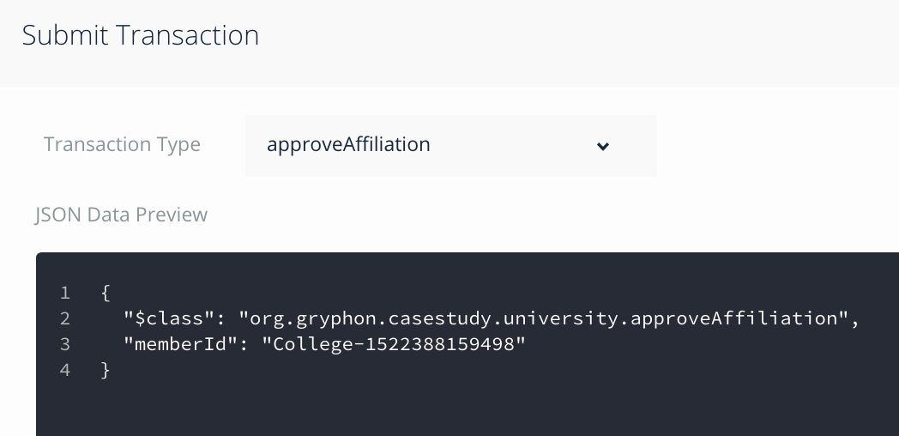

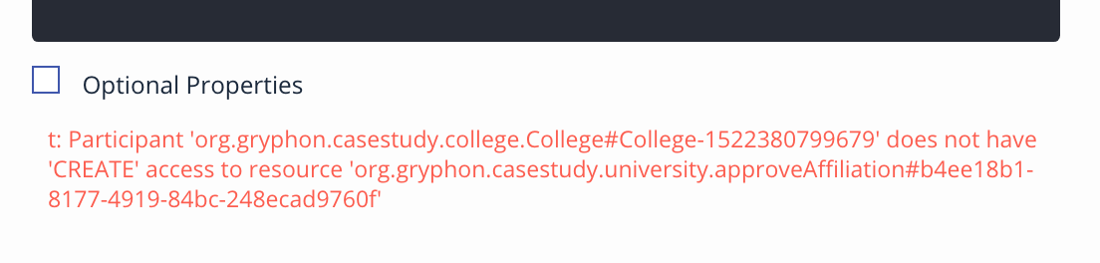

Transaction fails, showing that college participant does not have appropriate permissions



**Step 5.2:** SimilarlyLet us try to execute ***‘issueCertificate’*** transaction which only University is authorized as per our ‘permissions.acl’ file and validate our permissions;

## 

On submission of transaction we get permissions error as below;

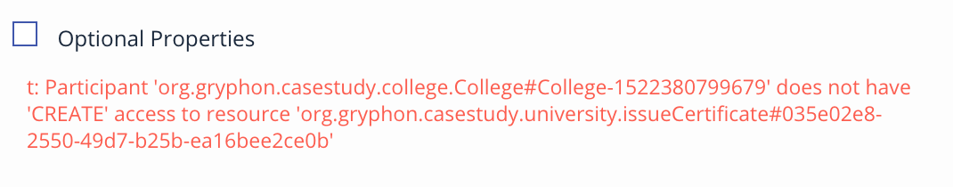

***#Result:*** *College Participant access to chaincode transactions are restricted only within namespace org.gryphon.casestudy.college. Hyperledger is a private permissioned network and access to the network can be provided/revoked using identities and selective permissions are defined in ‘.acl’ file.*

**Task 6 is complete!**

# Test Your Knowledge

In Hyperledg­­er Fabric business network application, access is granted to both known and unknown entities?

- TRUE

- FALSE

In which file do you define access permissions?

- .ACL file

- .CTO file

- .json file

- .yml file

Access to Hyperledger Fabric Business Network Application is granted based on the ______ of the participant

- Role

- Identity

- Documents

Participants are assigned an identity using:

- User Name / Password

- X509 Certificate

- SSO

Apart from Participants, are Organization and Hyperledger Infrastructure also issued a X509 certificate?

- True

- False

# SUMMARY

Hyperledger is a permissioned network. To be able to access resources or perform transactions network business cards/identities are needed.

In this chapter we have learnt the following:

* Participant & and their identities
* Adding a new participant to a participant registry
* Issuing a new identity to a participant
* Binding an existing identity to a participant
* Defining permissions to participant users using ACL (Access control Language)

# CHAPTER 4: HYPERLEDGER – CLIENT APP

## Theory

This chapter will be more hands-on. It will cover how we can build the client app, which can interaction with the fundamental blocks of Hyperledger blockchain i.e;

* Connecting to the Business Network
* Access Participant and Asset registries
* Invoke Transactions
* Query Resources (Static & Dynamic Queries)
* Handling events

## High Level Architecture

Model file, Transaction functions (chaincode), access control file and the static query file make the Business Network Archive (Package) for the Hyperledger Fabric.

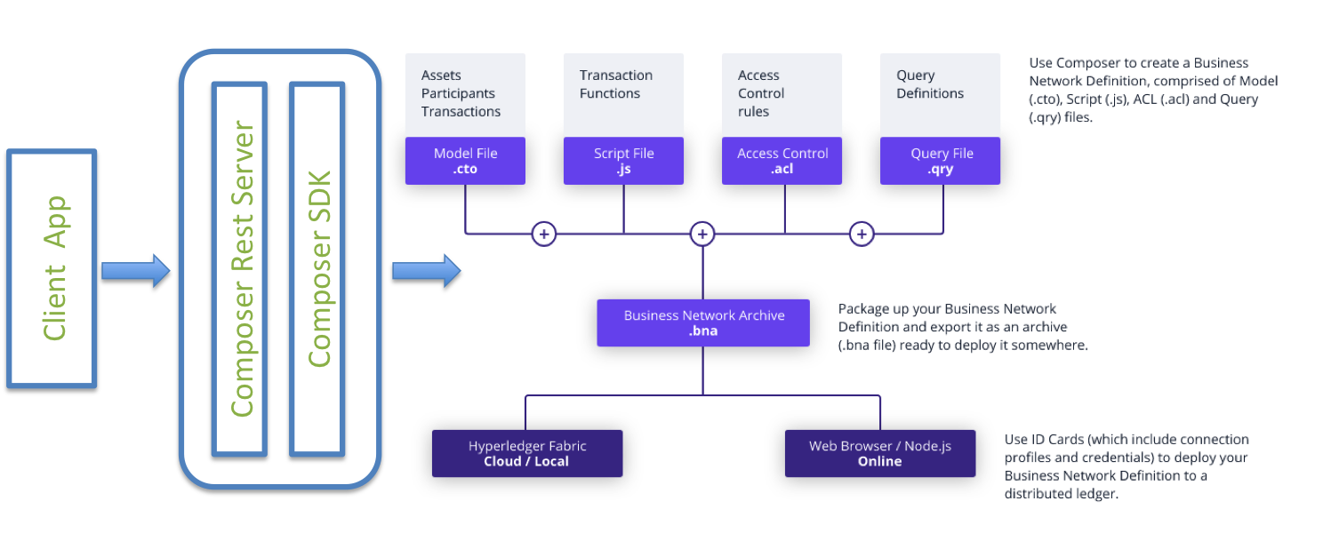

We will use Node.js and composer SDK to connect to the Fabric network and access/interaction with the blockchain resources.

## Queries:

The native query language can filter results returned using criteria and can be invoked in transactions to perform operations, such as updating or removing assets on result sets.

Queries are defined in a query file (.qry) in the parent directory of the business network definition. Queries contain a WHERE clause, which defines the criteria by which assets or participants are selected.

## Events

Event creates notifications of significant operations on the Blockchain (e.g. a new block), as well as notifications related to milestone achieved while processing a smart contract/chaincode. Does not include event distribution.

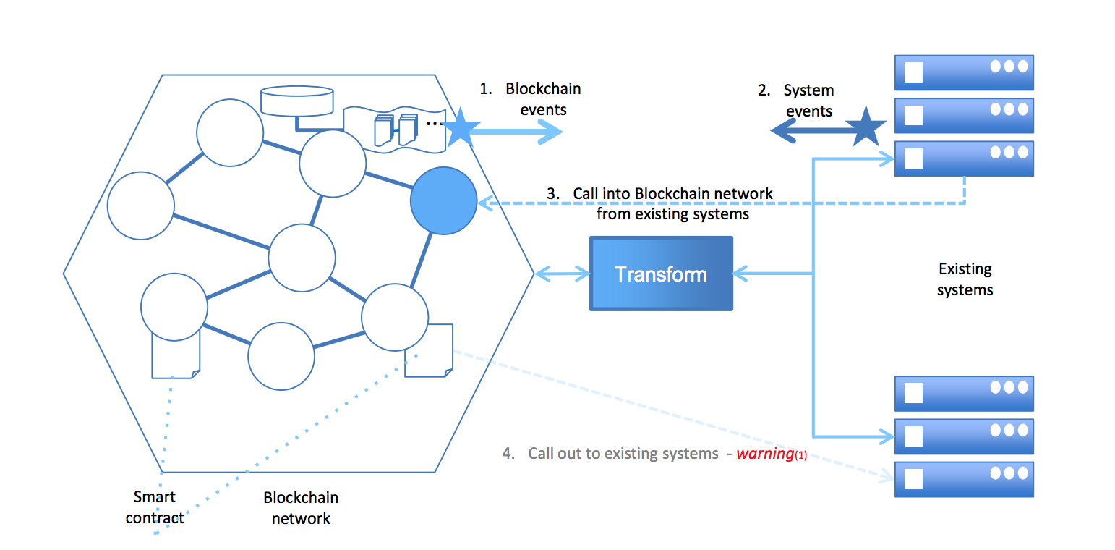

## 

The client app can subscribe to this event and take appropriate business actions. It’s an important part of any system to provide an insight ask for immediate attentions.

In the lab section we will generate an event in the chaincode and client app will subscribe for this event. We can then utilize this event to either send an email or appropriately notify the participant.

# Lab Exercise 4: Coding client App, Queries & Events

|  |
| --- |
|  |

1. **Coding Client App**
   1. **requestAffiliation()**
   2. **getCollegeList()**
   3. **approveAffiliation()**
   4. **enrollProgram()**
   5. **takeAdmission()**
   6. **getStudentList()**
   7. **issueCertificate()**
   8. **verifyCertificate()**
2. **Querying Registries**
3. **Events & Subscription**

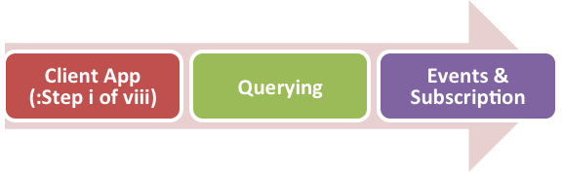

## TASK#1: Coding Client App

**Step 1:** Open ‘chapter04’ code provided in Visual Studio Code.

*#****Info****: ‘chapter04’ is a Business Network Scaffolding created as in Chapter#2-Task 1 with following changes:*

1. *Chaincode ‘logic.js’ is replaced with ‘chaincode.js’*
2. *Test ‘logic.js’ is replaced with ‘chaincode-test.js’*
3. *‘script’ folder is added*
4. *‘permissions.acl’ added*
5. *‘client_app’ folder added*

**Step 2:** Open terminal window of Visual Studio code and type run the following command

npm install

**Step 3:** Cd in the scripts folder and run buildAndDeploy.sh script to deploy the business network [Models and chaincode]

cd script

./buildAndDeploy.sh

### TASK#1.1: Coding requestAffiliation()

**Step 1**: Browse to directory ‘client_app/controller/composer’ and open file ‘hlcClient.js

*’*

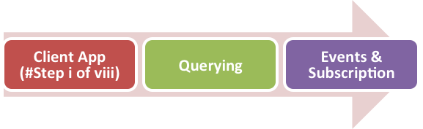

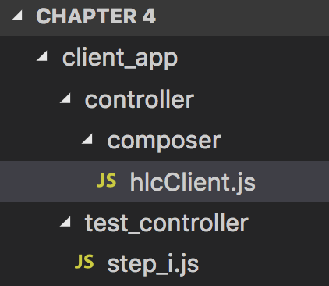

**Step 2:** Coding requestAffiliation() method

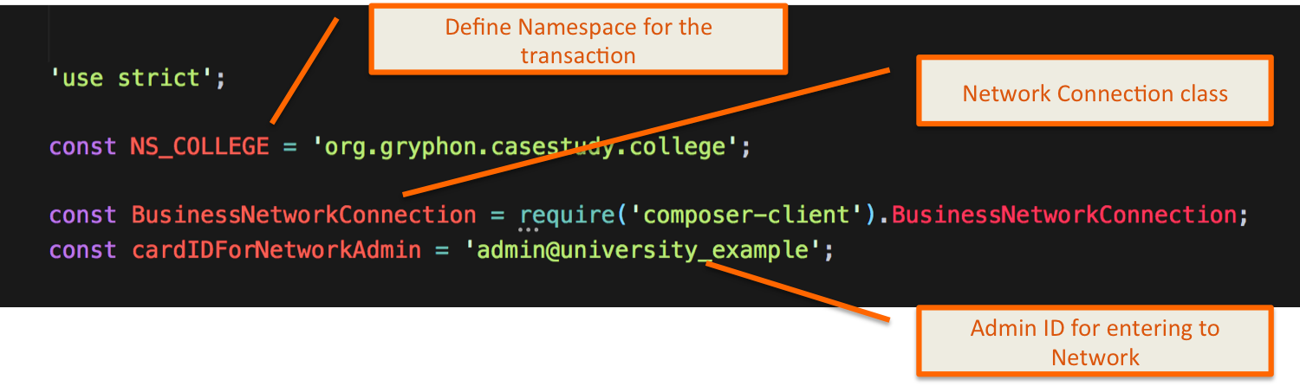

Actions:

* Create Business Network object
* Connect to network using permissioned card name (Participant or Admin) depending on usecase
* Create Transaction Object
* Set Transaction Arguments
* Submit Transaction
* Handle failure conditions by logging error info



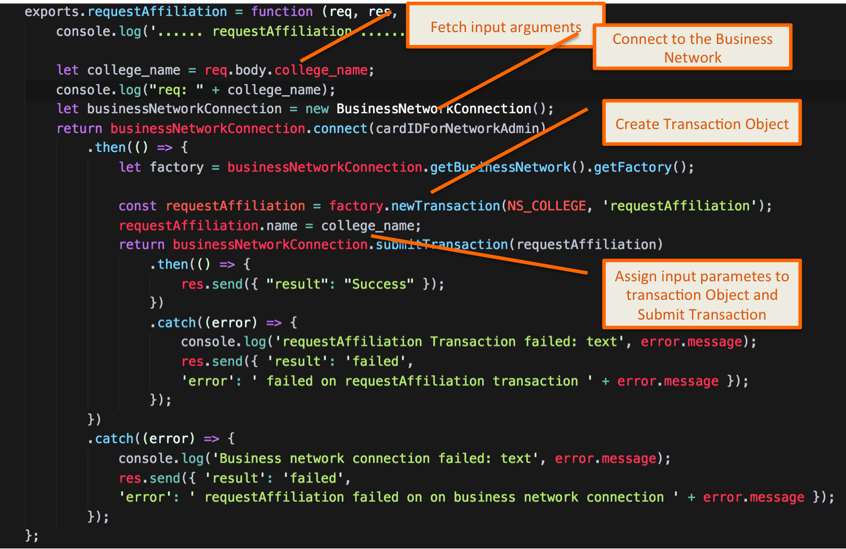

**Step 3:** To validate if requestAffiliation() works, open terminal in visual studio code and cd into following directory

cd client_app/test_controller/

**Step 4:** Run the test script using nodejs as below

node step_i.js

The result success signifies that our transaction was successful

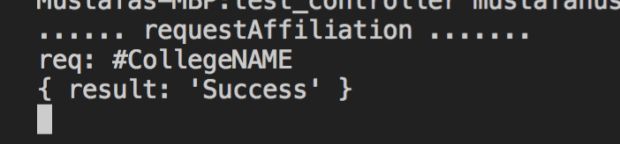

**Task 1 #i is complete!**

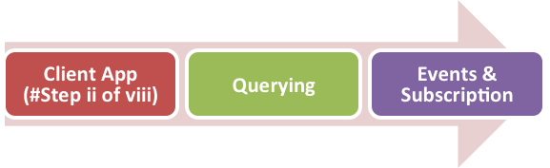

### TASK#1.2: Coding getCollegeList()

**Step 1**: Browse to directory ‘client_app/controller/composer’ and open file ‘hlcClient.js

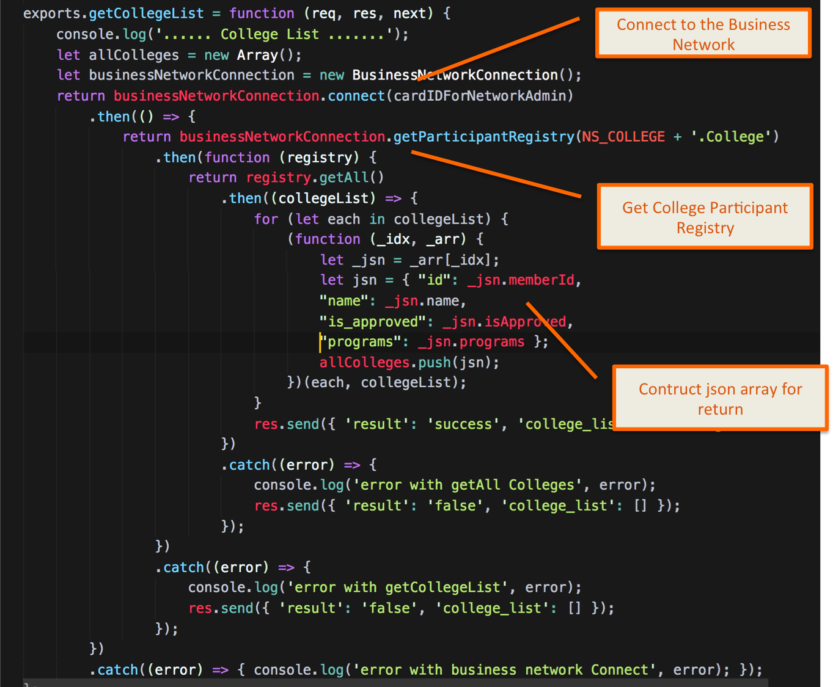

Actions:

* Create Business Network object
* Connect to network using permissioned card name (Participant or Admin) depending on usecase
* Get College Participant Registry



* Get All participants
* On success, build a json and return
* On error Handle failure conditions by logging error info

**Step 2:** To validate if getCollegeList() works, open terminal in visual studio code and cd into following directory

cd client_app/test_controller/

**Step 3:** Run the test script using nodejs as below

node step_ii.js

The result success with list of colleges signifies that our transaction was successful

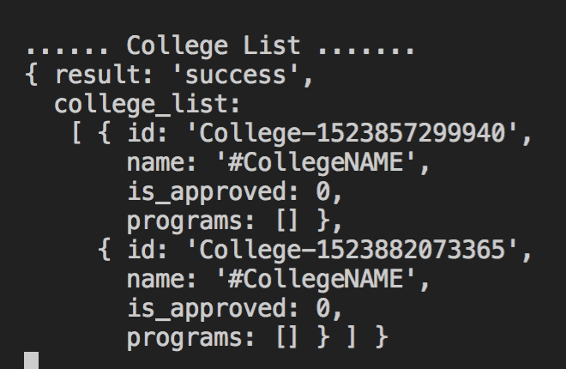

**Task 1 #ii is complete!**

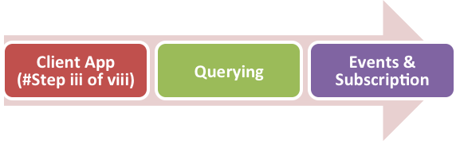

### TASK#1.3: Coding approveAffiliation()

**Step 1**: Browse to directory ‘client_app/controller/composer’ and open file ‘hlcClient.js

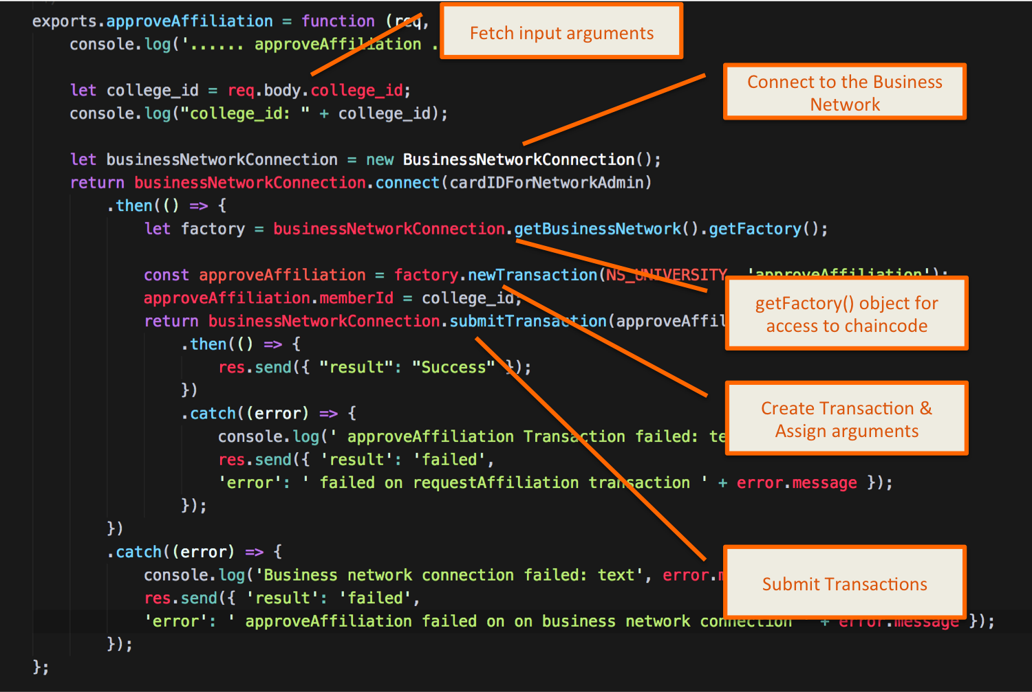

Actions:

* Create Business Network object
* Connect to network using permissioned card name (Participant or Admin) depending on usecase
* Create Transaction & assign input arguments
* Handle failure conditions by logging error info



**Step 2:** To validate if approveAffiliation() works, open terminal in visual studio code and cd into following directory

cd client_app/test_controller/

**Step 3:** Run the test script using nodejs as below to FETCH list of all colleges

node step_iii.js

The result success with list of colleges signifies that our transaction was successful

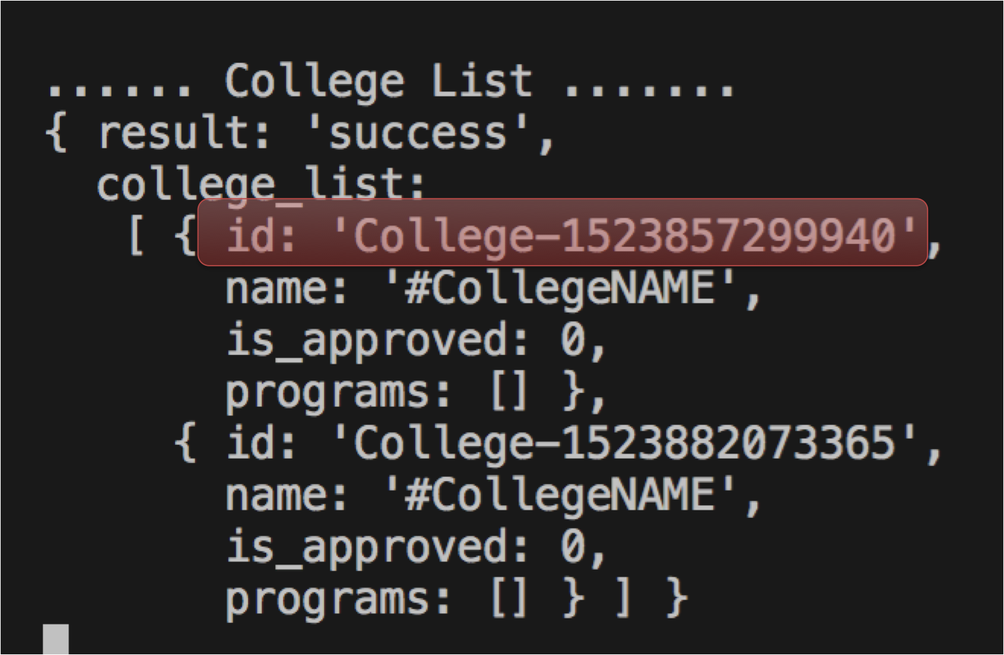

**Step 4:** Note the **CollegeID** in red above and run the test below script using nodejs to approve affiliation of college

node step_iii.js ReplaceWithYourCollegeID



The result success with approved flag of specified college ID signifies that our transaction was successful

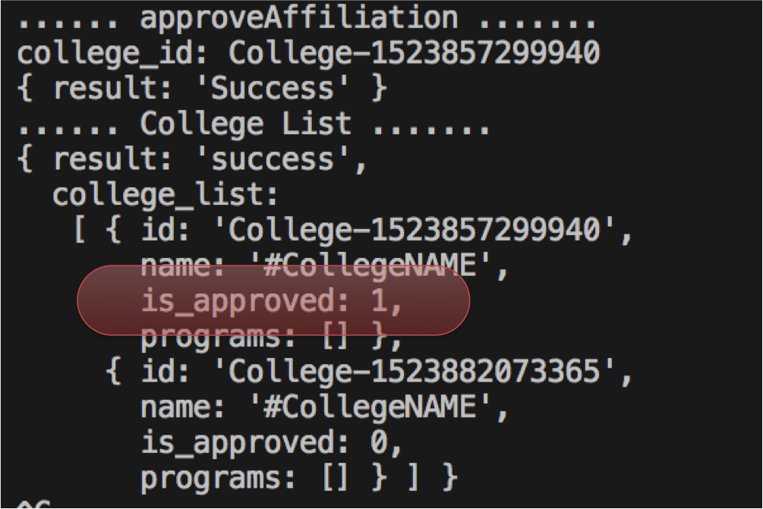

**Task 1 #iii is complete!**

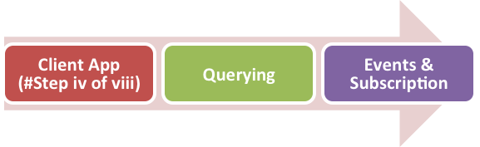

### TASK#1.4: Coding enrollProgram()

**Step 1**: Browse to directory ‘client_app/controller/composer’ and open file ‘hlcClient.js

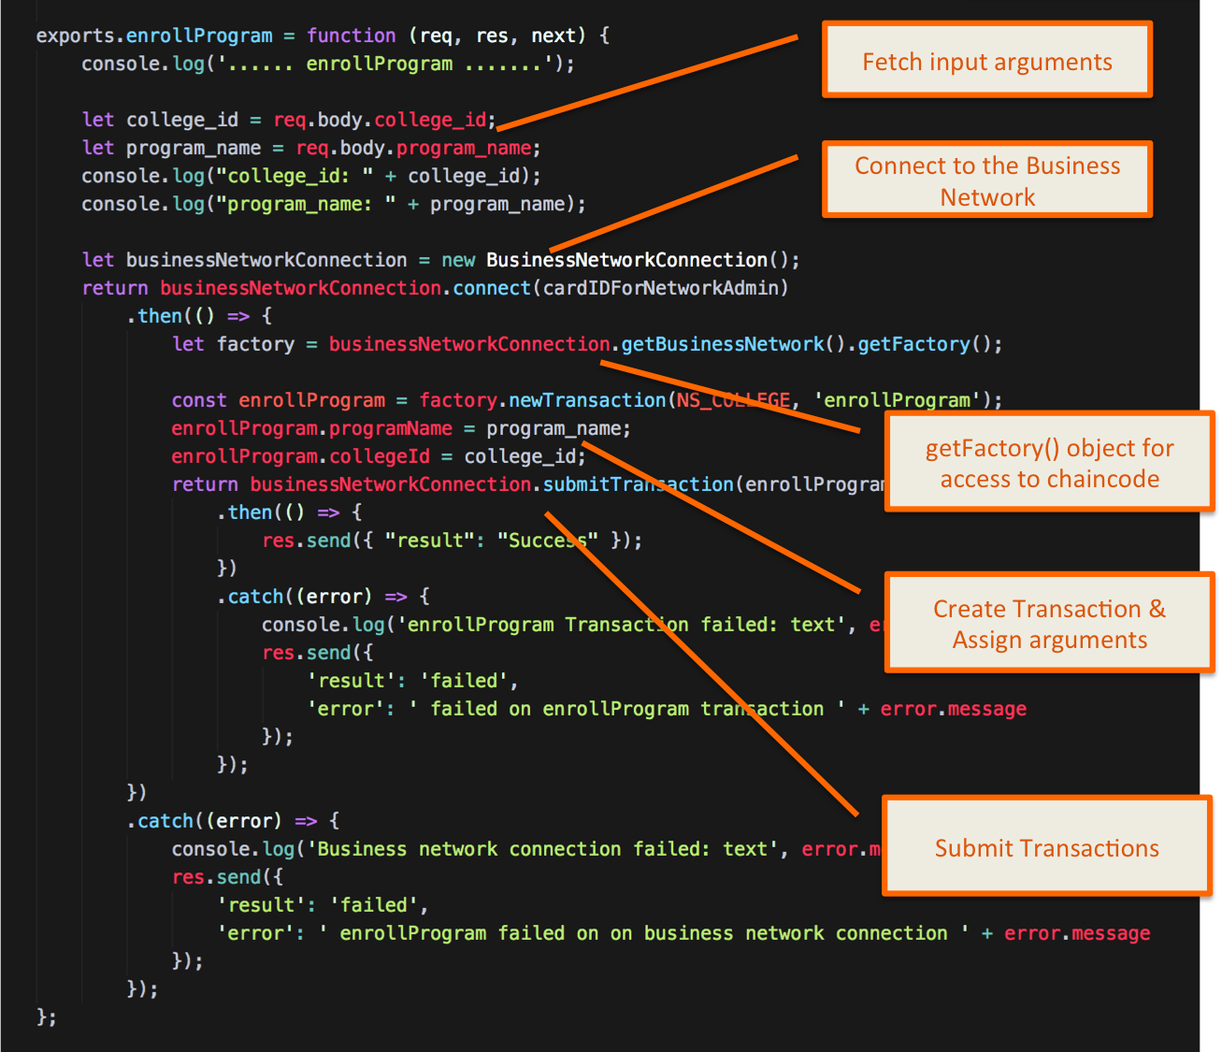



Actions:

* Create Business Network object
* Connect to network using permissioned card name (Participant or Admin) depending on usecase
* Create Transaction & assign input arguments
* Handle failure conditions by logging error info

**Step 2:** To validate if enrollProgram() works, open terminal in visual studio code and cd into following directory

cd client_app/test_controller/

**Step 3:** Run the test script using nodejs as below

**Note: Use CollegeID that was generated in you usecase

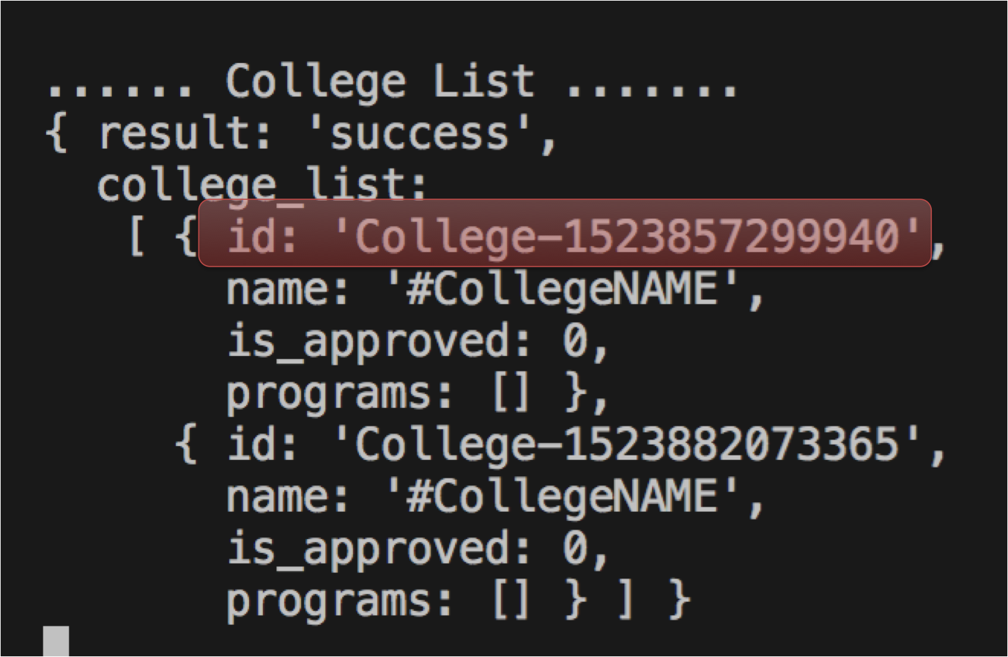

node step_iv.js College-1523857299940 M.B.A

The result success with list of program for the specified college signifies that our transaction was successful

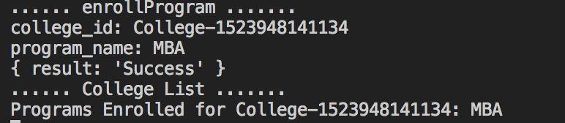

**Task 1 #iv is complete!**

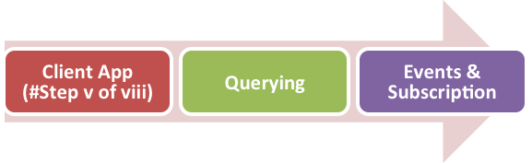

### TASK#1.5: Coding takeAdmission()

**Step 1**: Browse to directory ‘client_app/controller/composer’ and open file ‘hlcClient.js

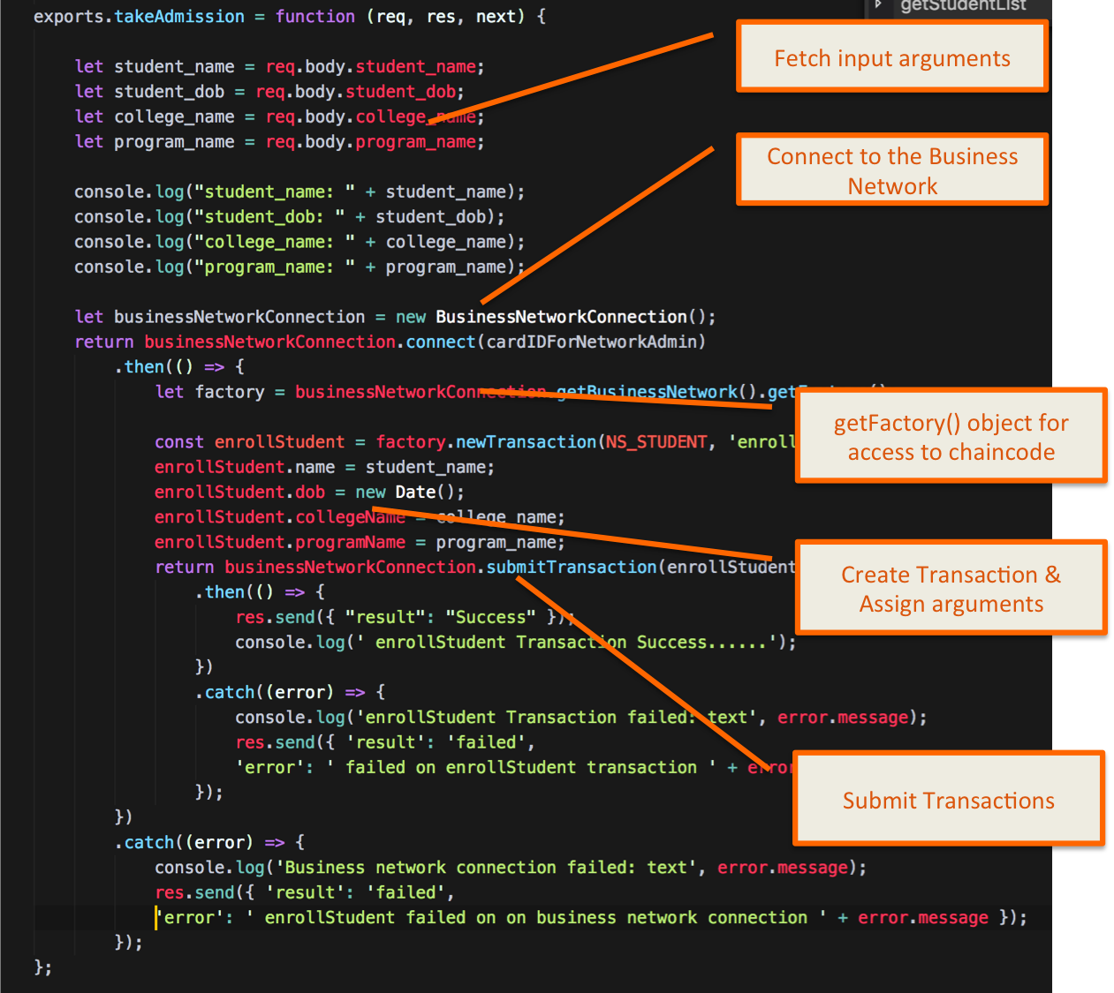



Actions:

* Create Business Network object
* Connect to network using permissioned card name (Participant or Admin) depending on usecase
* Create Transaction & assign input arguments
* Handle failure conditions by logging error info

**Step 2:** To validate if takeAdmission() works, open terminal in visual studio code and cd into following directory

cd client_app/test_controller/

**Step 3:** Run the test script using nodejs as below

**Note: In actual scenario ID for Student, College and Program Name should be taken. However this is just a demo usecase hence we are simply taking names

node step_v.js "John Doe" CollegeNAME MBA

The result success signifies that our transaction was successful

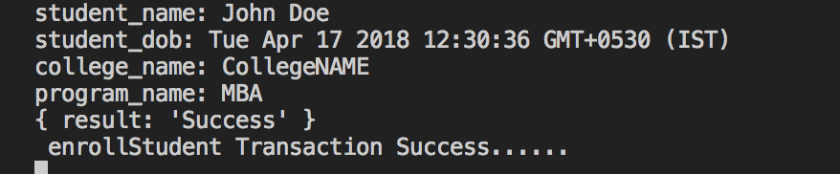

**Task 1 #v is complete!**

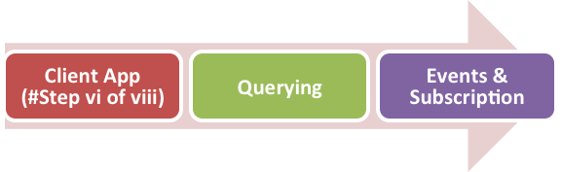

### TASK#1.6: Coding getStudentList()

**Step 1**: Browse to directory ‘client_app/controller/composer’ and open file ‘hlcClient.js

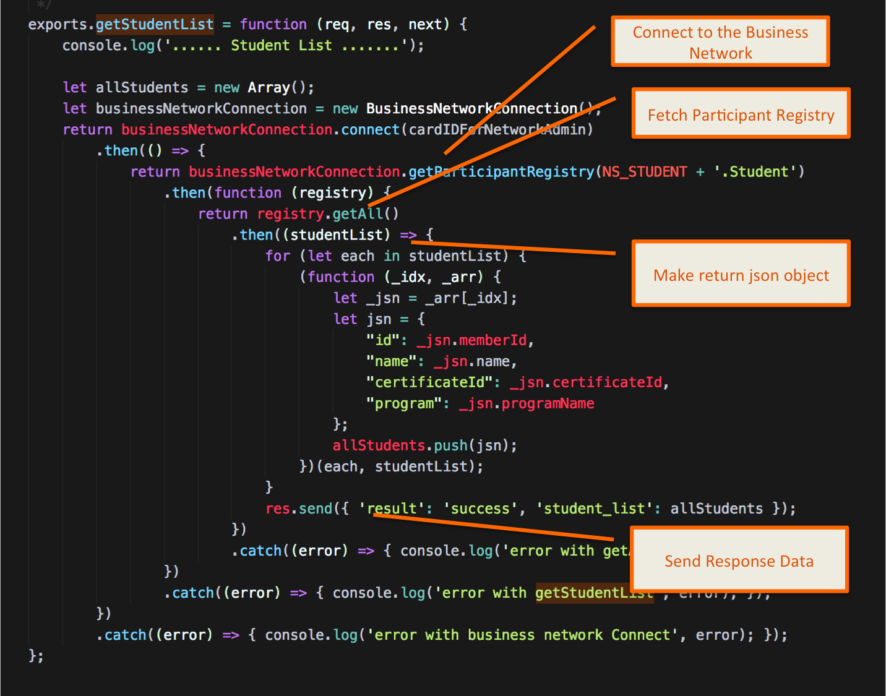



Actions:

* Create Business Network object
* Connect to network using permissioned card name (Participant or Admin) depending on usecase
* Create Transaction & assign input arguments
* Handle failure conditions by logging error info

**Step 2:** To validate if getStudentList() works, open terminal in visual studio code and cd into following directory

cd client_app/test_controller/

**Step 3:** Run the test script using nodejs as below

node step_vi.js

The result success signifies that our transaction was successful

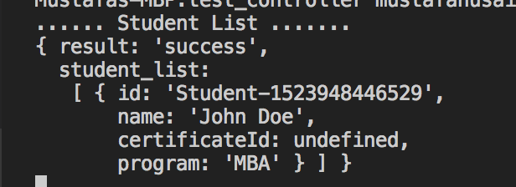

**Task 1 #vi is complete!**



### TASK#1.7: coding issueCertificate()

**Step 1**: Browse to directory ‘client_app/controller/composer’ and open file ‘hlcClient.js

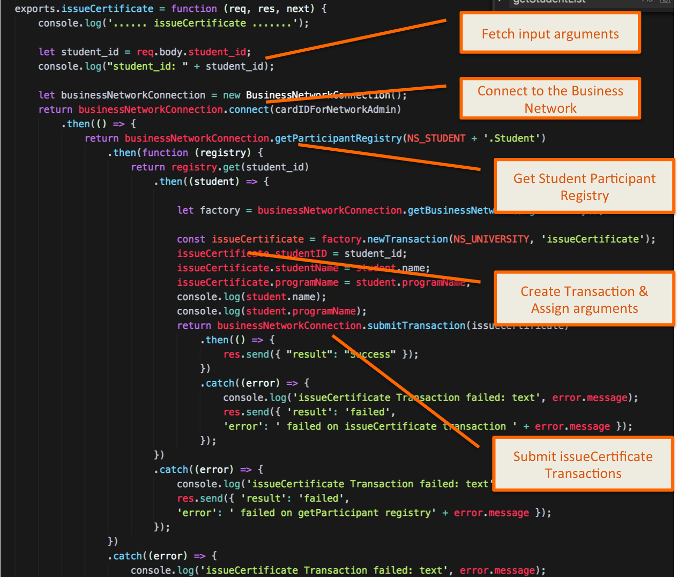



Actions:

* Create Business Network object
* Connect to network using permissioned card name (Participant or Admin) depending on usecase
* Fetch Student Participant Registry
* Get Student Records
* Create issueCertificate Transaction & assign input arguments
* Handle failure conditions by logging error info

**Step 2:** To validate if issueCertificate() works, open terminal in visual studio code and cd into following directory

cd client_app/test_controller/

**Step 3:** Run the test script using nodejs as below

**\*\*Note**: Please use Student ID generated on your system

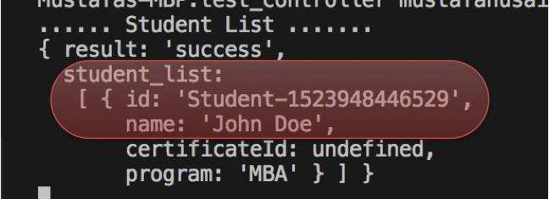

node step_vii.js Student-1523948446529

The result success signifies that our transaction was successful

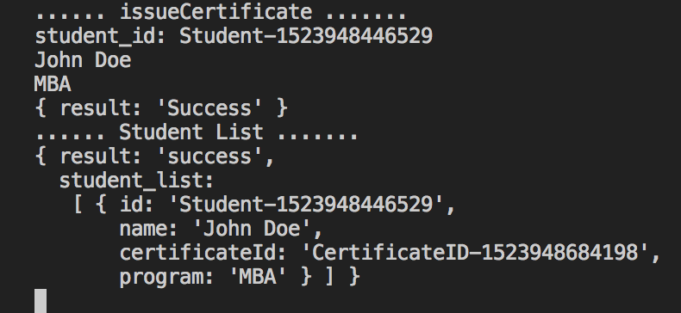

**Task 1 #vii is complete!**

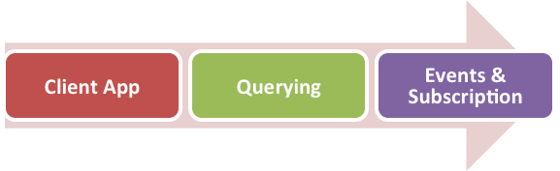

## TASK#2: Using Queries

**Step 1**: Open ‘chapter04’ code provided in Visual Studio Code.

**Step 2**: Open file ‘queries.qry’

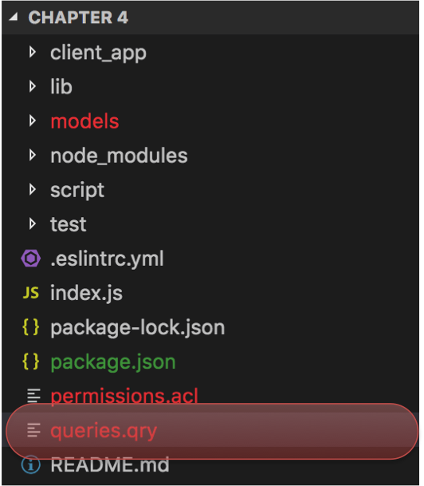

**Step 3**: Define query to find student by its ID

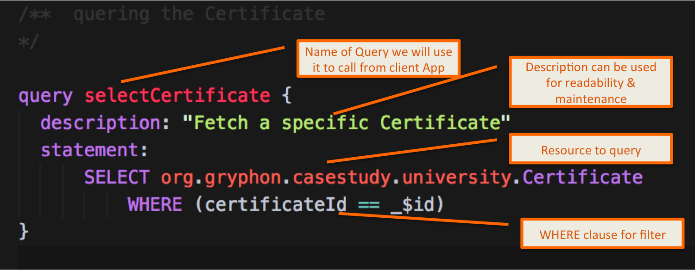

**Step 4**: Browse to directory ‘client_app/controller/composer’ and open file ‘hlcClient.js



**Step 5**: Coding getCertificateById() client App method

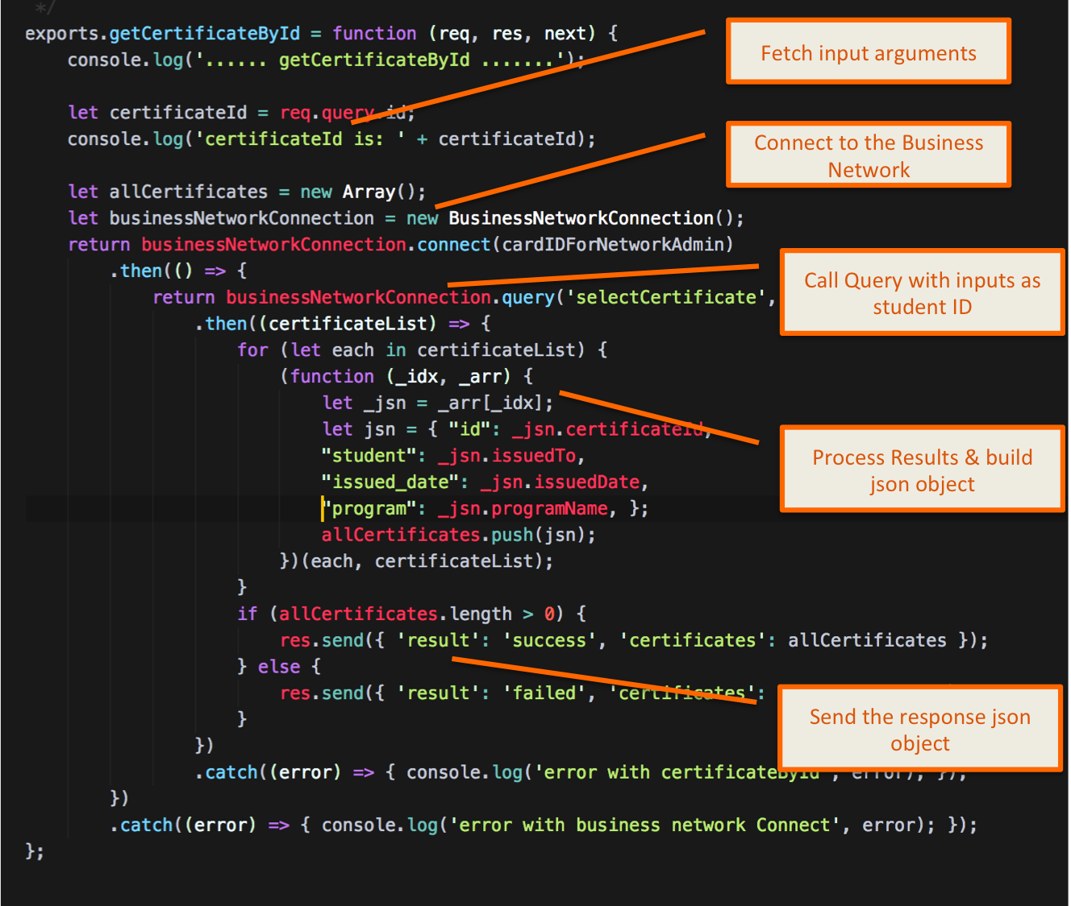



Actions:

* Create Business Network object
* Connect to network using permissioned card name (Participant or Admin) depending on usecase
* Call the query using student ID as filter
* Build the response json object
* Handle failure conditions by logging error info

**Step 6:** To validate if getCertificateById () works, open terminal in visual studio code and cd into following directory

cd client_app/test_controller/

**Step 7:** Run the test script using nodejs as below

**\*\*Note**: Please use Certificate ID generated on your system

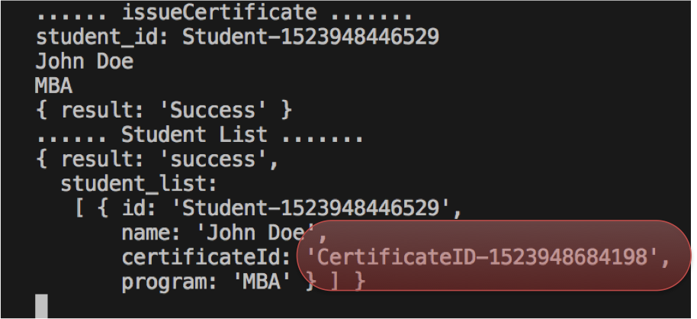

node step_viii.js CertificateID-1523948684198

The result success with details of certificate signifies that our transaction was successful

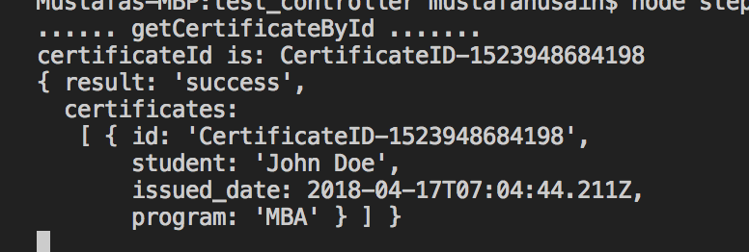

**Task 2 is complete!**



## TASK#3: Blockchain Events & Subscription

**Step 1**: Open ‘chapter04’ code provided in Visual Studio Code.

**Step 2**: Open file ‘org.gryphon.casestudy.university.cto’ under models folder

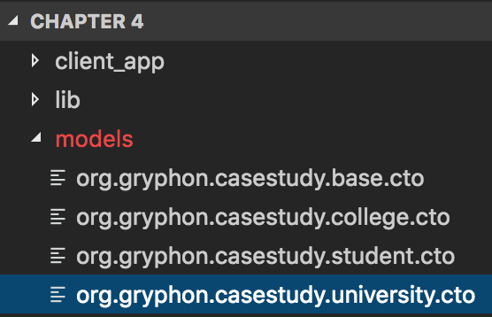

**Step 3**: Define Event

/**

* Notify Issue of certificate

* An event that can be substribed

*/

event certificateIssuedEvent {

o String certificateId

}

**Step 4**: Browse to directory ‘lib’ and open file ‘chaincode.js

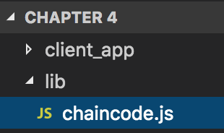



**Step 5**: Add Emit Event to the issueCertificate() chaincode

var event = factory.newEvent(NS_UNIVERSITY, 'certificateIssuedEvent');

event.certificateId = certificateId;

emit(event);

**Step 6**: Browse to directory ‘client_app/controller/composer’ and open file ‘hlcClient.js

**Step 7**: Subscribing to Events. Coding subscribeForEvents() method

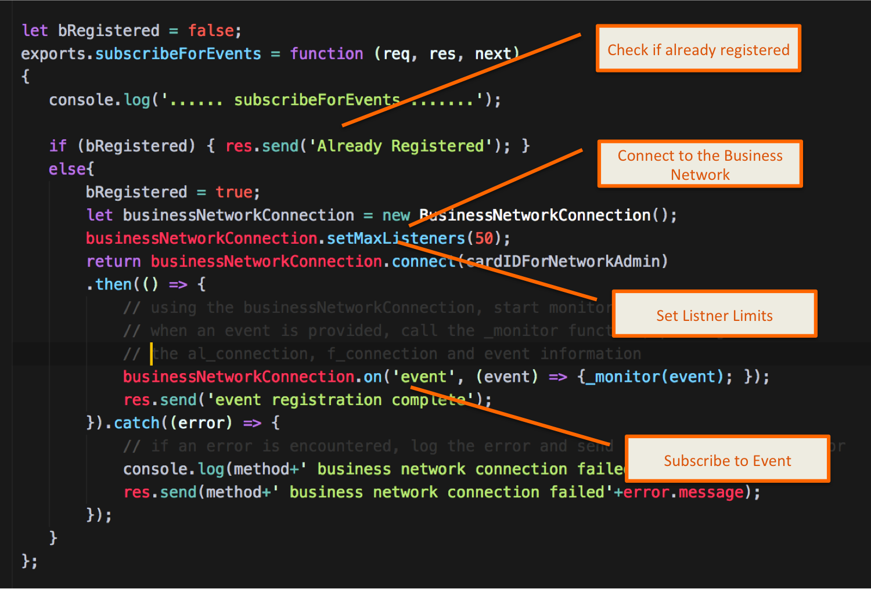



Actions:

* Create Business Network object
* Connect to network using permissioned card name (Participant or Admin) depending on usecase
* Set connection limits
* Subscribe to the events
* Handle failure conditions by logging error info

**Step 8**: Any blockchain event emitted will now call ***‘_monitor()’***

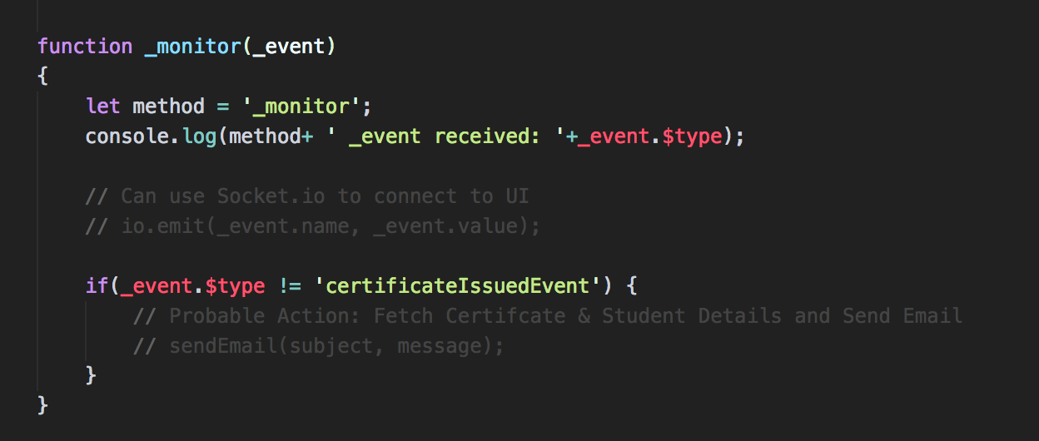

* For all events same _monitor() method will be called
* We need to check if event called was ‘certificateIssueEvent’, we do it by peeking into _event.$type variable

**Step 9:** We will have to deploy the runtime again as the chaincode has changed. Browse into the ‘script’ folder

cd script



**Step 10:** Install the new chaincode by running the following script

./updateRuntime.sh

**Step 11:** To validate if Event Subscription works, open terminal in visual studio code and cd into following directory

cd client_app/test_controller/

**Step 12:** Run the test script using nodejs as below;

We will call issueCertificate() transaction so that the event is emitted

node step_x.js CertificateID-1523948684198

The result success with details of certificate and monitor method called signifies that our subscription was successful

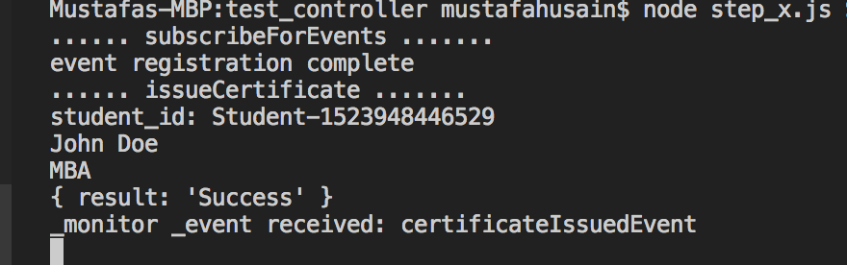

**Task 3 is complete!**

# Test Your Knowledge

What class do you need to connect to Business Network?

- BusinessNetworkDefinition

- BusinessNetworkConnection

- FactoryClass

- BusinessNetworkCardStore

In which file do you define static queries?

- .ACL file

- .CTO file

- .QRY file

- .SH file

Client code cannot create an instance of the Admin & Business Network Connection in the same code

- True

- False

Execution of the Named query using the API require you to use the *businessNetworkConnection.buildQuery()*function:

- True

- False

A subscriber application using the composer API receives the event data in the form of

- JSON

- Array

- Message

- UTF8 String

# CHAPTER 5: CREATING FRONT END INTERACTIVE INTERFACES

## Theory

This chapter again will be completely hands-on. In this chapter we will build a complete end-to-end interactive usecase utilizing the University example that we have built so far. We will cover all the missing links and FAQs

* How do we invoke the chaincode from an HTML or a frontend application?
* How do we setup the node server and routes to run the client app?
* How does the bloackchain look like in a real work scenario?
* How can a end-user access the blockchain?

## Front End Application Patterns

### Composer Rest Server middleware Architecture:

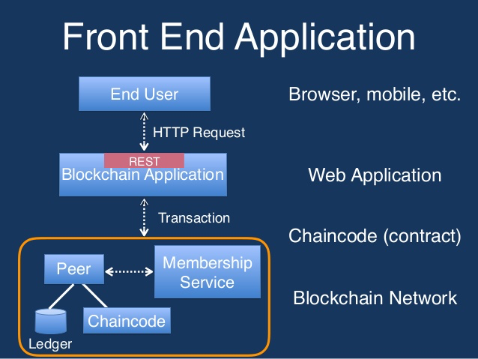

Considerations:

* Rest server must be secured – HTTPS
* Should use authentication – [Passport]
* Should use multi-user mode for rest api

### Custom middleware pattern:

*This is the pattern we will be using in our Demo usecase.*

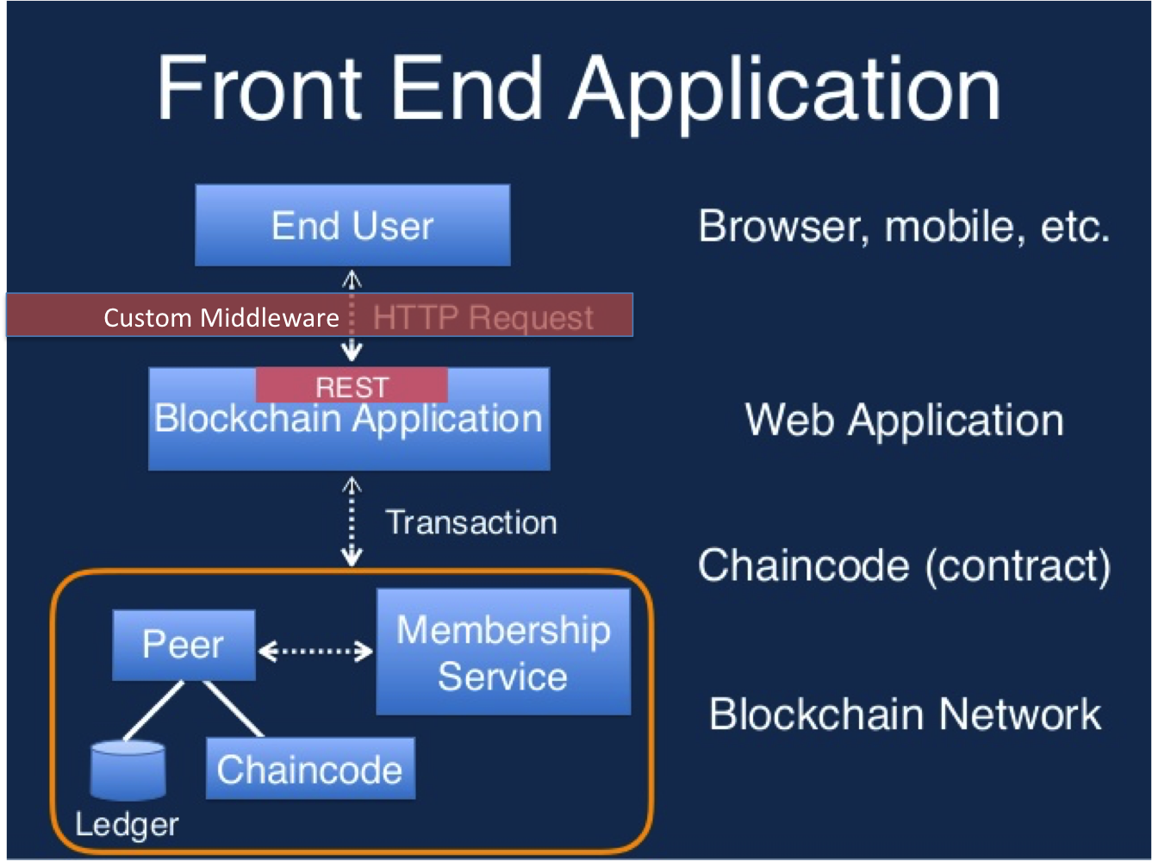

Advantages:

* More secure
* Better control and can plugin existing enterprise applications

### Desktop Application Architecture

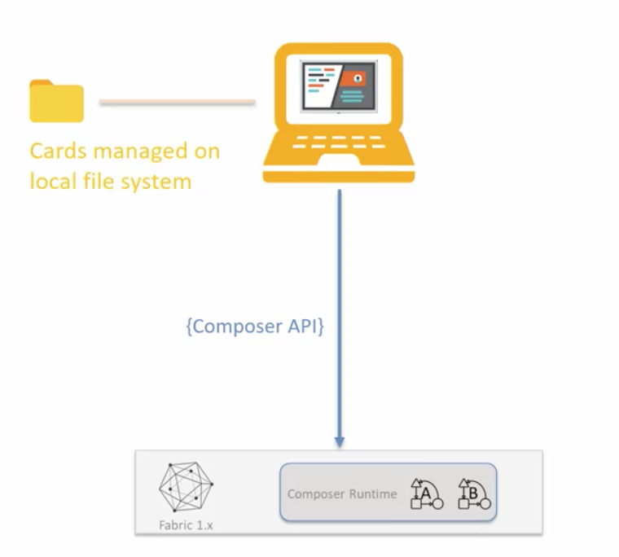

Pros:

* Most Secure

Cons:

* App distribution

# Lab Exercise 5: Building Interactive Frontend

|  |
| --- |
|  |

1. Coding the Web – HTML
   1. Directory Structure CSS and Script includes
   2. Coding HTML for different sections:
      1. University
      2. College
      3. Student
      4. Verifier
      5. Historian
   3. Other Model Dialogs
2. Connecting to the client App with JS
   1. On load functions
   2. Javascript to connect HTML to client App
3. Adding required node packages
4. Setting up node server
5. End to End Demo

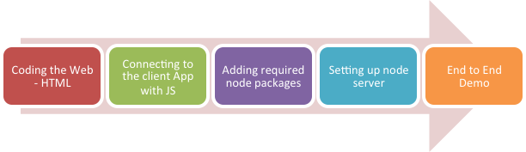

## TASK#1: Coding the Web – HTML

**Step 1:** Open ‘chapter05’ code provided in Visual Studio Code.

*#****Info****: ‘Chapter 5’ is a Business Network Scaffolding as in Chapter#4.*

*Additionally its has the following which we will build as a step by step process*

1. *‘html’ folder which contains all the frontend code*
2. *Updated ‘index.js’ file*
3. *Updated ‘pacakage.json’ file*
4. *‘router.js’ added in ‘client_app/controller’ folder*

**Step 2:** Open terminal window of Visual Studio code and type run the following command

npm install

**Step 3:** Cd into the ‘script’ folder and run ‘run.sh’ script to start the node server so that we can launch the frontend for a preview

cd script

./run.sh

The node server will startup and show the port + address where you can view the frontend html pages in the browser.

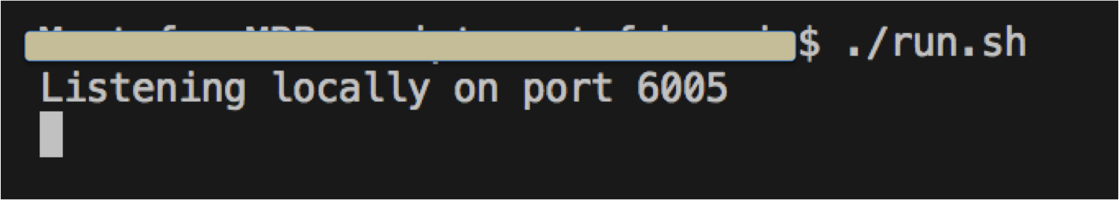

**Step 4:** Launch internet browser and type the URL as below with port number as displayed in previous step:



**URL:** localhost:6005

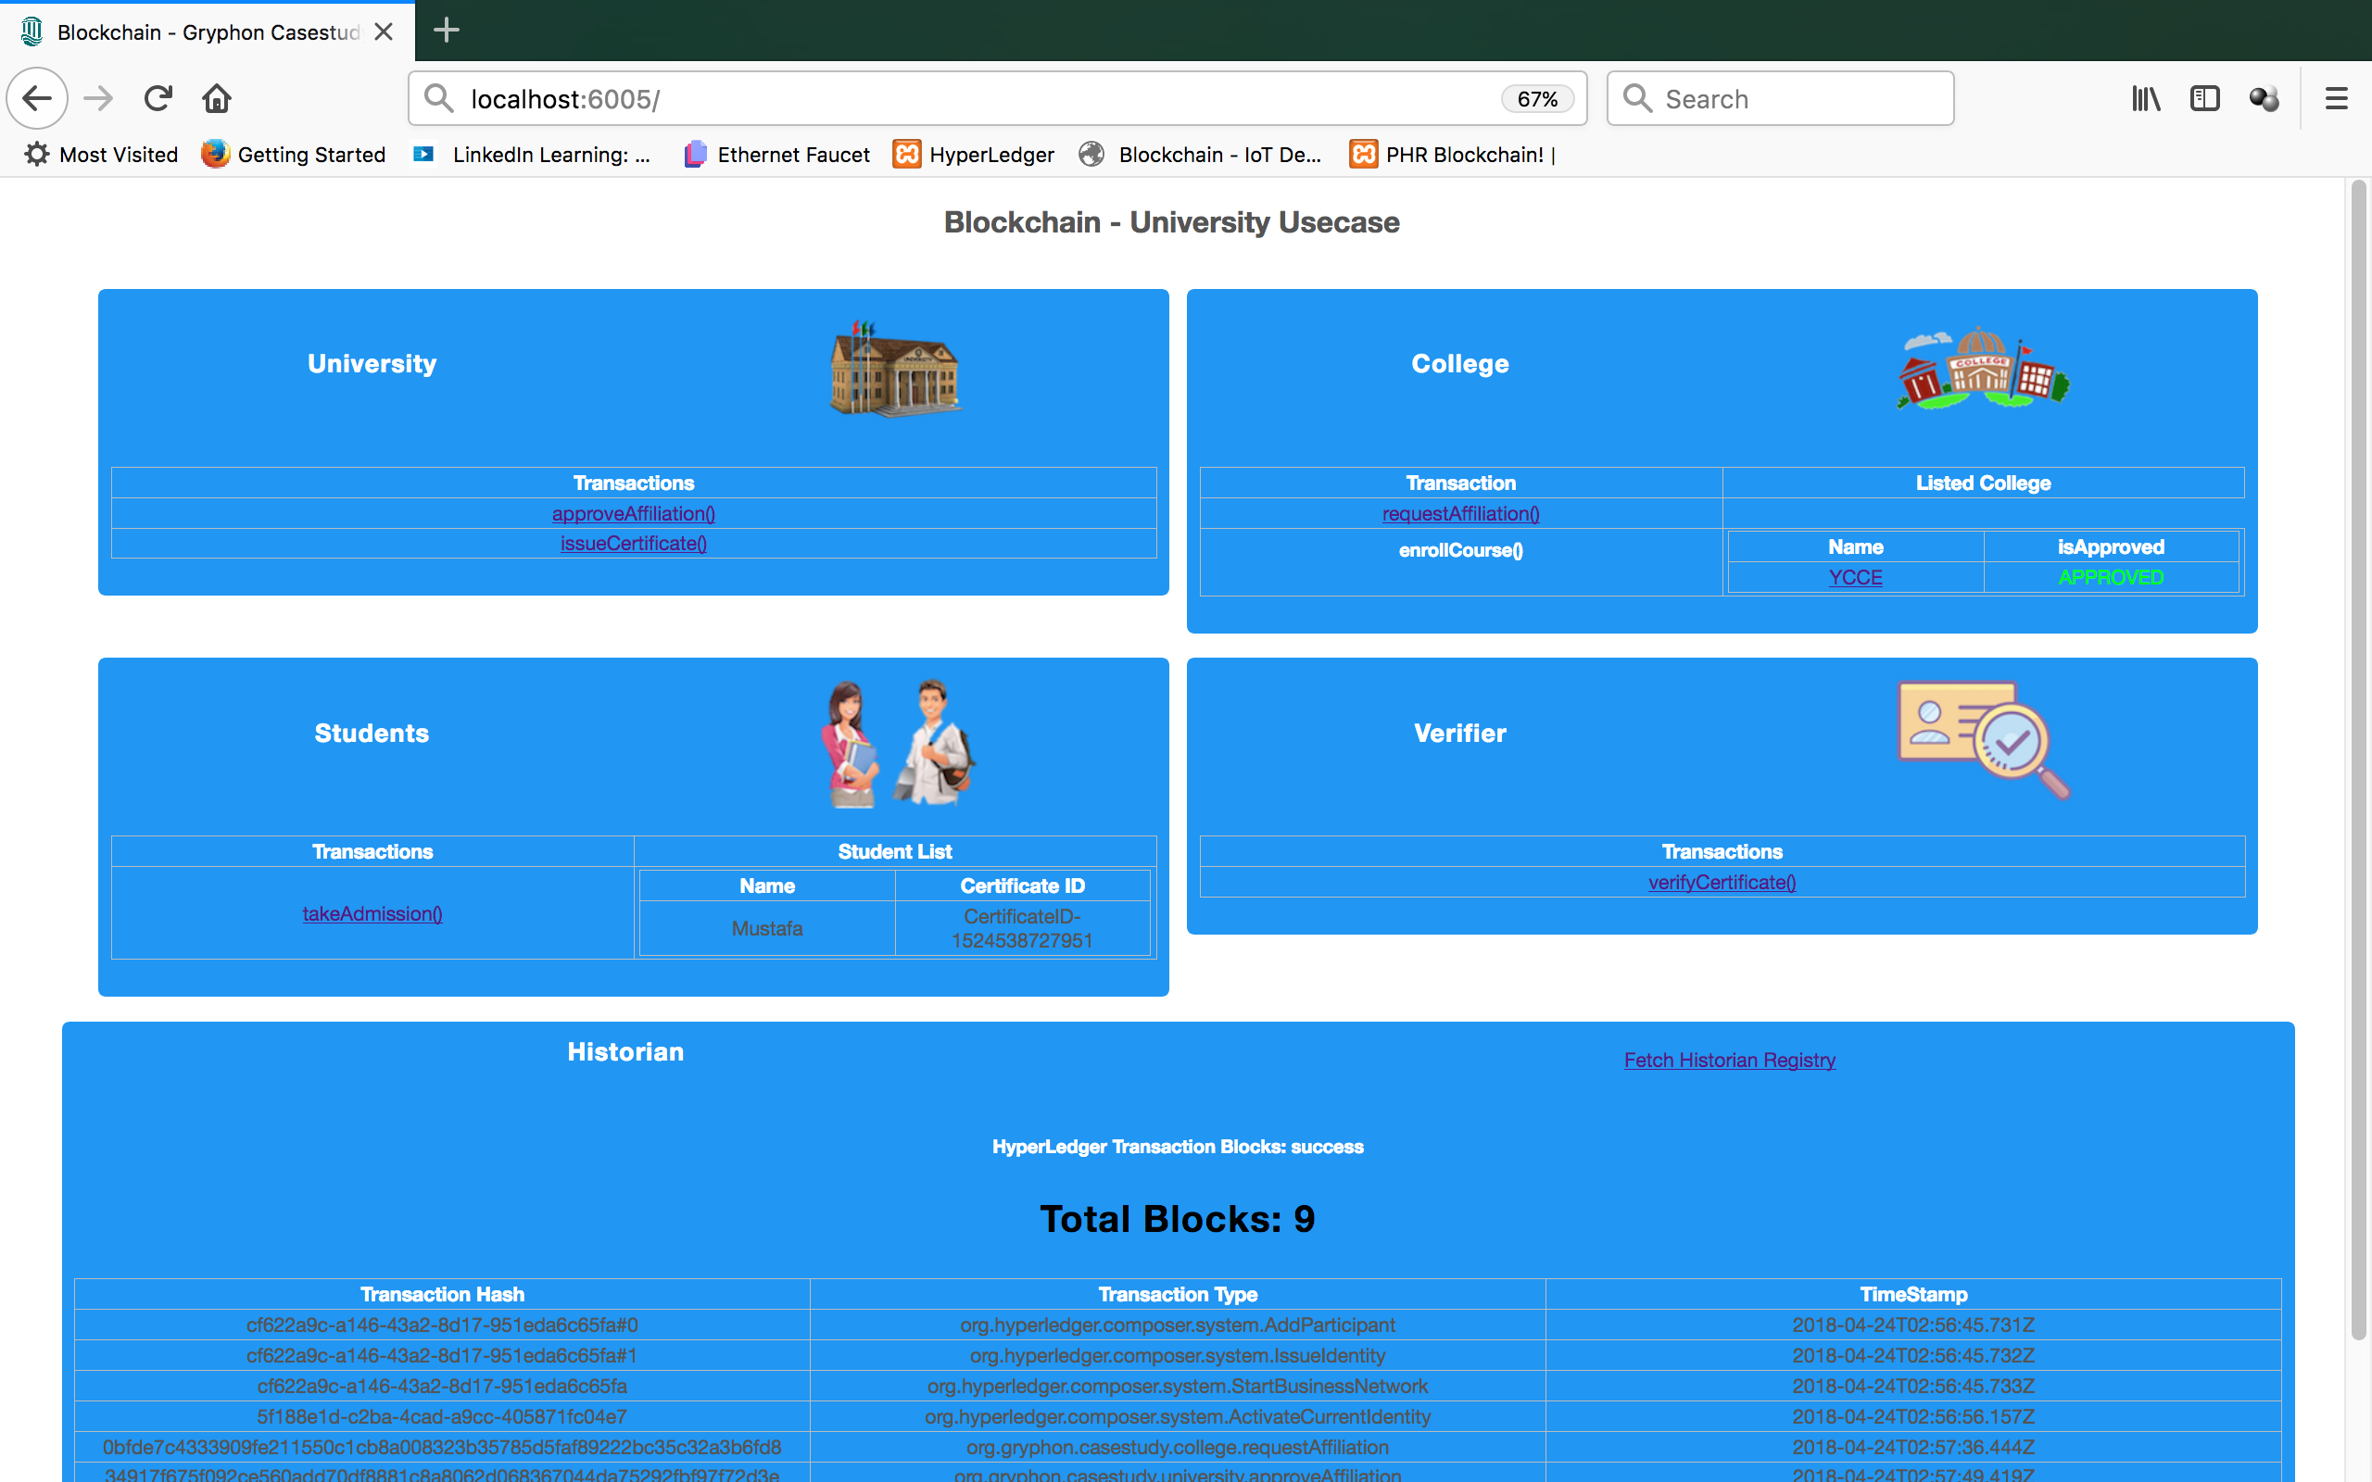

The UI has five sections, which we will build one by one:

* University Section with Two clickable links
* College Section with clickable actions and table to display college list
* Student Section with clickable actions and table to display student list
* Verifier Section with a clickable link (Transaction) action
* Historian Section that displays all the Blocks/Transactions that have occurred so far

Let’s build it step by step…



### TASK#1.1: Directory Structure CSS and Script includes

**Step 1**: Browse to directory ‘html’

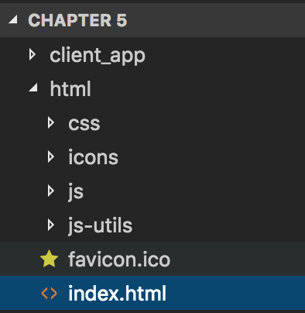

The ‘html’ folder has following contenst:

* Css folder:
  + Bootstrap CSS
  + Fonts CSS
  + Application CSS
* Icons:
  + Icons / Images used in our App Usecase
* Js:
  + Application JavaScript file: ‘event.js’
* Js-utils:
  + JavaScript files for the 3rd party libraries like jquery and bootstrap
* Favicon.ico: Default icon for the browser (near url)
* Index.html: Default and primary html file for the frontend

**Step 2**: Under ‘html’ folder open the file ‘index.html’



**Step 2**: Under ‘<head>’ section of the file ‘index.html’, lets include the css files we need for our UI

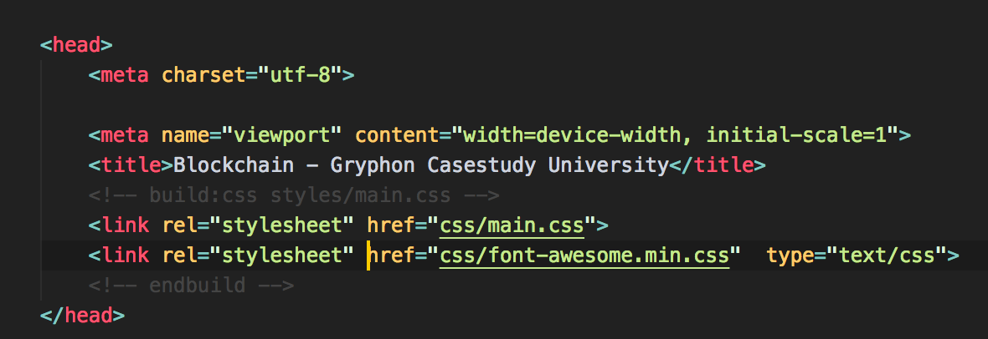

**Step 3**: Go to the End of the file ‘index.html’, and lets include the js files from both ‘js’ and ‘js-util’ folder

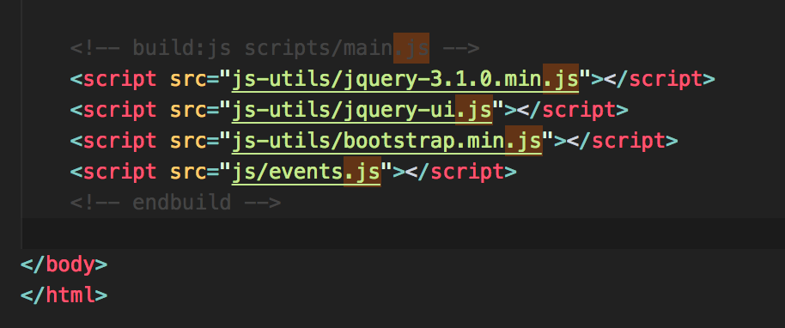

**Task 1.1 is complete!**



### TASK#1.2: Coding HTML for different sections

**Step 1**: Browse to directory ‘html’ and open file ‘index.html’. Look and code the university section

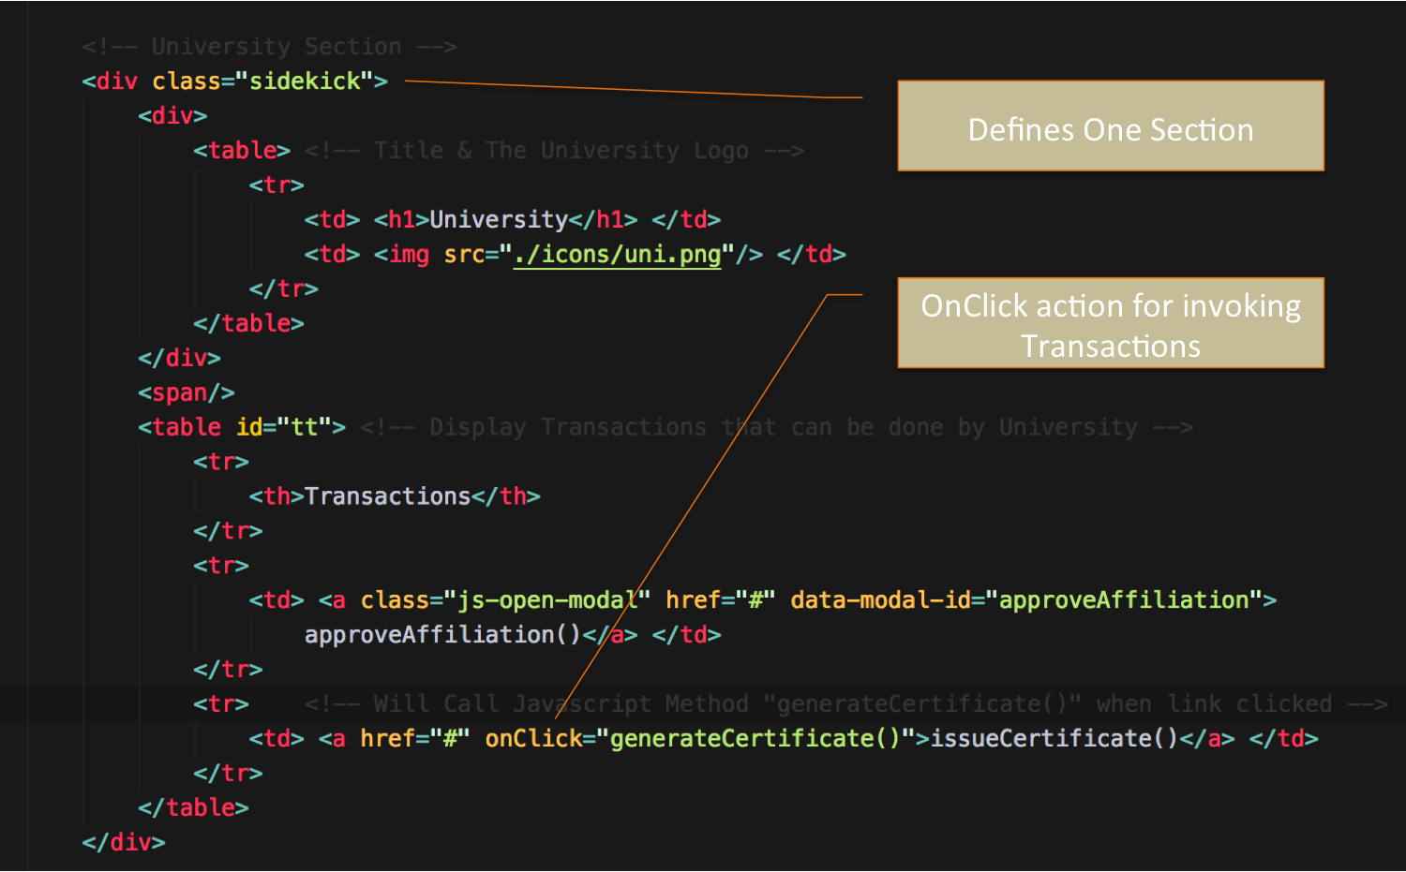



**Step 2**: Coding College Section

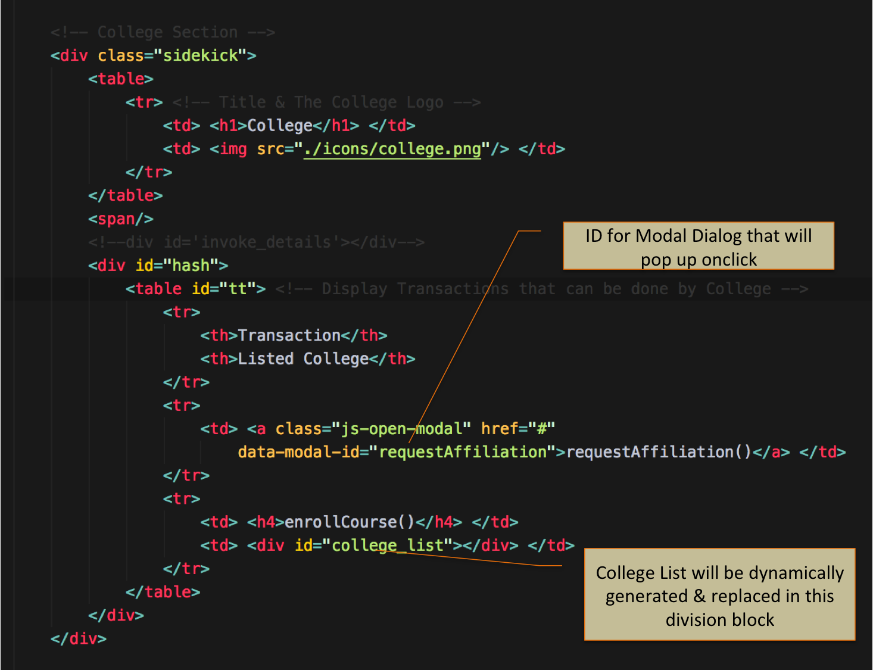



**Step 3**: Coding Student Section (Similar to College section with changes in Transaction function, images and corresponding texts)

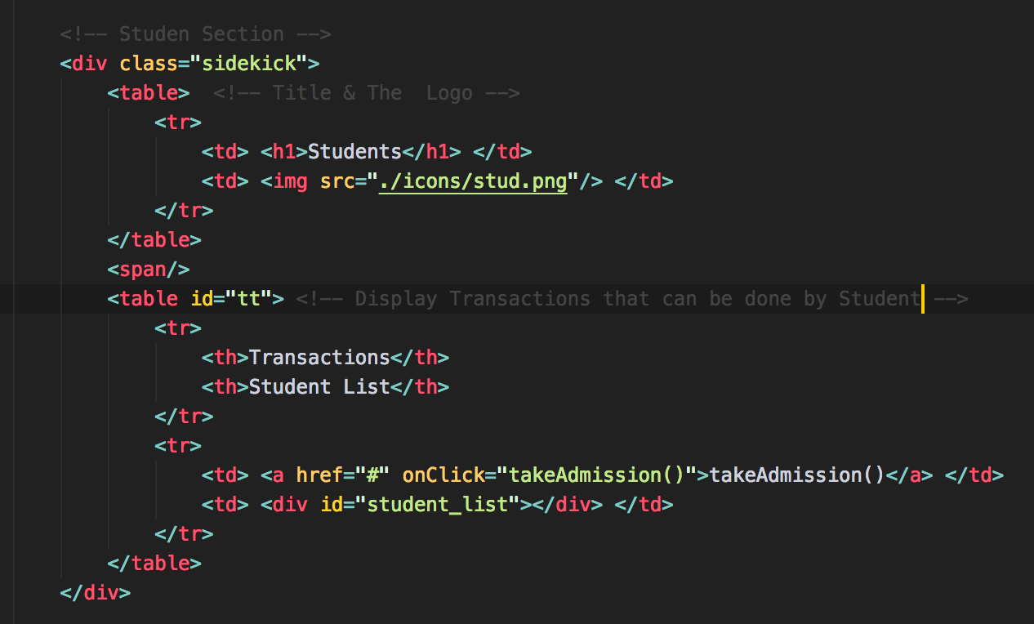

**Step 4**: Similarly code the verifier Section

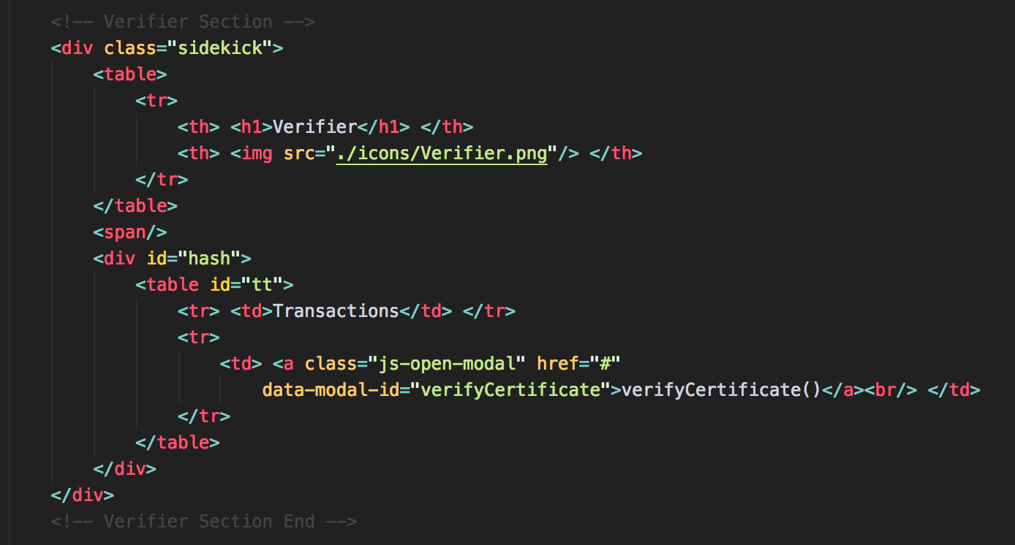



**Step 5**: Coding the Last section i.e Historian that has a link that invokes the javascript and returns the complete history table and that is displayed in the div section with name **id=“historian”**

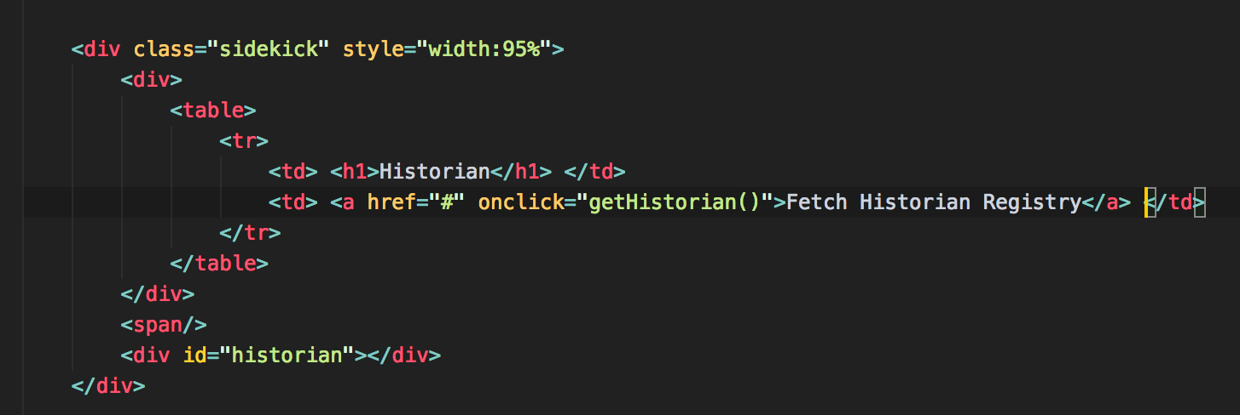

**Step 6**: Coding Modal Dialogs

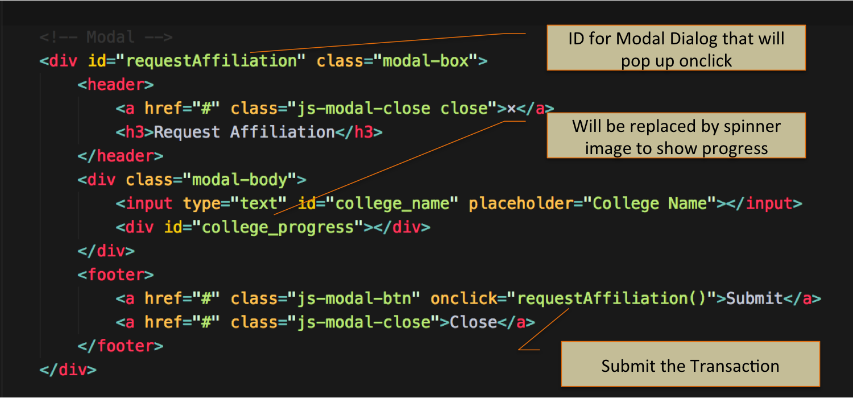

**Step 7**: Similarly coding for other Modal Dialogs

**Task 1 is complete!**

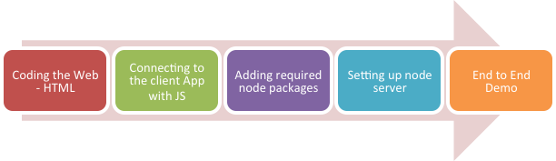

## TASK#2: Connecting the Frontend to call Client App

**Step 1:** Open ‘chapter05’ code provided in Visual Studio Code. Browse to the directory ‘html/js’ and open file ‘event.js’

**Step 2:** Let’s code the methods that we have declared with ‘OnClick’ in HTML file in Task#1.

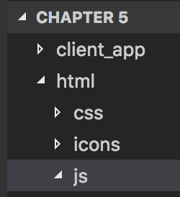

**Step 2:** Coding requestAffiliation() method that invokes the Client App rest api as below;

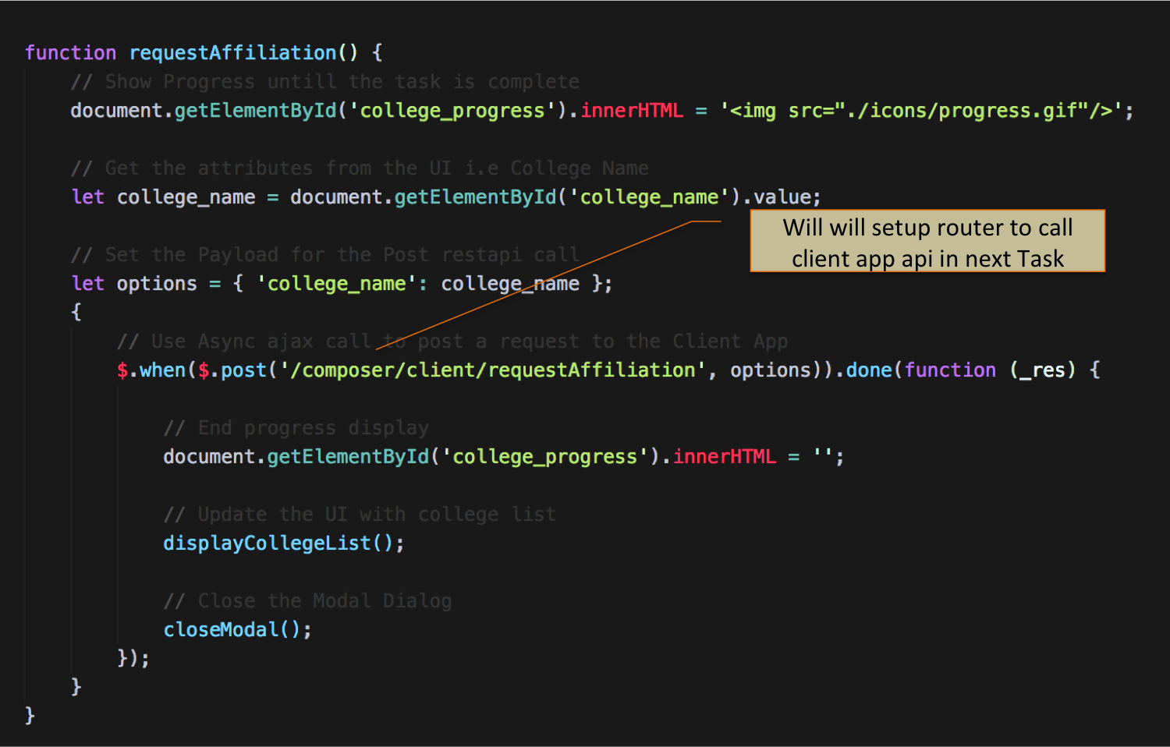



**Step 3:** Retrieving list of colleges from the client App and processing it to be displayed in HTML

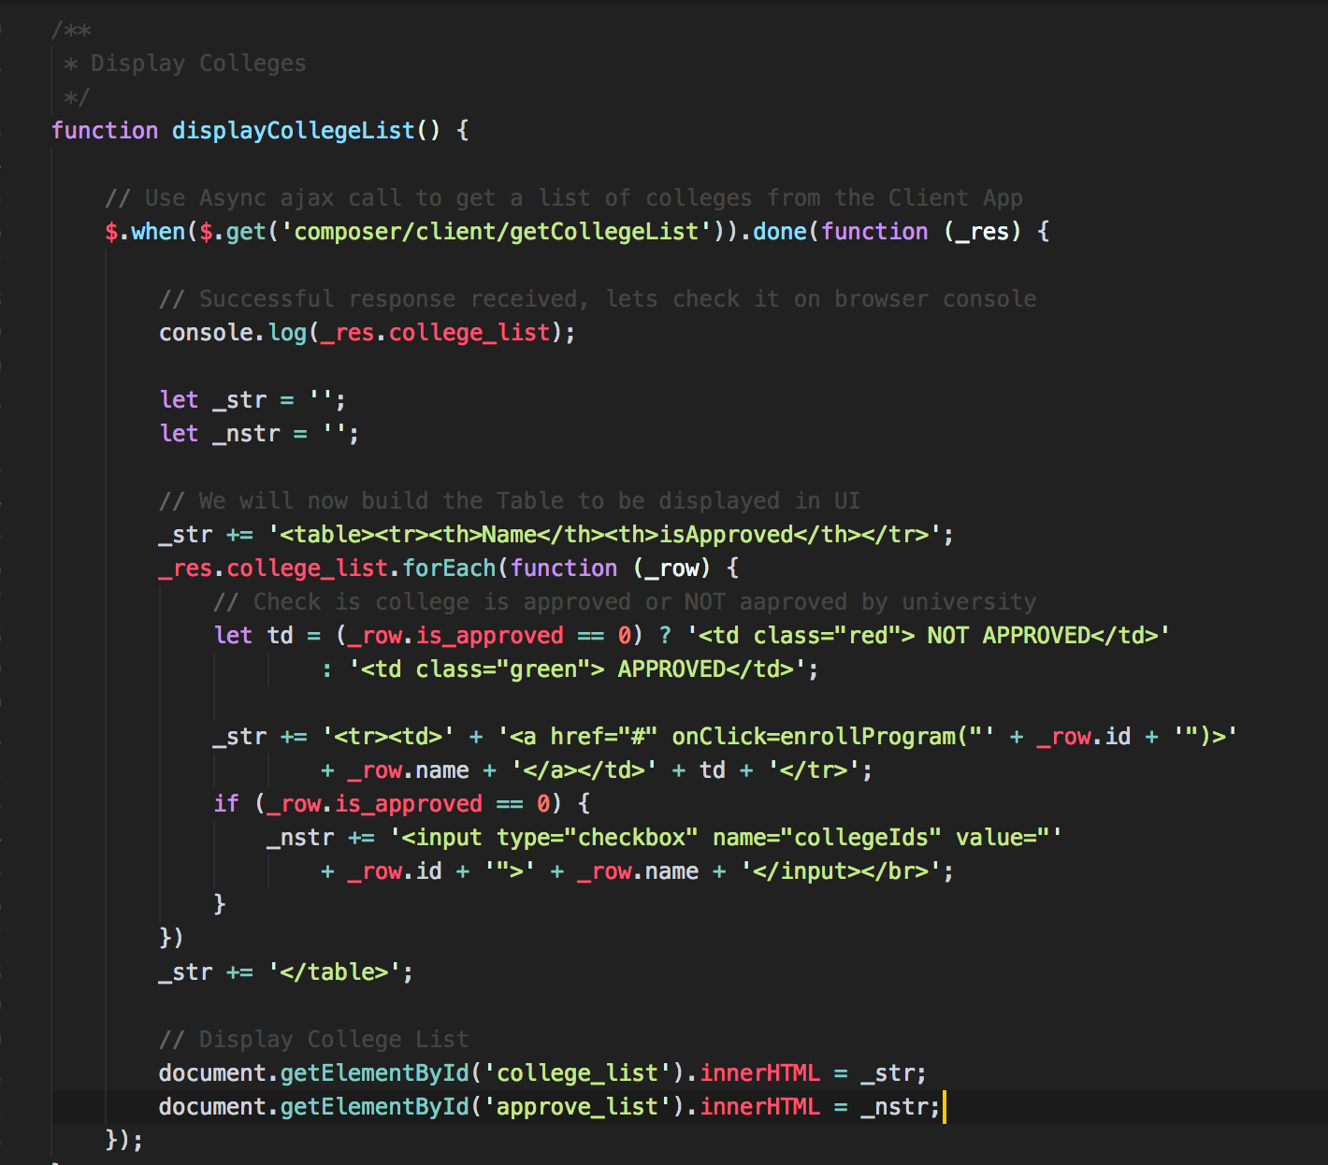

**Step 4:** Similarly we can code other methods to call the client App methods and process them to be displayed in HTML. Please visit ‘events.js’ for other methods.

**Task 2 is complete!**



## TASK#3: Adding dependency packages

**Step 1:** Open ‘chapter05’ code provided in Visual Studio Code. Browse to the open file ‘package.json’

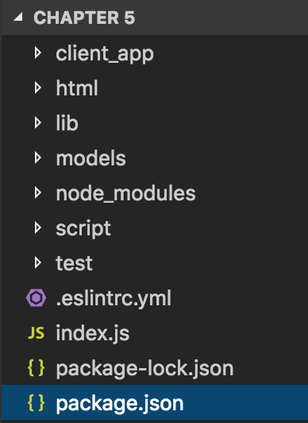

**Step 2:** Let’s add dependency packages that we will need for our nodejs server and routing the restapi calls

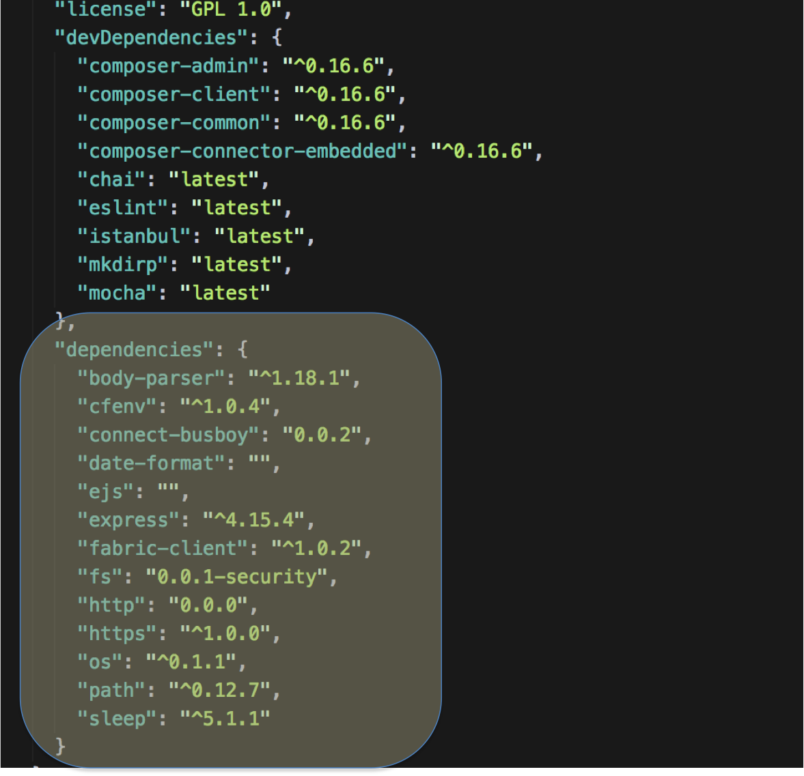



**Step 3:** Open terminal window of Visual Studio code and type run the following command

npm install

There might be some warnings but that is normal. Packages are now added to the system

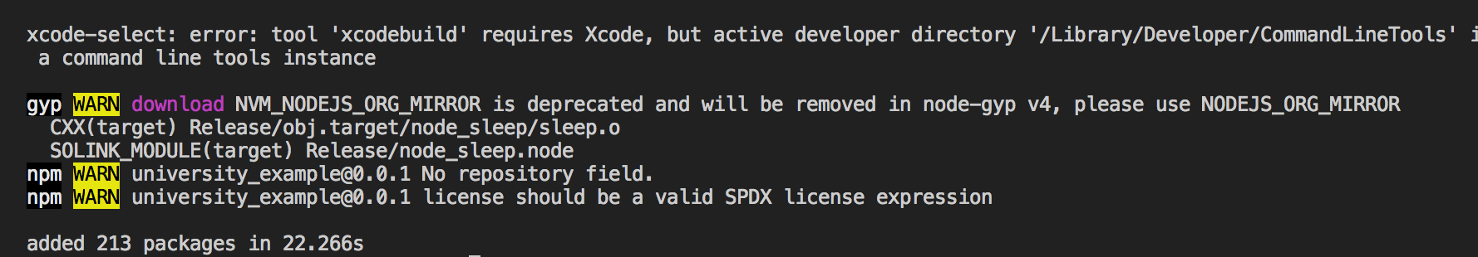

**Task 3 is complete!**



## TASK#4: Setting up the node server

**Step 1:** Open ‘chapter05’ code provided in Visual Studio Code. Browse to the open file ‘index.js’ in the main folder

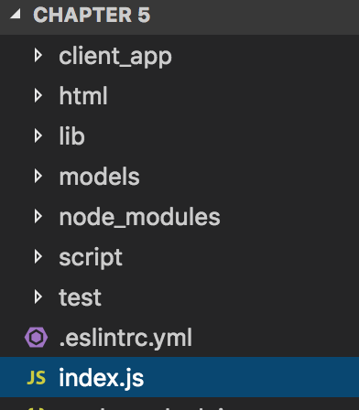

**Step 2:** Open ‘chapter05’ code provided in Visual Studio Code. Browse to the open file ‘index.js’ in the main folder

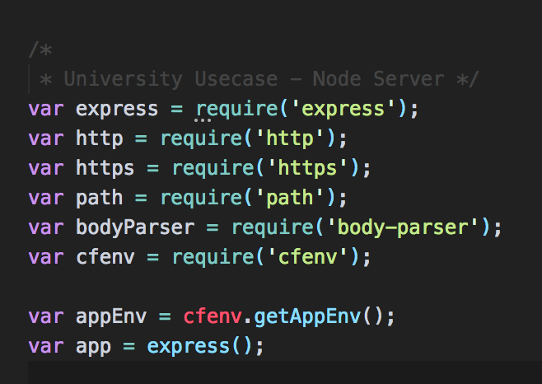

* Define required packages
* Setup the environment variable for selecting the right port



**Step 3:** Define where are the views, json parsing and application name for port registration

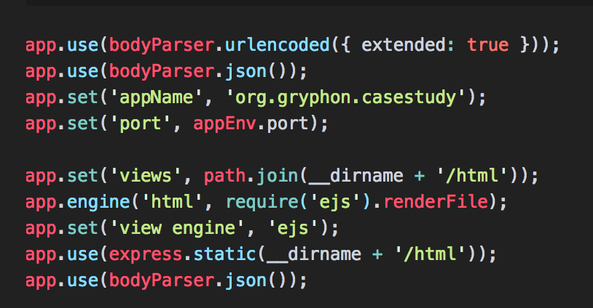

**Step 4:** Define restapi router and start listening to the port for rest api calls

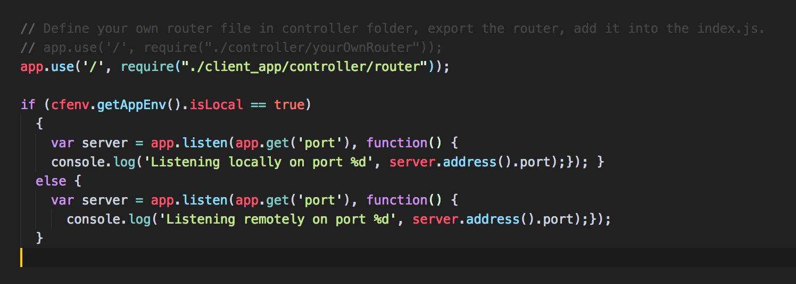

**Task 4 is complete!**



## TASK#5: Running the use-case End to End

**Step 1:** Open ‘chapter05’ code provided in Visual Studio Code. Open the terminal window and cd into the scripts folder

cd script

**Step 2:** Let’s completely build and deploy the blockchain application. Use the following script

./buildAndDeploy.sh

This will start the Hyperledger fabric, install the Business Network Application and created the Peer / Admin cards

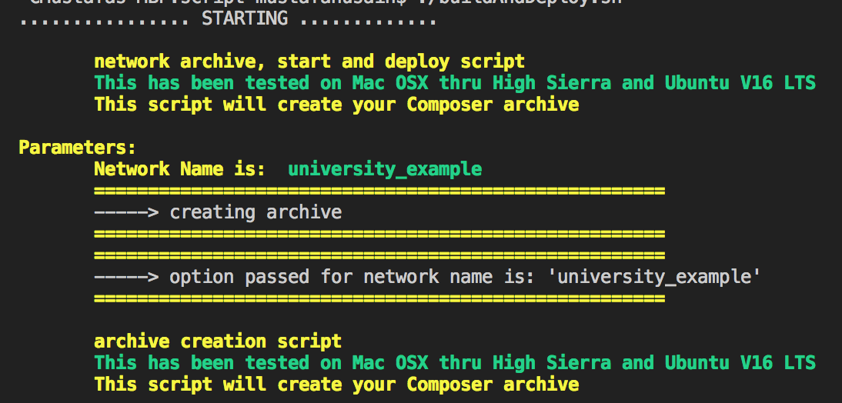

**Step 3:** Now let’s run the rest server using the following script

./run.sh

The node server will startup and show the port + address where you can view the frontend html pages in the browser.





**Step 4:** Launch Internet browser and type the URL as below with port number as displayed in previous step:

**URL:** localhost:6005 *(Use Port displayed on your screen)*

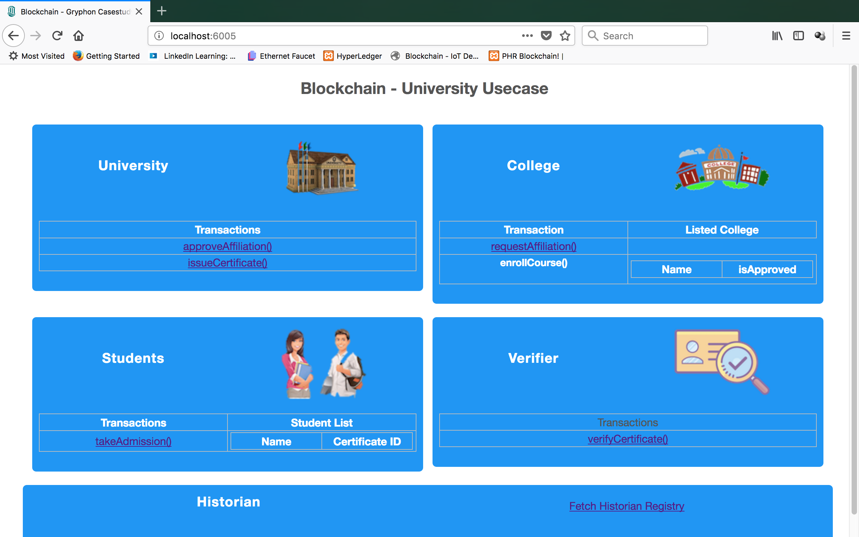

**Step 5:** Our use-case UI is ready for action, the sequence of order of transactions will be:

1. requestAffiliation() [ By College ]
2. approveAffliation() [ By University ]
3. enrollProgram() [ By College ]
4. takeAdmission() [ By Student ]



1. issueCertificate() [ By University ]
2. verifyCertificate() [ By Verifier ]
3. Finally we will check the transaction history using the Historian

Let’s execute the first transaction by clicking requestAffiliation() in College section.

**Step 6:** In the popup dialog enter any college name and click submit:

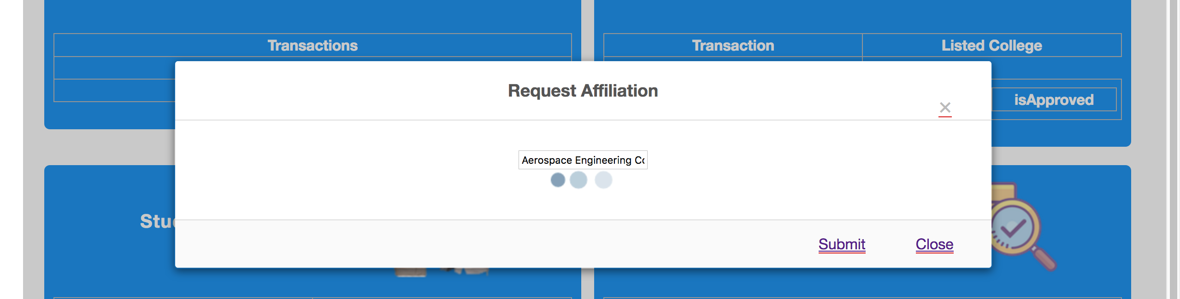

Progress image will show up and when transaction is complete, college will be listed in the College Section:

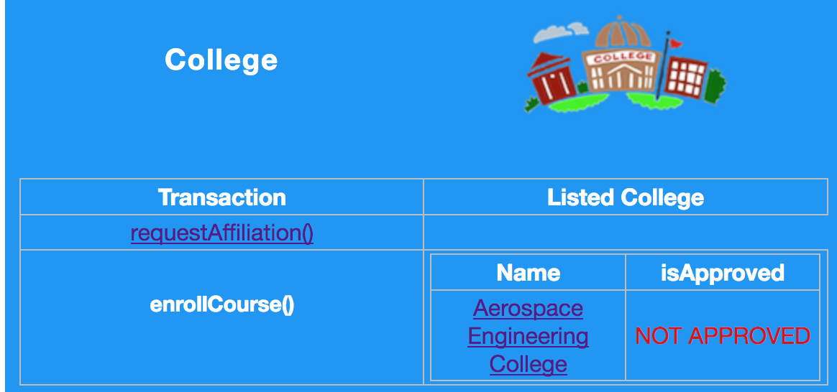



**Step 7:** Now from University Panel click on the approveAffiliation() link

**Step 8:** On the new popup dialog, select the college checkbox and click submit

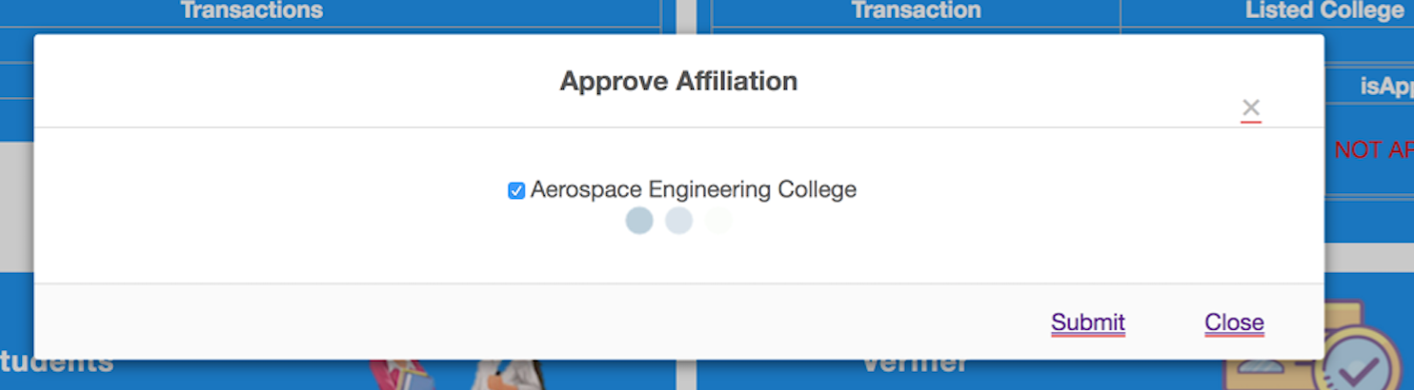

The college status should show up in green and as ‘Approved’

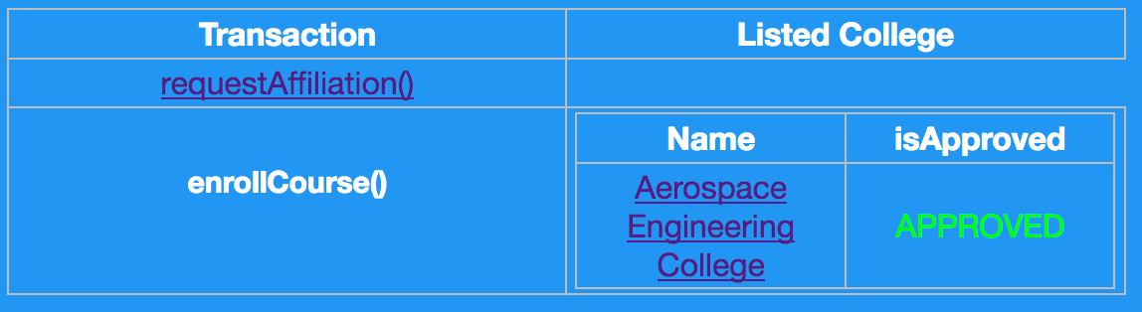

**Step 9:** Now college can start enrolling new programs. Click the college name to enroll program.

**Step 10:** A popup dialog asking for Program name should open up. Enter any name of the program and click submit

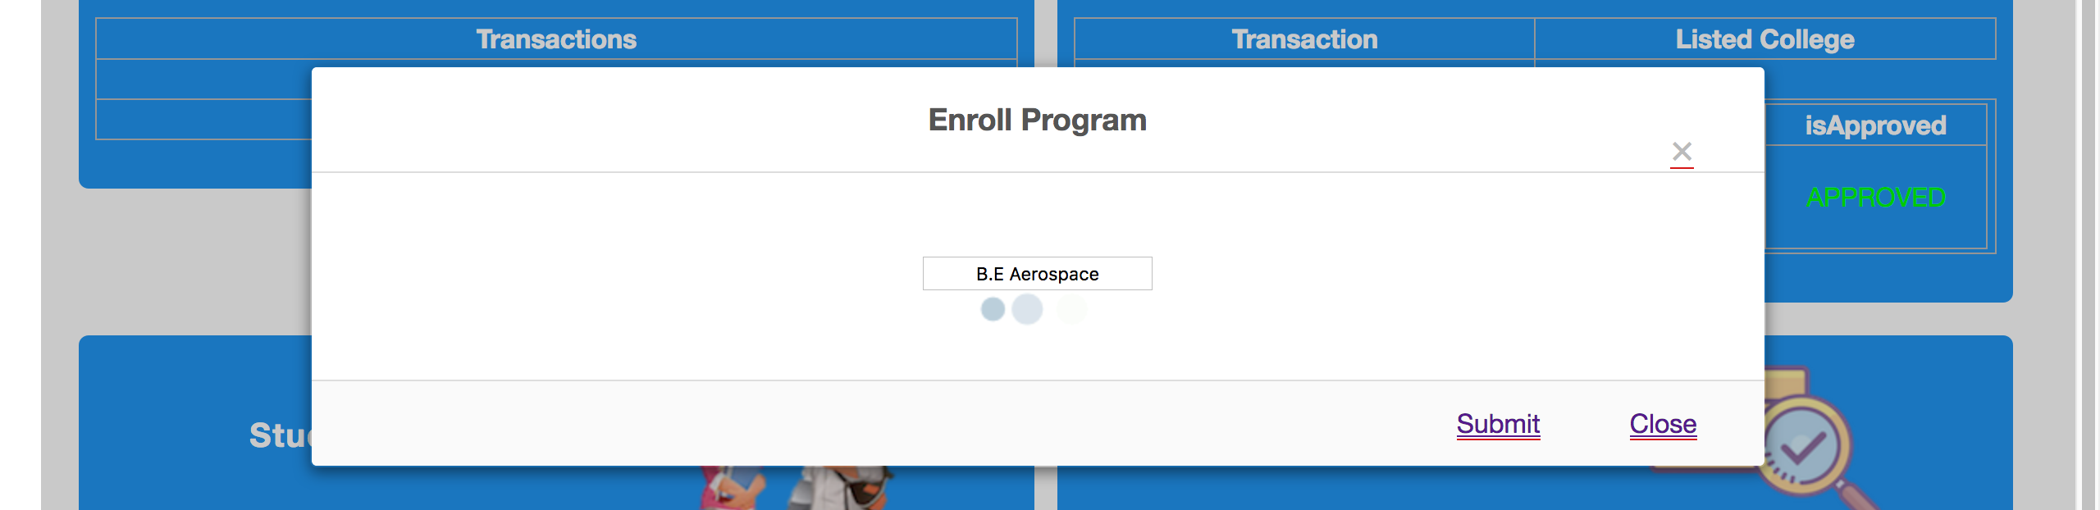



**Step 11:** Students can now take admission to the college for the respective programs offered by the college. Under Student section, click on takeAdmission() transaction link

**Step 12:** On the new opened dialog, enter the Student Name, date of birth and select appropriate college and program. Then click submit.

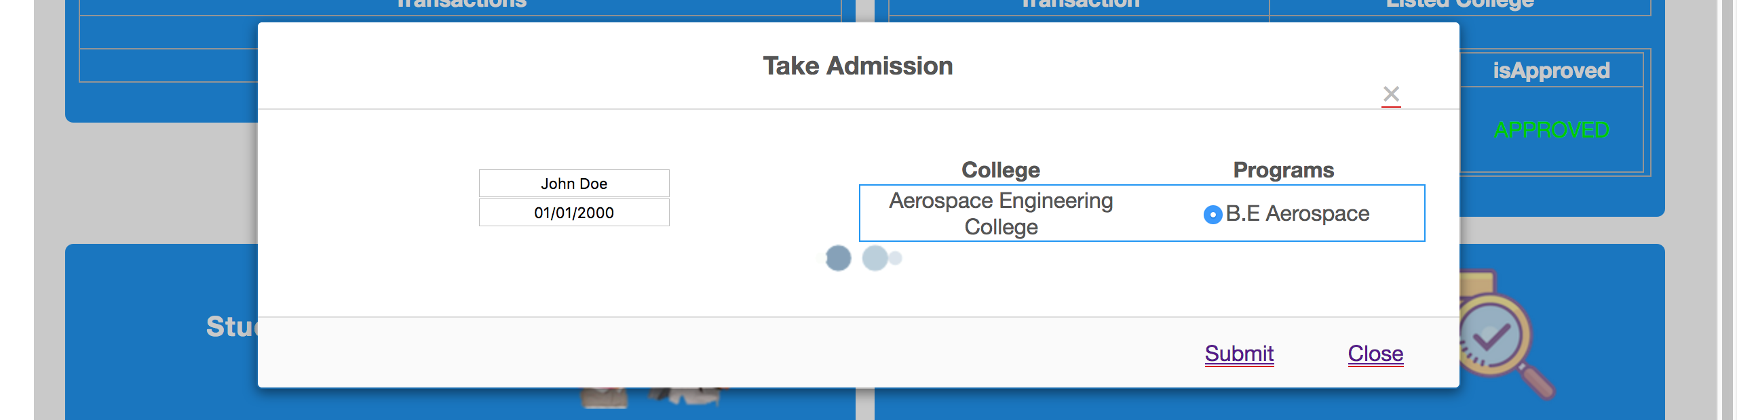

Student should be enrolled and student’s name starts showing up on the Student section

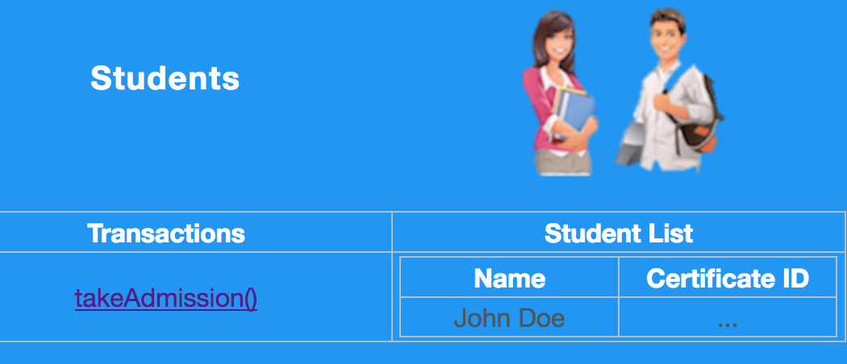

**Step 13:** Student has now completed the program and University will issue the certificate. Click on issueCertificate() under University section to generate the certificate for the student

**Step 14:** Select the student who has to be awarded the certificate and click submit



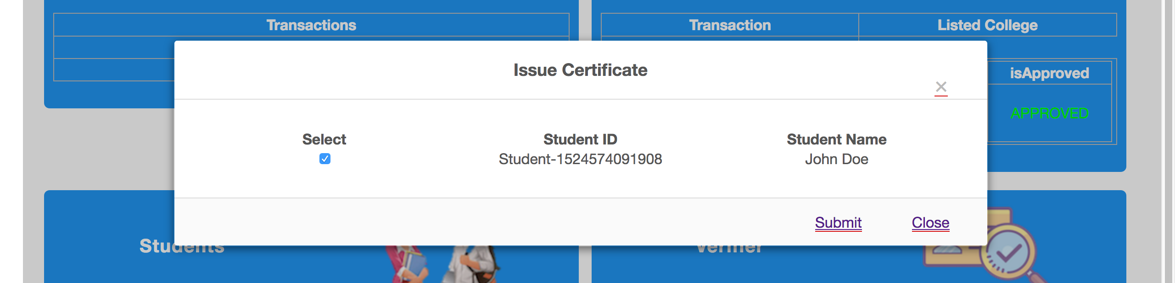

**Step 14:** Select the student who has to be awarded the certificate and click submit

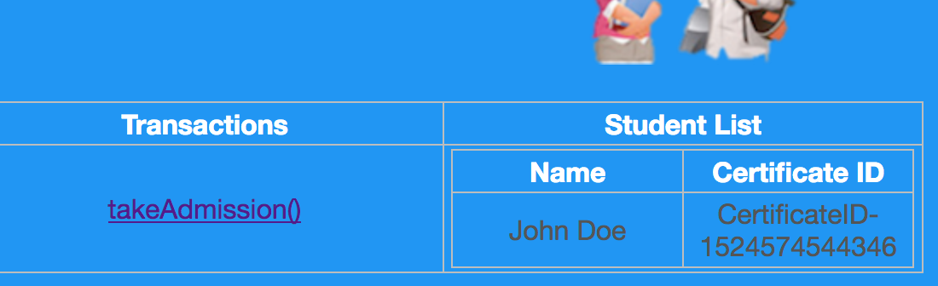

A certificate is generated and the Certificate unique ID is displayed against the student.

**Step 15:** Select the CertifcateID and copy it in clipboard. Now for verification click on verifyCertificate() under the verifier section.

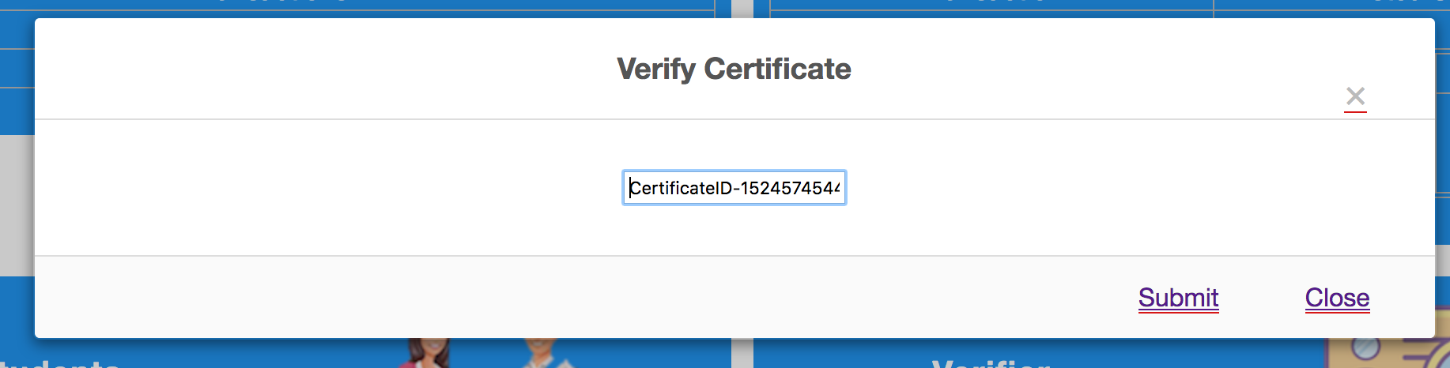



**Step 16:** Enter the generated certificate ID on the new window and click submit.



Certificate of completion of the program will be displayed. The Asset is now in blockchain, secured and uniquely identifies the student’s authentic academics.

**Step 17:** Blockchain represent an un-mutable set of transactions. To check what transactions have occurred on the blockchain and validate the authenticity of the transaction that created the certificate we can view the Historian – i.e the transaction log.



**Step 18:** To view the Historian, click on the ‘Fetch Historian Registry’ link in the bottom section.

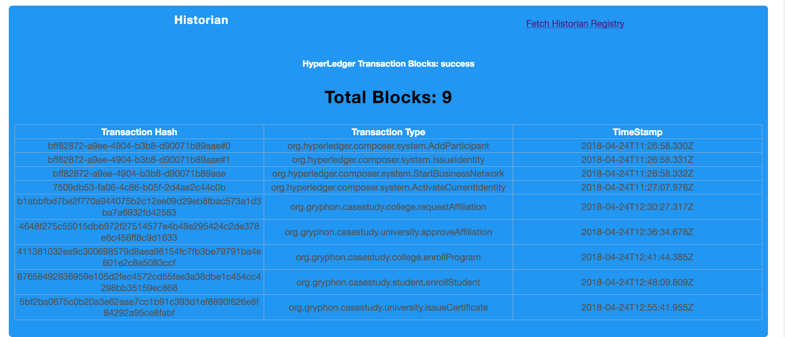

Complete list of transaction with their unique ID and time are displayed.

**Task 5 is complete!**

# SUMMARY

End to End use-case for Hyperledger is now ready for demo! Students are encouraged to play around with the UI and the functionality defined here and better it.

Please be aware that this is just for learning and many corner test-cases have not been considered.

Further to this there are few advanced topics that we shall cover in our next chapters like:

* Securing the Rest Server
* Adding Organizations & Creating the channels

In this chapter we have learnt the following:

* Developing Interactive frontend for Hyperledger
* Bridging the UI with client App using javascript calls
* Setting up node server and routing rest-api calls to call the client app
* Invoking Client App API

# CHAPTER 6: Exploring Blockchain

## Theory

In this chapter we will use Hyperledger Fabric provided sample application and a “Hyperledger Explorer” application to dig deeper and view the working & internals of Hyperledger in action;

* Multiple Organization & Peers
* Transactions & Actual Blocks of the blockchain
* Channel that is created for communication

## Hyperledger Fabric Blockchain Creation Workflow

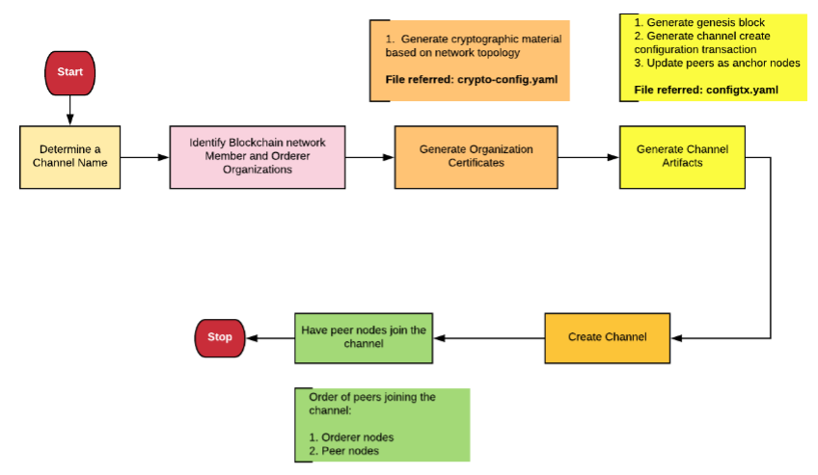

Using the Hyperledger Fabric example, we will

* Create a channel
* Identify the members, orderer
* Generate cryptographic material
* Join the network
* Explore the network

# Lab Exercise 6: Exploring Hyperledger

|  |
| --- |
|  |

1. Download & Setup Fabric Sample BYFN
2. Download fabric Samples
3. Download Docker Images & crypto gen path setup
4. Generate Crypto & launch network
5. Creating the Orgs, Solo Orderer, Peers and the channel (mychannel)
6. Adding Peers to the Channel
7. Identifying the Anchor peers for each org
8. Installation and Instantiation of Chaincode on the peers
9. Querying chaincode
10. Invoking transactions
11. Download & Setup Hyperledger Explorer
12. Download Explorer
13. Install Posgre SQL
14. Configure Postgre SQL
15. Run Tests & Build React App
16. Run the explorer
17. View Artifacts

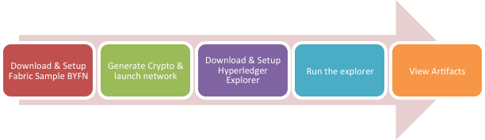

## TASK#1: Download & Setup Fabric Sample - BYFN

**Step 1:** Launch internet browser and type the URL as below:

[*https://github.com/hyperledger/fabric-samples*](https://github.com/hyperledger/fabric-samples)

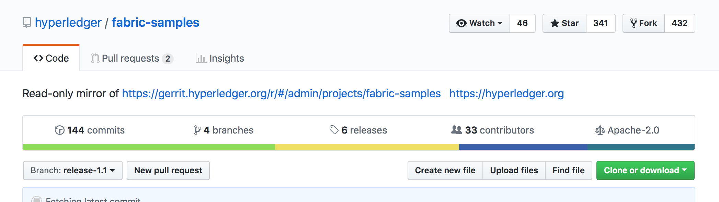

**Step 2:** Using the ‘clone or download’ button in green, download the fabric-samples code.

**Step 3:** Unzip the file just downloaded.

**Step 4:** Open the terminal window and CD into the unzip folder directory

cd Download/fabric-samples-release-1.1/ first-network

**Step 5:** Execute the following command from within the directory into which you will extract the platform-specific binaries:

curl -sSL https://goo.gl/6wtTN5 | bash -s 1.1.0

The command above downloads and executes a bash script that will download and extract all of the platform-specific binaries you will need to set up your network and place then in the **bin subdirectory**



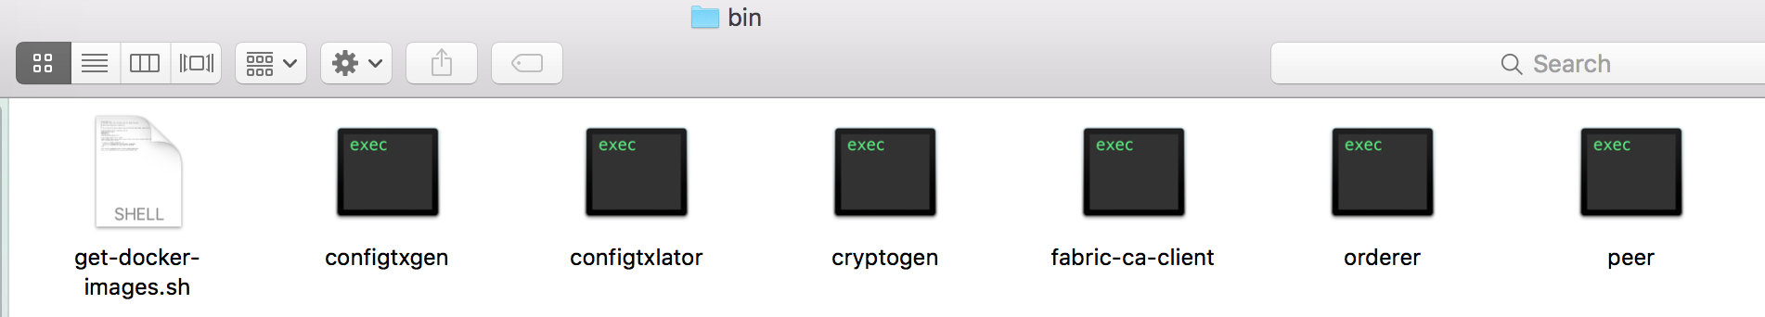

**Step 6:** Add that to your PATH environment variable so that these can be picked up without fully qualifying the path to each binary

export PATH=<path to download location>/bin:$PATH

At this stage we will have all the docker images required for our sample network downloaded, crypto binaries will be available in ‘bin’ folder and appropriate path is setup for our next step.

**Task 1 is complete!**



## TASK#2: Generate Crypto Material & launch network

**Step 1**: Using the same above terminal where we have setup path for our binaries we will use it to generate crypto materials

Now, move to the directory “first-network”:

cd fabric-samples/first-network

**Step 2**: Generate crypto materials using the following command:

./byfn -m generate

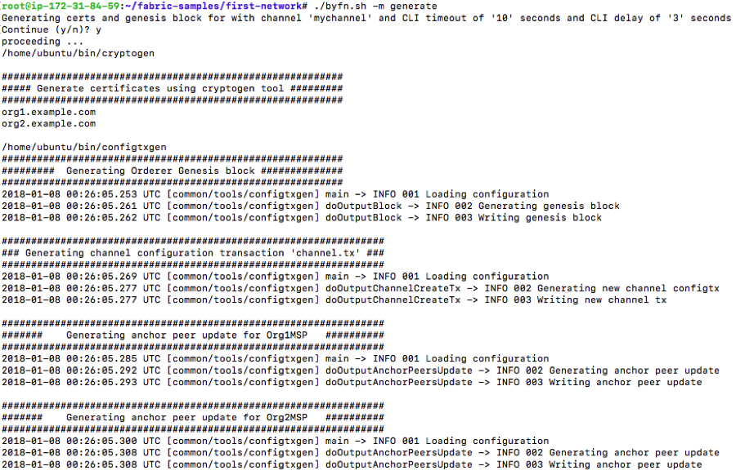



This command will add the ‘crypto-config’ directory to the “first-network” folder

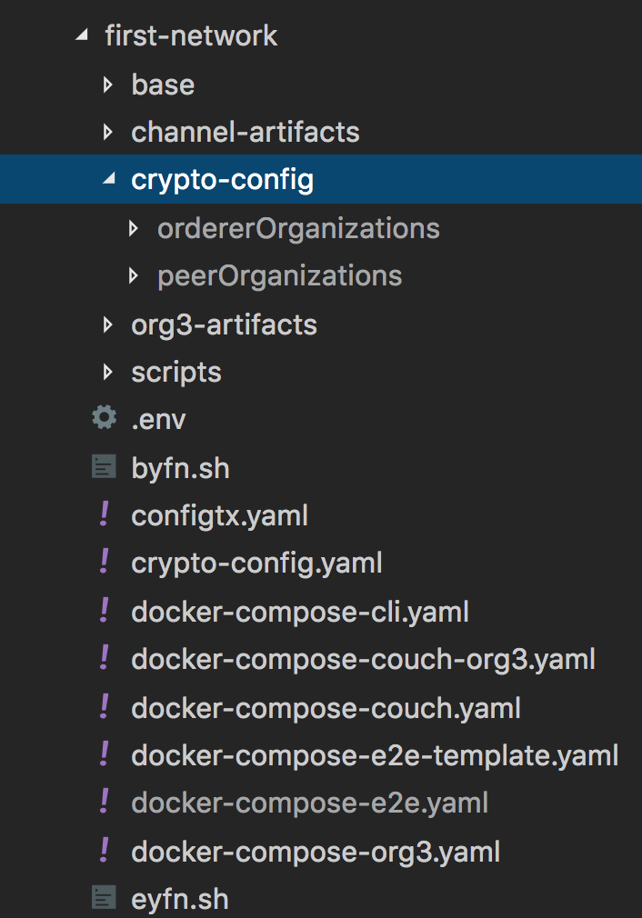

**Step 3**: Now, bring up the “first-network” and run the following commands:

./byfn -m up



**Understanding what went under the hood:**

Creating the Orgs, Solo Orderer, Peers and the channel (mychannel)

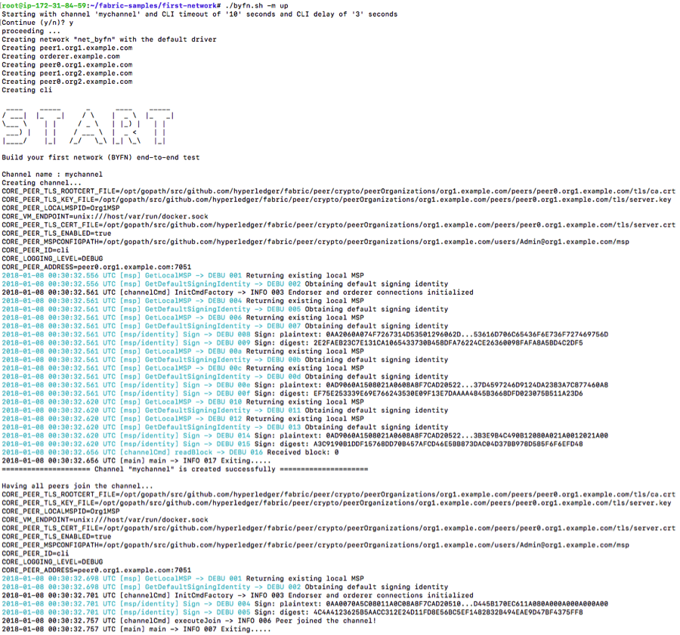



Adding Peers to the Channel

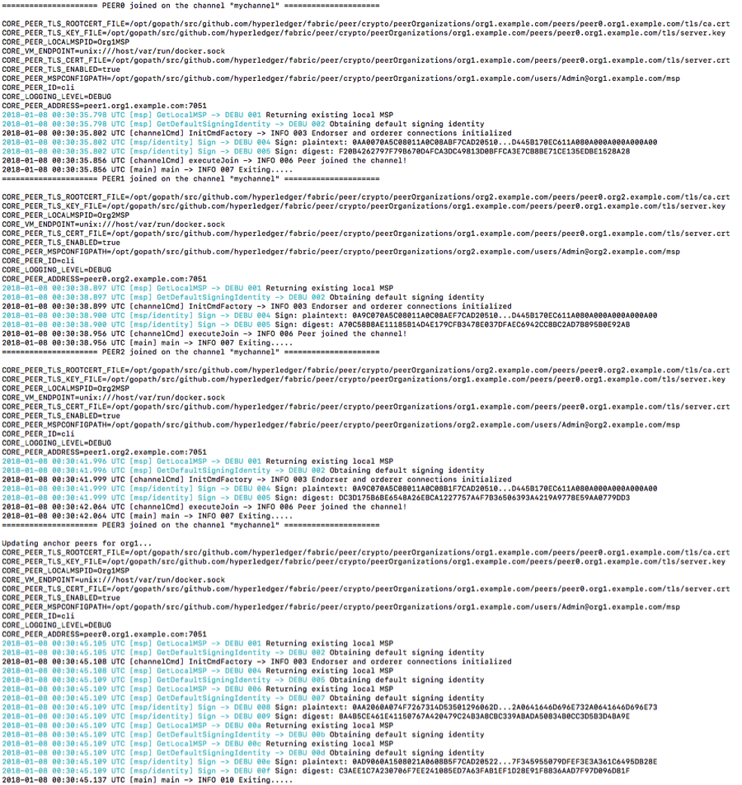



Identifying the Anchor peers for each org

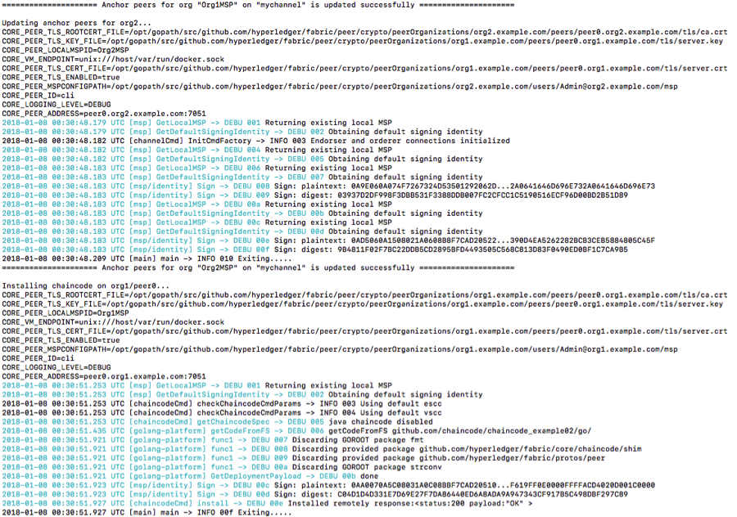



Installation and Instantiation of Chaincode on the peers

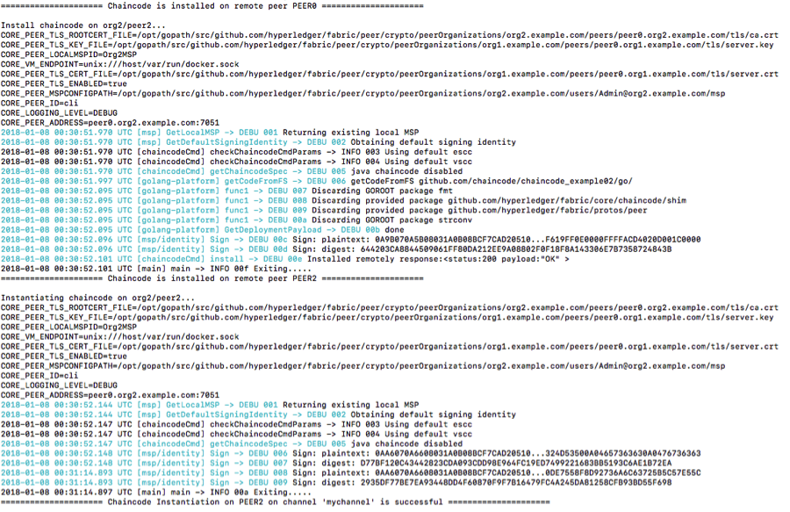

Querying chaincode



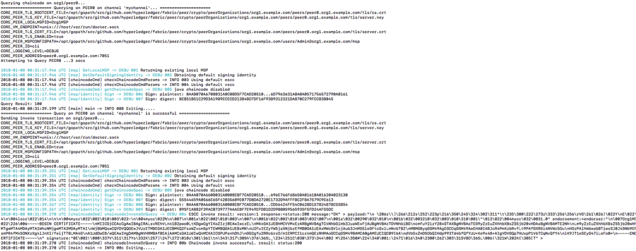

Invoking transactions

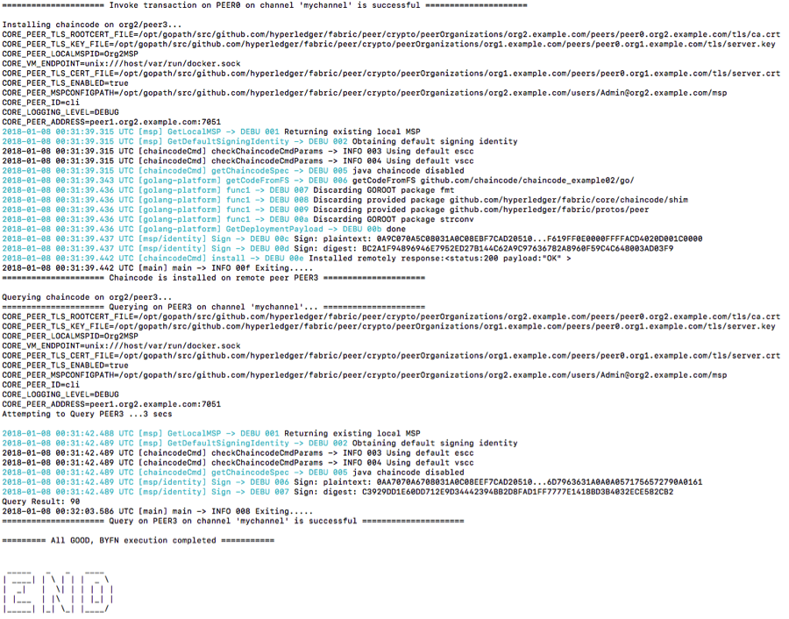

**Task 2 is complete!**

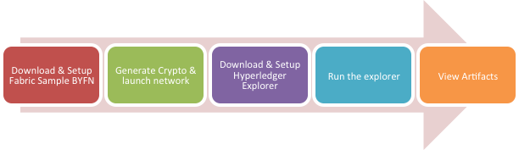

## TASK#3: Setup Hyperledger Explorer

**Step 1:** Open new terminal window and enter the following commands:

sudo apt-get update

sudo apt-get install postgresql postgresql-contrib

Above commands will install postgresql to the system

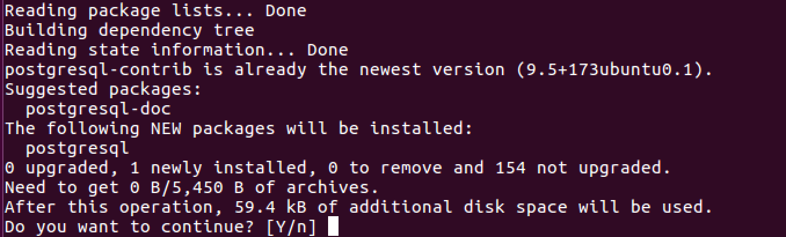

** Please Note: On Mac – download the Postgre Installable Binary and install it.

**Step 2:** Launch internet browser and type the URL as below:

[*https://github.com/hyperledger/blockchain-explorer*](https://github.com/hyperledger/blockchain-explorer)



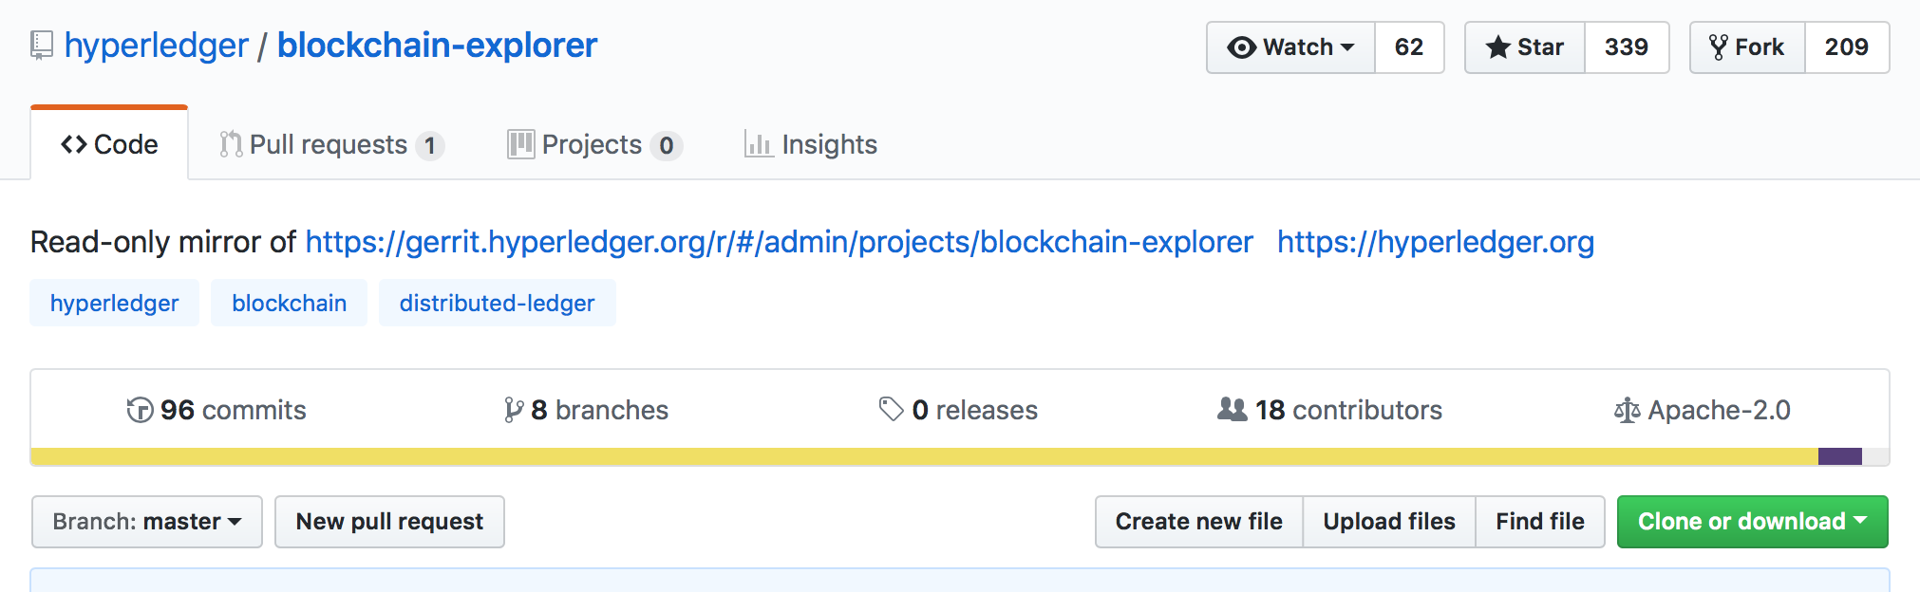

**Step 3:** Using the ‘clone or download’ button in green, download the blockchain-explorer.

**Step 4:** Unzip the file just downloaded.

**Step 5:** Open the terminal window and CD into the unzip folder directory

cd blockchain-explorer

**Step 6:** Execute the following command from within the blockchain-explorer: to connect to the postgresql database server

sudo -u postgres psql

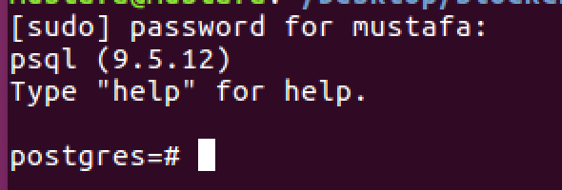

You will be logged in to postgres db with postgres command prompt



**Step 7:** Execute the following command to run create database script

\i app/db/explorerpg.sql

and

\i app/db/updatepg.sql

This will create the entire required database for the explorer application

**Step 8:** To validate the db is created successfully Run db status commands as below;

\l

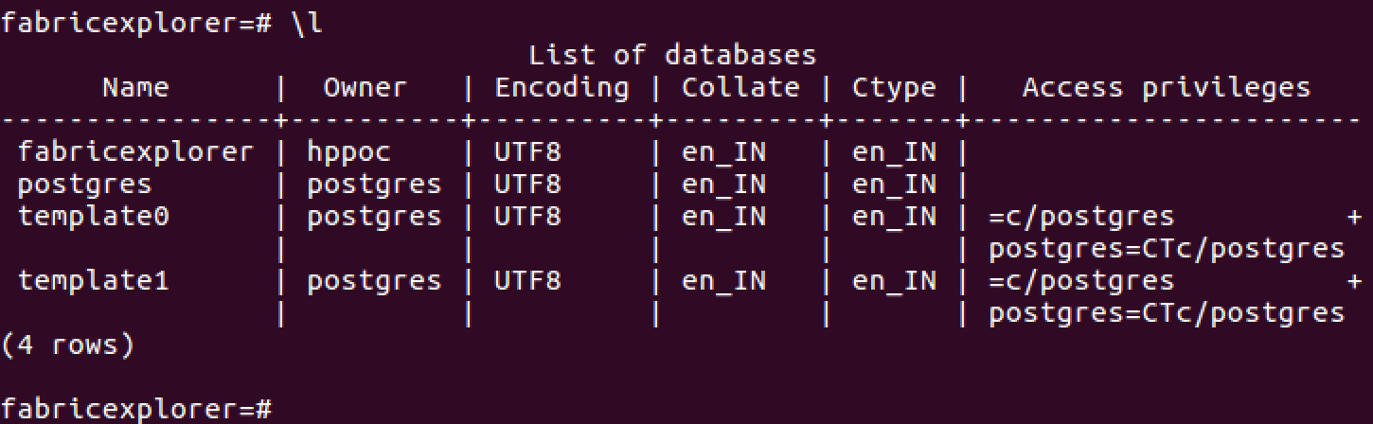

Also run the following command to view created tables

\d



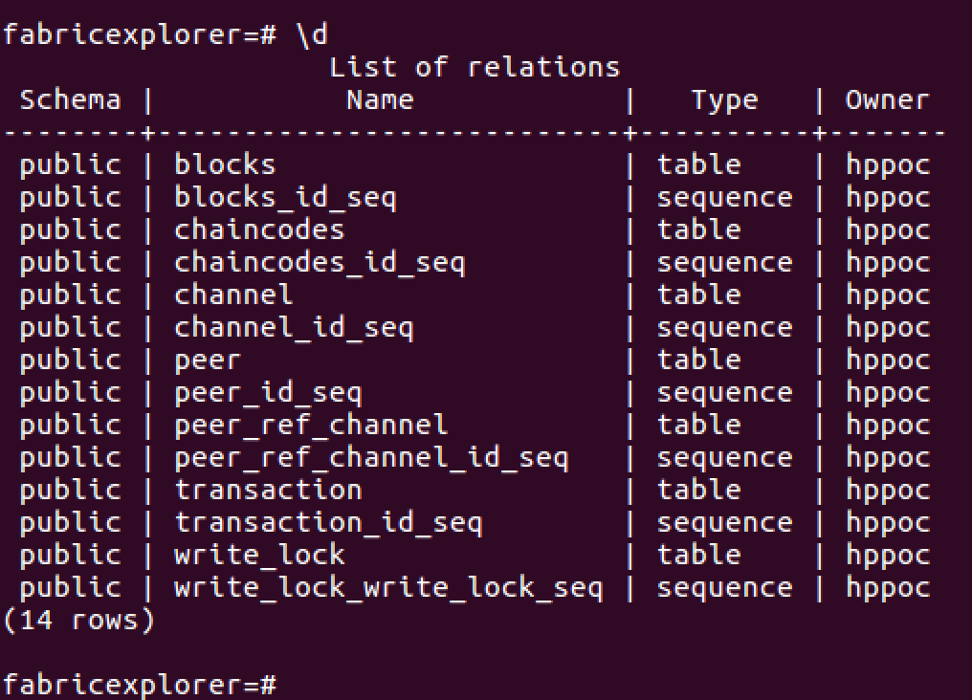

**Step 8:** Open Visual Studio code application and open the file “***config.json***” under “blockchain-explorer” directory

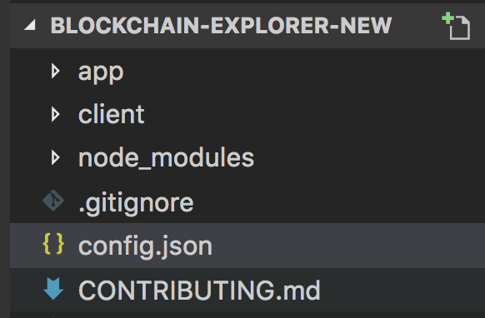

**Step 9:** Edit the path to “crypto-config” directory

Modify config.json to update network-config.



* Change "fabric-path" to your fabric network path, example: "/home/user1/Download/fabric-samples" for the following keys: "tls_cacerts", "key", "cert".
* Final path for key "tls_cacerts" will be: "/home/user1/ Download /fabric-samples/first-network/crypto-config/peerOrganizations/org1.example.com/peers/peer0.org1.example.com/tls/ca.crt".
* Similiarly replace all "fabric-path" to reflect the actual path on your system

**Task 3 is complete!**



## TASK#4: Build & Run the Explorer

**Step 1:** Open new terminal window and cd into the “blockchain-explorer” directory where the explorer code is

cd blockchain-explorer

**Step 2:** Run npm install in the main explorer folder

npm install

**Step 3:** Cd into the app/test folder

cd app/test

**Step 4:** Again run npm install now in the app/test folder

npm install

**Step 5:** Now cd into the client folder

cd ../../client/

**Step 6:** Again run npm install now in the client folder

npm install



**Step 7:** Finally run the test and coverage to verify things are OK

npm install npm test -- -u --coverage

**Step 8:** Everything is now set to run build and create production react explorer app

npm run build

**Step 9:** Once the build is done; cd back to main directory

cd ..

**Step 10:** Time to run the explorer App

./start.sh

This will start the Hyperledger Blockchain explorer – nodejs server

**Step 10:** Launch Internet explorer and type the following URL:

[*http://localhost:8080/*](http://localhost:8080/)

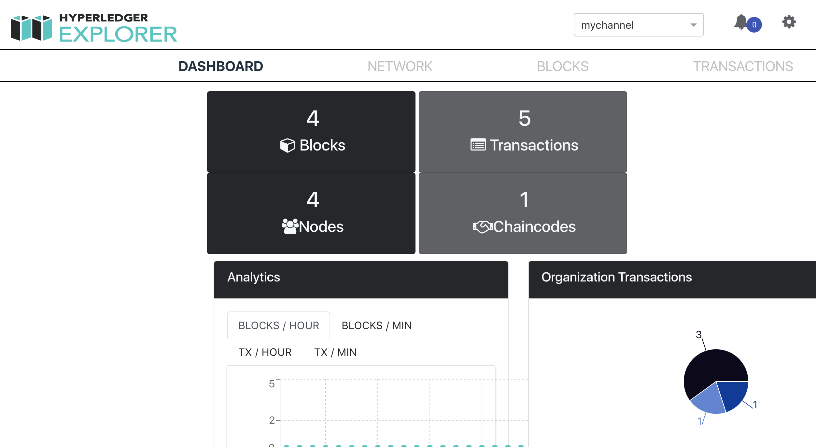

**Task 4 is complete!**



## TASK#5: Exploring the explorer…

**Step 1**: Hyperledger Explorer Dashboard

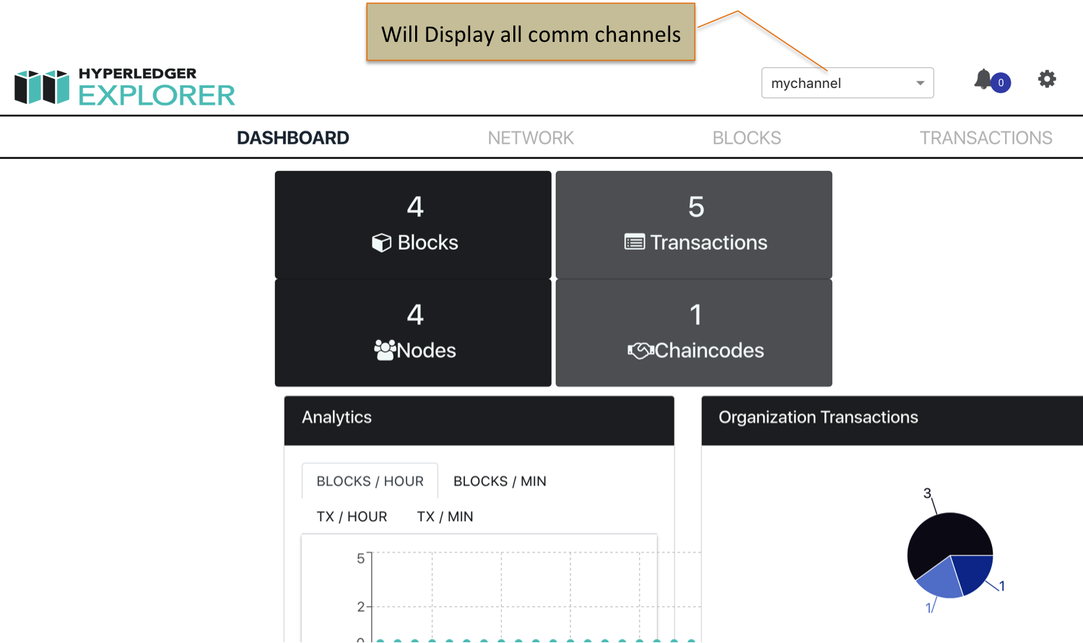

You can also create new channels using ./byfn.sh script and check the transaction and new channel updated here.

**Step 2**: Observe the Organization Graph section:

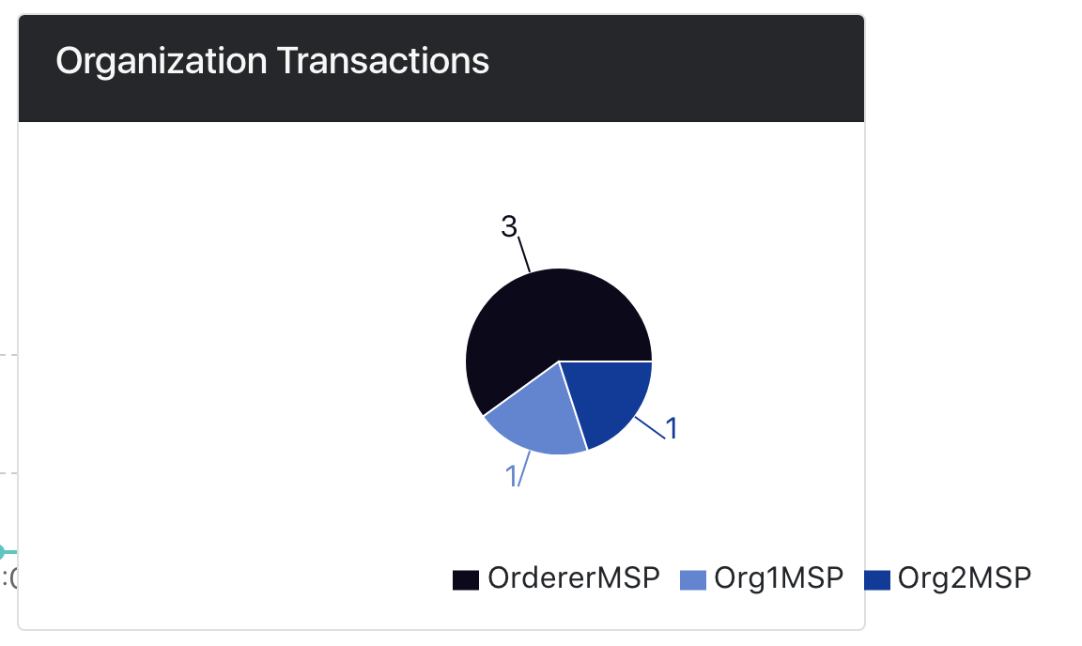



The graph shows that our network is having 2 organizations and three orderer service.

**Step 3**: Scroll Down to the PeerGraph section:

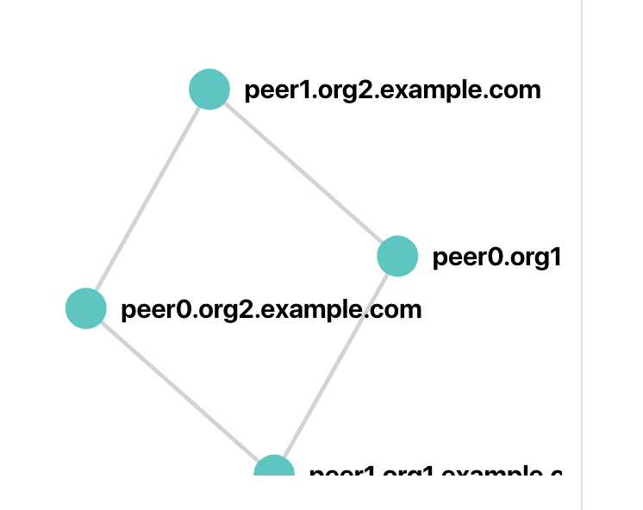

Its shows that we have two organizations and each org has 2 peers (peer0 & peer1)

This can be validated from the Task #2 logs

**Step 3**: Click on the Network Tab of the main menu

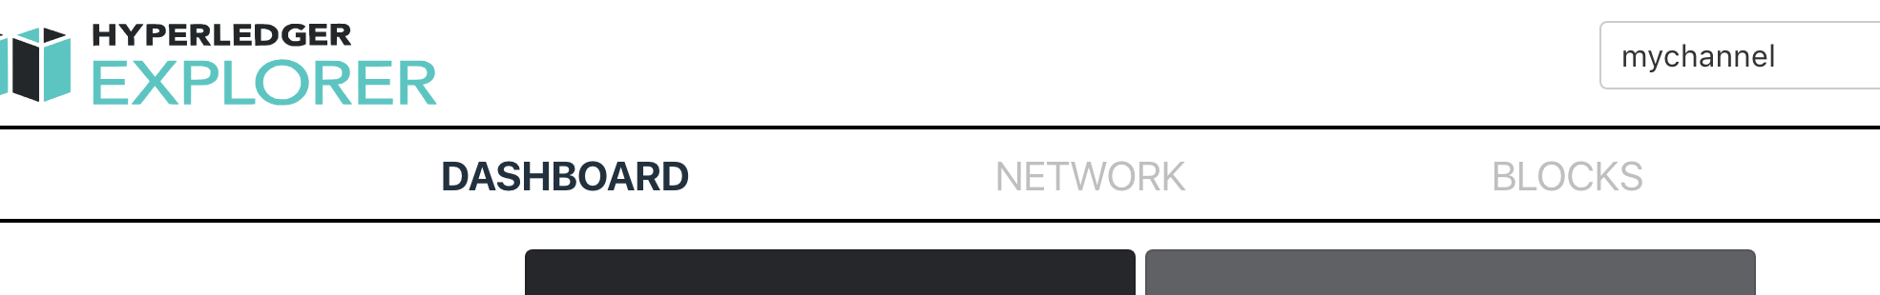

This Validates the step#2 about 4 peers



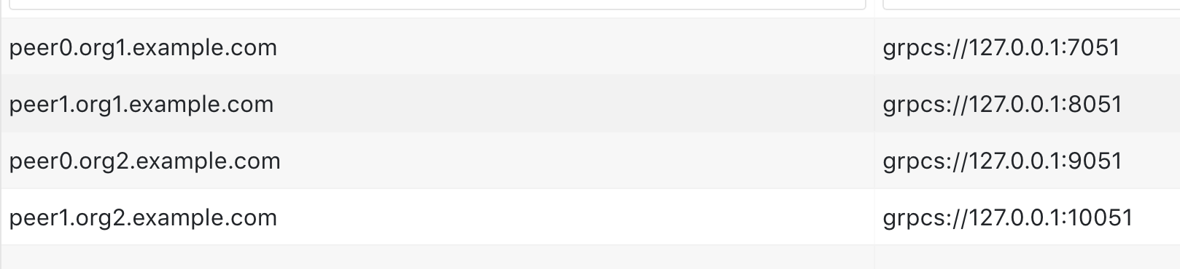

**Step 4**: Click on the BLOCKS Tab of the main menu

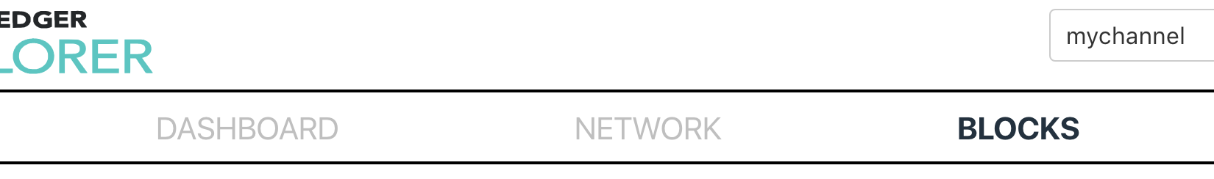

This Tab shows all the blocks generated till now for all the transactions that have been done so far – with current and prev hash

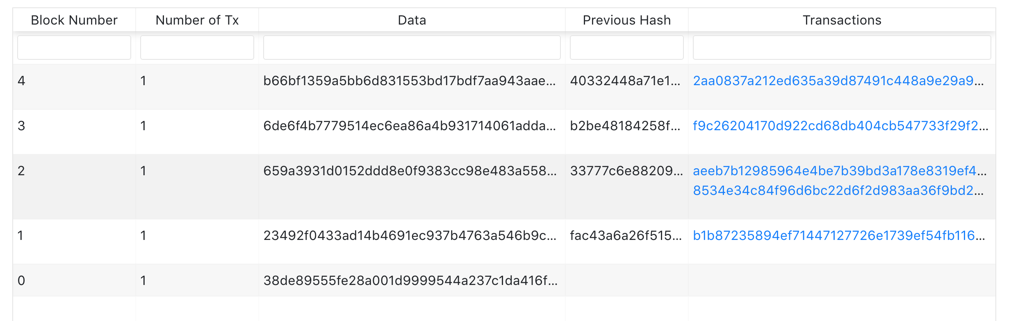

**Step 4**: Finally click on the TRANSACTIONS Tab of the main menu



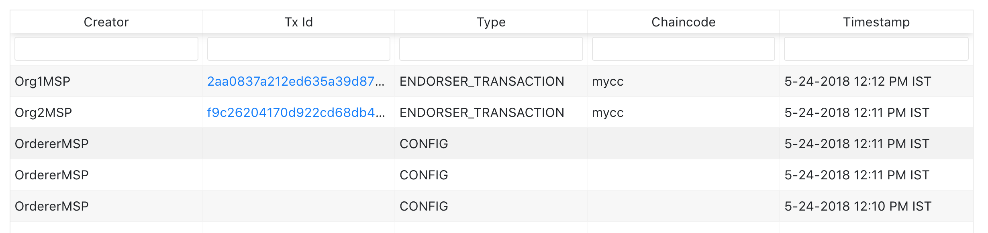

It displays all the transactions that has been endorsed and by which orgs.

**Step 5**: Click on any Transaction ID (shown in blue as url)

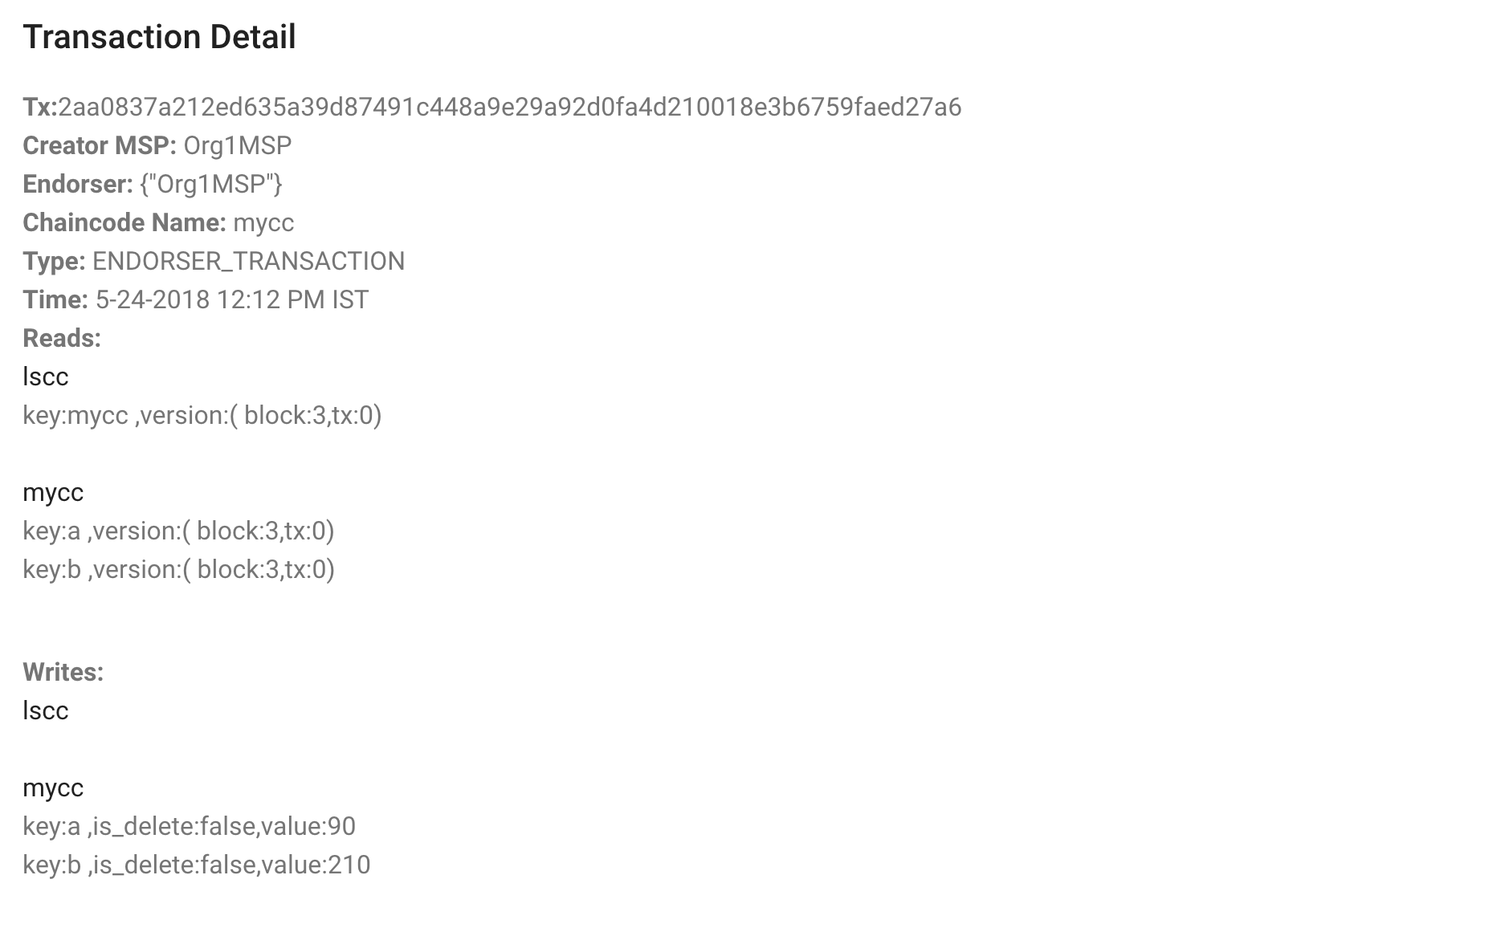

Details of Transaction, endorser, chaincode, time & block are displayed.

**Task 5 is complete!**

# SUMMARY

In this chapter we

* Created a Business network with 2 organization and 2 peers each (total 4 peers).
* Generated the crypto material for the organizations and peers
* Created Solo Orderer and the channel (mychannel)
* Added Peers to the Channel
* Identified the Anchor peers for each org
* Installed Chaincode on the peers
* Query chaincode & Invoked transactions

Finally we used a Blockchain explorer to view all the above hyperledger components.

Students are further encouraged to explore deeper and play with the Hyperledger explorer for better learning.

# CHAPTER 7: Adding a new Peer

## Theory

In this chapter we will add a new peer to our business network and deploy our University Usecase to it.

This topic focusses on peers, and their relationship to those other elements in a Hyperledger Fabric blockchain network.

## Peers

A blockchain network is primarily comprised of a set of peer nodes. Peers are a fundamental element of the network because they host ledgers and smart contracts.

Ledger immutably records all the transactions generated by smart contracts. Smart contracts and ledgers are used to encapsulate the shared processes and shared information in a network, respectively. These aspects of a peer make them a good starting point to understand Hyperledger Fabric network.

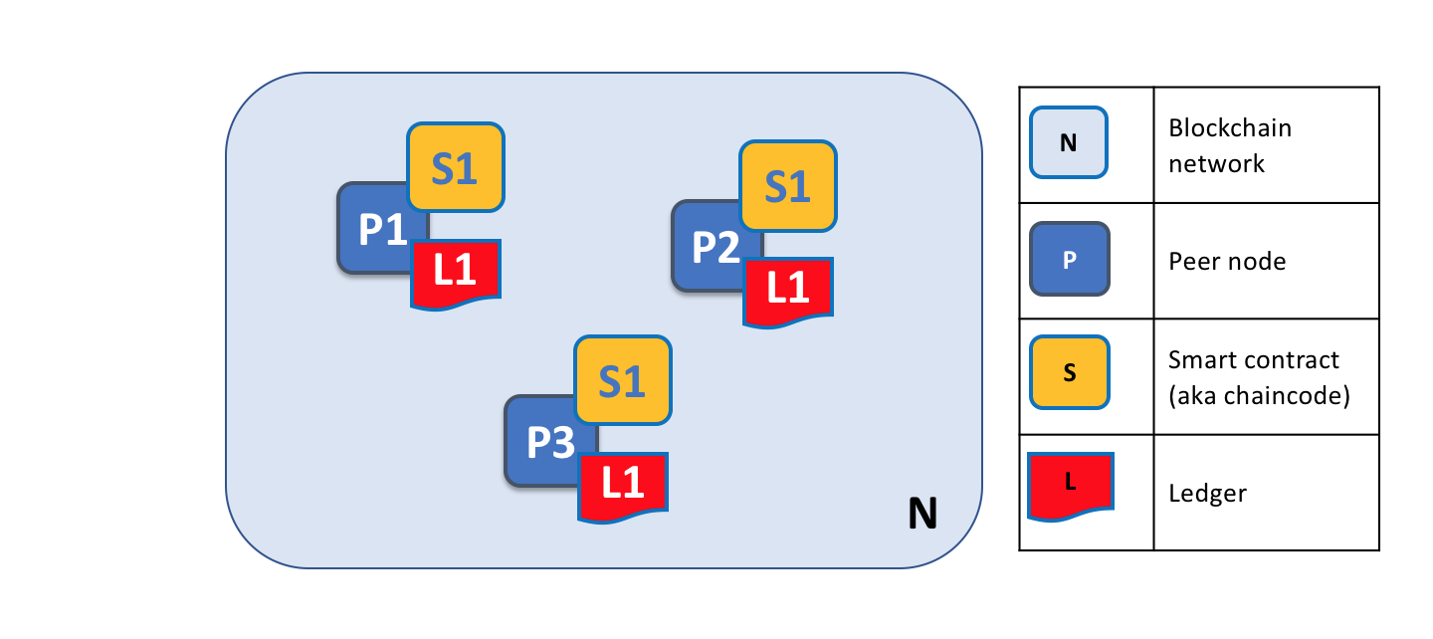

A blockchain network is formed from peer nodes, each of which can hold copies of ledgers and copies of smart contracts. In this example, the network N is formed by peers P1, P2 and P3. P1, P2 and P3 each maintain their own instance of the ledger L1. P1, P2 and P3 use chaincode S1 to access their copy of the ledger L1.

## University Usecase – A new Peer

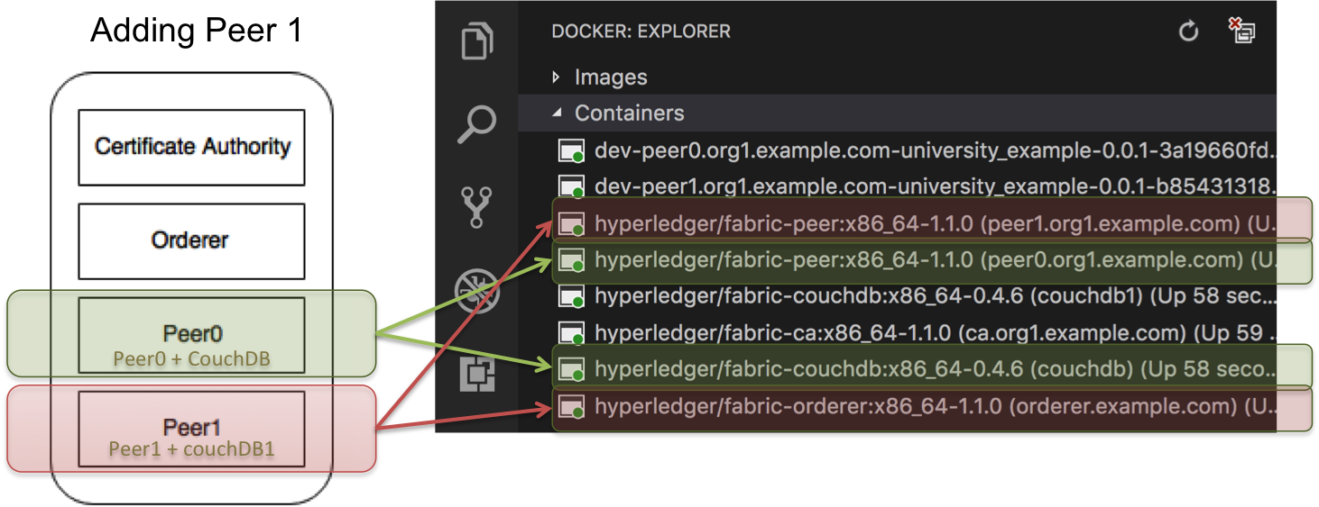

Using the University Usecase Hyperledger Fabric example, we will

* Create a channel - **composerchannel**
* Identify the members,
  + Orderer
  + CA
  + Peer0 (+ couchdb)
  + Peer1 (+ couchdb1)
* Generate cryptographic material
* Setup Docker for multiple peers
* Join peer to the channel
* Create Peer Admin card
* Deploy the business network
* Test the peers

# Lab Exercise 7: Adding a peer to Hyperledger Fabric

|  |
| --- |
|  |

1. Download binaries to generate crypto material
2. Generate Crypto material
3. Update cypto-config.yaml
4. Generate Crypto
5. Configure Docker Services
6. Add Peers + CouchDb
7. Update crypto keys
8. Configure Scripts
9. Add script to join Peer1 to the channel
10. Peer Admin Card creation
11. Update connection string
12. Test the network
13. Visualize Docker setup
14. Deploy university usecase
15. Stop 1 Peer and validate

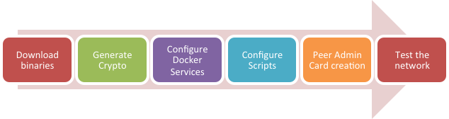

## TASK#1: Download Binaries & setup path

**Step 1:** Open the terminal window and CD into the Fabric’s root folder directory

|  |
| --- |
| **\*\* Please Note:** In this book for compatibility reasons we have renamed Fabric’s root directory to **‘fabric-tools’**. So If you have **NOT** installed Hyperledger using this Book & Scripts root folder name will be **‘fabric-dev-servers’** instead |

cd $HOME/fabric-tools

**Step 2:** Execute the following command from within the directory into which you will extract the platform-specific binaries:

curl -sSL https://goo.gl/6wtTN5 | bash -s 1.1.0 -d -s

The command above downloads and executes a bash script that will download and extract all of the platform-specific binaries you will need to set up your network and place then in the **bin subdirectory**



**Step 3:** Add that to your PATH environment variable so that these can be picked up without fully qualifying the path to each binary



export PATH=$HOME/fabric-tools/bin:$PATH

** Don’t close the Terminal Window, we will be using the same terminal window for generating crypto-materials

**Task 1 is complete!**

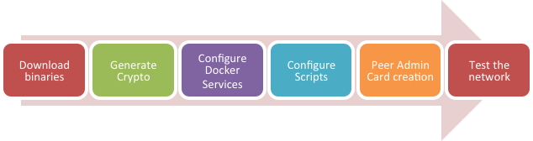

## TASK#2: Generate Crypto Material

**Step 1**: Using the same above terminal where we have setup path for our binaries we will use it to generate crypto materials

Now, move to the directory Hyperledger 1.1 – composer directory:

cd $HOME/fabric-tools/fabric-scripts/hlfv11/composer

**Step 2**: Delete the existing ‘crypto-config’ directory

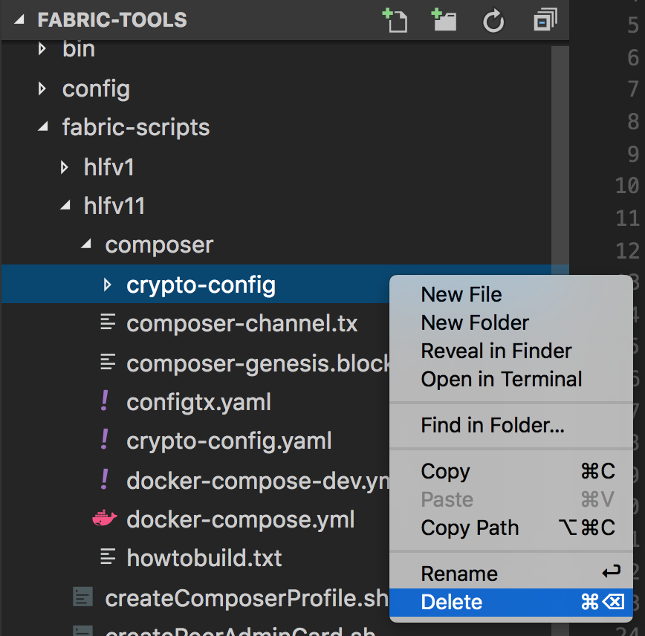

**Step 3**: Using Visual Studio Code Open the “fabric-tools” folder and open the “crypto-config.yaml” for editing



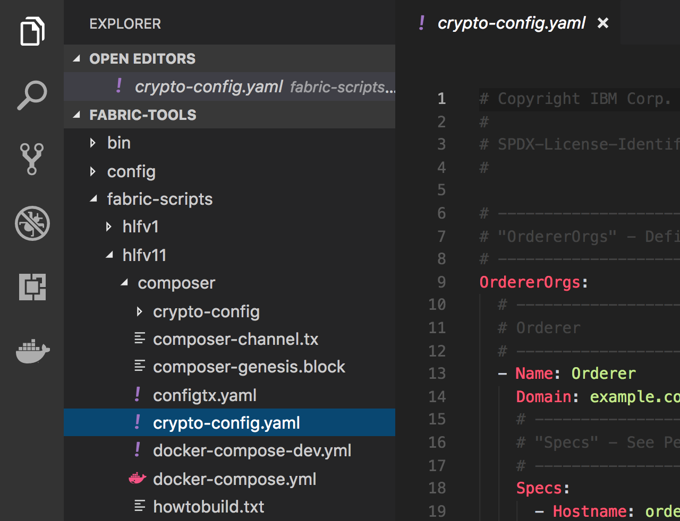

**Step 2**: We want 2 peers instead of existing 1 – hence we update the crypto material required in “crypto-config.yaml” to **‘2’ as shown below**

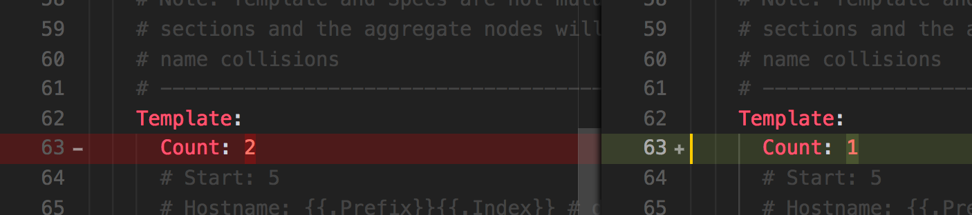

**Step 3**: Generate crypto materials using the following commands:

cryptogen generate --config=./crypto-config.yaml

export FABRIC_CFG_PATH=$PWD



* Now write genesis block

configtxgen -profile ComposerOrdererGenesis -outputBlock ./composer-genesis.block

* Time to define new channel

configtxgen -profile ComposerChannel -outputCreateChannelTx ./composer-channel.tx -channelID composerchannel

On running these commands new crypto material is generated in the “cryto-config” directory as shown below;

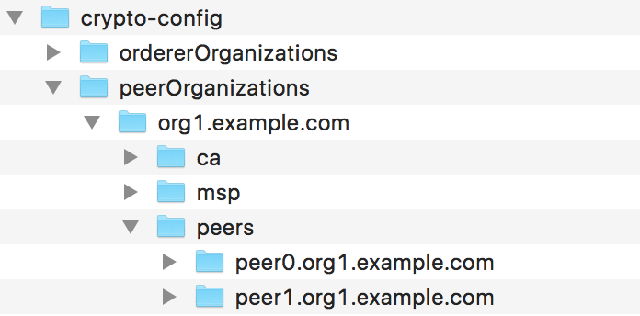

**Task 2 is complete!**



|  |
| --- |
| **\*\* Please Note:** As a reference a sample **Fabric Root** folder **‘fabric-tools-2peers.zip’** is provided. Its encouraged that Students should do a Diff of files to counter-check and not land up in errors. |

## TASK#3: Configure Docker Services

In the docker-compose.yml we already have services 1 to 4 in the listing below. We will add the additional peer1 & couchdb1 services.

1. ca.org1.example.com [Update crypto-material]
2. orderer.example.com
3. peer0.org1.example.com
4. couchdb
5. peer1.org1.example.com [Add New]
6. couchdb1 [Add New]

**Step 1**: Using Visual Studio Code Open the “fabric-tools” folder and open the “docker-compose.yml” of hlfv11 for editing

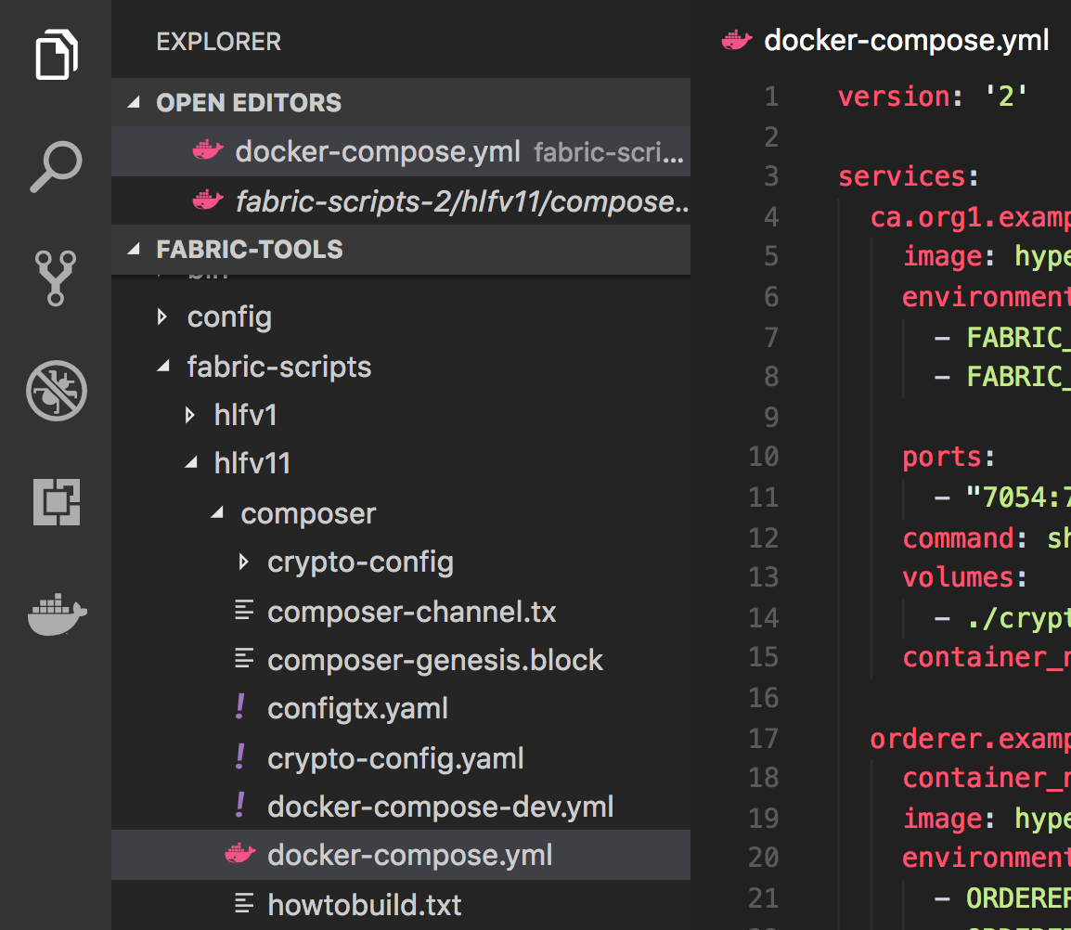



**Step 2**: Configure the Certificate Authority, using the certificates that have been generated newly. In the command section of ca.org1.example.com make sure to use the proper private key file.

Private Key File located under composer/crypto-config/peerOrganizations/

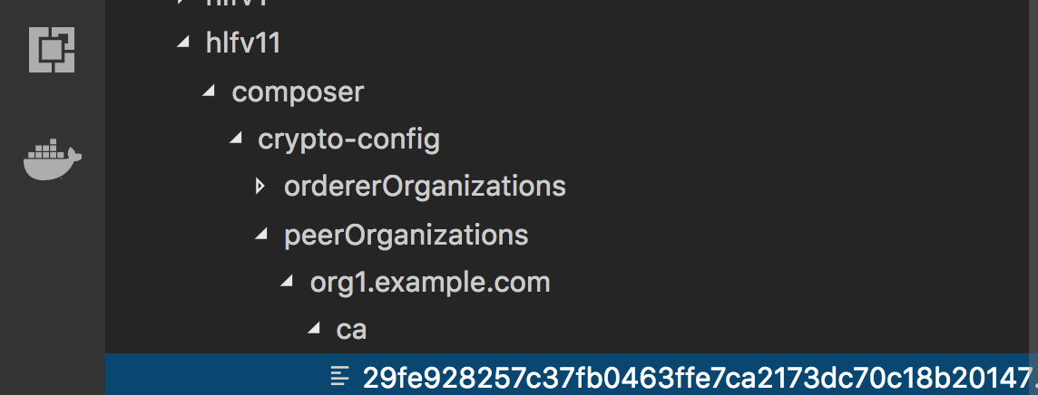

* Use this **File Name** – ends with **_sk** in the **“docker-compose.yml”**

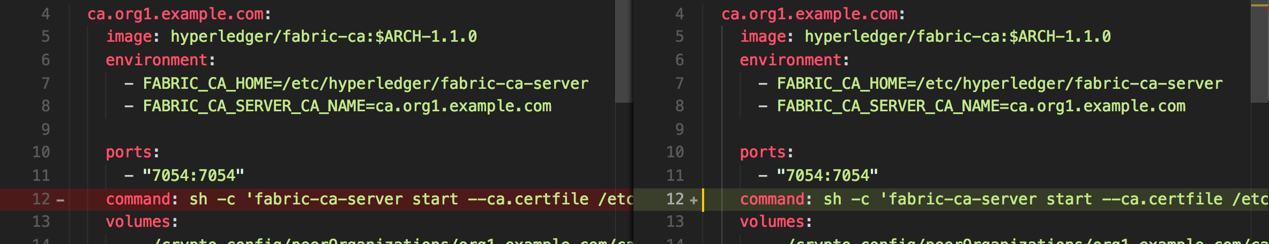

**Step 3**: Add the new “peer1.org1.example.com:” section in the **“docker-compose.yml”**

**Please Note:** Take special care about the changes marked in image below;



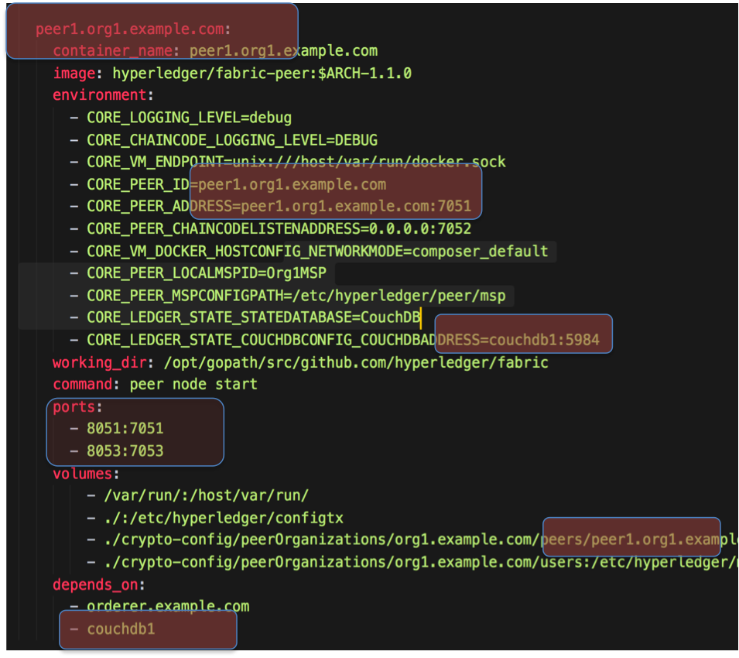

**Step 4**: Add the new “couchdb” section in the **“docker-compose.yml”**

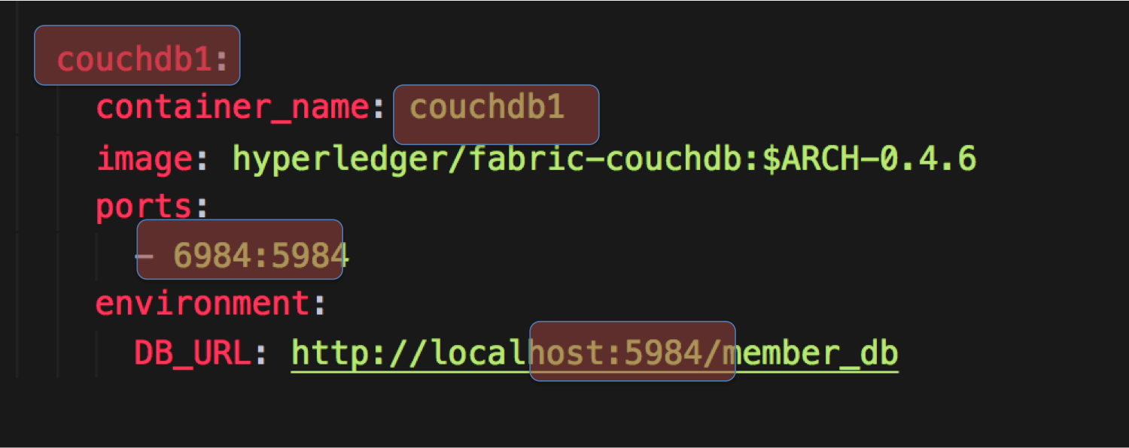

**Task 3 is complete!**



## TASK#4: Configure Scripts – Join Peer1 to the channel

**Step 1**: Using Visual Studio Code Open the “fabric-tools” folder and open the “startFabric.sh” of hlfv11 for editing

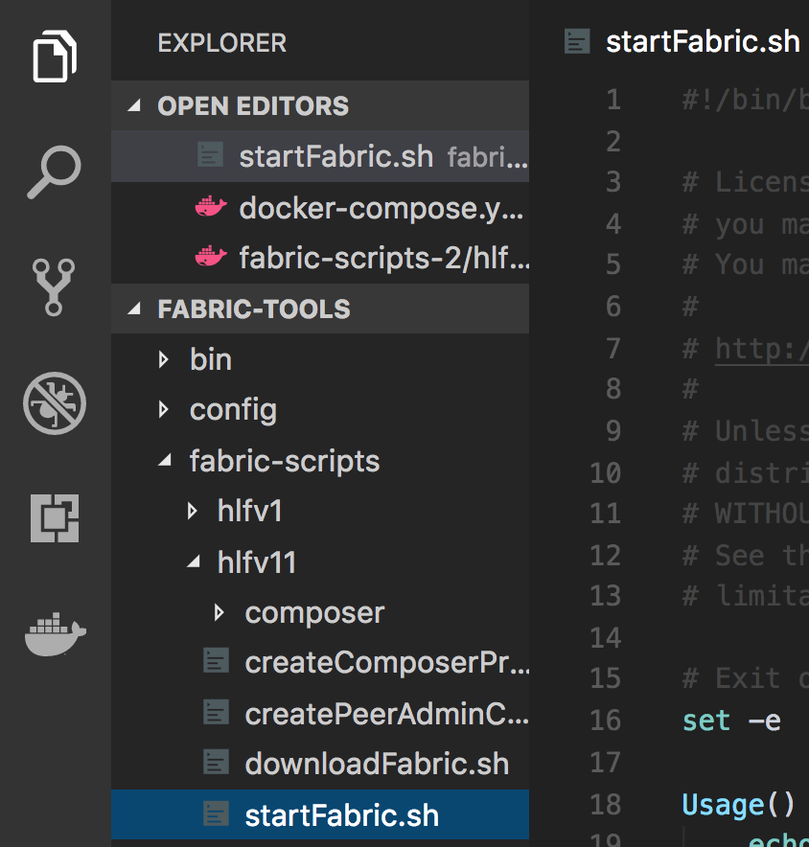

**Step 2**: Channel is already created and peer0 is added to the channel as shown below:

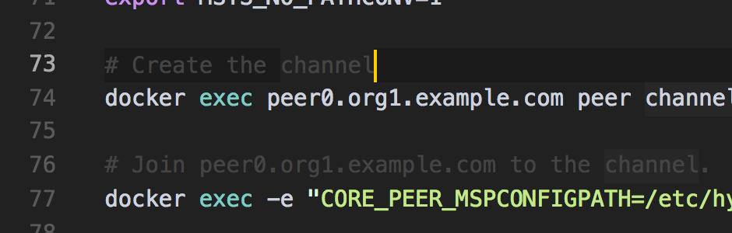



Add following lines below it to add peer1 to the channel

# # Fetch channel block from orderer

docker exec -e "CORE_PEER_MSPCONFIGPATH=/etc/hyperledger/msp/users/Admin@org1.example.com/msp" peer1.org1.example.com peer channel fetch config -o orderer.example.com:7050 -c composerchannel

# # Join peer1.org1.example.com to the channel.

docker exec -e "CORE_PEER_MSPCONFIGPATH=/etc/hyperledger/msp/users/Admin@org1.example.com/msp" peer1.org1.example.com peer channel join -b composerchannel_config.block

**Task 4 is complete!**



## TASK#5: Peer Admin Card creation

**Step 1**: Using Visual Studio Code Open the “fabric-tools” folder and open the “createPeerAdminCard.sh” of hlfv11 for editing

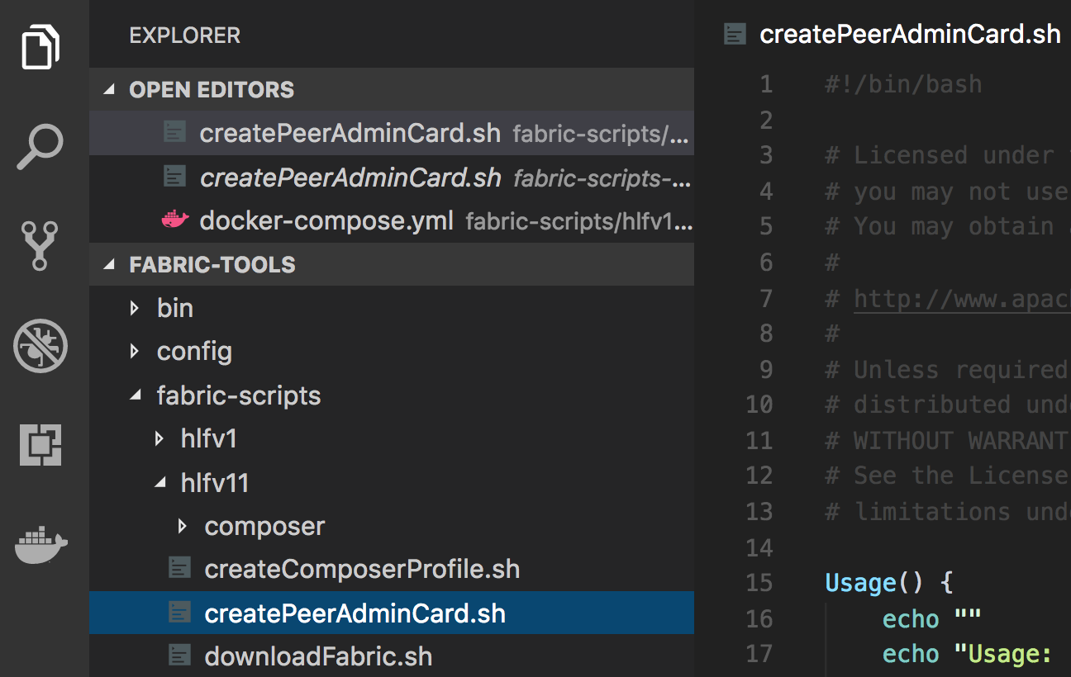

**Step 2**: Update the connection string to add **peer1** as shown in the images below:

#1:

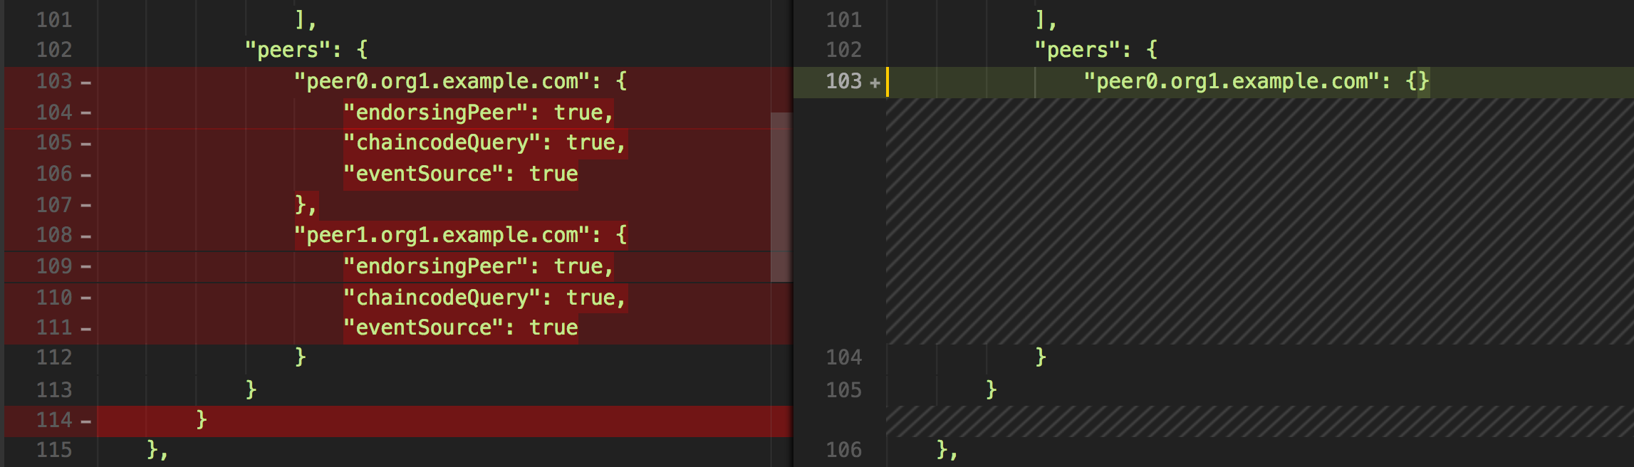

#2:

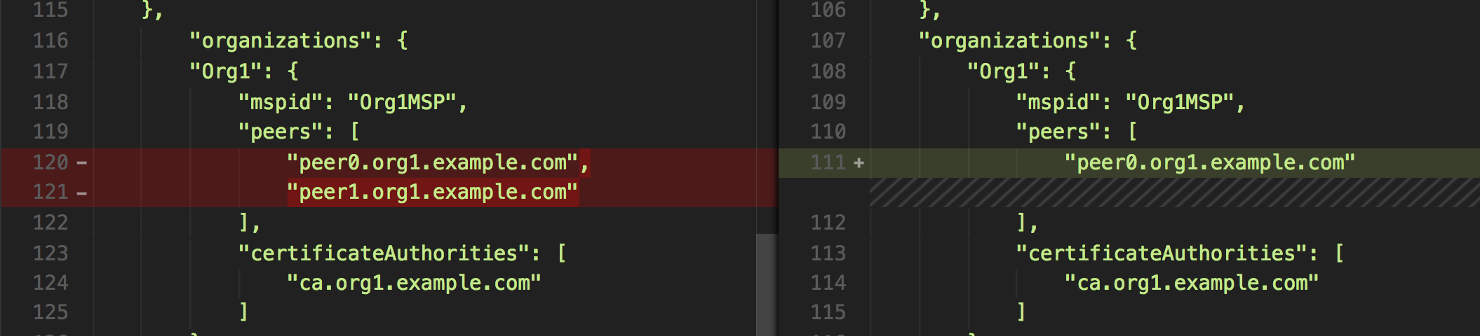



#3:

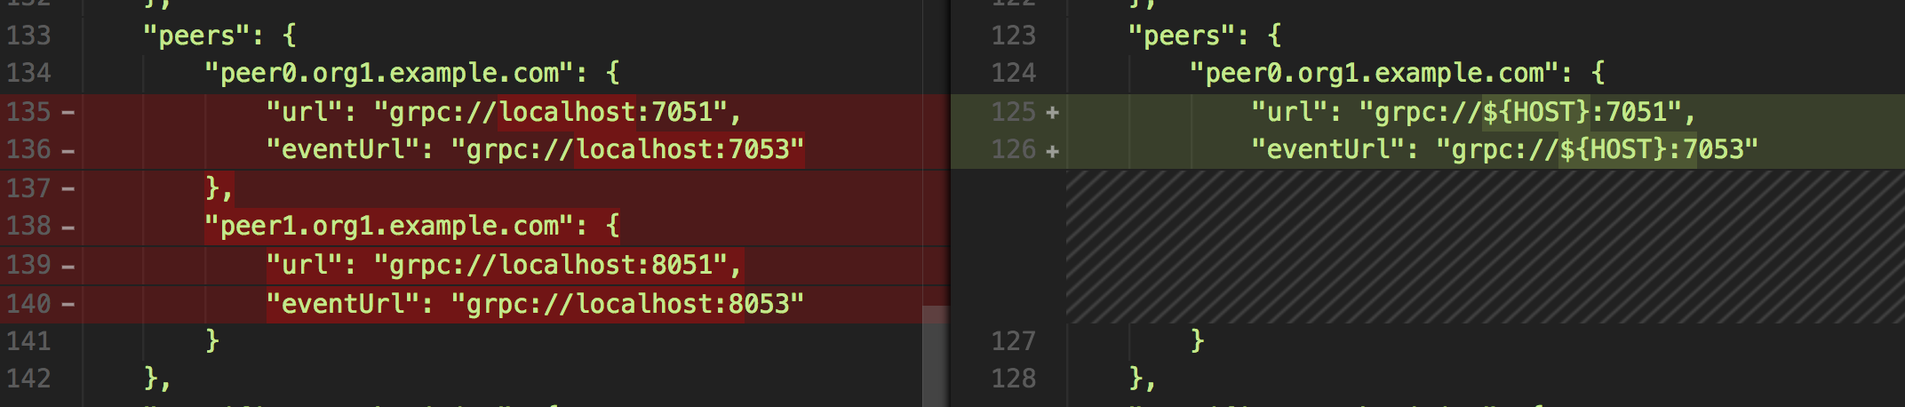

**Step 3**: Update the PRIVATE KEY for the MSP as we did in TASK#3 Step-2.



**LOCATION for Key:**

[*crypto-config/peerOrganizations/org1.example.com/users/Admin@org1.example.com/msp/keystore/*](mailto:crypto-config/peerOrganizations/org1.example.com/users/Admin@org1.example.com/msp/keystore/)

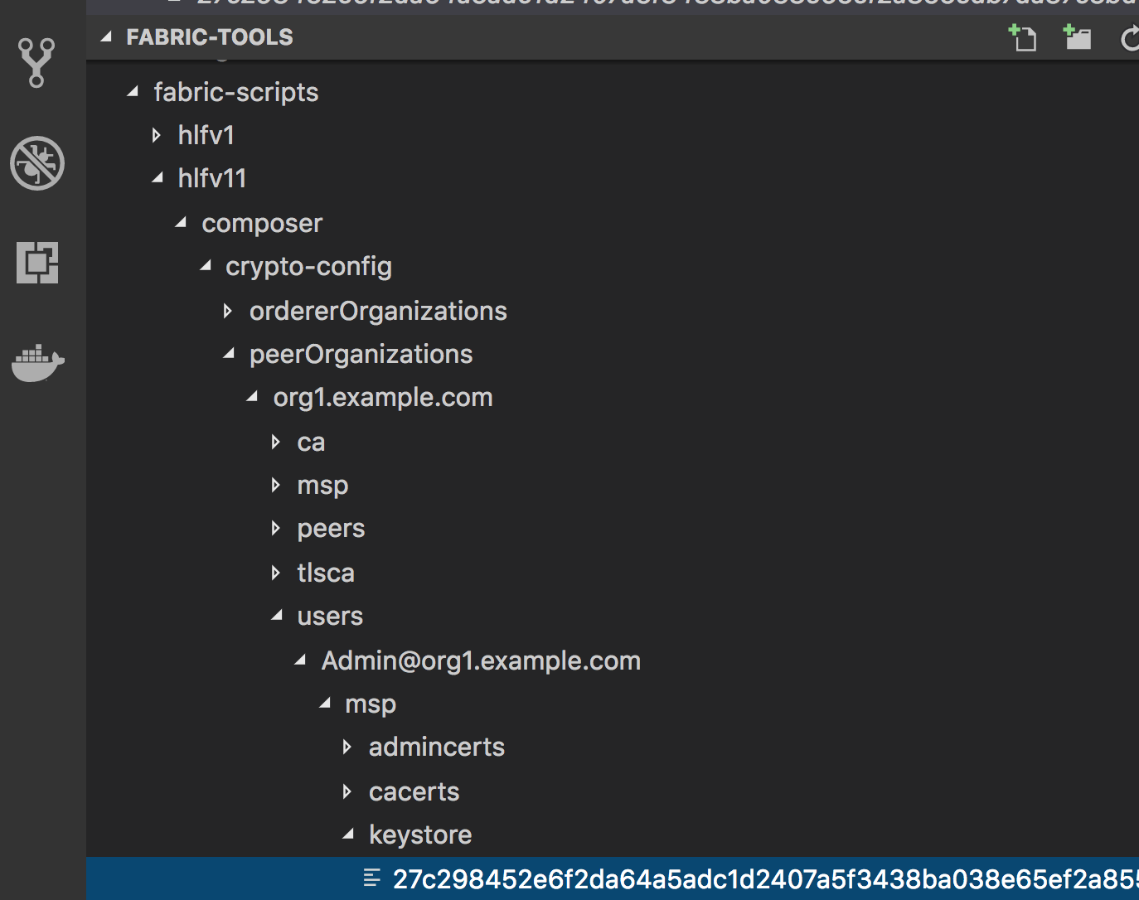

**Task 5 is complete!**



## TASK#6: Test the network

### TASK#6.1: Visualize Docker Setup

**Step 1**: Open the terminal window and CD into the Fabric’s root folder directory

cd $HOME/fabric-tools

**Step 2**: Start Fabric using the following command

**Please ensure docker service is running

./startFabric.sh

Fabric should now start with Peer0 and Peer1 along with new couchdb1

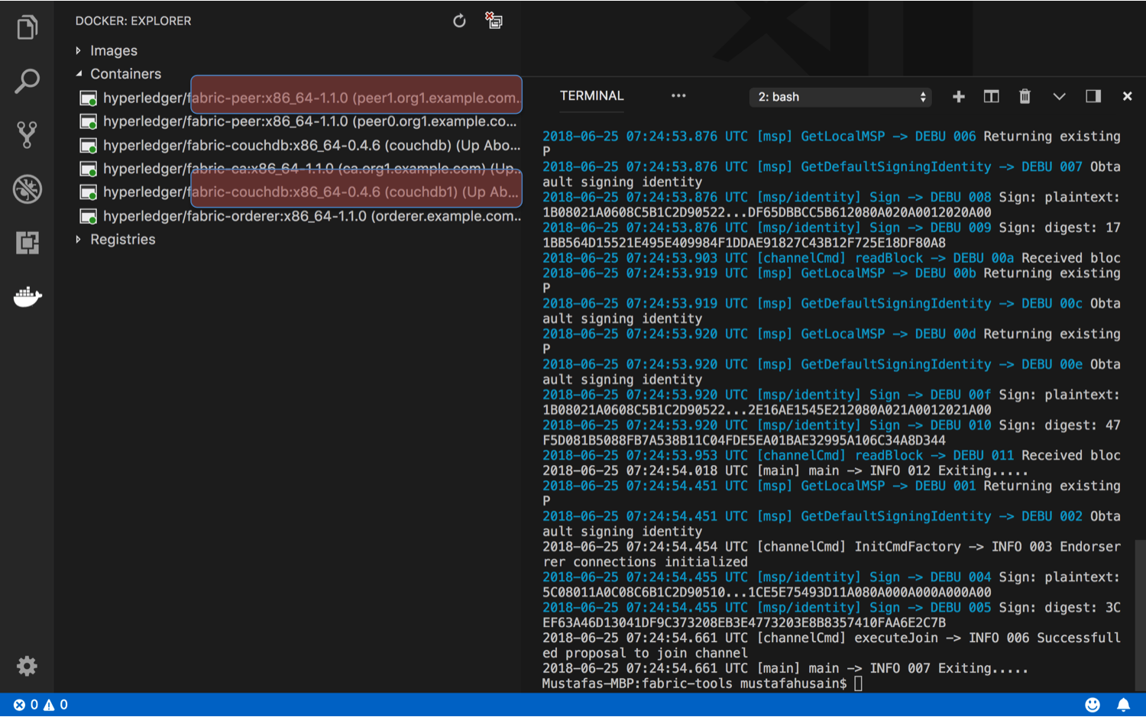

**Task 6.1 is complete!**



### TASK#6.2: Launch University-Usecase example

**Step 1**: Unzip “chapter05.zip” code and CD into the “chapter05” directory

**Step 2**: Run NPM install to install all required dependencies

npm install

**Step 3**: CD in the scripts directory

cd script

**Step 4**: Run buildAndDeploy Script

./buildAndDeploy.sh

On Successful completion of command

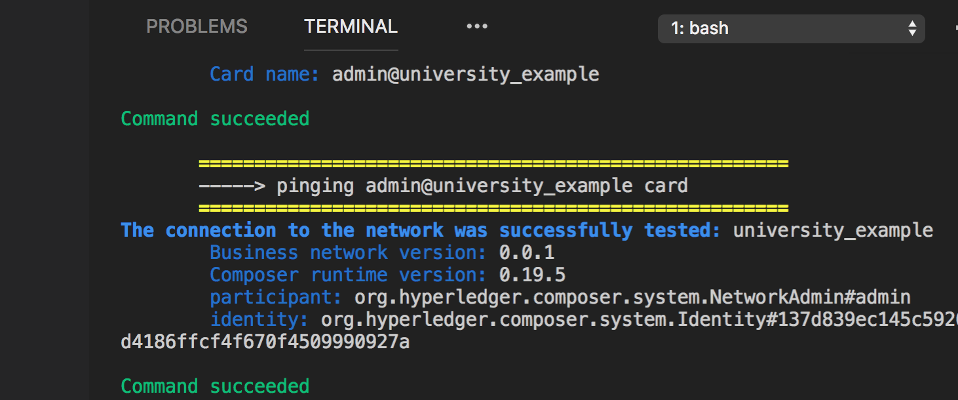



Composer uses the “connection” profile we added to the PeerAdminCard and deploys university example chaincode to both peers

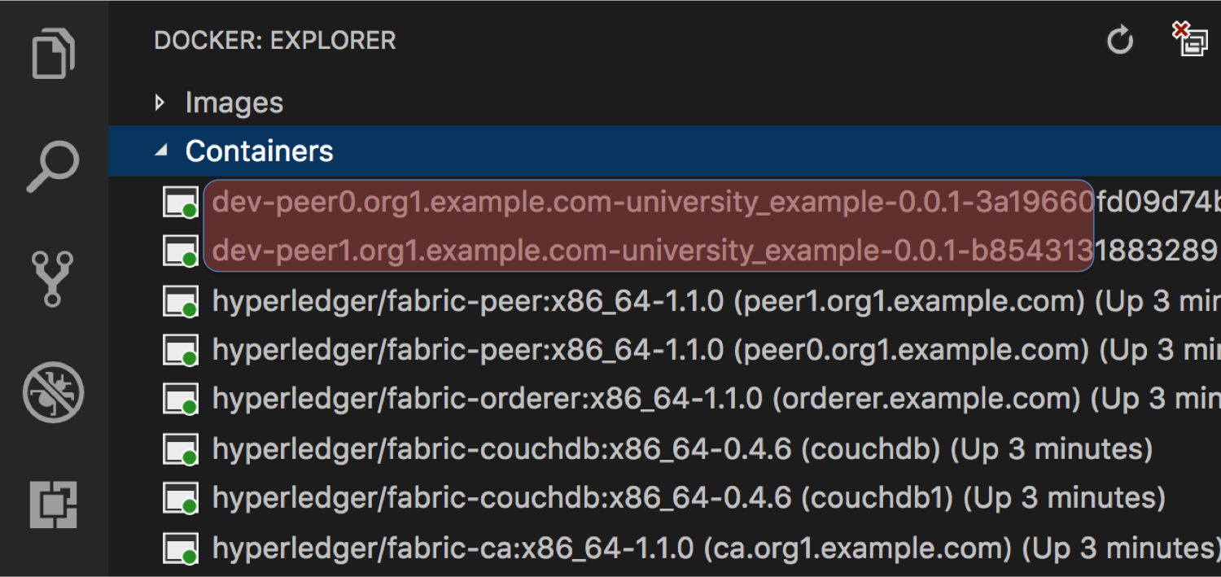

**Task 6.2 is complete!**



### TASK#6.3: Stop 1 Peer and Validate Blocks

|  |
| --- |
| Student are encouraged to complete this validation on their own. Few minimal pointers shall be provided which are essential. |

**Step 1**: Post deploying the “chapter05” University usecase run the UI using the following command from the ‘script’ folder

./run.sh

**Step 2**: Open couchDB database admin/util page using separate browsers:

For Peer0 : couchDB

URL: localhost:5984/_utils/

For Peer1 : couchDB1

URL: localhost:6984/_utils/

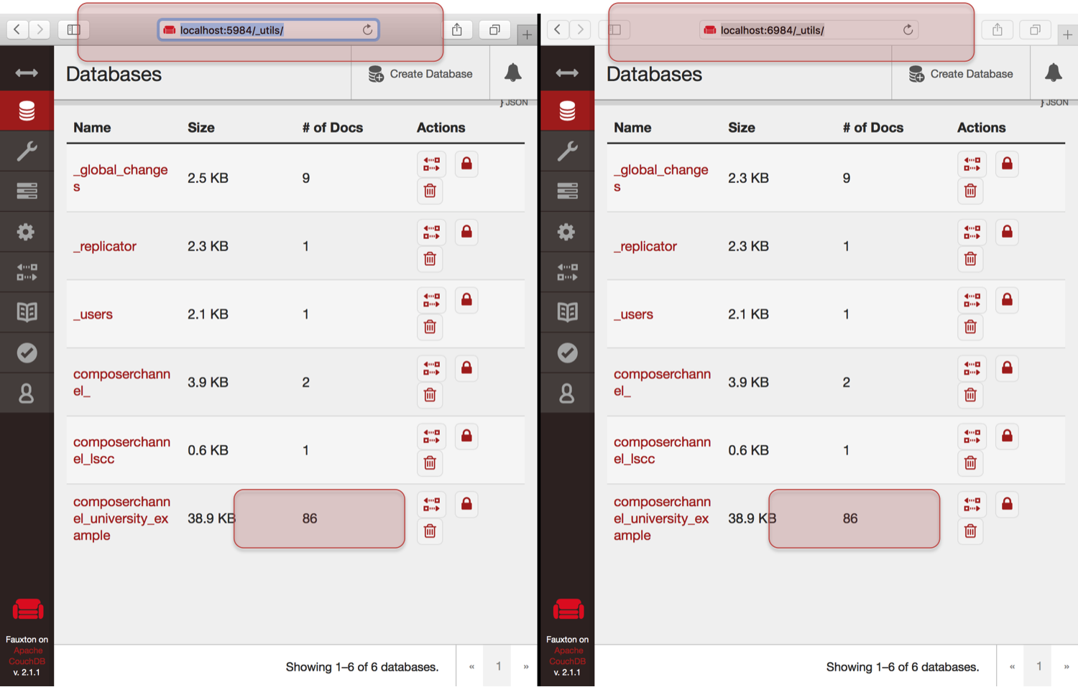

**Please Note:** Note that both the blocks are in sync as shown highlighted



**Step 3**: Open UI using the URL as shown up after running ./run.sh script in step-1

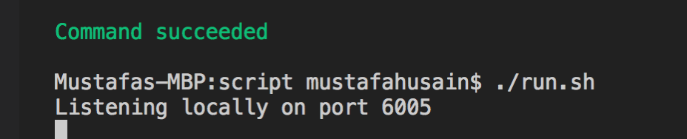

URL: localhost:6005

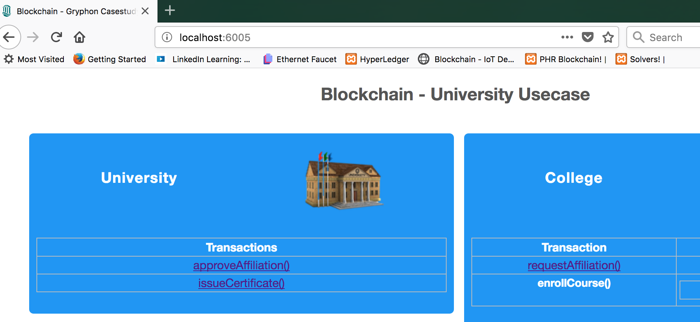

**Step 4**: Run requestAffiliation() Transaction

**Step 5**: Refresh both DB browsers and check that the blocks are updated



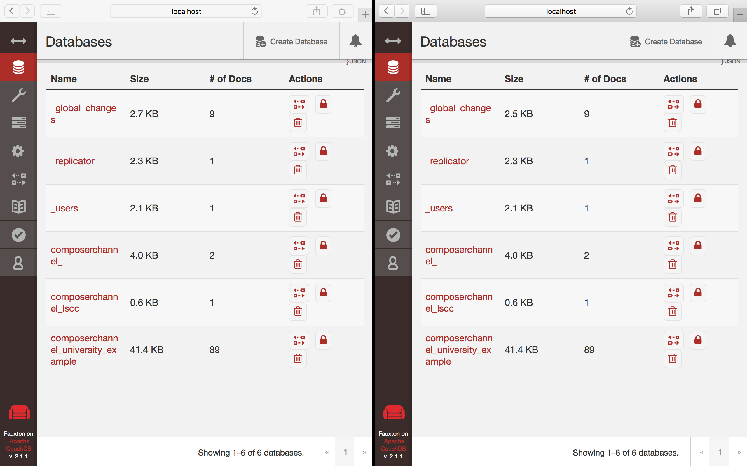

**Step 6**: Bring down couchdb1 service

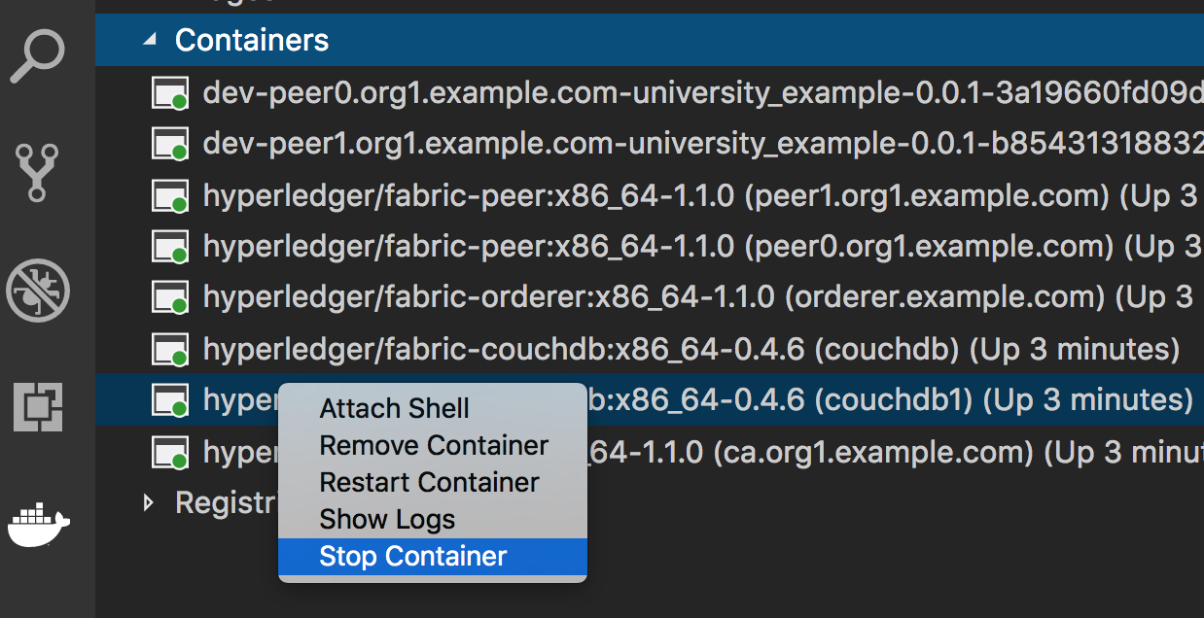

**Step 7**: Run requestAffiliation() Transaction Again



**Step 8**: Refresh both db browser. One DB should reflect the new block creation. Other should be down.

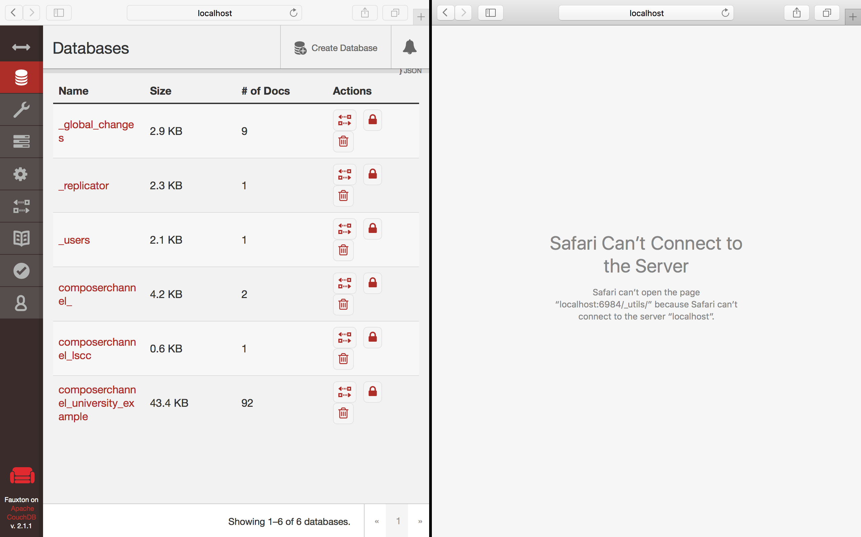

**Step 9**: Bring Up the couchdb service again – Using restart command

**Step 10**: Verify the blocks again: You will see a difference in Number of blocks



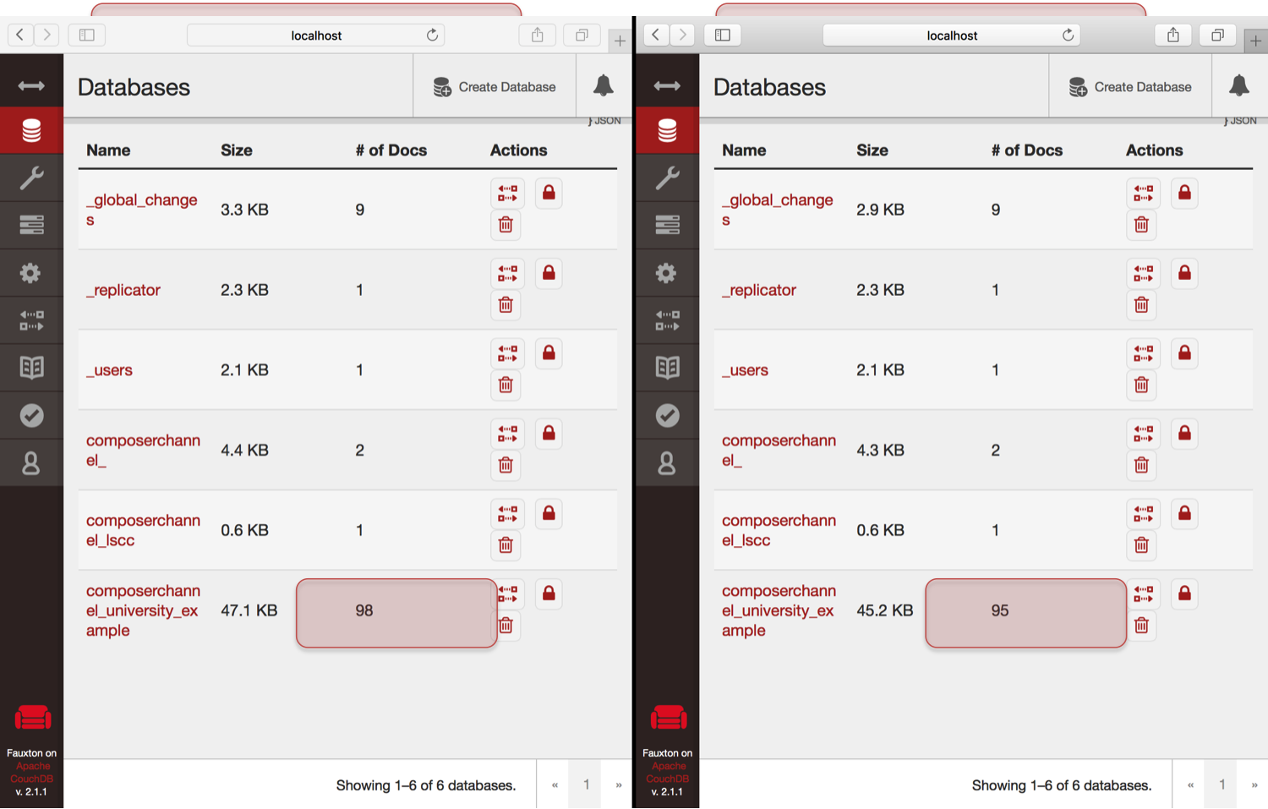

**Step 11**: Now bring up the peer1.example.com node as well using restart command

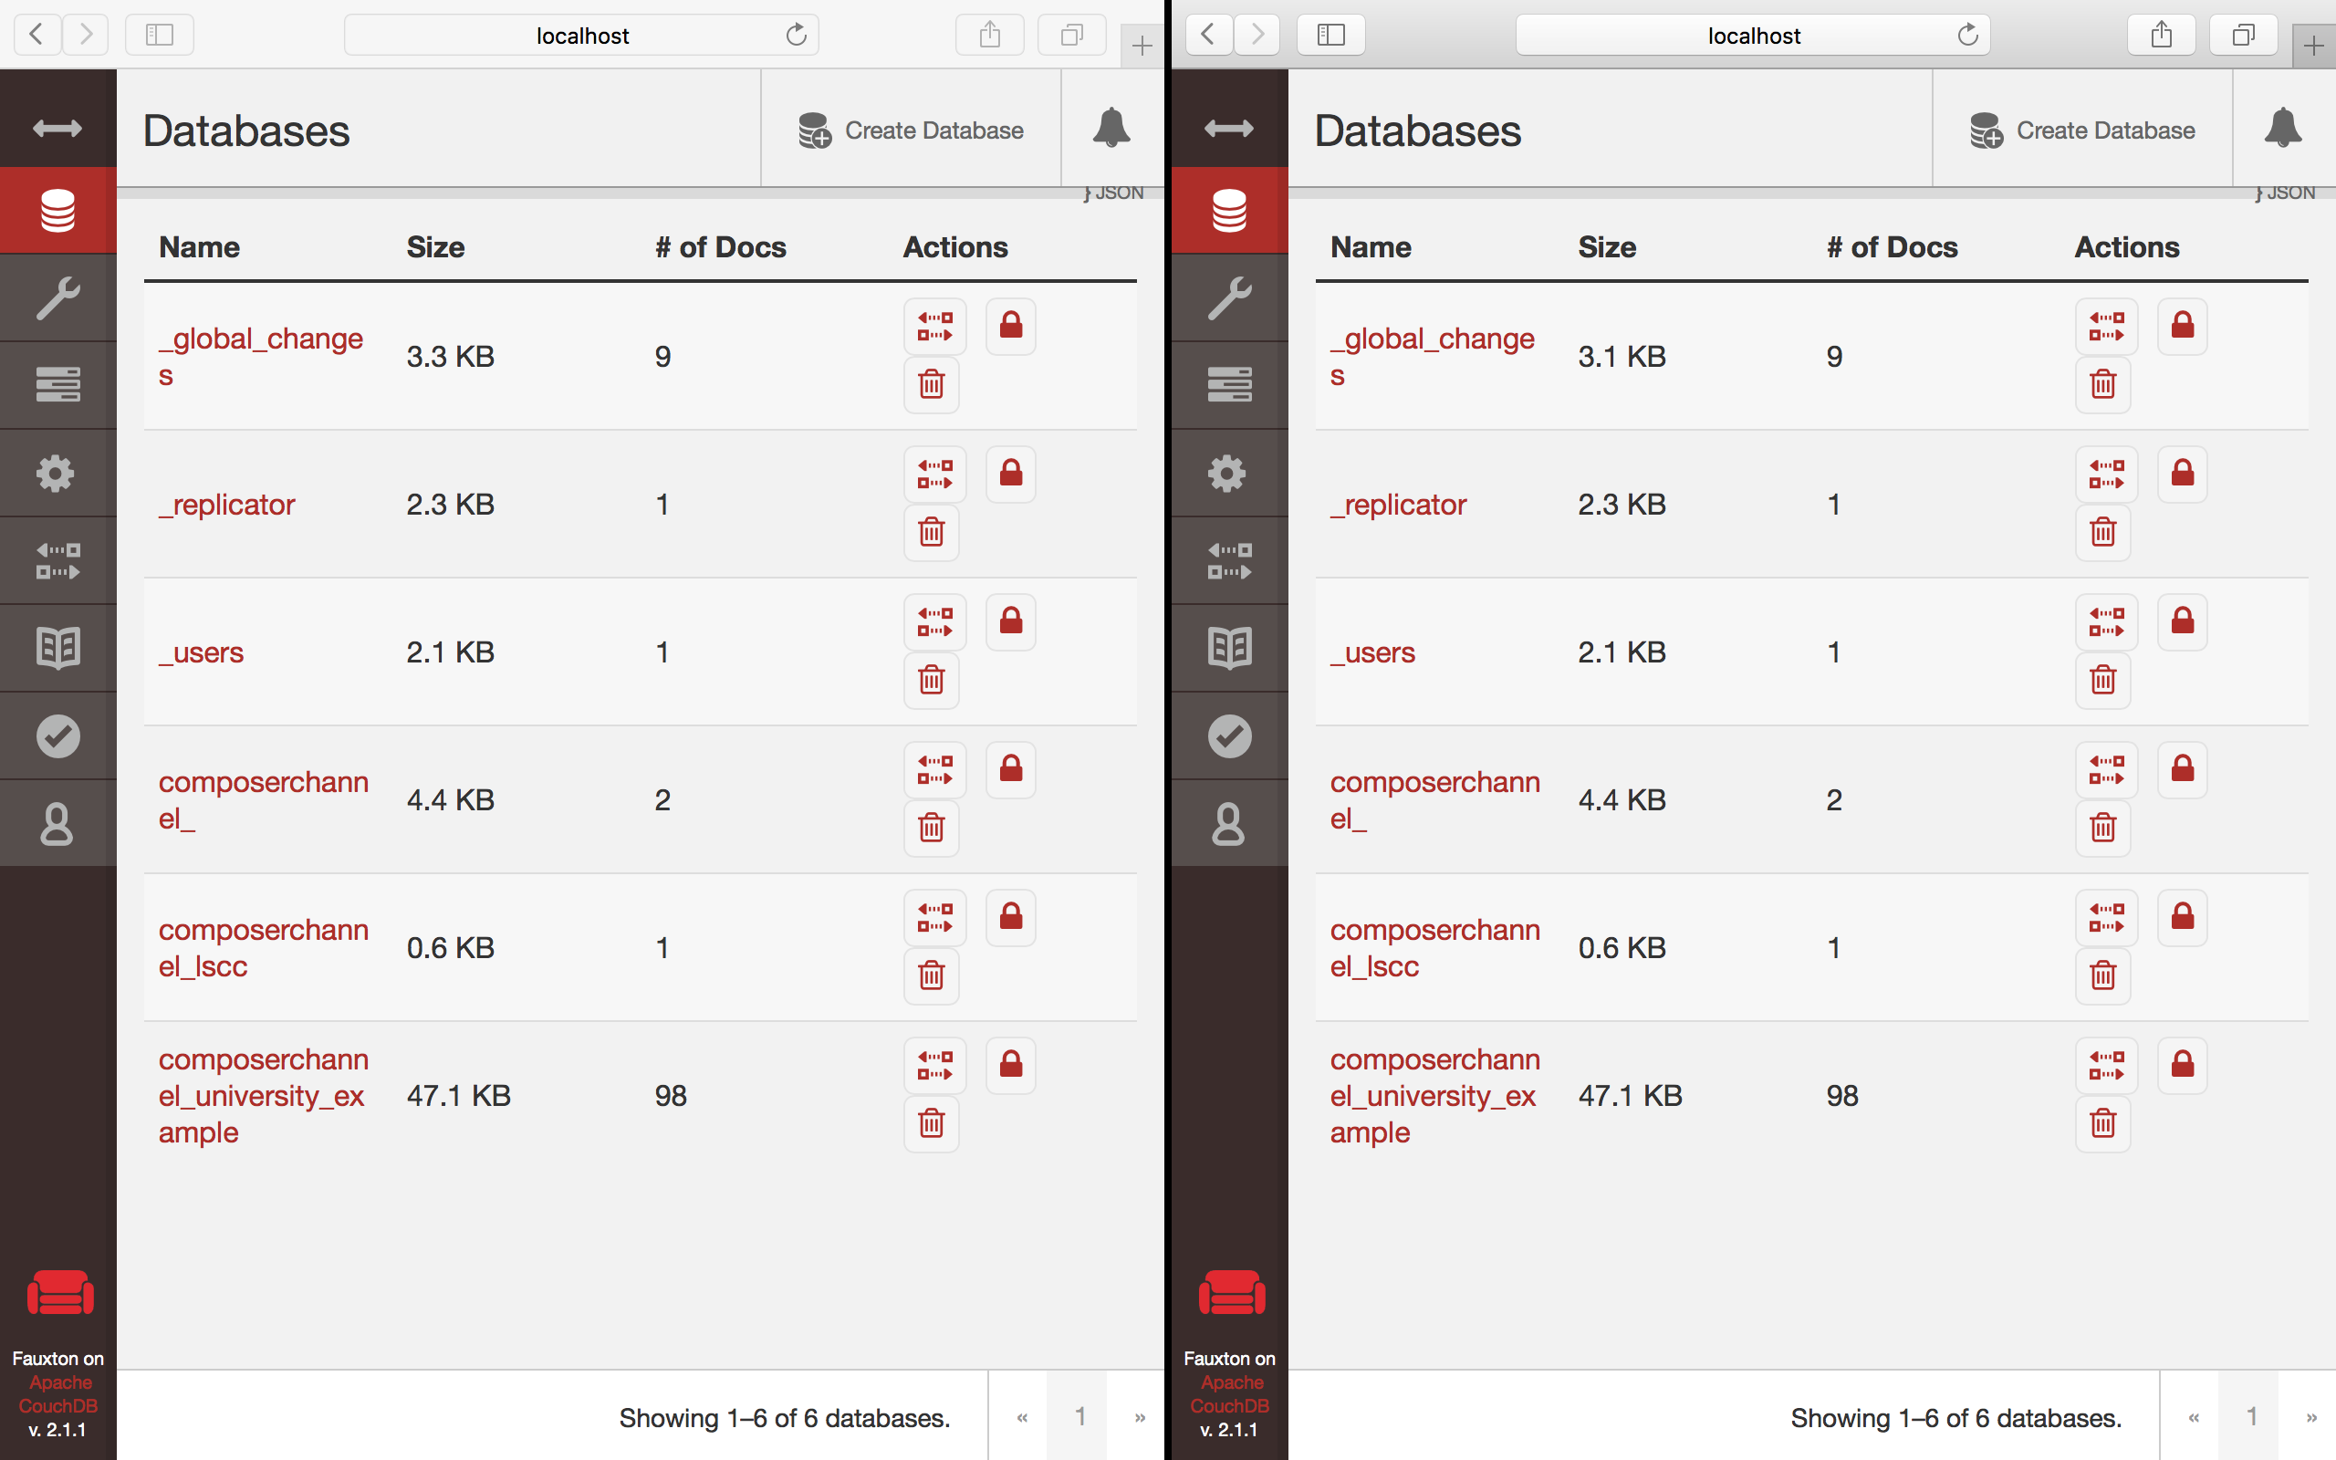

Orderer Sync the blocks and now it starts reflecting on the restarted peer couchdb.

**Task 6.3 is complete!**

# SUMMARY

In this chapter we

* Created a Business network with 1 organization and 2 peers
* Generated the crypto material for the organizations and peers
* Created CA, Orderer and peer services
* Defined the channel (composerchannel)
* Added Peers to the Channel
* Installed university Usecase Chaincode on the peers
* Tested the Peers

Students are further encouraged to explore deeper and play with the Hyperledger business network & the explorer for better learning.

# CHAPTER 8: Adding a new organization to the existing Network.

## Theory

Congratulations!!! Our TRUSTED Academic Certificate on the Blockchain concept was a big hit!!! Now many other universities want their certificates also on the blockchain…

### Problem Statement:

* All other Universities don’t want to create their own blockchain network. Else there would be hundreds of such network and if someone as a verifier who wants to validate the certificate authenticity would first have to find the respective university website for validation or it would never work.
* Each University would want to have their own set of Admin users and participant to be able to manage the registration and certification process.
* It has to be a distributed Application and NOT centrally owned
* If we create a new network from scratch – existing data will be washed out and no more be a part of blockchain decentralized network

### Solution:

* Add a new Organizations to the existing system

## Business Network

### Current Setup

Our current composer business network compromises of the following:

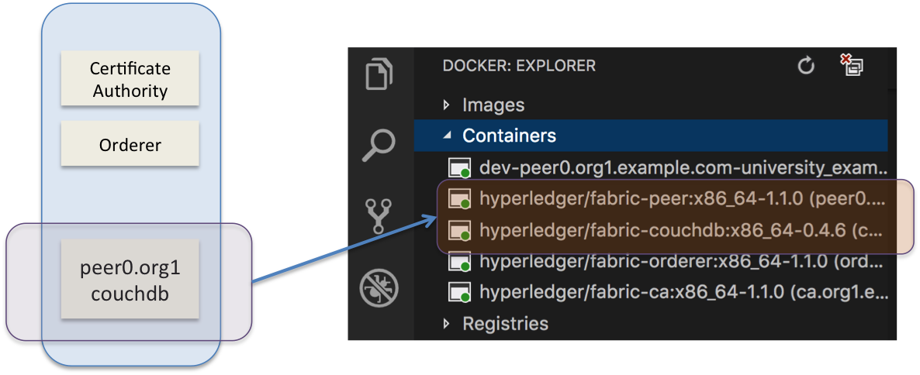

### New Setup

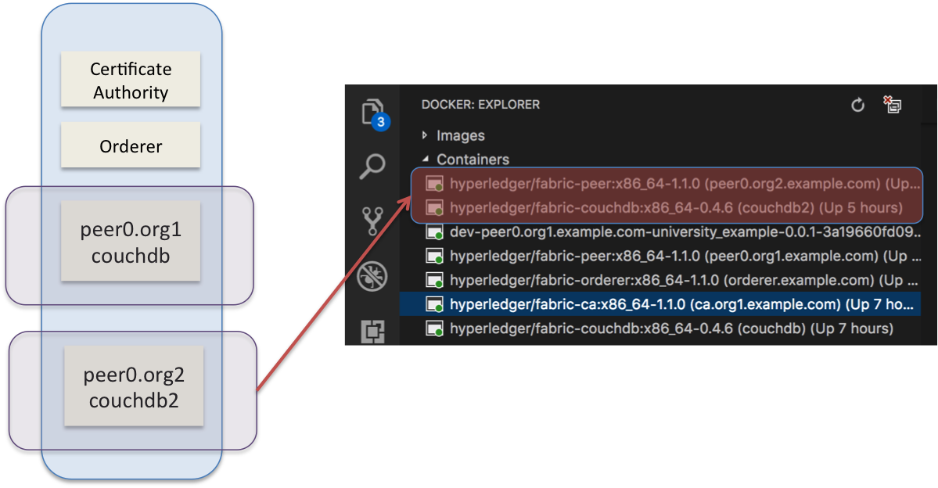

To be able to add new Organization to the existing system we will need following steps:

* Create crypto material and artifacts for the new Organization
* Decode the existing configuration block and update with new organization details
* Encode; sign and update orderer with new configuration transaction
* Spin up new Organization and peers/couchdb
* Join new Org to the existing channel

In this chapter we will add a new organization to our existing business network.

# Lab Exercise 8: Adding a new Org to existing Hyperledger Fabric Composer Network

|  |
| --- |
|  |

1. Setup Envoirnment
   1. Copy org2-artifact files necessary for adding envoirnment & download binaries + setup path
   2. [Optional] Make changes to existing docker-compose yaml – (Just to validate intermediate steps. And we are going as expected)
   3. Spin Up the university example if NOT already running
2. Generate Crypto material
3. Generate Crypto for new Org
4. Generate configuration json for new Org
5. Copy crypto material to crypto-config folder
6. Fetch-Decode existing configurations & add Org2 json
7. Sign & Update new configurations with Org2
8. Spin Up new Org2 Containers
9. Join Org2 to the channel
10. Test the network
11. Visualize Docker setup
12. Using CouchDB
13. Blockchain Explorer

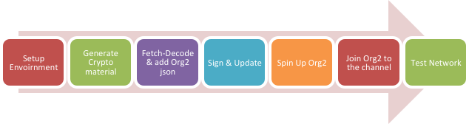

## TASK#1: Setup Environment

**\*\* Please NOTE:** This chapterconsiders that Our Network has 1 Org and 1 Peer. If you have worked with Lab-7 and have 2 Peer in Org1, the steps still remains the same. NO Change is NEEDED.

### TASK#1.a: Copy org2 artifacts & setup fabric binaries

**Step 1:** Take ‘chapter08’ and cd into it

cd chapter08

**Step 2: ‘org2-artifacts’** Folder contain the artifacts for Org2. Lets copy that to the **‘fabric-tools’** home directory.

|  |
| --- |
| **\*\* Please Note:** In this chapter for compatibility reasons we have renamed Fabric’s root directory to **‘fabric-tools’**. So If you have **NOT** installed Hyperledger using Chapter#0 of this booklet, root folder name will be **‘fabric-dev-servers’** instead |

mv org2-artifacts $HOME/fabric-tools

**Step 3:** CD into the ‘**fabric-tools’** home directory

cd $HOME/fabric-tools/org2-artifacts

**Step 4:** Execute the following command from within the directory into which you will extract the platform-specific binaries:

curl -sSL https://goo.gl/6wtTN5 | bash -s 1.1.0 -d -s



The command above downloads and executes a bash script that will download and extract all of the platform-specific binaries you will need to set up your network and place then in the **bin subdirectory**



**Step 5:** Add that to your PATH environment variable so that these can be picked up without fully qualifying the path to each binary

export PATH=$HOME/fabric-tools/org2-artifacts/bin:$PATH

** Don’t close the Terminal Window, we will be using the same terminal window for generating crypto-materials

***Task 1.a is now Complete!***



### TASK#1.b: Map peer0.org1 volume to host

***\*\* Task#1.b is NOT mandatory for adding the new Org, however for our learning purpose it is HIGHLY recommended***

**Step 1:** Launch Visual Studio editor and open the ‘fabric-tools’ folder.

**Step 2:** Open “docker-compose.yml” file for editing

**fabric-tools -> fabric-scripts -> hlfv11 -> composer -> docker-compose.yml**

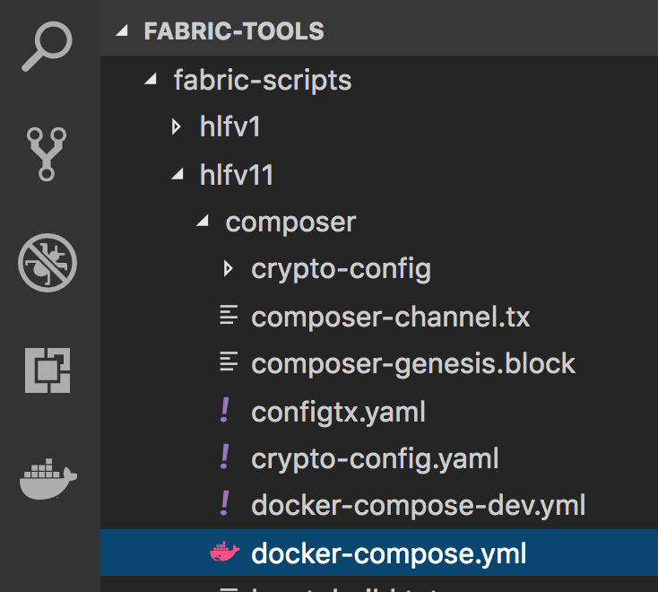

**Step 8:** Map the ‘org2-artifacts’ directory in the yaml file.

This is recommended so that we are able to get all the files that will be generated in the ***peer0.org1*** container in the ***org2-artifacts*** folder without having to copy it every time for inspection.



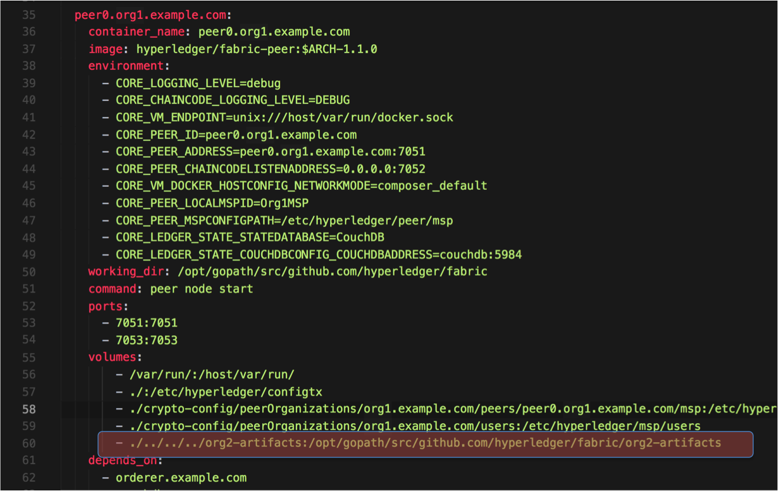

Now we are all set to start our university_example [if NOT already running]

**\*\*Note**: Because we have made changes to ***docker-compose.yml*** file we will have to re-launch the network so that the volume mapping exists in the peer container.

***Task 1.b is now Complete!***



### TASK#1.c: Launch University-Usecase example

**\*\*Note**: If you have University-Usecase already running and have NOT used step #1.b, you may choose NOT to re-run the example to preserve the existing state of the blockchain. For new students it **recommended** to re-run following step to avoid any un-desired behaviors

**Step 1**: Unzip “chapter05.zip” code and CD into the “chapter05” directory

**Step 2**: Run NPM install to install all required dependencies

npm install

**Step 3**: CD in the scripts directory

cd script

**Step 4**: Run buildAndDeploy Script

./buildAndDeploy.sh

On Successful completion of command



***Task #1.c is now Complete!***



## TASK#2: Generate Crypto Material for Org2

In task#1 we copied ‘***org2-artifacts***’ folder to the ‘**fabric-tools**’ folder it has following files:

* **org2-crypto.yaml :** It Defines
  + The name of new Org,
  + Domain name for the org and
  + Number of peers for which crypto material has to be generated
  + ** We are using USERS – count as ‘0’ hence we will have only Admin user generated

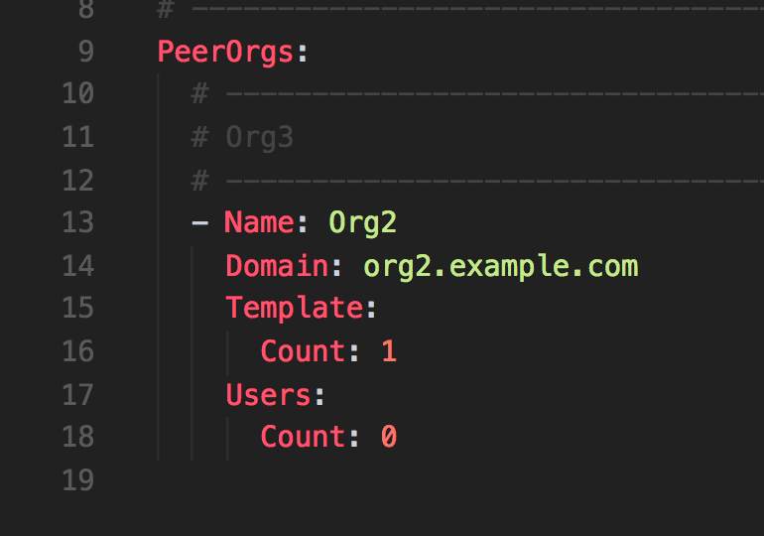

* **configtx.yaml :** Which Defines
  + The MSP id for the new ORG
  + Directory path where MSP crypto material need to be placed
  + Anchor peers and the ports

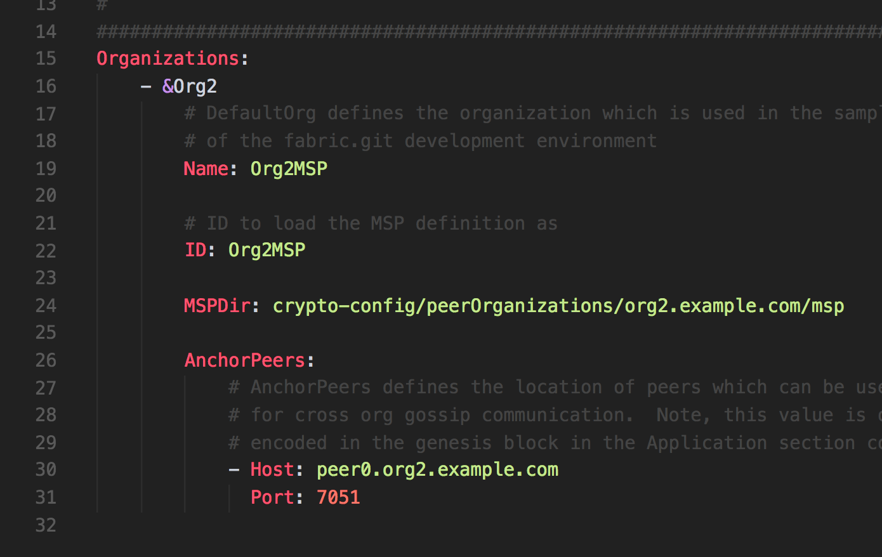



**Step 1**: Using the same above terminal where we have setup path for our binaries we will use it to generate crypto materials

Now, move to the directory for org2 artifacts:

cd $HOME/fabric-tools/org2-artifacts/

**Step 2:** Run the following command to generate the crypto material

cryptogen generate --config=./org2-crypto.yaml

A folder within the ‘**org2-artifacts**’ directory with name ‘**crypto-config’** is created which has org2.example.com as shown below;

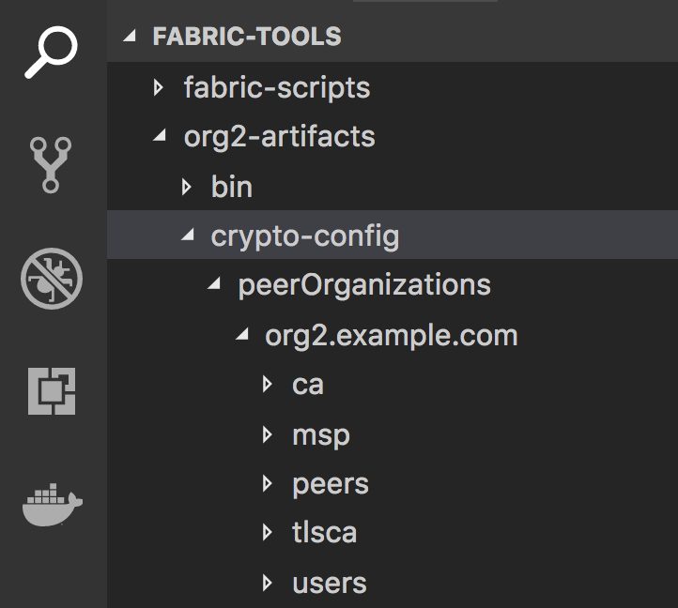

**Step 2:** Also generate the config json for Org2 with these crypto material recently generated

configtxgen -printOrg Org2MSP > org2.json



Config file with name org.json is created

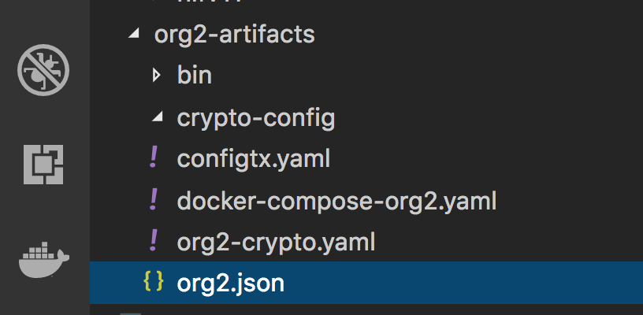

**Step 3:** Let’s move the ‘**org2.example.com**’ directory to the peerOrganization folder where org1 crypto material already exists

mv ./crypto-config/peerOrganizations/org2.example.com ./../fabric-scripts/hlfv11/composer/crypto-config/peerOrganizations

Post above command we get the following directory structure;

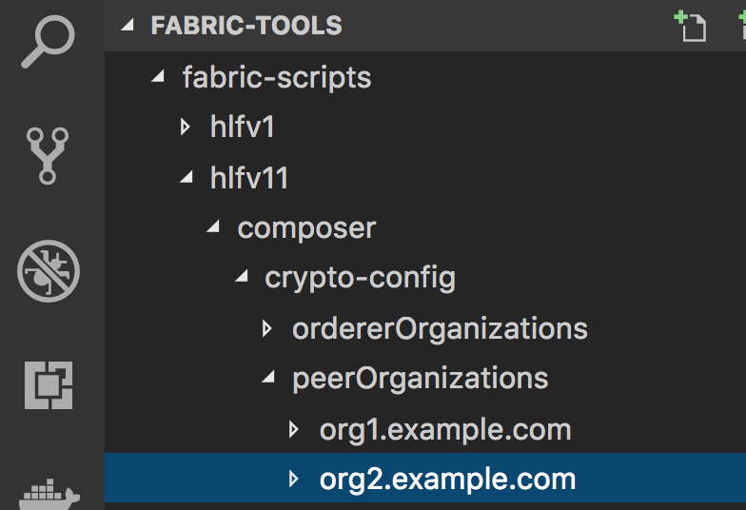

***Task #2 is now Complete!***



## TASK#3: Fetch current config block and append the new Org2 material

**Step 1**: Under visual code editor we have already installed docker plugin. Launch **Docker Explorer** as shown below;

** Click the tab in RED below for docker explorer

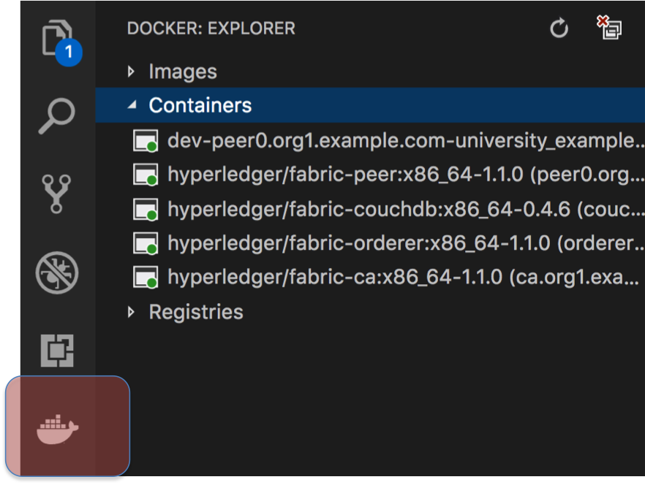

**Step 2**: Right click on the ‘**peer0.org1.example.com**’ container and click ‘Attach Shell’ option to move into peer0 container of org1 as shown below;

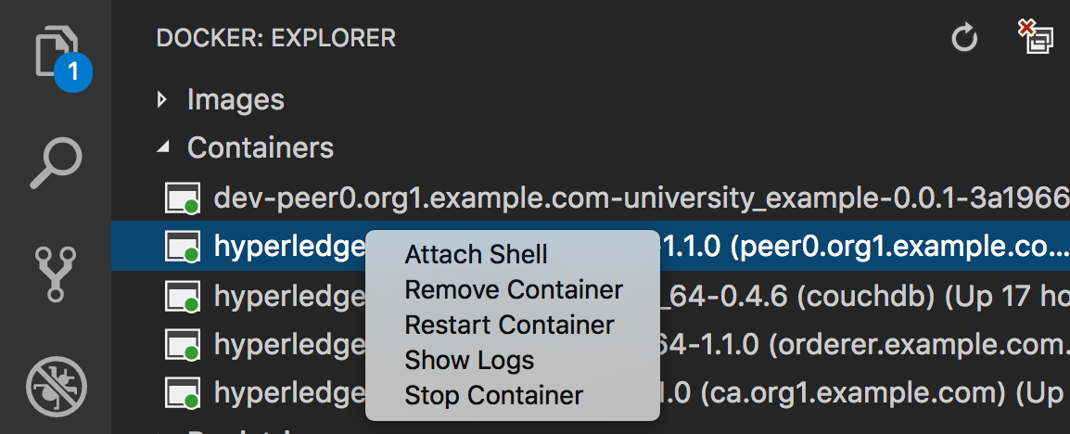

**Step 3**: A shell terminal for peer0 is started in Visual Code. Type following command to switch to super user



su

After this command we should be able to see the following in the VS code terminal window;

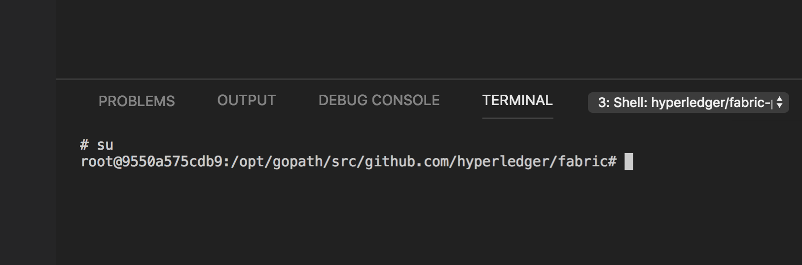

**Step 4**: Use the following command to install ‘**curl**’ and ‘**jq**’ utilities on the peer0 container. JQ utility will be use for json manipulations

*** Wait for sometime as it might take a long time and look like the command didn’t work;

apt-get -y -qq update && \

apt-get install -y -qq curl && \

apt-get clean

curl -o /usr/local/bin/jq http://stedolan.github.io/jq/download/linux64/jq && \

chmod +x /usr/local/bin/jq



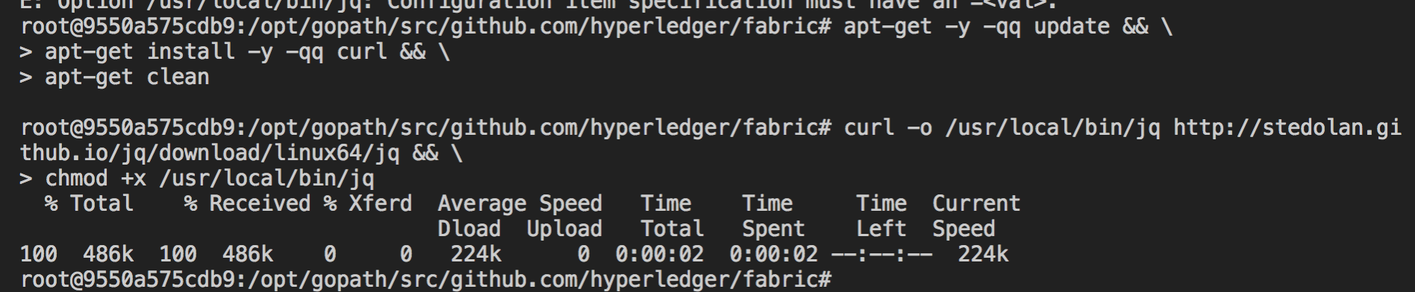

**Step 5**: Download Fabric binaries on the peer0 container using following commands;

curl -sSL https://goo.gl/6wtTN5 | bash -s 1.1.0 -s -d

**Step 6**: Update PATH variable so that the system can locate fabric binaries;

export PATH=/opt/gopath/src/github.com/hyperledger/fabric/bin:$PATH

** We will now be generating many intermediate files; lets move into the artifact directory we mapped in docker-composer.yaml in Task#1

**Step 7**: CD into the mapped directory for creating artifacts;

cd org2-artifacts

**Step 8**: Start the configtxlator tool in the background so that we can fetch the configurations and translate them to readable json files

configtxlator start &





**Step 8**: Now do some house-keeping to save efforts using variables

Let’s make our life easy using some variables: use exports for channel name and the transalator url…

export CHANNEL_NAME=composerchannel

export CONFIGTXLATOR_URL=http://127.0.0.1:7059

**Step 9**: Finally… now let’s retrieve the current configuration

peer channel fetch config config_block.pb -o orderer.example.com:7050 -c $CHANNEL_NAME

We should receive the block 2 – after genesis block for configuration as shown below;

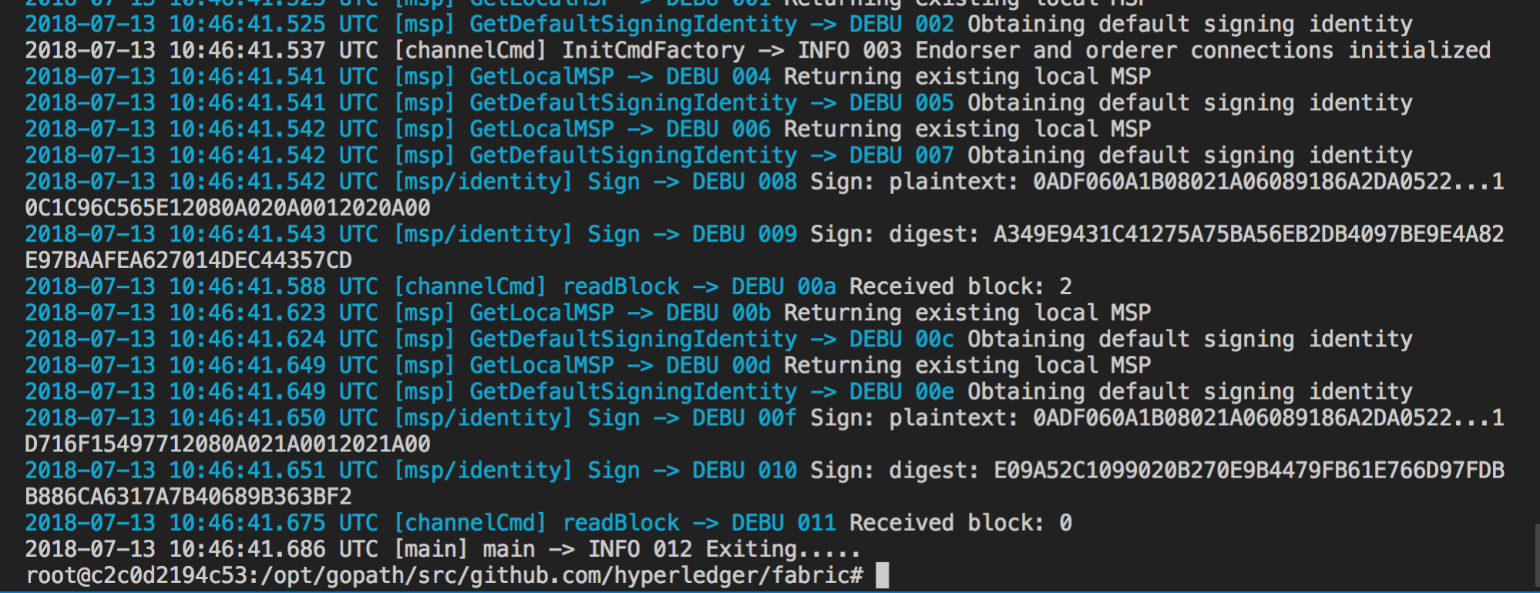



We should be able to see the retrieved ‘**config_block.pb**’ file in our mapped ‘**org2-artifact**’ folder of the host system

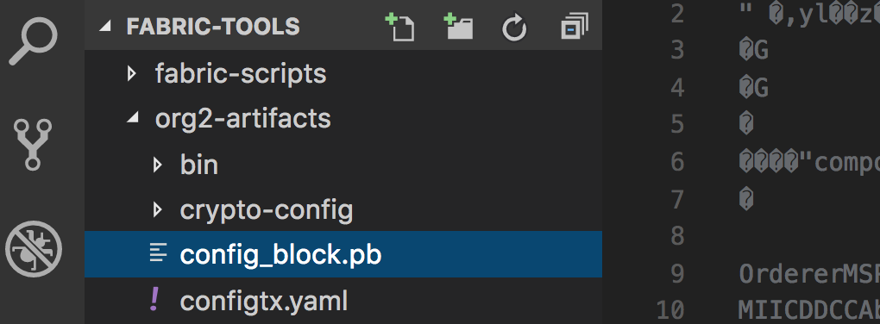

**Step 10**: Using configtxlator we can convert this config into a readable JSON file

curl -X POST --data-binary @config_block.pb $CONFIGTXLATOR_URL/protolator/decode/common.Block > config_block.json

On running the above command a new json file is created ‘**config_block.json**’

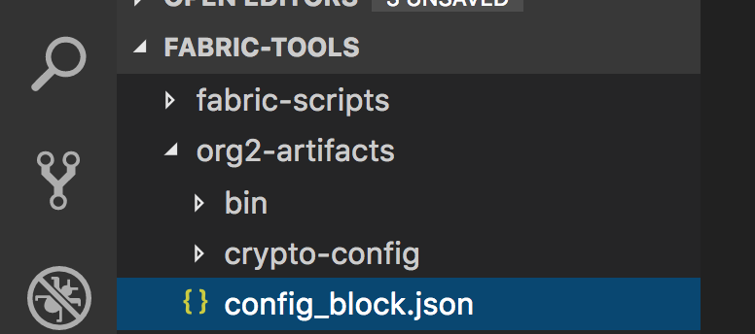

**Step 11**: Using jq tool extract the config section

jq .data.data[0].payload.data.config config_block.json > config.json



**Step 12**: In Task#2 we had created a config file for Org2, lets use this org2.json config file to get the additional configuration settings

jq -s '.[0] * {"channel_group": {"groups": {"Application": {"groups": { "Org2MSP":.[1]}}}}}' config.json org2.json >& updated_config.json

**Step 13**: Encode both updated and original configurations using configtxlator.

curl -X POST --data-binary @config.json $CONFIGTXLATOR_URL/protolator/encode/common.Config > config.pb

curl -X POST --data-binary @updated_config.json $CONFIGTXLATOR_URL/protolator/encode/common.Config > updated_config.pb

**Step 15**: Compute the config update delta, which represents the changes to the config.

curl -X POST -F original=@config.pb -F updated=@updated_config.pb $CONFIGTXLATOR_URL/configtxlator/compute/update-from-configs -F channel=$CHANNEL_NAME > config_update.pb

**Step 16**: Now we decode the delta config block to human readable json so that we can wrap it again with header contents that we removed earlier;

curl -X POST --data-binary @config_update.pb $CONFIGTXLATOR_URL/protolator/decode/common.ConfigUpdate > config_update.json



**Step 17**: Create the final configuration json by wraping the header informations

echo '{"payload":{"header":{"channel_header":{"channel_id":"'$CHANNEL_NAME'","type":2}},"data":{"config_update":'$(cat config_update.json)'}}}' > config_update_as_envelope.json

**Step 18**: Convert back readable json to a binary file that is understood by the Fabric envoirnment

curl -X POST --data-binary @config_update_as_envelope.json $CONFIGTXLATOR_URL/protolator/encode/common.Envelope > config_update_as_envelope.pb

We now have the updated new config file with Org2 additions. In next task we will sign and submit this configuration.

** Don’t close the Terminal Window, we will be using the same terminal window for updating configuration to the fabric environment in next TASK

***Task #3 is now complete!***



## TASK#4: Sign & Update the new configuration

**Step 1**: Using the same terminal window as in Task#3; use the following command to sign the new updated configuration block with peer0 crypto material

peer channel signconfigtx -f config_update_as_envelope.pb

The terminal output shows the success of signing to ensure everything went right as below;

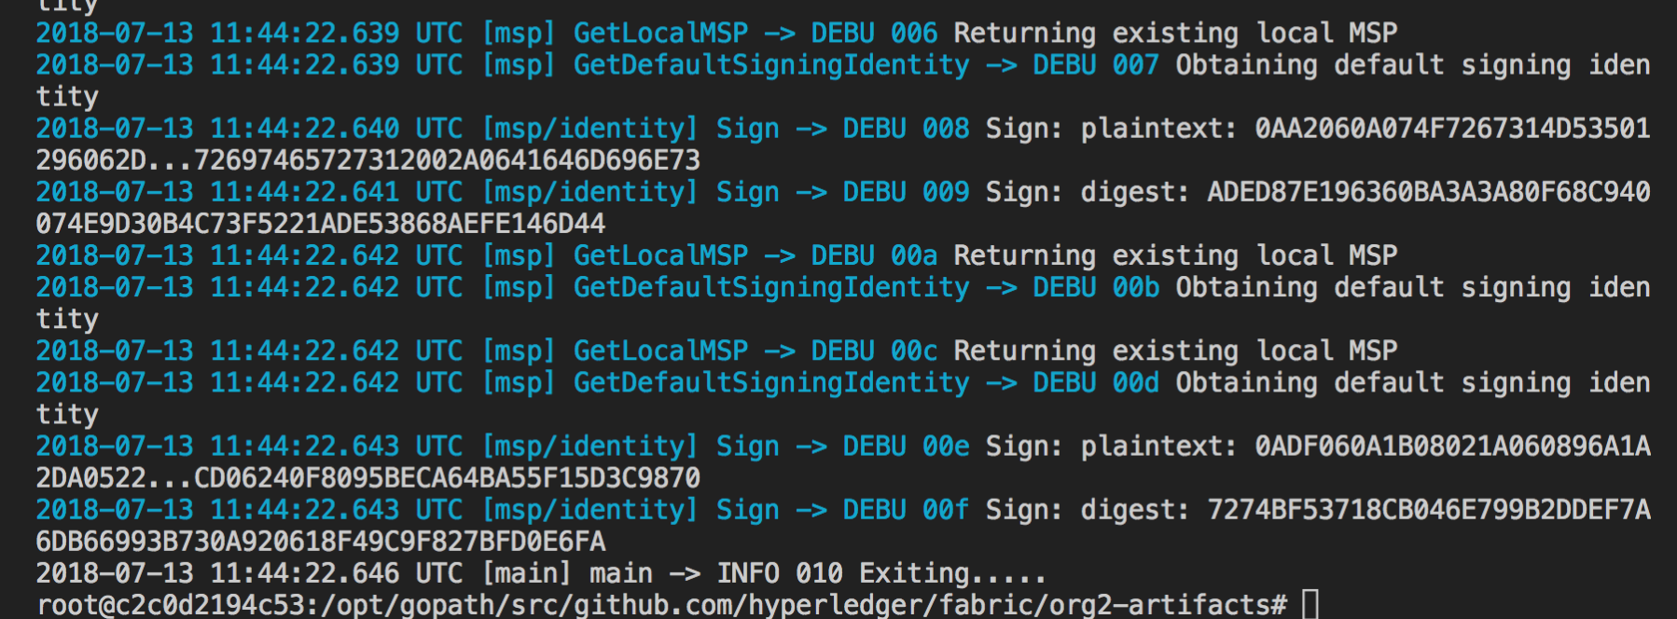

**Step 2**: Finally submit to Fabric for update channel configuration transaction using the commands below;

peer channel update -f config_update_as_envelope.pb -o orderer.example.com:7050 -c $CHANNEL_NAME



Terminal window logs will show if the update was successful; as shown below

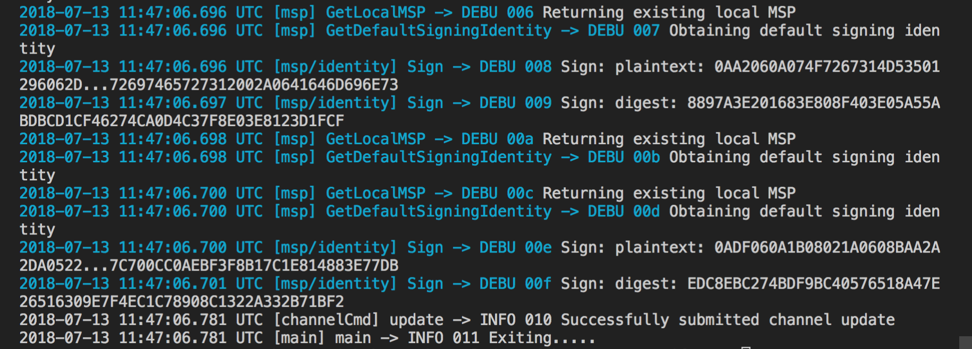

**Step 3**: Lets also validate by retrieving the updated configuration block from the – Orderer;

peer channel fetch config config_block_Org2MSP.pb -o orderer.example.com:7050 -c $CHANNEL_NAME

curl -X POST --data-binary @config_block_Org2MSP.pb $CONFIGTXLATOR_URL/protolator/decode/common.Block > config_block_Org2MSP.json

With above commands we fetch and also convert the new configuration block from orderer to a readable json

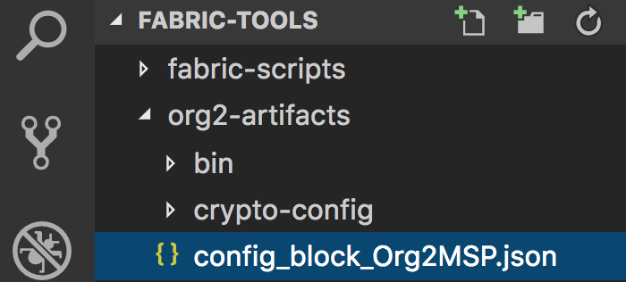



**Step 4**: Search for ‘Org2’ in the json file retrieved ‘**config_block_Org2MSP.json’**

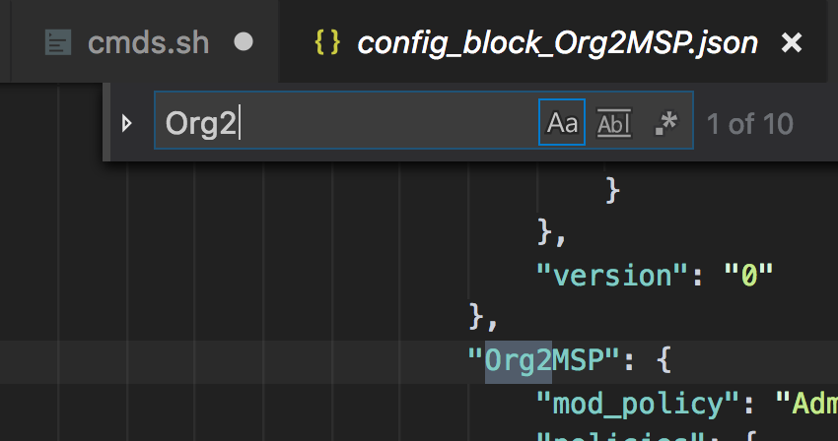

In the configuration retrieved from Orderer we find instances of Org2 – hence we can conclude that – update transaction was a success.

**Step 5**: Also verify orderer logs as below’

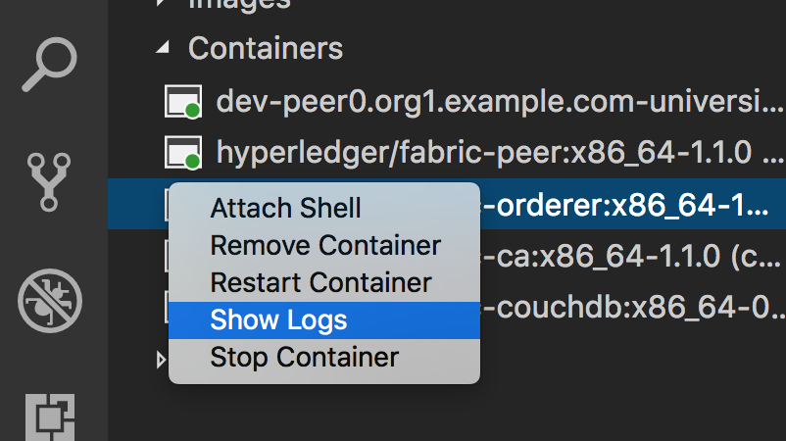

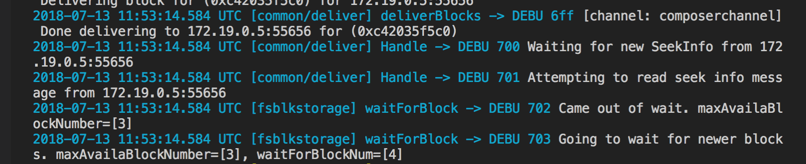

This shows that a new block – ‘3’ was created with the update transaction success.

***Task #4 is now complete!***



## TASK#5: Spin Up Org2

** Now we have updated the channel configuration to accommodate Org2. We can now launch a new peer node with Org2 crypto materials

Under the ‘org2-artifacts’ folder we copied a ‘***docker-compose-org2.yaml***’ file from the chapter08 file. Lets check what we have in that file;

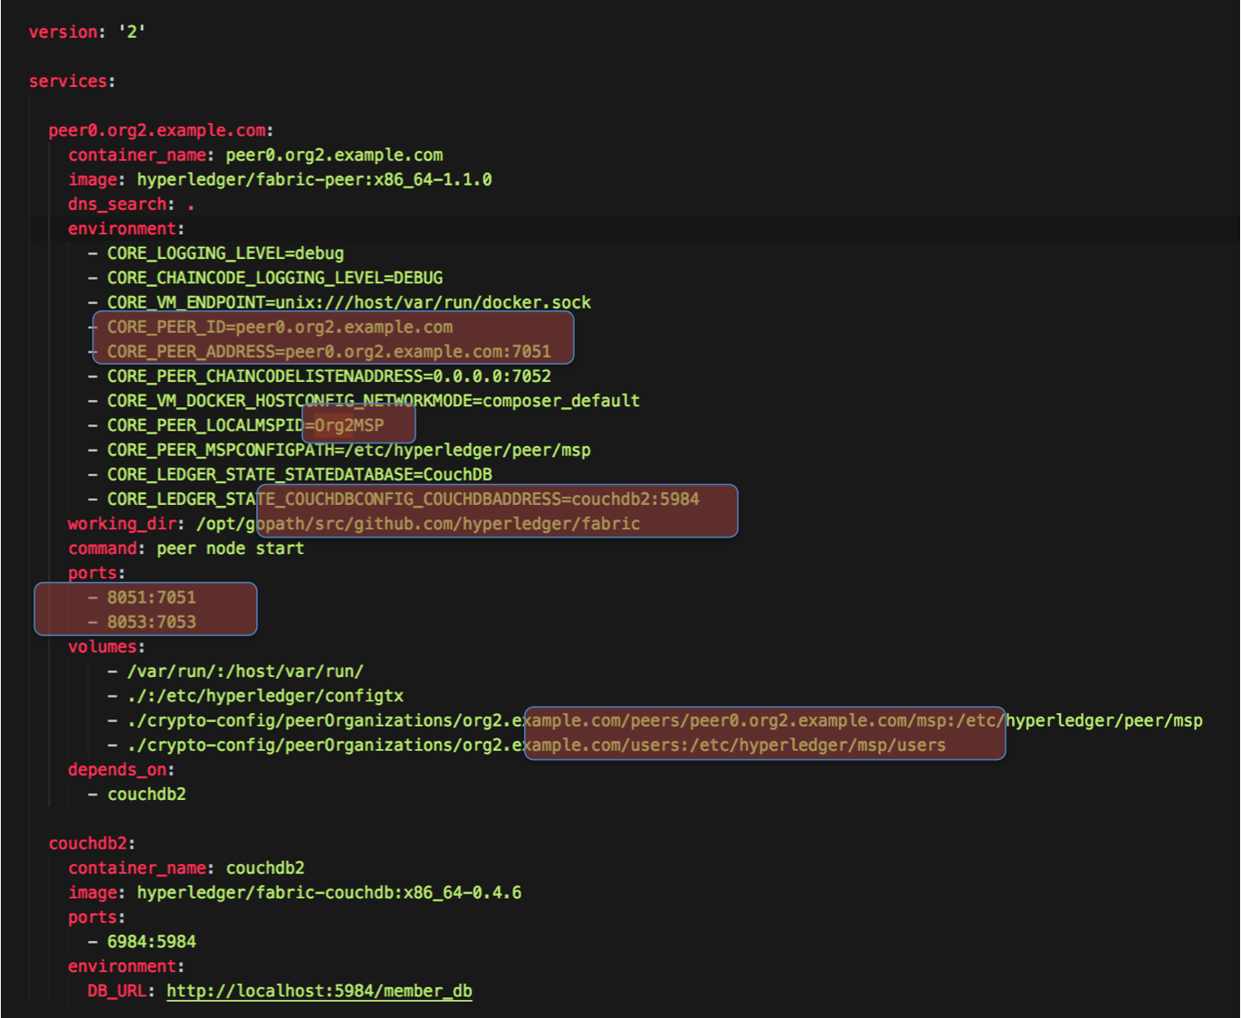

It is similar to the original ‘**docker-composer.yaml’** file but has only 1 peer service with name peer0.org2.example.com which was specified in the channel configurations



**Step 1**: Open a terminal window and CD into the ‘**org2-artifacts**’ folder

cd $HOME/fabric-tools/org2-artifacts

**Step 2**: We have all the crypto material in the ‘**composer**/crypto-config’ folder of hlf11 where we copied the org2 crypto as well in Task#1.

Lets move the ‘**docker-composer-org2.yaml’** file to the composer folder

mv ./docker-compose-org2.yaml $HOME/fabric-tools/fabric-scripts/hlfv11/composer

**Step 3**: CD into the composer folder to launch docker container

cd $HOME/fabric-tools/fabric-scripts/hlfv11/composer

**Step 4**: Retrieve machine architecture into a variable so that appropriate docker container can be launched

ARCH=`uname -m`

**Step 5**: Launch the new peer0.org2 node docker container

ARCH=$ARCH docker-compose -f docker-compose-org2.yaml up



**Step 6**: Use Docker explorer to validate that both ‘peer0.org2’ and ‘couchdb2’ nodes have successfully started;

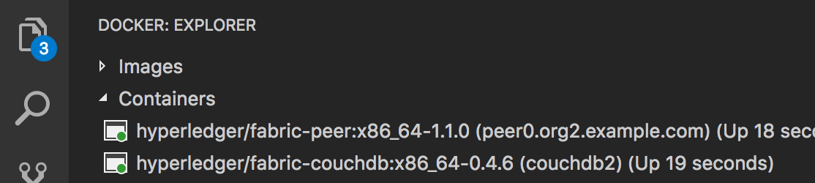

***Task#5 is now complete!***



## TASK#6: Org2 Joins the channel

**Step 1**: Launch Visual Studio code and open the Docker explorer as in task#5

**Step 2**: This time we want to launch bash terminal for ‘**peer0.org2**’ so that Org2 can join the channel. Use image below;

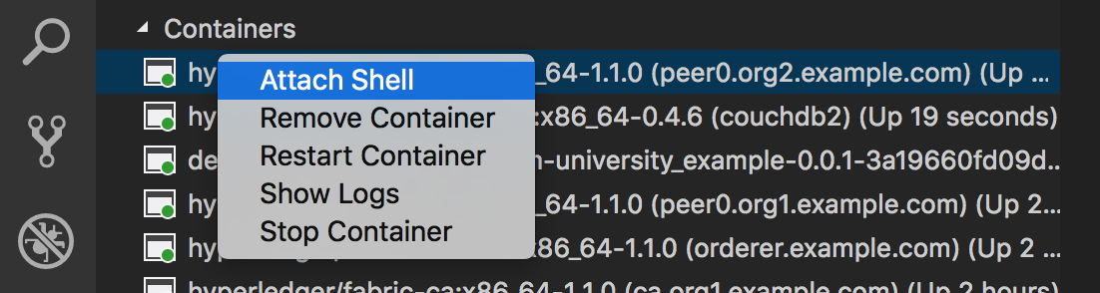

**Step 3**: In the terminal window for **peer0.org2** use following command to switch to super user or use bash command

su

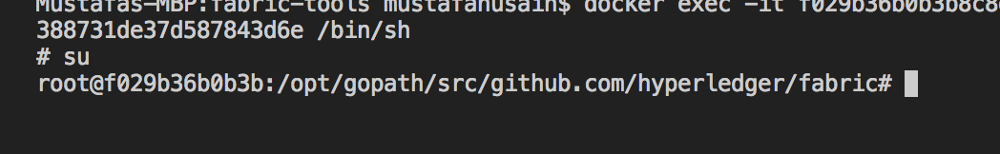

**Step 4**: Update the Environment variable so that the peer can use the correct crypto materials;

** As a part of crypto material generation for Org2 we had created an Admin user only which has the authority to transact with Orderer when dealing with Org2



CORE_PEER_MSPCONFIGPATH=/etc/hyperledger/msp/users/Admin@org2.example.com/msp

**Step 5**: Set channel name to be used in further commands;

export CHANNEL_NAME=composerchannel

**Step 6**: We now need to fetch the genesis block in order for the new org to join. Use the following command;

peer channel fetch 0 composerchannel.pb -o orderer.example.com:7050 -c composerchannel

We are fetching the genesis block here!!! Hence will receive block 0 as shown below;

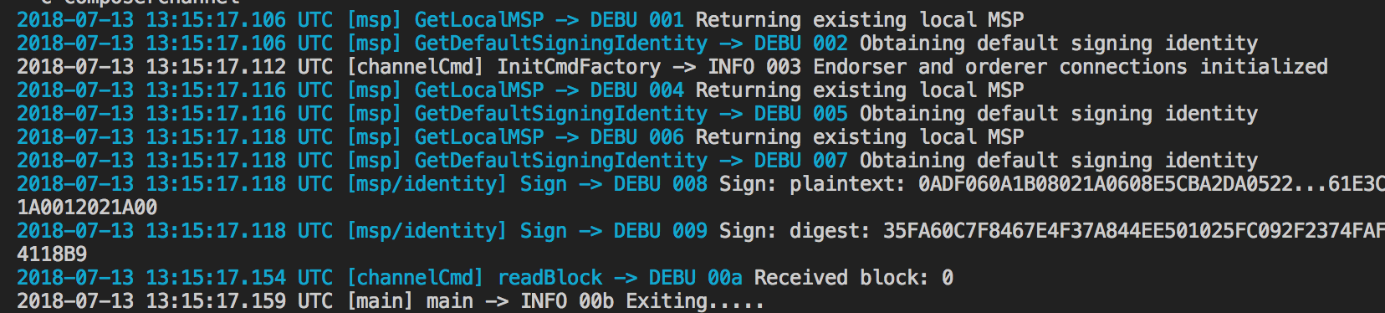

**Step 7**: We have couchdb and couchdb2 up and running; let’s check out what documents we have in both so far;

Launch internet explorer and go to the following URL for **couchdb**:

<http://localhost:5984/_utils/>

**Step 8**: Launch second internet explorer and go to the following URLfor **couchdb2**:

<http://localhost:6984/_utils/>



**Step 9**: Compare that couchdb2 still does not have the channel: composerchannel transaction details NOR our university_example BNA chaincode & transactions

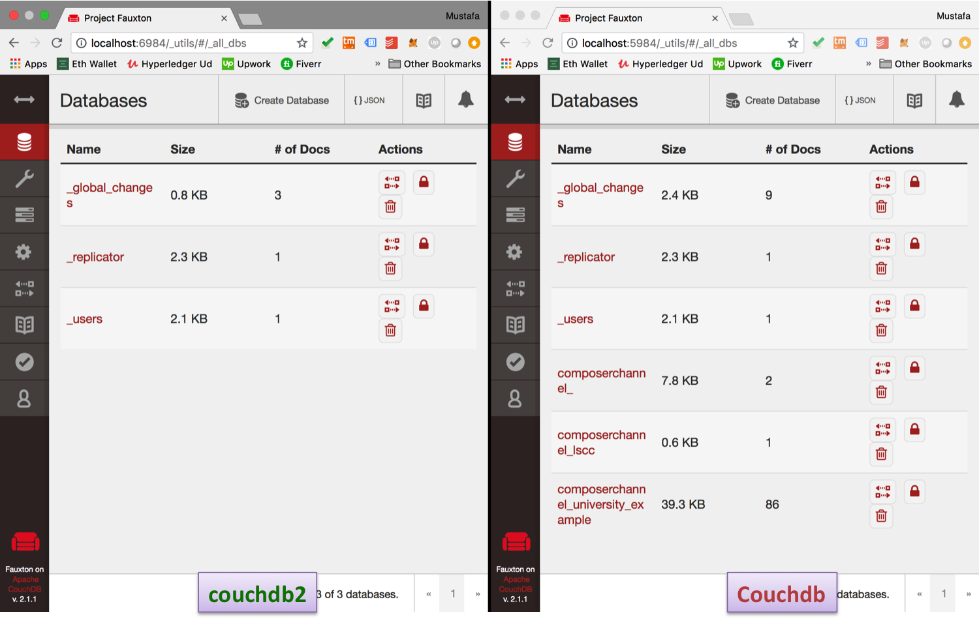

**Step 10**: Join Org2 to the existing network now using the composerchannel genesis block file & the following command;

peer channel join -b composerchannel.pb

Terminal log shows that Org2 has been successfully inducted to the channel

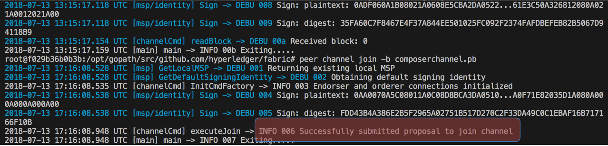

***Task#6 is now complete!***

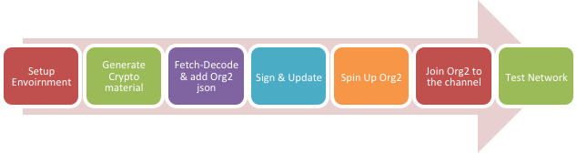

## TASK#7 Test Network

**Step 1**: Visualize that the docker containers for couchdb2 and peer0.org2.example.com both exists;

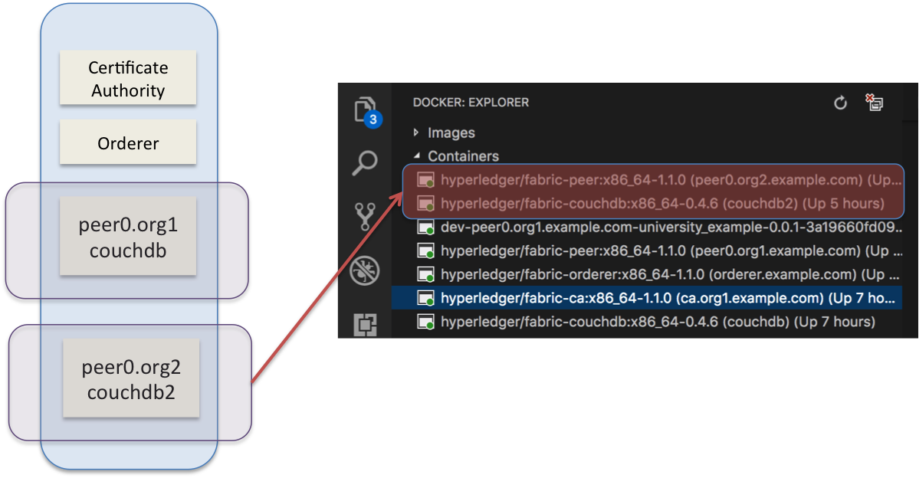

**Step 2**: Check both couchdb again now as done in Task#6

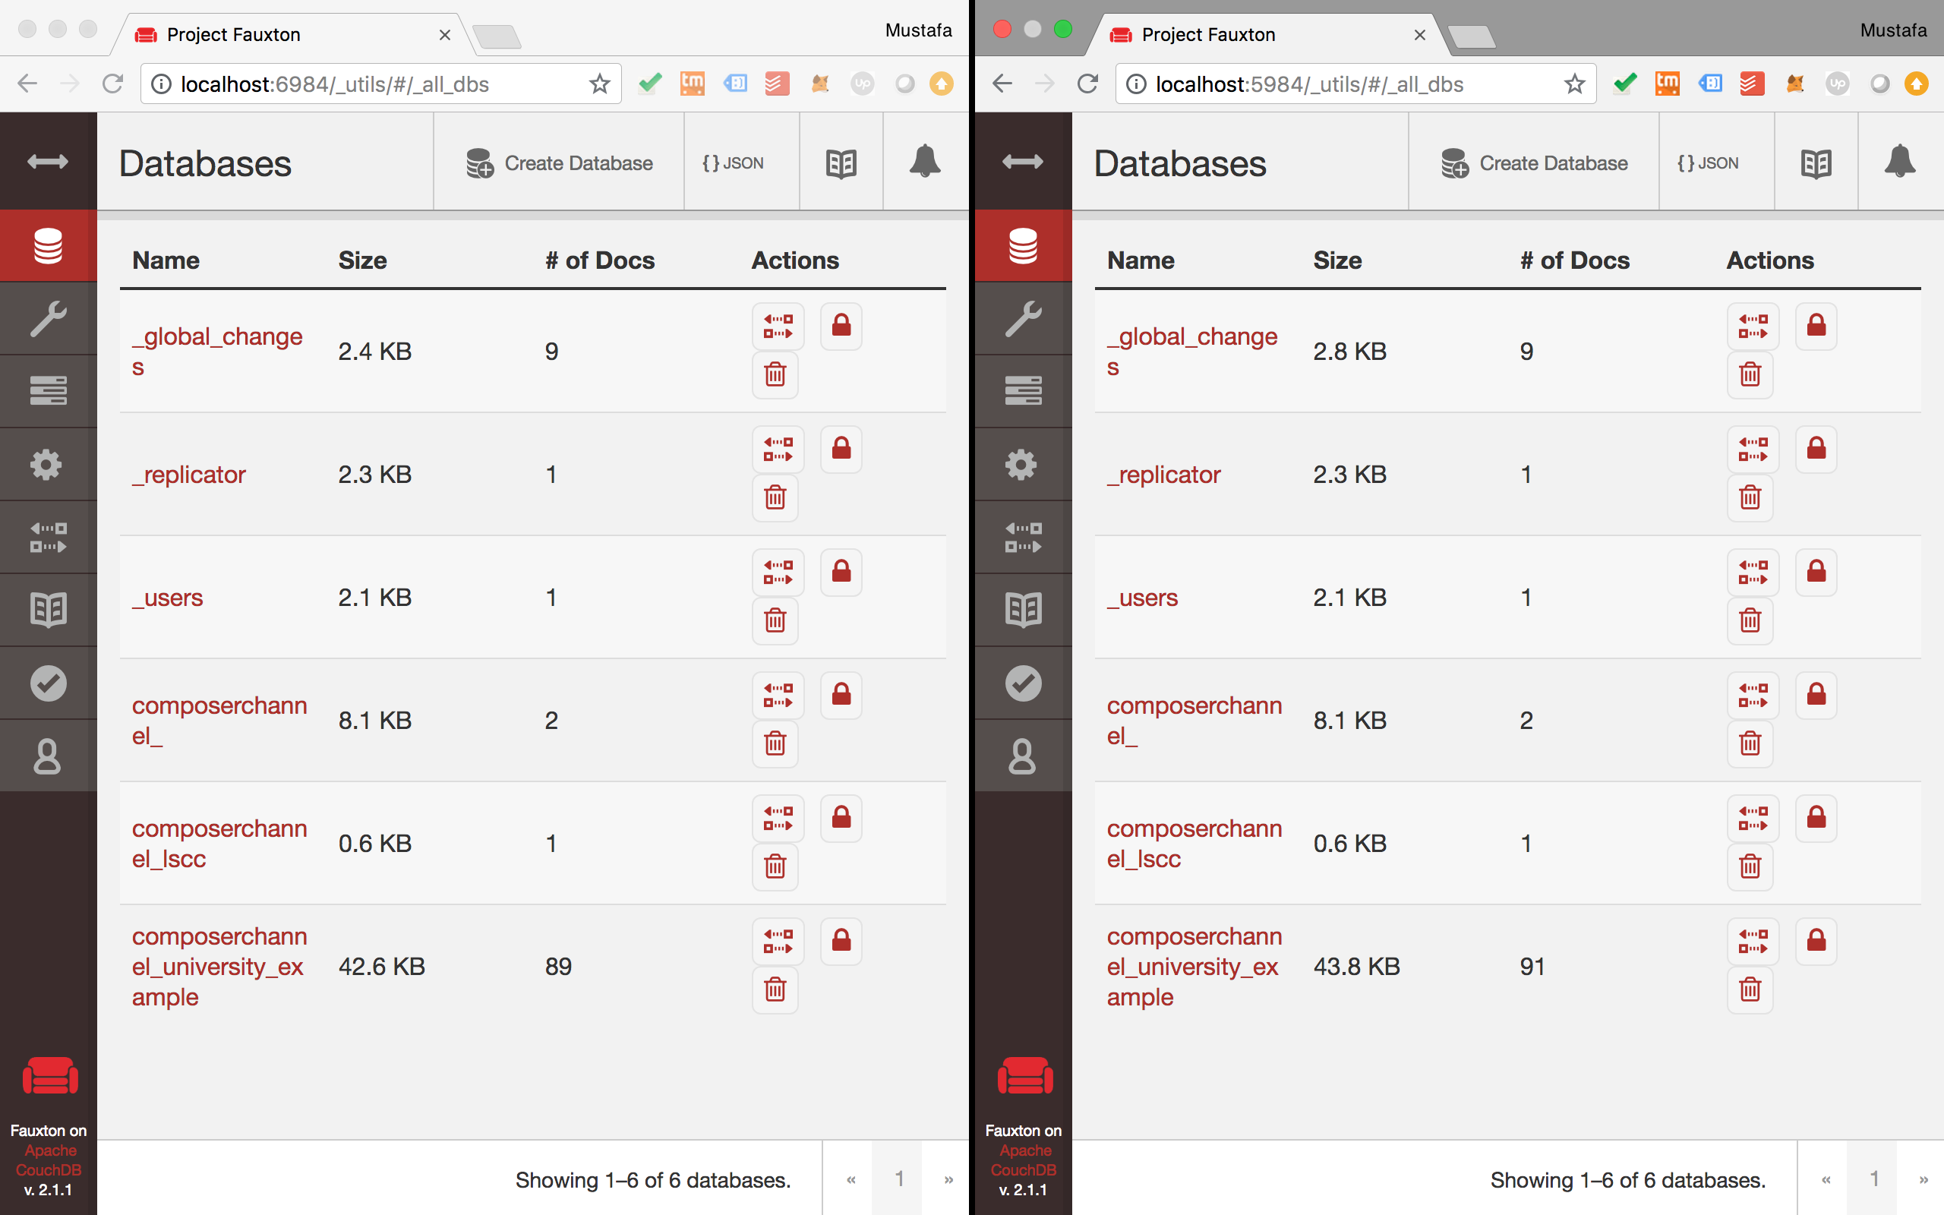



**Please Note:** In above couchdb & couchdb2 utils page side by side

* Composer channel table and corresponding entries now exists for Org2
* It also has university_example BNA transaction documents

**Step 3**: Validate using Hyperledger Blockchain explorer;

**Students are encouraged to Utilize-Chapter 6 to setup blockchain explorer and view complete Org1 & Org2 artifacts

**Task #8 is complete!**

# SUMMARY

In this chapter we

* Decoded the existing network/channel configuration
* Generated the crypto material for the second organization and peer
* Updated the channel configuration setup with new Org2
* Launched containers for the new Org2
* Added new Org2 to the channel

Students are further encouraged to explore deeper and play with the Hyperledger business network & the explorer for better learning.

# CHAPTER 9: Scaling Hyperledger on Multiple Hosts

## Theory

In this chapter we will add a new peer to our business network and deploy it on a separate host machine.

## University Usecase – New Setup

Host#1:

* CA – ca.org1.example.com
* Orderer – orderer.example.com
* Peer0 – peer0.org1.example.com
* Couchdb – couchdb
* Peer1 – peer1.org1.example.com
* Couchdb1 – couchdb1

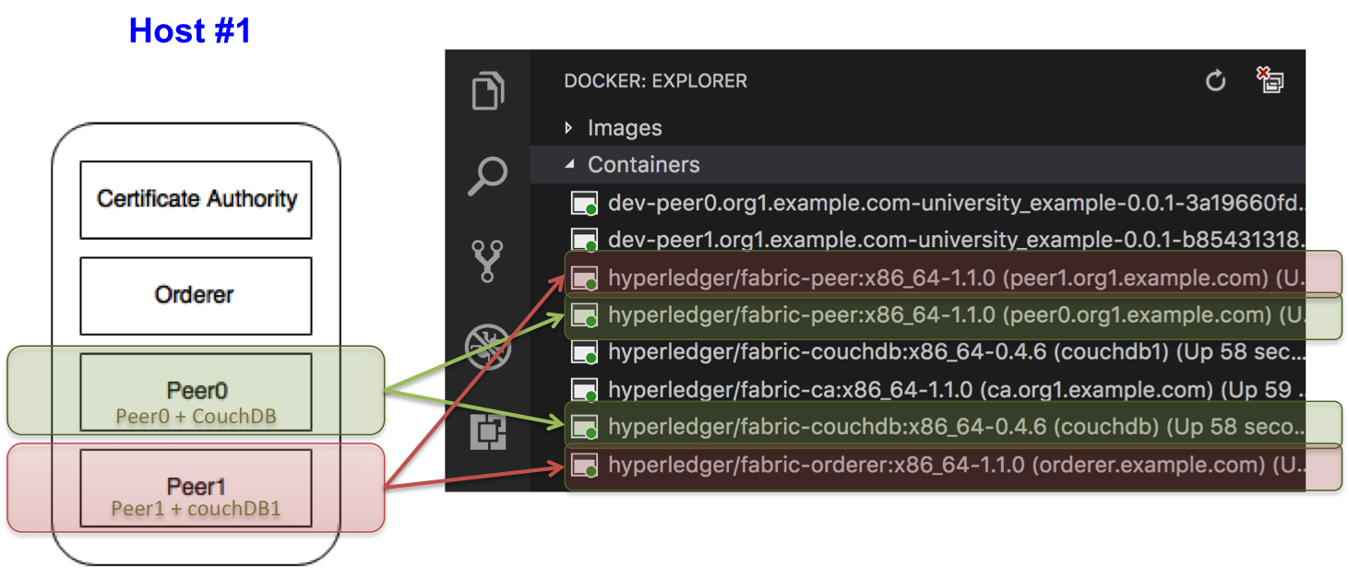

Host#2:

* Peer2 – peer2.org1.example.com
* Couchdb2 – couchdb2

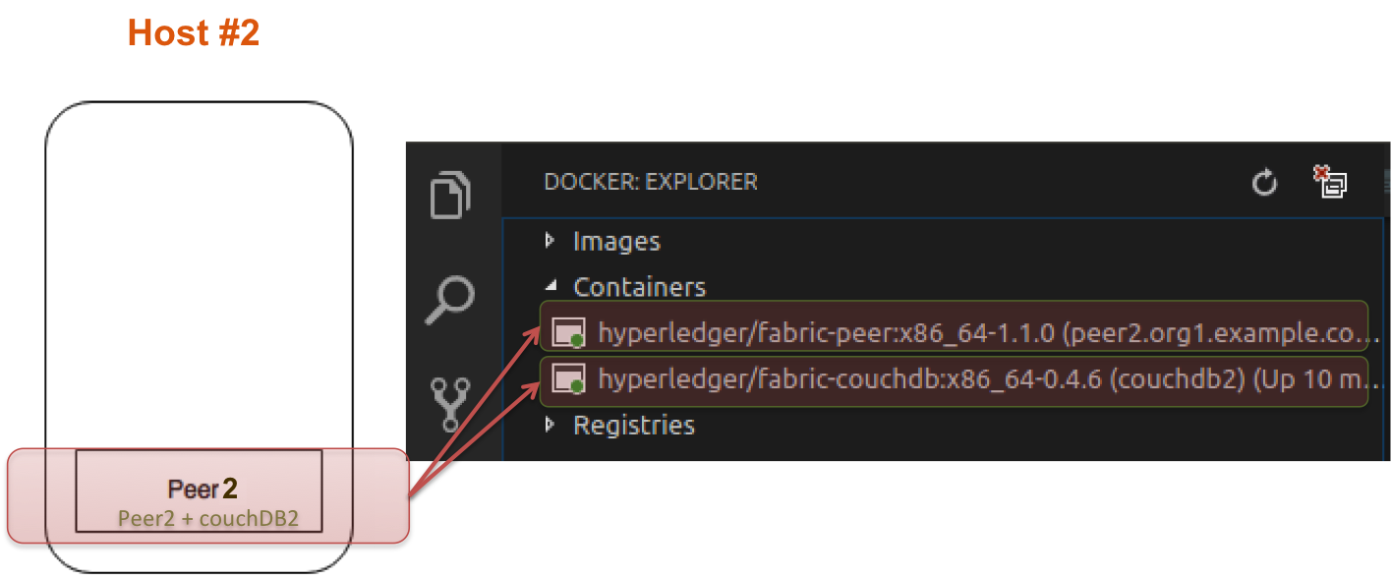

# Lab Exercise 9: Scaling Hyperledger on Multiple Hosts

|  |
| --- |
|  |

1. Download binaries to generate crypto material
2. Generate Crypto material & copy on second host
3. Update cypto-config.yaml
4. Generate Crypto
5. Copy the crpto material on Host#2
6. Configure Docker Services
7. Add new Peer + CouchDb to Host#1
8. Update crypto keys
9. Create new Docker Service for Host#2
10. Configure Scripts
11. Update startFabric.sh script to join Peer1 to the channel on Host#1
12. Update startFabric.sh script to join Peer2 to the channel on Host#2
13. Peer Admin Card creation
14. Update connection string for Host#1
15. Make connection string for Host#2
16. Create Docker Swarm network
17. Create docker swarm on Host#1 & Host#2 join as Manager
18. Install & Start Business Network
19. Test the network
20. Visualize Docker setup
21. Validate Couch DB on both Hosts
22. Install University example & validate blocks on both hosts

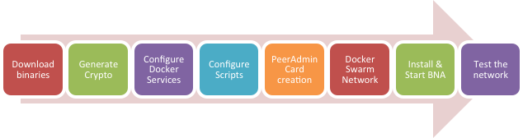

|  |
| --- |
| **Note: Multi-Host does NOT currently work on Mac system. Hence you will need TWO Ubuntu 16.04 systems  **Prerequisites:**   * Hyperledger Fabric Composer is installed on both hosts   **Color Coding:**  All tasks in this chapter shall start with an indication where this task has to be executed. It will be either of the following   * **Host#1:** To be executed on Host#1 only * **Host#2:** To be executed on Host#2 only * **Host#1 & Host#2:** To be executed on both hosts |

## TASK#1: Download Binaries & setup path On Host#1

**Step 1:** Open the terminal window and CD into the Fabric’s root folder directory

|  |
| --- |
| **\*\* Please Note:** In this chapter for compatibility reasons we have renamed Fabric’s root directory to **‘fabric-tools’**. So If you have **NOT** installed Hyperledger using this Book & Scripts, root folder name will be **‘fabric-dev-servers’** instead |

Host#1

cd $HOME/fabric-tools

**Step 2:** Execute the following command from within the directory into which you will extract the platform-specific binaries:

Host#1

curl -sSL https://goo.gl/6wtTN5 | bash -s 1.1.0 -d -s



The command above downloads and executes a bash script that will download and extract all of the platform-specific binaries you will need to set up your network and place then in the **bin subdirectory**



Host#1

**Step 3:** Add that to your PATH environment variable so that these can be picked up without fully qualifying the path to each binary

Host#1

export PATH=$HOME/fabric-tools/bin:$PATH

** Don’t close the Terminal Window, we will be using the same terminal window for generating crypto-materials

**Task 1 is complete!**



## TASK#2: Generate Crypto Material

**Step 1**: Using the same above terminal where we have setup path for our binaries we will use it to generate crypto materials

Now, move to the directory Hyperledger 1.1 – composer directory:

Host#1

cd $HOME/fabric-tools/fabric-scripts/hlfv11/composer

**Host#1 & Host#2**

**Step 2**: Delete the existing ‘crypto-config’ directory



Host#1

**Step 3**: Using Visual Studio Code Open the “fabric-tools” folder and open the “crypto-config.yaml” for editing





Host#1

**Step 2**: We want 3 peers instead of existing 1 – hence we update the crypto material required in “crypto-config.yaml” to **‘3’ as shown below**

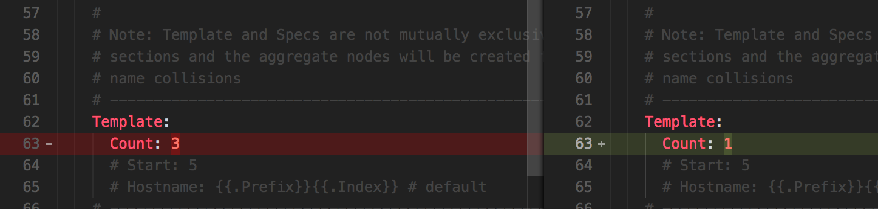

Host#1

**Step 3**: Generate crypto materials using the following commands:

cryptogen generate --config=./crypto-config.yaml

export FABRIC_CFG_PATH=$PWD



* Now write genesis block

configtxgen -profile ComposerOrdererGenesis -outputBlock ./composer-genesis.block

* Time to define new channel

configtxgen -profile ComposerChannel -outputCreateChannelTx ./composer-channel.tx -channelID composerchannel

Host#1

On running these commands new crypto material is generated in the “cryto-config” directory as shown below;

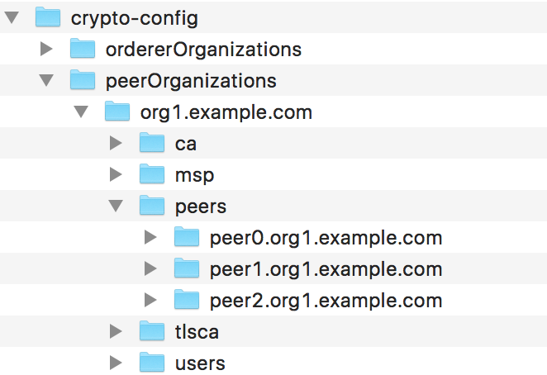

Host#1

**Step 4**: Crypto Materials have been generated now we need to move the crypto materials for Peer2 to Host#2



**\*\*IMP**:

* Ensure that ‘**crypto-config’** folder on Host#2 in hlfv11/composer directory is deleted
* Replace $USERNAME with the username of Host#2
* Replace $HOST2_IP with the IP of Host#2

scp $HOME/fabric-tools/fabric-scripts/hlfv11/composer **$USERNAME@$HOST2_IP:**/fabric-tools/fabric-scripts/hlfv11/composer

Host#2

**Step 5**: Ensure that all the crypto material has been transferred to Host#2



**\*Please Note**: In actual scenario we should only transfer the crypto material relevant to Peer2 to Host#2 but for simplicity of learning here we are transferring all the crypto material.

**Task 2 is complete!**



|  |
| --- |
| **\*\* Please Note:** As a reference a sample **Fabric Root** folder for Host#1 & Host#2 are provided. Its encouraged that Students should do a Diff of files to counter-check and not land up in errors. |

## TASK#3: Configure Docker Services

Host#1

In the docker-compose.yml we already have services 1 to 4 in the listing below. We will add the additional peer1 & couchdb1 services.

1. ca.org1.example.com [Update crypto-material]
2. orderer.example.com
3. peer0.org1.example.com
4. couchdb
5. peer1.org1.example.com [Add New]
6. couchdb1 [Add New]
7. Use Docker Swarm Network [Add New]

Host#1

**Step 1**: Using Visual Studio Code Open the “fabric-tools” folder and open the “docker-compose.yml” of hlfv11 for editing





Host#1

**Step 2**: Configure the Certificate Authority, using the certificates that have been generated newly. In the command section of ca.org1.example.com make sure to use the proper private key file.

Private Key File located under composer/crypto-config/peerOrganizations/



* Use this **File Name** – ends with **_sk** in the **“docker-compose.yml”**



Host#1

**Step 3**: Add the new “peer1.org1.example.com:” section in the **“docker-compose.yml”**

**Please Note:** Take special care about the changes marked in image below;





Host#1

**Step 4**: Add the new “couchdb” section in the **“docker-compose.yml”**





Host#1

**Step 5**: Request docker to use externally created docker swarm network for all the containers; Add the following code to the **“docker-compose.yml”**

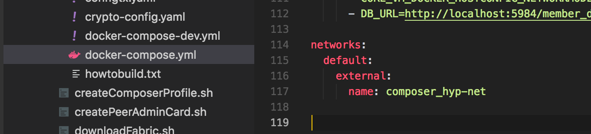

Host#1

**Step 6**: Add the new environment variable to each container for using docker swarm as shown below;



Add the above environment variable to all the container services as below:

* ca.org1.example.com
* orderer.example.com:
* peer0.org1.example.com:
* couchdb:
* peer1.org1.example.com:
* couchdb1:

Host#2

On second host we need only peer2 and corresponding couchdb2 hence in the docker-compose.yml we will add the additional peer2 & couchdb2 services and remove all other services.



Host#2

**Step 7**: Use the **“docker-compose.yml”** file from the provided fabric-tools folder for host#2 i.e “***fabric-tools-PC2***”

On Host#2 replace the content of **“docker-compose.yml”** file with that in the provided **“fabric-tools-PC”** as shown below;

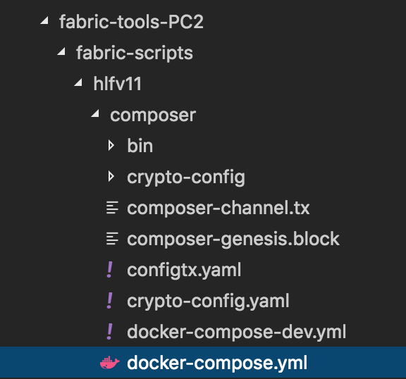

With this we are all set to launch the peers on multiple host. In next task we will make provisions to join the peer on host1 & host2 to the same network

**Task 3 is complete!**



## TASK#4: Configure Scripts – Join Peers to the channel

Host#1

**Step 1**: Using Visual Studio Code Open the “fabric-tools” folder and open the “startFabric.sh” of hlfv11 for editing



Host#1

**Step 2**: Channel is already created and peer0 is added to the channel as shown below:





Add following lines below it to add peer1 to the channel

Host#1

# # Fetch channel block from orderer

docker exec -e "CORE_PEER_MSPCONFIGPATH=/etc/hyperledger/msp/users/Admin@org1.example.com/msp" peer1.org1.example.com peer channel fetch config -o orderer.example.com:7050 -c composerchannel

# # Join peer1.org1.example.com to the channel.

docker exec -e "CORE_PEER_MSPCONFIGPATH=/etc/hyperledger/msp/users/Admin@org1.example.com/msp" peer1.org1.example.com peer channel join -b composerchannel_config.block

Host#2

**Step 3**: On Host#2 we repeat the same steps as done for adding Peer1 on Host#1. Using Visual Studio Code Open the “fabric-tools” folder and open the “startFabric.sh” of hlfv11 for editing





Host#2

**Step 4**: As the channel is already created in Host#1 we will fetch these details and add Peer2 to the channel.

On Host#2, replace the following lines shown with lines in next steps.



Add following lines below it to add peer2 to the channel

Host#2

# # Fetch channel block from orderer

docker exec -e "CORE_PEER_MSPCONFIGPATH=/etc/hyperledger/msp/users/Admin@org1.example.com/msp" peer2.org2.example.com peer channel fetch config -o orderer.example.com:7050 -c composerchannel

# # Join peer1.org1.example.com to the channel.

docker exec -e "CORE_PEER_MSPCONFIGPATH=/etc/hyperledger/msp/users/Admin@org1.example.com/msp" peer1.org1.example.com peer channel join -b composerchannel_config.block

**Task 4 is complete!**



## TASK#5: Peer Admin Card creation

Host#1

**Step 1**: Using Visual Studio Code Open the “fabric-tools” folder and open the “createPeerAdminCard.sh” of hlfv11 for editing



Host#1

**Step 2**: Update the connection string to add **peer1** as shown in the images below:

#1:



#2:





#3:



Host#1

**Step 3**: Update the PRIVATE KEY for the MSP as we did in TASK#3 Step-2.



**LOCATION for Key:**

[*crypto-config/peerOrganizations/org1.example.com/users/Admin@org1.example.com/msp/keystore/*](mailto:crypto-config/peerOrganizations/org1.example.com/users/Admin@org1.example.com/msp/keystore/)

**



Host#2

**Step 4**: We need to repeat similar steps on Host2 for Peer2. Using Visual Studio Code Open the “fabric-tools” folder and open the “createPeerAdminCard.sh” of hlfv11 for editing



Host#2

**Step 5**: Update the connection string to remove **peer0** & **peer1** and instead add **peer2** as shown in the images below:

#1:

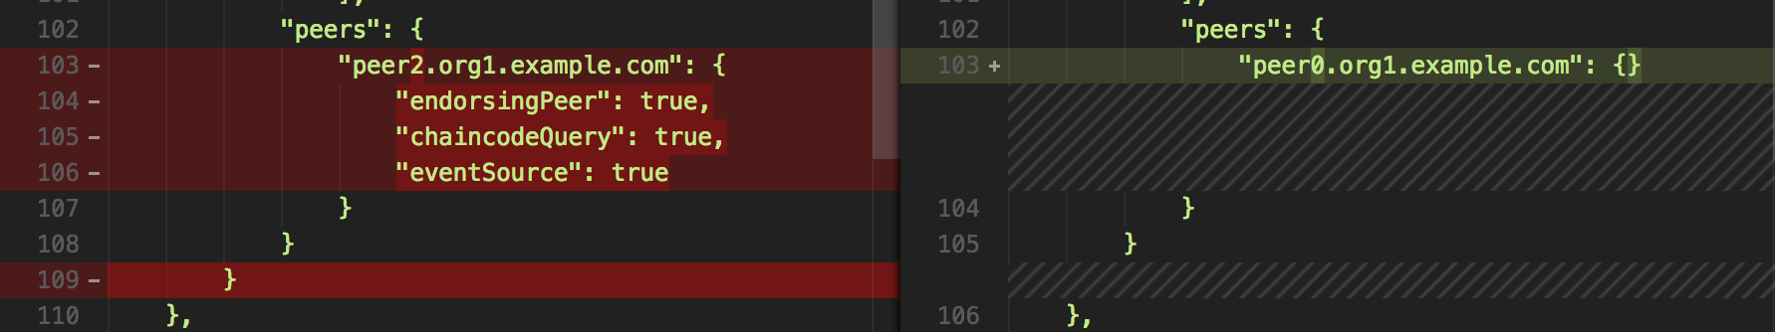

#2:





#3:

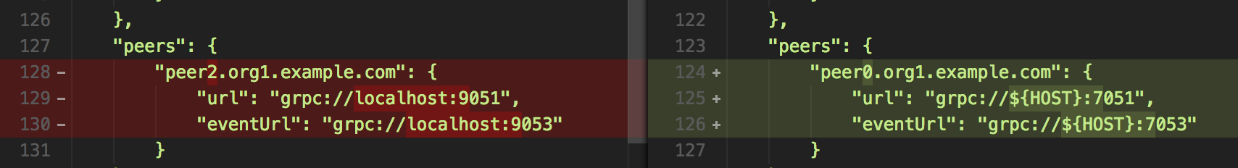

Host#2

**Step 6**: Orderer & CA in the script is assumes to be on the same localhost. We need to explicitly call it by its name to be identified on the docker swarm network.

For Orderer use **orderer.example.com** instead of ${HOST}

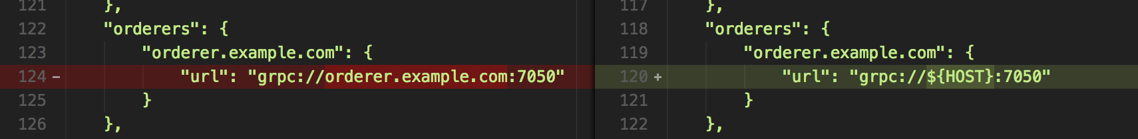

Similiarly use **ca.org1.example.com** instead of ${HOST}

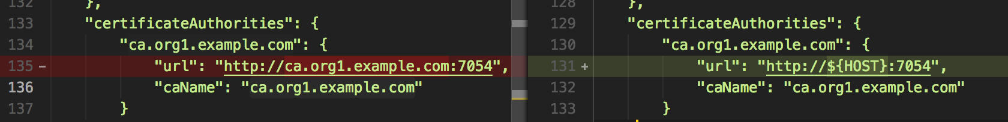

Host#2

**Step 7**: Update the PRIVATE KEY for the MSP as we did in Step-3.



**LOCATION for Key:**



[*crypto-config/peerOrganizations/org1.example.com/users/Admin@org1.example.com/msp/keystore/*](mailto:crypto-config/peerOrganizations/org1.example.com/users/Admin@org1.example.com/msp/keystore/)

**

**Task 5 is complete!**



## TASK#6: Create Docker Swarm network

**Please ensure docker service is running on both the HOSTs

Host#1 & HOST#2

**Step 1**: Open the terminal window and CD into the Fabric’s root folder directory

cd $HOME/fabric-tools

Host#1 & HOST#2

**Step 2**: Shutdown all docker containers using the following command

./teardownAllDocker.sh

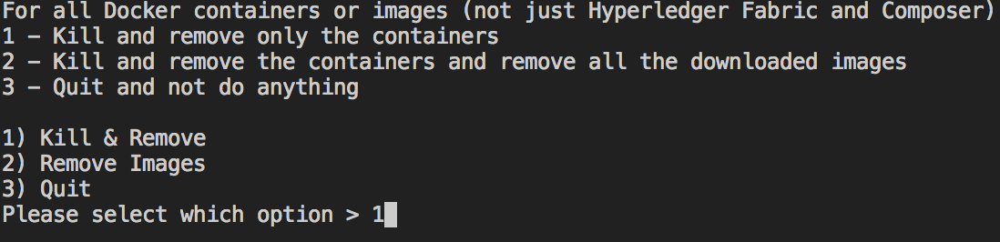

Choose **option 1** and press enter

Host#1

**Step 3**: Run the following command to start a docker swarm

** Please replace the text in blue below by the IP of Host#1

docker swarm init --advertise-addr **192.168.43.5**



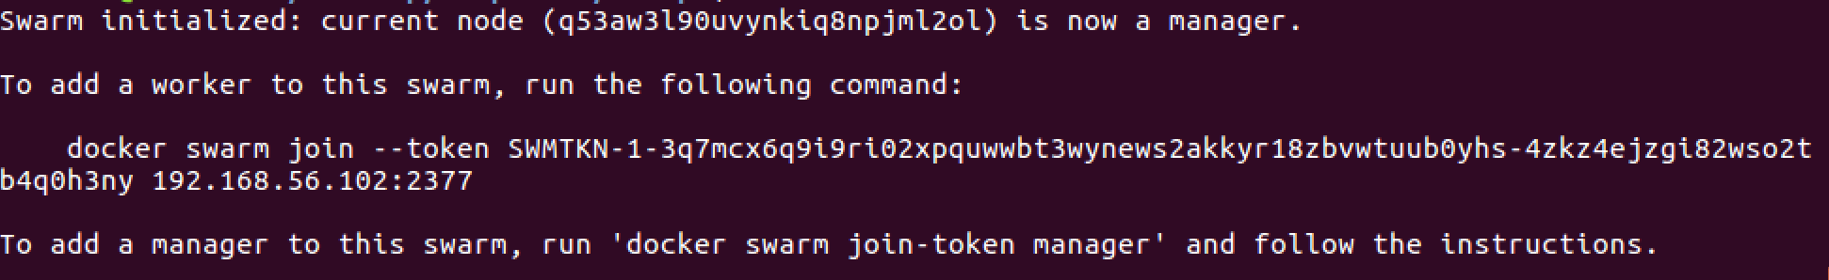

Host#1

**Step 3**: We need the other host HOST#2 to join as a manager hence run the following command on HOST#1

docker swarm join-token manager

On running above command you will get a string that you need to run on HOST#2

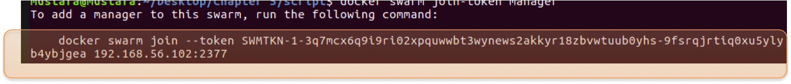

Host#2

**Step 4**: Use the highlighted command provided as a result of step3 on HOST#2 to join the docker swarm as a manager

docker swarm join --token SWMTKN-1-2hsbwmhd3gxmrzy2o2rpheb3rwukzninrvk1i041z4333okioe-73tsd5ig3tik0gbstn3qydk5e 192.168.56.102:2377

Host#2

**Step 5**: Use the highlighted command provided as a result of step3 on HOST#2 to join the docker swarm as a manager





Host#1

**Step 6**: Now we need to create an Overlay Network. Use the following command to generate the overlay;

docker network create --attachable --driver overlay composer_hyp-net

Host#1 & Host#2

**Step 7**: Validate that the overlay is created. Use following command to verify;

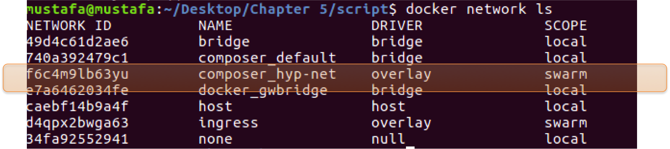

**Task 6 is complete!**



## TASK#7: Deploy and Launch the Network

Host#1 & Host#2

**Step 1**: Unzip “chapter05.zip” code and CD into the “chapter05” directory

Host#1 & Host#2

**Step 2**: Run NPM install to install all required dependencies

npm install

Host#1 & Host#2

**Step 3**: CD in the scripts directory

cd script

Host#1 & Host#2

**Step 4**: Using Visual Studio Code Open the “chapter05/script” folder and open the “deployNetwork.sh” file for editing

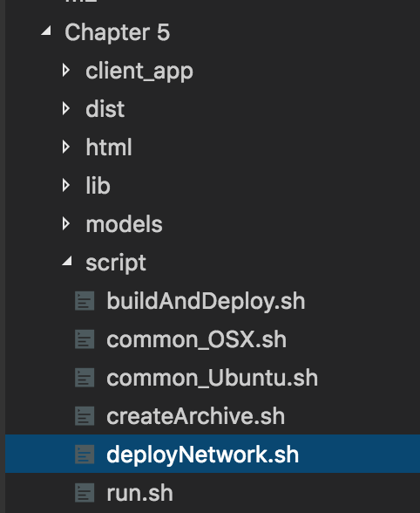



Host#1

**Step 5**: Along with this chapter two files “deployNetwork.1.sh” and “deployNetwork.2.sh” is provided in “**chapter5-script**” folder.

On Host#1 use the content of “deployNetwork.1.sh” and paste in the existing “deployNetwork.sh” file.

Host#2

**Step 6**: On Host#2 use the content of “deployNetwork.2.sh” and paste in the existing “deployNetwork.sh” file.

Host#1

**Step 7**: Run buildAndDeploy Script inside Chapter5/script folder

./buildAndDeploy.sh

The script will run the “startFabric.sh” and the “createPeerAdminCard.sh” files we created in the above tasks.

Let’s understand what happened with this script…

* Rather than creating a new network bridge the docker has now utilized our overlay we recently created

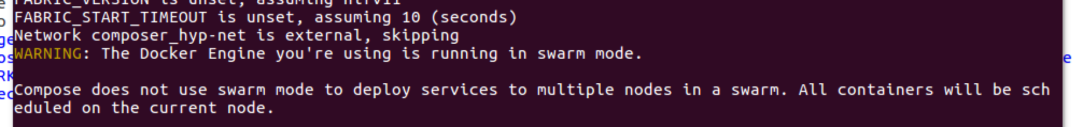

* Peer0 and Peer1 docker container is now created along with couchdb and couchdb1 containers



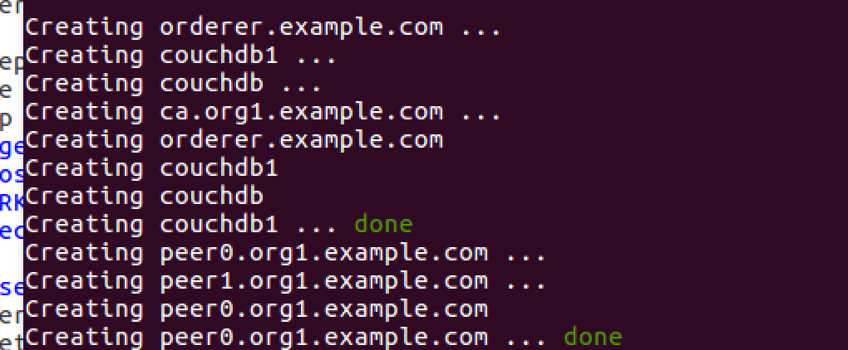

* ‘composer_channel’ is created

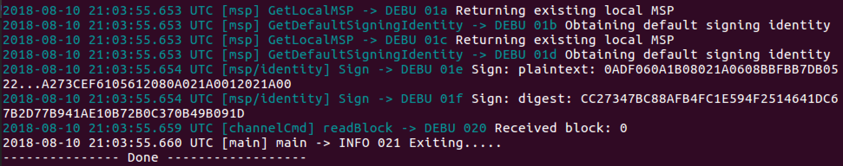

* Peer0 joined channel

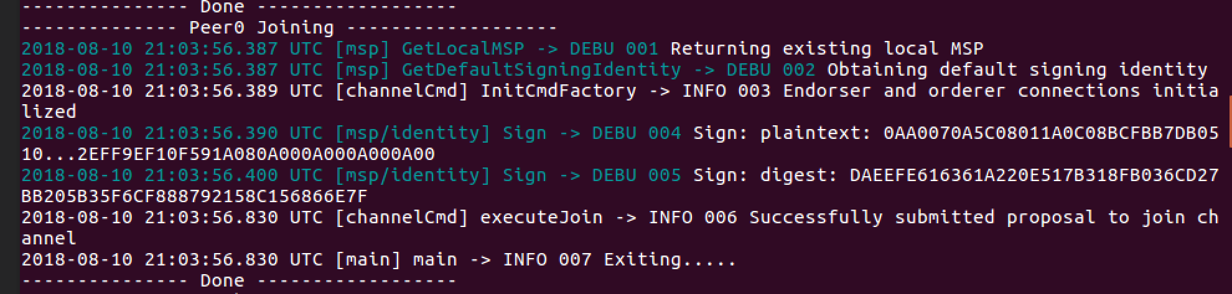

* Now as the channel is not empty, before Peer1 joining the channel we need to fetch existing channel blocks



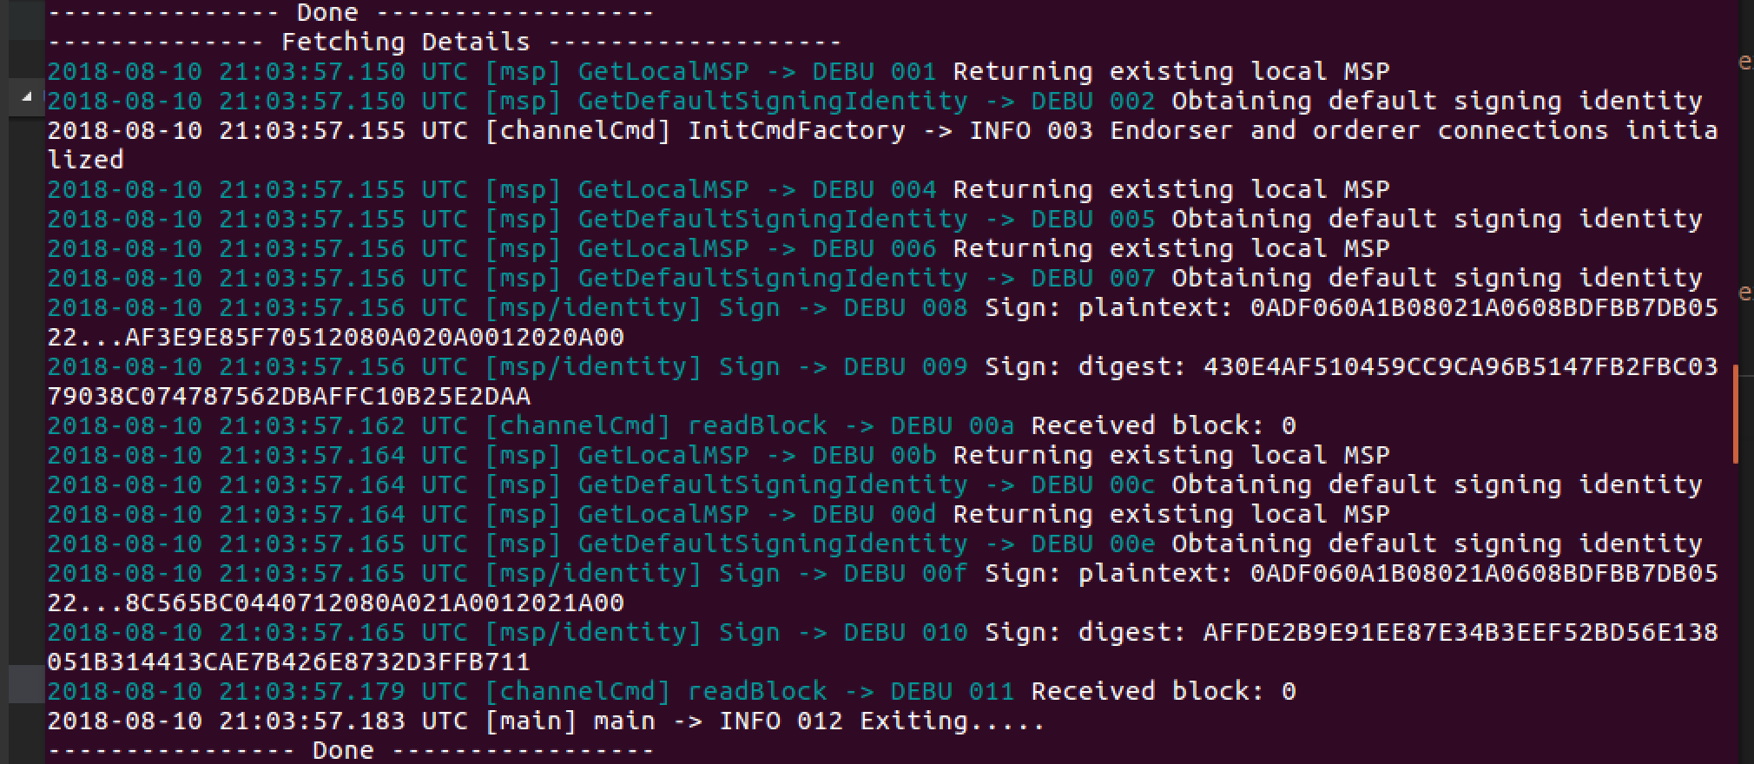

* Peer1 joined the channel

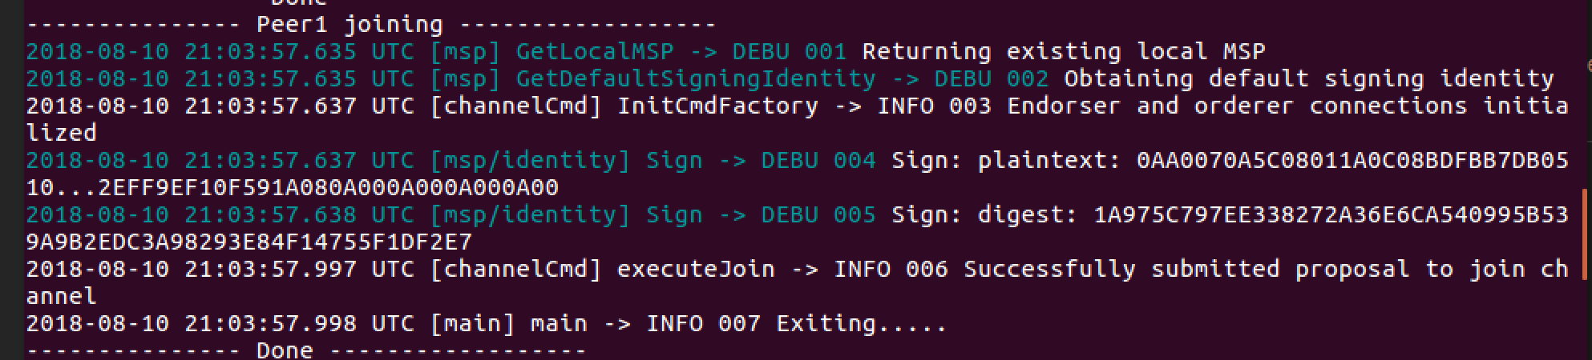

* New peerAdminCard is created & imported into the system

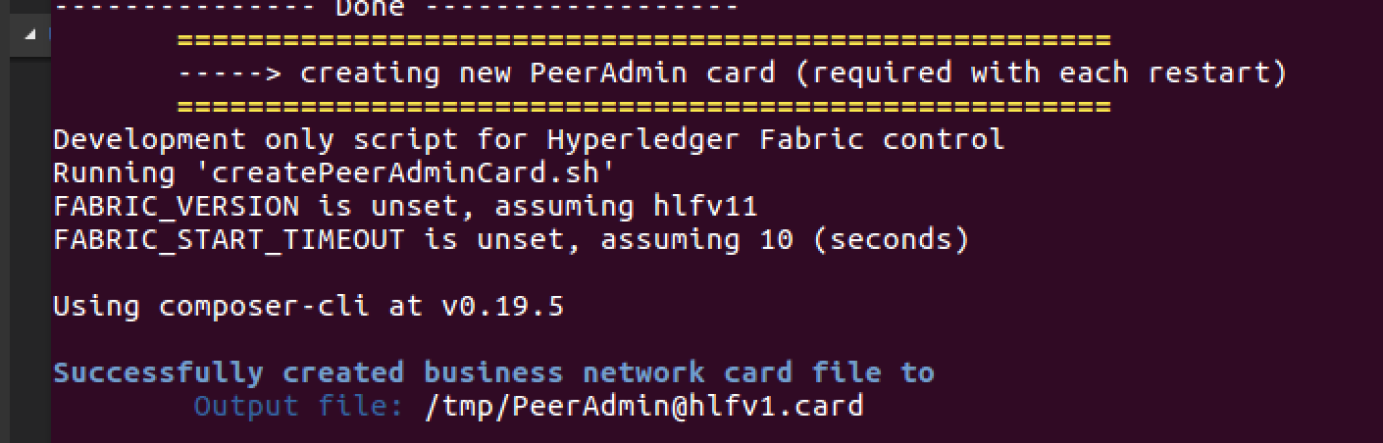



Host#1

**Step 8**: On Host#1 the script will halt. Before installing the network we need to launch the peer2 on host#2

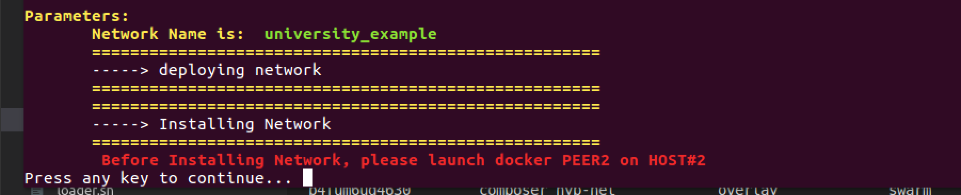

Host#2

**Step 9**: on Host#2 run buildAndDeploy Script inside Chapter5/script folder

./buildAndDeploy.sh

The script will again run the “startFabric.sh” and the “createPeerAdminCard.sh” files for Host#2.

Host#2 should also now utilize the same OVELAY network ‘***composer_hyp-net***’

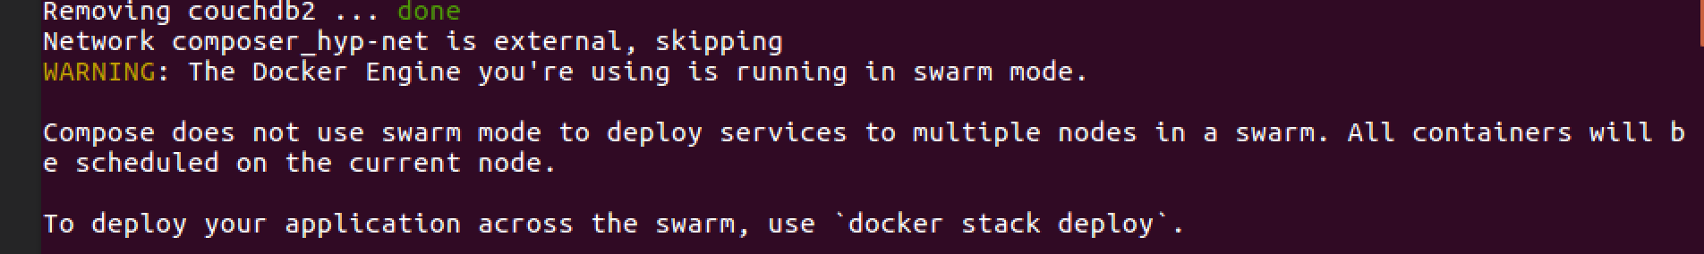

This script will do the following:

* Fetch exiting channel blocks
* Enroll and join Peer2 to the channel
* Create Peer Admin card for the Host#2



Host#2

**Step 10**: On Host#2 the script will halt. Before installing the network on Host#2 we install it on Host#1

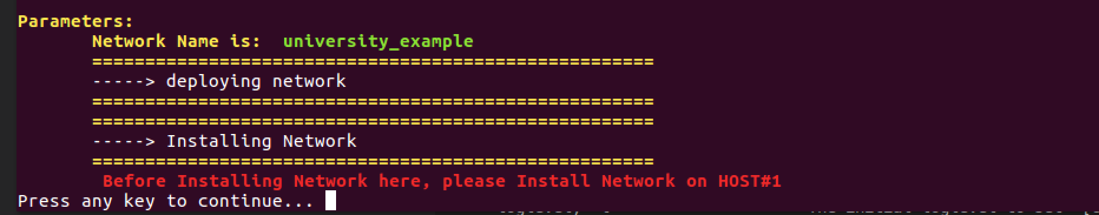

Host#1

**Step 11**: On Host#1 press any key to continue installing the network.

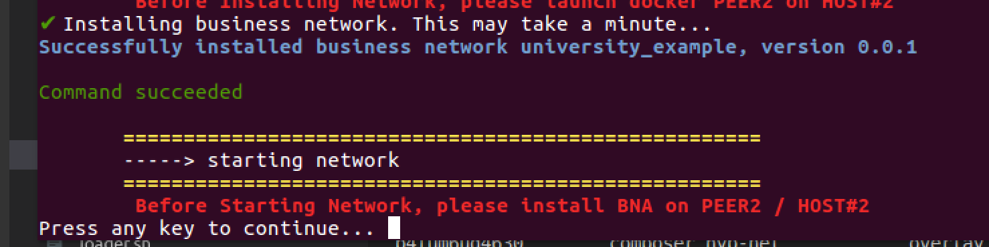

Host#2

**Step 12**: Now on Host#2 install the network by continuing the script execution. Press any key.

Host#1

**Step 13**: Finally we will start the Business Network by continuing the execution of script.



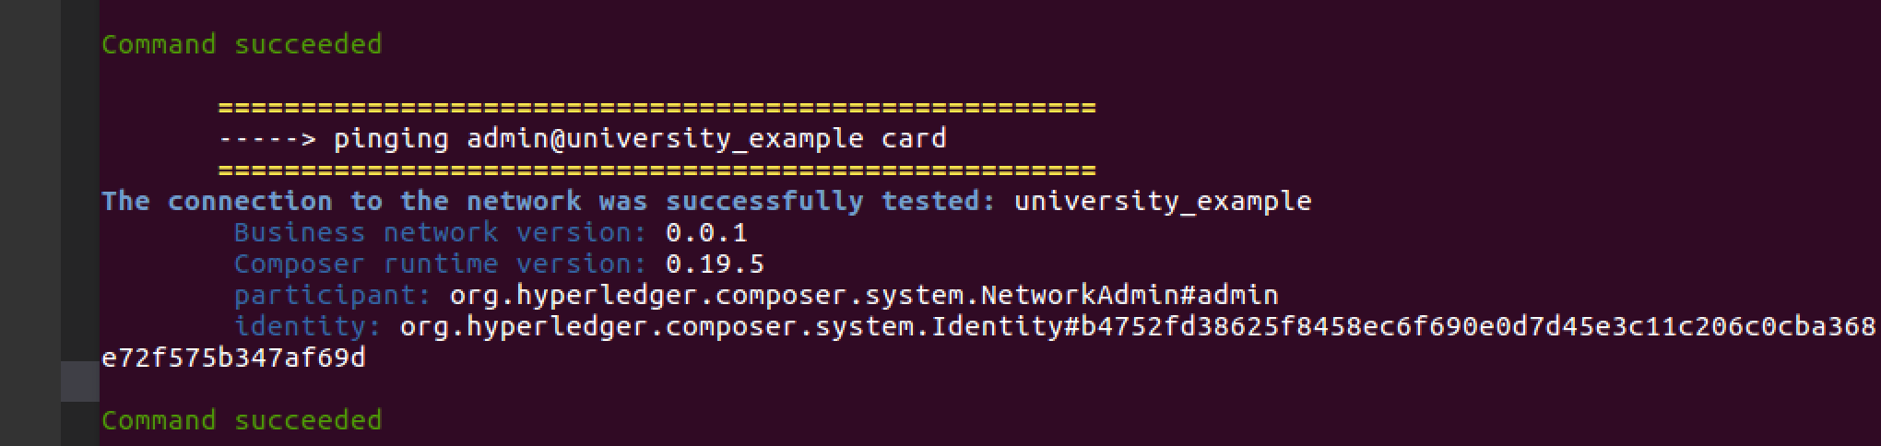

Now we are all done with deployment and starting of business network.

**Task 7 is complete!**



## TASK#8: Testing the network

### TASK#8.1: Visual Testing docker containers

Host#1

**Step 1**: On Host#1 launch docker-explorer installed on visual studio code.

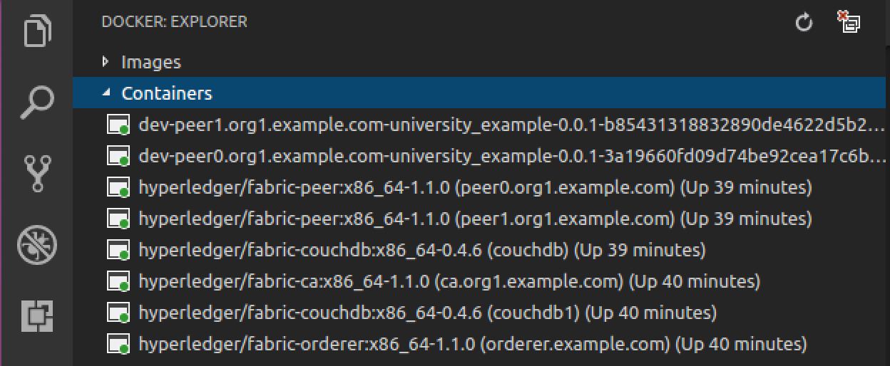

Host#2

**Step 2**: On Host#2 launch docker-explorer installed on visual studio code.

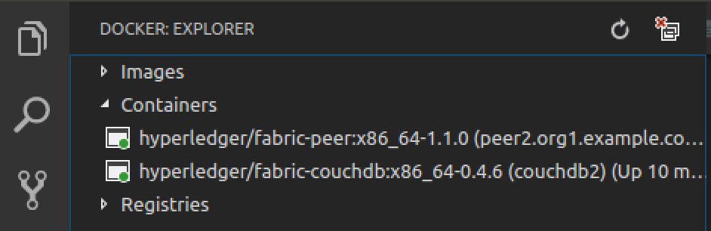

**Task 8.1 is complete!**



### TASK#8.2: couchDB Validation

Host#1

**Step 1**: On Host#1 launch Internet explorer and go to the following URL

Open couchDB database admin/util page using separate browsers:

For Peer0 : couchDB

URL: localhost:5984/_utils/

For Peer1 : couchDB1

URL: localhost:6984/_utils/



**Please Note:** Note that both the blocks are in sync as shown highlighted



Host#2

**Step 2**: On Host#2 open couchDB database admin/util page using separate browsers:

For Peer2 : couchDB

URL: localhost:7984/_utils/

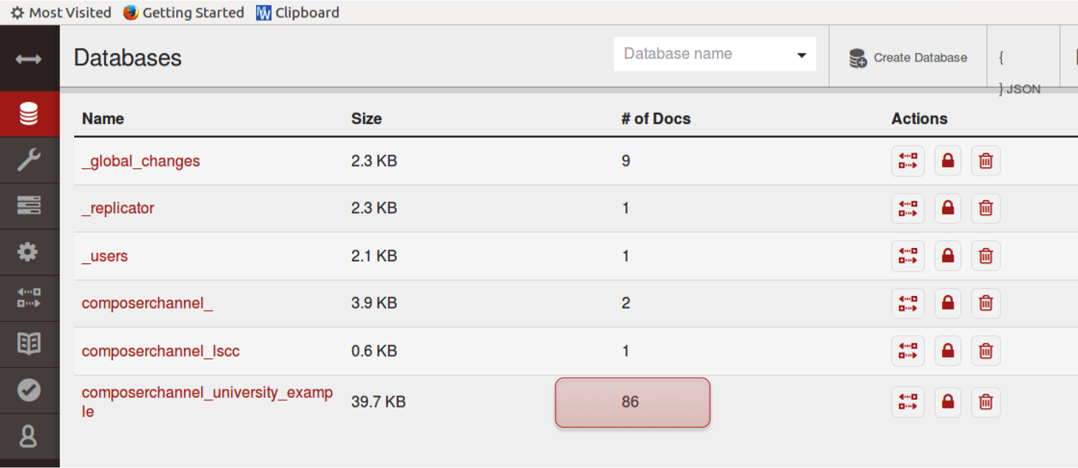

**Please Note:** Note that both the blocks are in sync as shown highlighted

**Task 8.2 is complete!**



### TASK#8.3: Run UI – Make Transaction & Validate Blocks

|  |
| --- |
| Student are encouraged to complete this validation on their own. Few minimal pointers shall be provided which are essential. |

Host#1

**Step 1**: Post deploying the “chapter5” University usecase run the UI using the following command from the ‘script’ folder

./run.sh

**Step 2**: Open couchDB database admin/util page using separate browsers:

Host#1

For Peer0 : couchDB

URL: localhost:5984/_utils/

Host#1

For Peer1 : couchDB1

URL: localhost:6984/_utils/

Host#2

For Peer2: couchDB2

URL: localhost:7984/_utils/



**Step 3**: Open UI using the URL as shown up after running ./run.sh script in step-1



URL: localhost:6005



**Step 4**: Run requestAffiliation() Transaction

**Step 5**: Refresh all DB browsers on both hosts and check that the blocks are updated



Host#1



Host#2

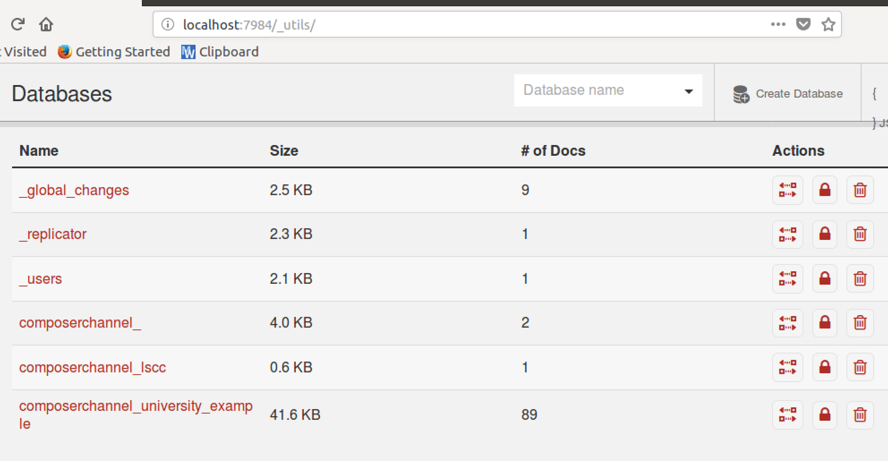

Students are further encouraged to explore more test scenarios to learn more.

**Task 8.3 is complete!**

# SUMMARY

In this chapter we

* Created a Docker Swarm Network and an overlay to connect two hosts, both running docker services
* Connected both Hosts as a Manager Node
* Passed and environment variable CORE_VM_DOCKER_HOSTCONFIG_NETWORKMODE to match the docker swarm overlay network we created
* Deployed & launched peers and BNA on both hosts
* Finally did a quick test to validate the working